LAB REPORT WRITING

What will you learn in this Lab?

This semester you will be expected to write a lab report for every exercise you complete. This first exercise of the semester is designed to acquaint you with our expectations of you, and lead you through the process of performing a lab, taking data and writing it up. You should keep this exercise for reference throughout the semester.

What do I need to bring to the Class with me to do this Lab?

For this lab you will need:

- A copy of this lab script
- A pencil
- A scientific calculator
- Graph paper
Introduction:

In all laboratory experiments the lab report is the heart of all record keeping and allows the experimenter to keep track of what has been done, and under what conditions. The one pivotal role that a lab report serves is to allow the experimenter to return to the experiment at a later date, and find enough information to completely reproduce the experiment should a re-analysis of the data be necessary. Without this the entire experiment is rendered null and void and leaves it filed under the “irreproducible result” folder. The experiment would have to be completely repeated.

This exercise is going to take you through a simple procedure to measure a set of values and from them determine another quantity. Ultimately you will need to record your data in an orderly manner, graph some of the results and draw conclusions from the information. This is the type of process you will need to follow with every lab exercise you complete this semester.

Background:

In this simple exercise your goal will be to evaluate a hypothesis that you probably already know the answer to, but the point is to lead you through how to find the answer using standard lab practices. The exercise is to measure the volume of space occupied by a selection of students in the classroom, and to see how that value correlates with the height of each student.
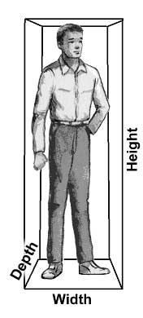
The volume (V) occupied by a given student is given by the product of the depth (d), width (w) and height (h):

V = d × w × h

This is the equation that you will need to use during your data analysis later in the lab.

The goal of this exercise is to evaluate the idea that taller students occupy a larger volume of space. Initially discuss how you would measure this and what analysis you would conduct to test this assertion. Each lab you conduct this semester will have a specific goal – you will be given information and asked to form the best model to arrive at your conclusion.

Data Acquisition:

Measure the depth, width and height of several students in the classroom. Students are free to volunteer to be measured; it is not mandatory. You need to make sure you know which person is which, so maybe a map with the location of each student and their name would help you to distinguish and record the various individual numbers. Record your data in Table 1 (at the end of the lab script) so you know your data for every person and can easily find and review the data later in the lab. (For this lab exercise, sample tables are provided, but in the future you may need to make your own.) Make sure you record the units you used in the measurements and a numerical estimate of your measurement uncertainty (how well you think you could measure each quantity). Measure enough students to get a decent sample – probably 7 or 8.

A clear presentation of the data taken in a lab is a critical component of any lab report. Also record any other pertinent information about the conditions under which the data was taken. Did you use a tape measure, a meter rule, or something else? For example, if the weather plays a role in the measurements (for astronomy this would be true), you would record the weather conditions too.

When measuring data you need to make sure that you are consistent about the number of figures you quote. If you are measuring something with a ruler whose smallest division is 1 mm, then you cannot measure a length to really any better than 1 tenth of this division or 0.1 mm. So quoting a length as 2.6743 mm makes no sense at all. In this case the right way to quote the measurement would be as, say, 2.7 mm.

For each student calculate the volume occupied by that individual. Record the data in the appropriate column in Table 1. Make sure you record the units of the derived quantity (in this case, the volume).

Analysis:

In this section you now need to take the data, and the derived results, and attempt to test the assertion we’ve made: taller students occupy a larger volume of space. We need to see how the volume calculated for each student compares with the height of each student. There are a variety of ways of doing this, including eyeballing the numbers. One particularly useful way is to graph the data, so let’s try this. Follow the Appendix on graphing included with the Math Evaluation Exercise.

Make a plot of volume vs. student height. Look at the data. Does the distribution of points indicate a correlation between the height of a student and the volume they occupy? An absence of a correlation would be represented by a scatterplot – where the data points fall evenly in a random grouping, as shown by the first graph below. (Note: your graph might be plotted on different scales, depending on the type and values of your data.)

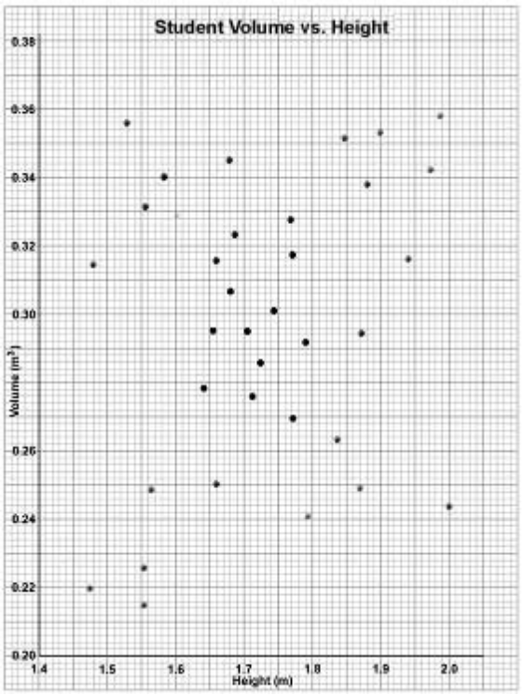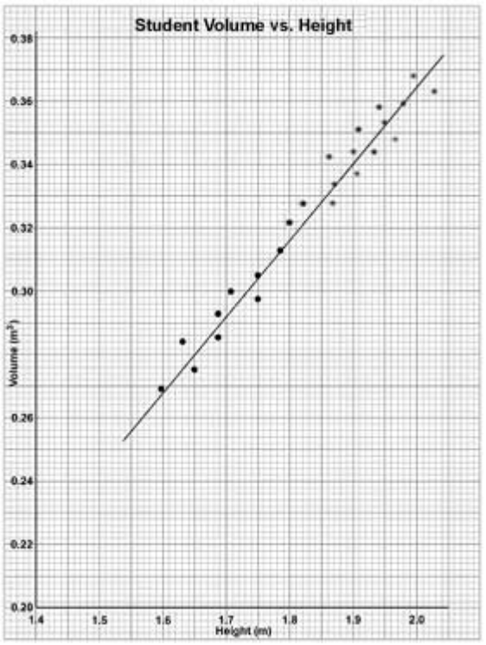

The second graph indicates a correlation between the two variables – there seems to be some kind of relationship between the two that shows up as a trend or ordered sequence of data points. How we characterize this correlation can vary a lot. In this case we have assumed the simplest relationship – a linear one – where we assert that a single line defines the relationship between the data points.

Be cautious at this point. Often adopting a linear relation between two sets of data is the simplest solution to adopt, but many times not the correct one. How well you can fit a line through the data depends on how many points you’ve got – more points would let you define the correlation better. The resulting line or curve need not pass exactly through all the data points – just fit the distribution well enough (as shown above). This issue is what drives experimenters to get as much data as possible so they are more confident of their results.

In the second graph we see what’s called a positive correlation – that the two variables increase together. A negative correlation would be one that slopes downward from left to right – that one variable decreases as the other increases. Note that a negative correlation is not an absence of a correlation – it defines the direction of the correlation.

Carefully consider your graph in light of what we’ve just discussed. Do your data support any kind of correlation or not? If so, what kind? What statement can you make to support the idea: taller students occupy a larger volume of space? Why? How do your data support or refute this claim? Or do they offer no insight? Why?

These are exactly the kinds of questions you should ask yourself at the end of every lab exercise. It makes you stand back and assess the success or otherwise of the endeavour you have been involved in. Any lab exercise should offer some form of conclusion, even if it’s a lack of a conclusion! An absence of information is still useful in the scientific process.

Now write up your lab report for this exercise following the template listed in the Lab Report Writing Appendix. You should keep this script and the one on mathematics handy as references throughout the semester. They define the standards against which you will be judged on a weekly basis by your conduct in class, the report you produce and the mathematical tools you use to arrive at your conclusions. Any lab report should address the issues listed in the Appendix, but it should also contain somewhere in it specific answers to questions posed in the lab script. Make sure you answer or address all questions asked of you – you will lose points if you don’t.

Table 1: Height, Width, Depth and calculated Volume
Person | Height H |  |  | Average H | Width W |  |  | Average W | Depth D |  |  | Average D | Volume

