Lunar Observing

What will you learn in this lab?

The Moon is the second most noticeable object in the sky. This lab will first introduce you to observing the Moon with a telescope. You will be looking at the Moon in different ways and drawing representative pictures of what you see. This lab will then introduce you to how you can use the pictures that you draw while observing to give information and data about the specific object, creating a geologic history for the Moon.

What do I need to bring to the Class with me to do this Lab?

- A copy of this lab script
- Pencil and eraser

Introduction:

Frequently when we look up into our night sky (and even into our daytime sky) we see the
Moon, Earth's only natural satellite. This planetary body orbits the Earth with a period of about 28 days, the same as its rotation period. This is why the same side of the Moon always faces the Earth. But what we notice when we observe the Moon in the sky is that it seems to go through phases of light and dark during the course of one month.

The reason the Moon goes through phases is simply the angle at which we observe the Moon in its orbit around the Earth. The phases are not caused by the shadow of the Earth. The cycle of phases begins with new moon when the Moon is positioned between the Sun and the Earth (the illuminated face of the Moon is facing away from our view). This is why we don't see a moon during this part of the lunar cycle. From new the phases move through waxing crescent, first quarter (where the west half of the Moon is illuminated), waxing gibbous, full (where the Earth is positioned between the sun and the Moon so we see the face of the Moon fully illuminated), waning gibbous, third or last quarter (where the east half of the Moon is illuminated), waning crescent, and then back again to new moon. During its monthly orbit the Moon moves about 13º eastward in the sky each day so the time the Moon rises and sets changes with the phase.

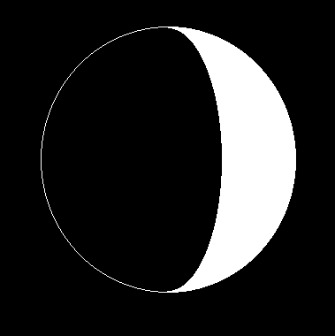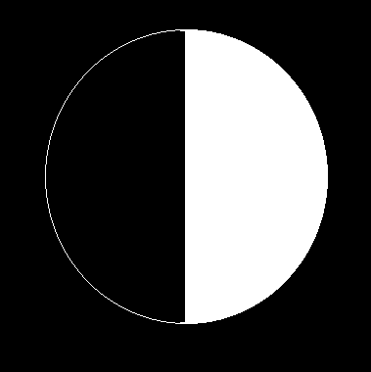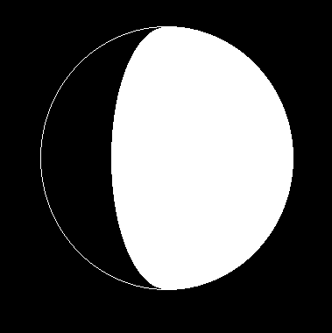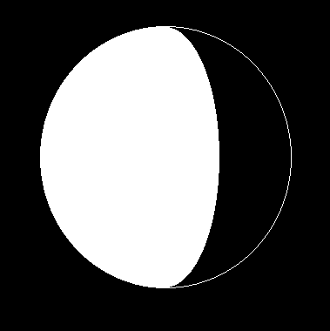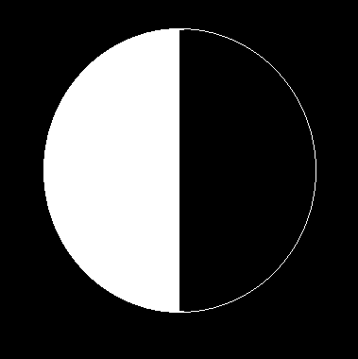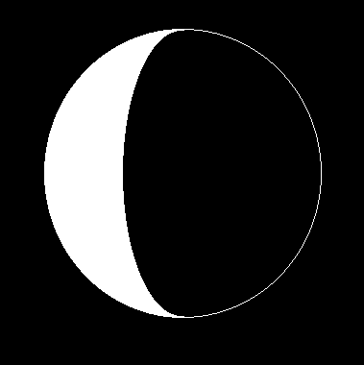
Figure 1 - Phases of the Moon

Knowing this, when is the best time to observe the Moon? Would we want to observe near full when the entire face is illuminated? Maybe near one of the quarters when only half of the face is illuminated? Picture how the light from the sun will be striking the Moon in each of the different phases. The best opportunity to observe features on the Moon most clearly is before or after new moon when the angle of the light from the sun is not as direct and will then show the features in high contrast with each other.

When you observe the Moon in the sky you should notice a dividing line between the illuminated part and the dark part of the Moon. This is called the terminator. The edge of the Moon where the sky meets the Moon is called the limb of the Moon.

This lab will have you look at different features of the Moon and draw them on an observation sheet. The lunar features are usually divided into three categories - maria, craters, and highlands. The following will describe each of these features for use in your pictures of the Moon.

Maria - These are the dark areas on the Moon that look like "seas". In Latin the word mare (singular) means sea. Maria are lowland, flat plains that resulted from the flow of lava from the Moon's interior when one or more large impactors struck the Moon and broke through the crust.

Craters - Virtually all of the Moon's craters were formed by meteoroid impacts about 4 billion years ago, in a heavy bombardment period. They are usually circular in shape and can vary in size. On the Moon the craters are usually named for famous astronomers, scientists, or explorers. The majority of craters seen through a telescope are concentrated towards the highlands and are very old. A few craters are visible in the maria which makes them younger than the event that formed the maria.

Highlands - These are the mountain- like structures on the Moon. They are the oldest part of the Moon's surface and were not formed by tectonic activity like the mountains on Earth. The highlands were formed by millions of meteorite craters, one on top of the other, that have pushed the top layer of the Moon's surface upward. These features are named after mountains and mountain ranges on Earth.

Your Audubon guide has identifying pictures and images of the Moon on plate pages 1-16 showing the different phases. You will be observing the Moon between new and full so that the features you will be seeing will be on the west side of the Moon.

Part I: Observations

In this section, you will be making several drawings of the Moon. Each of your drawings should contain the following information:

- Indicate North and South on drawing.
- Indicate areas that are dark and areas that are light.
- Where are the maria?
- Where are the highlands?
- Where do you see craters?
- Use the provided map of the Moon to label the main features (maria, highlands, craters) you have drawn on your pictures.

The first thing you will need to do is familiarize yourself with how the Moon looks in the sky. Look at the Moon through binoculars/finderscope and with your eyes. Draw and label what you see in the spaces on page 7. Use a pencil!

Next you will be looking at the Moon through the telescope. The telescope should already have a 40-mm eyepiece in it, which has the largest field of view and is therefore optimal for viewing the entire disk of the Moon. Draw what you see in the space on page 7.

- Compare your three drawings. Are there differences among the pictures you drew with the binoculars, your eyes, and through the telescope? If there is, explain what the differences are and what you believe created this difference.

Next you will draw detailed pictures of three different areas of the Moon. The locations you will be asked to draw will be given to you by your TA depending on what phase the Moon is in. This part of the lab requires you to change the eyepiece to a 12.5-mm eyepiece. The new eyepiece will give you a smaller field of view and therefore a more magnified view of the Moon. Be sure to ask your TA for the list of regions and the new eyepiece. Draw and label what you see in the spaces on page 8.

Part II: Analysis

Examine the pictures you drew looking through the telescope at the specific locations. You should be able to notice certain things: some craters may be on top of others, other craters may be filled in and look like the surrounding maria, the maria itself may have craters in it, there may be many highland areas or there may be none. These are all things you will want to make note of as you examine the pictures. Make careful notes on what it is you see - you will be using these in the next part of the lab.

You will now determine a simple geologic history for the Moon. A geologic history is just a story of how a planetary body formed from beginning to end. Since the Moon has not had much recent geologic activity we can look at a few different locations on the Moon and be able to determine a global geologic history from the locations of the craters, maria, and highlands. For this part you will need to understand the difference between relative and absolute time, as well as the law of superposition for craters.

Relative time is determining the ages of events by comparing them against other events. The events are then ordered by when they occurred. With relative dating no exact date is identified (e.g. WWI and WWII). For the Moon relative dating is determined by using the law of superposition. An easy way to think about the law of superposition is to think of a paint canvas. Let's say the artist throws different colored splotches of paint onto the canvas. If we see a blue splotch under a red splotch we know that the blue splotch was thrown first. If we are looking at craters and see one crater underneath another crater we know the bottom one was created first. By looking at craters, maria, and highlands in the same way we can determine a relative timeline for how things occurred.

Absolute time on the other hand means the exact time or date of an event can be identified (e.g. 65 million years ago). For the Moon absolute time was determined by radioactive dating of lunar rocks brought back by the Apollo Moon missions. From this we know that the solar system was formed approximately 4.6 billion years ago with a period of heavy bombardment by planetesimals (debris from the formation of the planets) occurring about 4 billion years ago.

- By using these concepts and by looking at your three drawings determine a geologic history for the Moon. All this should be is a plain english description of what happened, in what order, and how it affected the surrounding regions. Be sure to state your evidence to support your hypothesis and include all three features - craters, highlands, and maria.

Questions:

- If you wanted to see the height and depth of mountains and craters, would you want to look at the Moon in Full phase or some other phase? Justify your answer.

- By knowing that the heavy bombardment period was 4 billion years ago can you give any relative ages to the features of the Moon you looked at tonight - craters, highlands, or maria? Give general estimates. What other information would you need to make better estimates?

- What process did you use to reach your geologic history of the Moon? What other evidence or data would you have liked to have had to help you with the history? Remember that we are after a list of what happened, in what order, and how you arrived at your conclusion.

Conclusion:

Part I: Observations
The circles below indicate the moon. Draw and shade the features you see from different observing methods. Indicate North and South, shade dark and bright areas, label the maria, highlands, and craters, and label those features with their proper names using your lunar map.

Eye Binoculars/Finderscope

Entire Moon through Telescope  Telescope Size:  __________ inches  Eyepiece:  __________ mm | 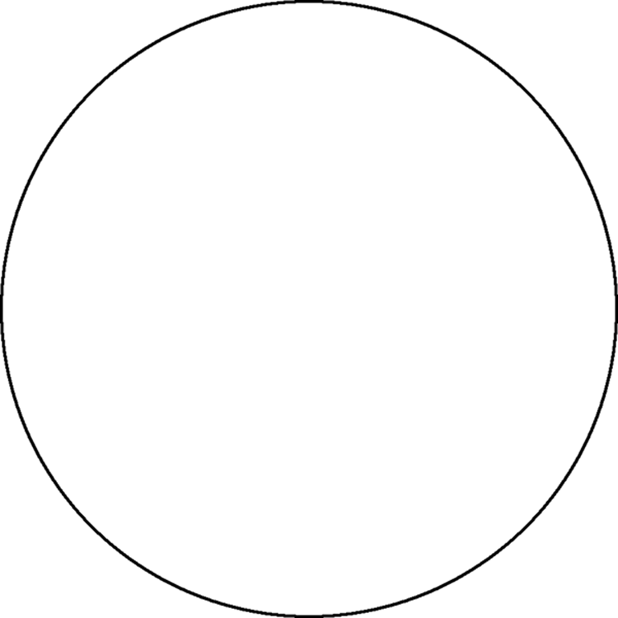
These circles indicate the entire telescope field of view for detailed drawings. Label as above.

Region #1

Region Name: ___________________

Telescope Number:

__________

Eyepiece:

__________ mm

Region #2

Region Name: ___________________

Telescope Number:

__________

Eyepiece:

__________ mm

Region #3

Region Name: ___________________

Telescope Number:

__________

Eyepiece:

__________ mm

Bad Weather Alternative

In the event of bad weather, or cloudy skies, you will use the images provided below. You should still be able to answer the questions posed, and you are still responsible for labeling the major surface features.

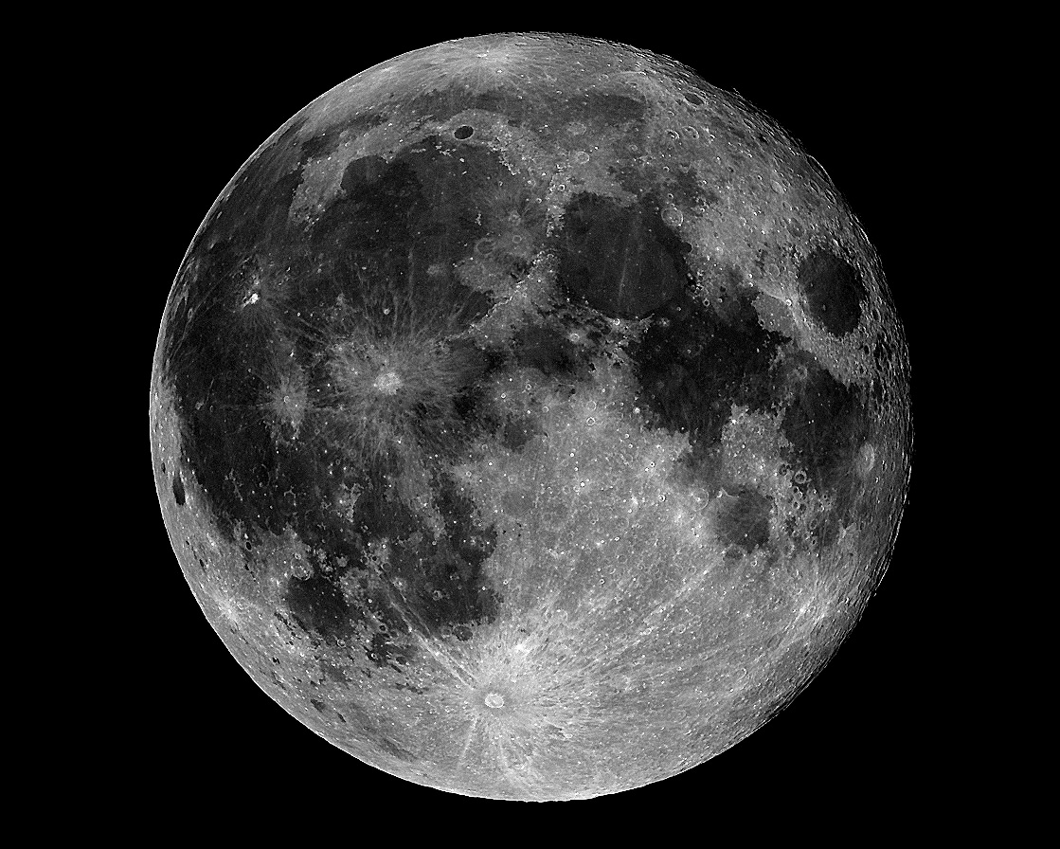
Figure 1 - Full Moon

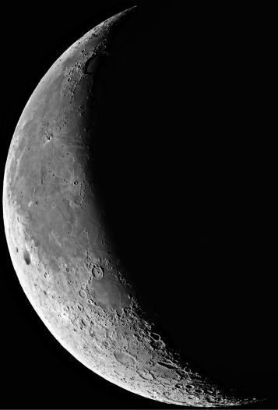
Figure 2 - Partial phase

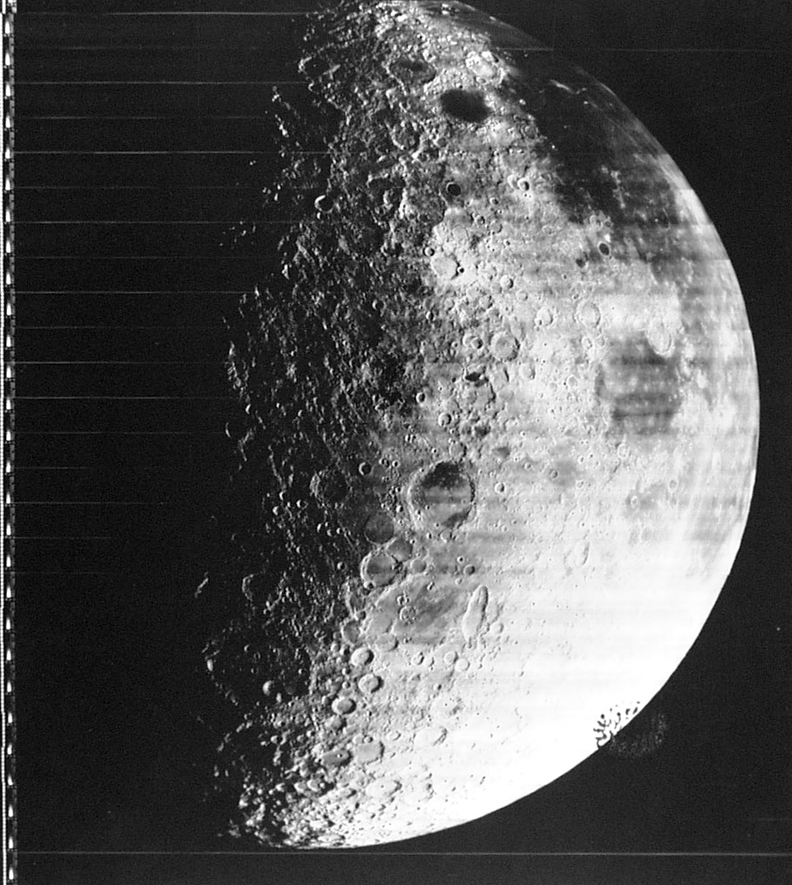
Figure 3 - Grimaldi crater

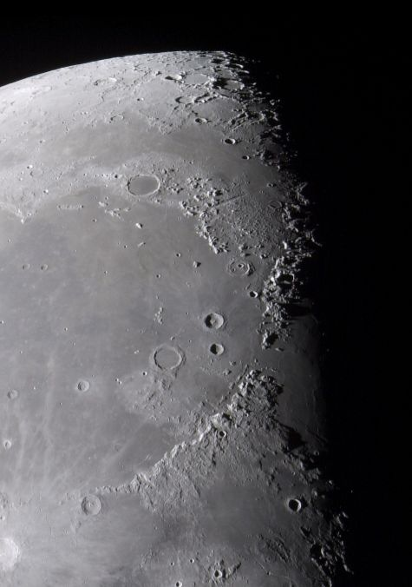
Figure 4 - Mare Imbrium

