Name: ____________________________________ Score: _____ / 50

Math Refresher Answer Sheet
(NOTE: Only this answer sheet and the following graph will be evaluated)

- ____________________
- ____________________
- ____________________
- ____________________
- ____________________
- ____________________
- ____________________
- ____________________
- ____________________
- ____________________
- ____________________
- ____________________
- ____________________
- ____________________
- ____________________
- ____________________
- ____________________
- ____________________
- ____________________
- ____________________
MAKE SURE CALCULATOR IS IN DEGREE MODE!
- ____________________
- ____________________
- ____________________
- ____________________
- ____________________
- ____________________
- ____________________
- ____________________
- ____________________
- ____________________
- ____________________
- ____________________
- ____________________
- ____________________
- ____________________
- ____________________
- ____________________
____________________
____________________
- ____________________
- ____________________
- ____________________
- ____________________
- ____________________
- ____________________

Three answers for #37 are your three measurements of Callisto. #41-#44 have algebraic answers.

DON'T FORGET THE GRAPH!

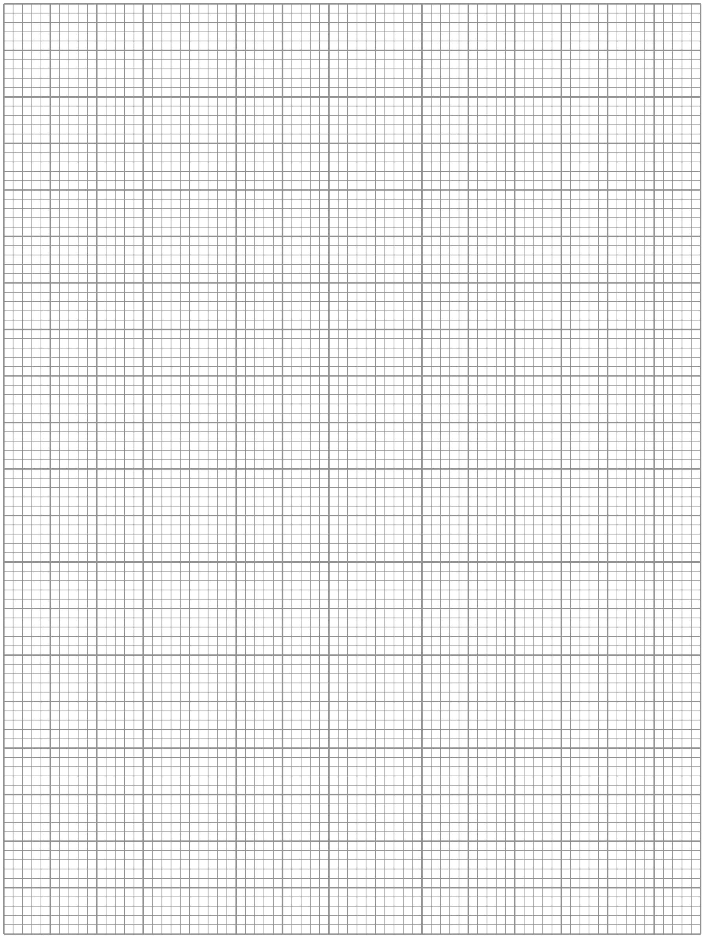

Math REFRESHER

What will you learn in this Lab?

This exercise is designed to assess whether you have been exposed to the mathematical methods and skills necessary to complete the lab exercises you will be given this semester. This is not a test. It is merely a tool for us and yourself to determine whether you will be OK in your mathematical challenges this semester. The outcome will minimally feature in your final grade (25 points), but you should take the results seriously in light of what they could mean to your final class grade.

What do I need to bring to the Class with me to do this Lab?

For this lab you will need:

- A copy of this lab script
- A pencil
- A scientific calculator

Introduction:

Mathematics is a language that scientists use to describe the world and universe around them. As such it is a vital and indispensable part of any science lab class, since the tools afforded to the experimenter by mathematics allow him or her to analyze the data and come to conclusions that just staring at the numbers would never reveal.

During this class you will be asked to carry out the type of routine mathematical procedures that you might use this semester to analyze your data. You need to complete this exercise in class and hand it in before you leave. You cannot complete it at home and hand it in later.

Addition, Subtraction, Precedence of Multiplication and Division

Just as a reminder to you, your calculator follows rules called “orders of operation”. Put simply, if you type in a long string of operations, your calculator will compute them in the following order: operations in parentheses, exponents/logarithms, multiplication/division, addition/subtraction

Answer the following problems:

- 1546 + (645 – 123) + 789 =
- 1634 - 67 × (185 – 23) =
- 1634 - (67 x 185) - 23 =
(Note: the only difference between questions 2 and 3 is the placement of the parentheses!!!!!)
- 189 × 54 + 336 ÷ 24 =

Expressing Numbers to Significant Figures and Decimal Places

When conducting physical experiments in a laboratory setting, you need to be aware that your final answer cannot be more accurate than your initial measurements. For example:

You measure the length of a rectangle to be 3.45 centimeters (cm). You measure the width to be 5.65 cm. You also know that the area of a rectangle equals length times width.

3.55 cm x 5.50 cm = 19.525 cm²

But you know that your ruler cannot measure to thousandths of a cm. So the correct answer due to the accuracy of your measuring tool is 19.5 cm. This answer also has the same number of “significant figures” as the initial measurements. For example:

0.00027745 to 3 significant figures = 2.77 x 10⁻⁴
884536 to 4 significant figures = 884500

Answer the following problems:

- 3.72511x10⁴ to 2 significant figures =
- 0.0074221 to 4 significant figures =
- 4.9211x10⁵ to 2 significant figures =

For all subsequent questions you should quote the answers to the same number of significant figures that are presented in the problem.

Converting Numbers into Scientific Notation and Performing Arithmetic

Many numbers that we will encounter in astronomy are either very large or very small, so it is convenient to express these numbers using scientific notation. Here are three examples:

Mass of the Sun = 2,000,000,000,000,000,000,000,000,000,000 kg = 2 x 10³⁰ kg
Mass of the hydrogen atom = 0.00000000000000000000000000167 kg = 1.67 x 10⁻²⁷ kg
Distance to the nearest star = 40,200,000,000,000,000 m = 4.02 x 10¹⁶ m

Notice that the leading number is between 1.00 and 9.99 and that the exponent represents the number of places left (positive) or right (negative) that the decimal point must be moved to make it so.

To add and subtract using scientific notation, the numbers must be raised to the same power of 10. For example,

200 + 20 = 2 x 10² + 2 x 10¹ = 2 x 10² + 0.2 x 10² = (2 + 0.2) x 10² = 2.2 x 10² = 220

To multiply (or divide) numbers expressed in scientific notation, you must multiply (or divide) the leading number, but add (or subtract) the exponent. Here are a few examples:

2.5 x 10⁸ × 3.0 x 10² = (2.5 × 3.0) x 10⁽⁸ ⁺ ²⁾ = 7.5 x 10¹⁰
8.24 x 10⁸ ÷ 2.00 x 10³ = (8.24 ÷ 2.00) x 10^{(8 – 3)} = 4.12 x 10⁵

For the purpose of this course, you can complete these calculations with your calculator; the above information is so that you understand what your calculator is doing.

Express the answers to the following problems in scientific notation:

- 65538.11 in scientific notation =
- 0.0005521 in scientific notation =
- 2.7718x10⁵ + 3.8821x10⁷ =
- 5.2119x10⁶ – 3.2764x10⁵ =
- 8.772x10⁴ ÷ 5.339x10⁶ =
- 5.229x10³ x 5.119x10² =
Taking Logarithms and Exponents

The logarithm (or “log”) of a number is the exponent to which 10 must be raised to equal that number; or log (10^{x}) = x. Logarithms are another shorthand for expressing extremely large or small numbers. For example:

log(1,000,000) = log(10⁶) = 6
log(36,000,000) = log(3.6 x 10⁷) = 7.6
log(0.0021) = log(2.1 x 10⁻³) = -2.7

For the purpose of this course, you can complete these calculations with your calculator; the above information is so that you understand what your calculator is doing.

Answer the following problems:

- log(2678834.11) =
- log(0.0002663) =
- 10^{(0.00277)} =

Taking Roots and Raising Numbers to Powers

Use your calculators to answer the following problems:

- (3.4421)⁵ =

- (0.0081)³ =

Trigonometric Mathematics, Geometry and Angles

It will also be useful to manipulate triangles in our study of astronomy. It is necessary to recall the three trigonometry functions sine, cosine, and tangent. The definitions are shown below. Use these trig definitions to answer the following questions. Make sure that your calculator is in degree mode (not radian mode). If you do not know how to check this, please ask for assistance.

sin(θ) = A/C
θ
cos(θ) = B/C
tan(θ) = A/B

θ = sin⁻¹(A/C)
A C θ = cos⁻¹(B/C)
θ = tan⁻¹(A/B)

A² + B² = C² (Pythagorean theorem)
B

- It is also helpful to recall that the sum of the interior angles of a triangle equals 180°. Calculate X:

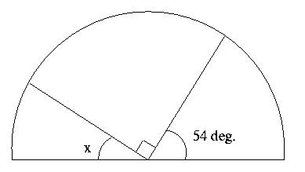

- Calculate X:

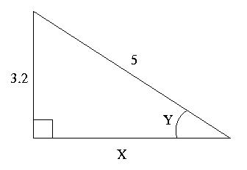

- Calculate Y from the previous problem.

Answer the following problems, using your calculator. Give angles in degrees (check again: is your calculator in degree mode?):

- tan(23°) =
- Solve for y: cos(y) = 0.773
- Solve for z: sin(z) = 0.0012
- sin⁻¹(0.472) =
- Solve for y: tan⁻¹(y) = 14º
- Solve for z: cos⁻¹(z) = 63.9º

Time and Angles

Here are some basic definitions about angular measure.

1 circle = 360 degrees = 360°
1 degree = 60 arcminutes = 60'
1 arcminute = 60 arcseconds = 60"

Answer the following problems (and remember to use significant figures):

- Express 2.1º in arcseconds(“).
- Express 44º 23’ 12” in degrees.
- Express 12.8854º in (º ‘ “)
(See #31: should be single answer, not three separate answers.)
- Express 23.24 hours in minutes.
- Express 23.24 hours in days.

Calculating Percentage Errors

The term “error” means that a result deviates from some value known to be “true.” Usually, in our lab exercises, we shall want to compare the values we obtained experimentally with some known value. One way to calculate the error in our experiment is to obtain the “percentage error:”

Answer the following problems:

- Known value = 54.3; Measured Value = 55.2; % error =

- Known value = 633.2; Measured Value = 721.5; % error =

- You are given an image of one of Jupiter’s moons, Callisto. Measure the diameter of Callisto in cm using a ruler. Measure Callisto THREE TIMES, total, from a variety of different angles.

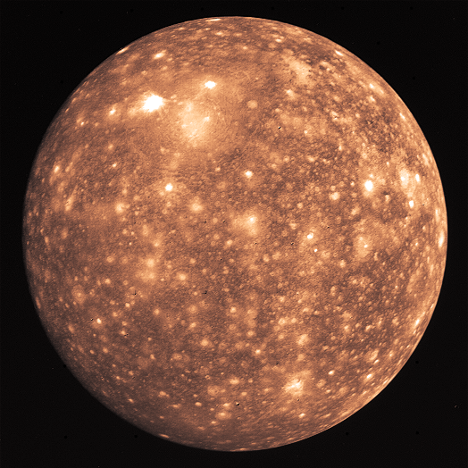
- Average your three values for the diameter of Callisto. (Taking measurements multiple times and using the average value decreases the uncertainty in your experiment.)

- If you printed this math evaluation on standard US letter paper, one page per sheet, the scale on the map is 1 cm = 630 km. Assume this is correct. Use this knowledge to calculate your experimental value of the diameter of Callisto.

- The diameter of Callisto is known to be 4800 km. What was the percentage error in your experiment?

- What assumptions did you make that introduced error into this experiment?

Graphing Data

Graph the following table of information on the provided graph paper (see end of lab before you make the graph). This is a skill you will use almost every week.

X value: Distance (m) | Y value: Velocity (m/s)
12.2 | 3.49
14.3 | 4.22
16.1 | 5.19
18.4 | 6.33
20.1 | 7.88
24.3 | 9.11
29.6 | 13.2

Draw the best curve or line that fits this data. Which is the most accurate or best measured part of the graph?

Rearranging Formulae

Solve the following equations for the variable listed:

- Solve for c: 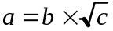

- Solve for b: 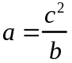

LAST BUT NOT LEAST – Plotting Graphs

When plotting a graph there are several things you need to do, in a specific order, to make sure the graph turns out right. Learn how to do this – you are going to do this a LOT this semester.

- You need to fill the grid as much as possible in order to interpret the data.
- A graph plots one variable against another. Usually the measured quantity is on the horizontal or X-axis. The derived quantity is usually plotted on the vertical or Y-axis.
- For each variable determine the minimum and maximum value for each. Use these values to determine the needed range of values to appear on the graph. For example, if your heights range from 1.4 to 2.0m, then your range is 0.6m. You may then round this number up to a sensible value that still covers your range of data but is easier to plot on a graph.
- Look at your piece of graph paper. Count the number of major divisions across the page, and up the page. If there were, as in the case of the page shown here, 15 major divisions across the page, then it would make sense to use 2.5 major divisions for each 0.1 (0.6=0.1x6) of the X-axis (15/6=2.5). When you choose your scale you need to make sure there’s enough room for labels, etc. Do the same exercise for the Y-axis. The origin of the graph need not be (0,0). It should be the minimum value needed for both sets of data. Add labels for each axis and include units. Add a title to the graph. You are now ready to start plotting your data. You can never change scale once you have started plotting – if you need to change the scale – start over.
- Never “connect the dots”!

When plotting your data you need to make sure you’re reading your own graph correctly! Let’s say you need to plot a data point at (1.74, 0.256). You need to find where these data values occur on your two axes.
First let’s look at the X value (the first number in a coordinate quoted this way). The value of 1.74 is clearly going to be between 1.7 and 1.8 – so you need to find that part of the X-axis (shown). Then you need to count the number of minor divisions between these two end points, in this case 10. So, each minor division is equal to (1.8-1.7)/10 = 0.01. The position of 1.74 = 1.7 + (4x0.01): 4 minor divisions past 1.7, as indicated by the arrow.
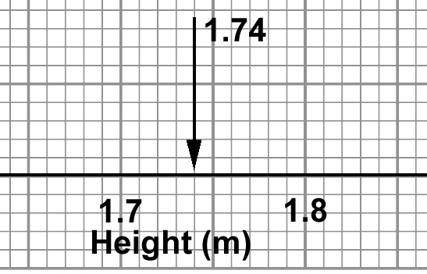
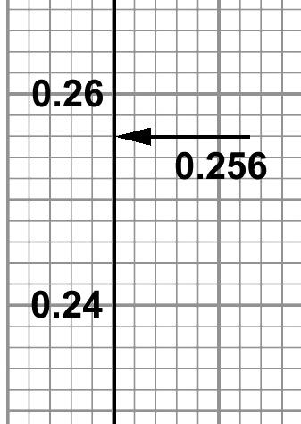
Next, let’s look at the Y-axis value. Again 0.256 is going to be between 0.24 and 0.26 on the axis. This time the minor divisions correspond to a different value: (0.26-0.24)/10 = 0.002. This means that 0.256 = 0.240 + (8x0.002): 8 minor divisions past 0.24, as indicated by the arrow.
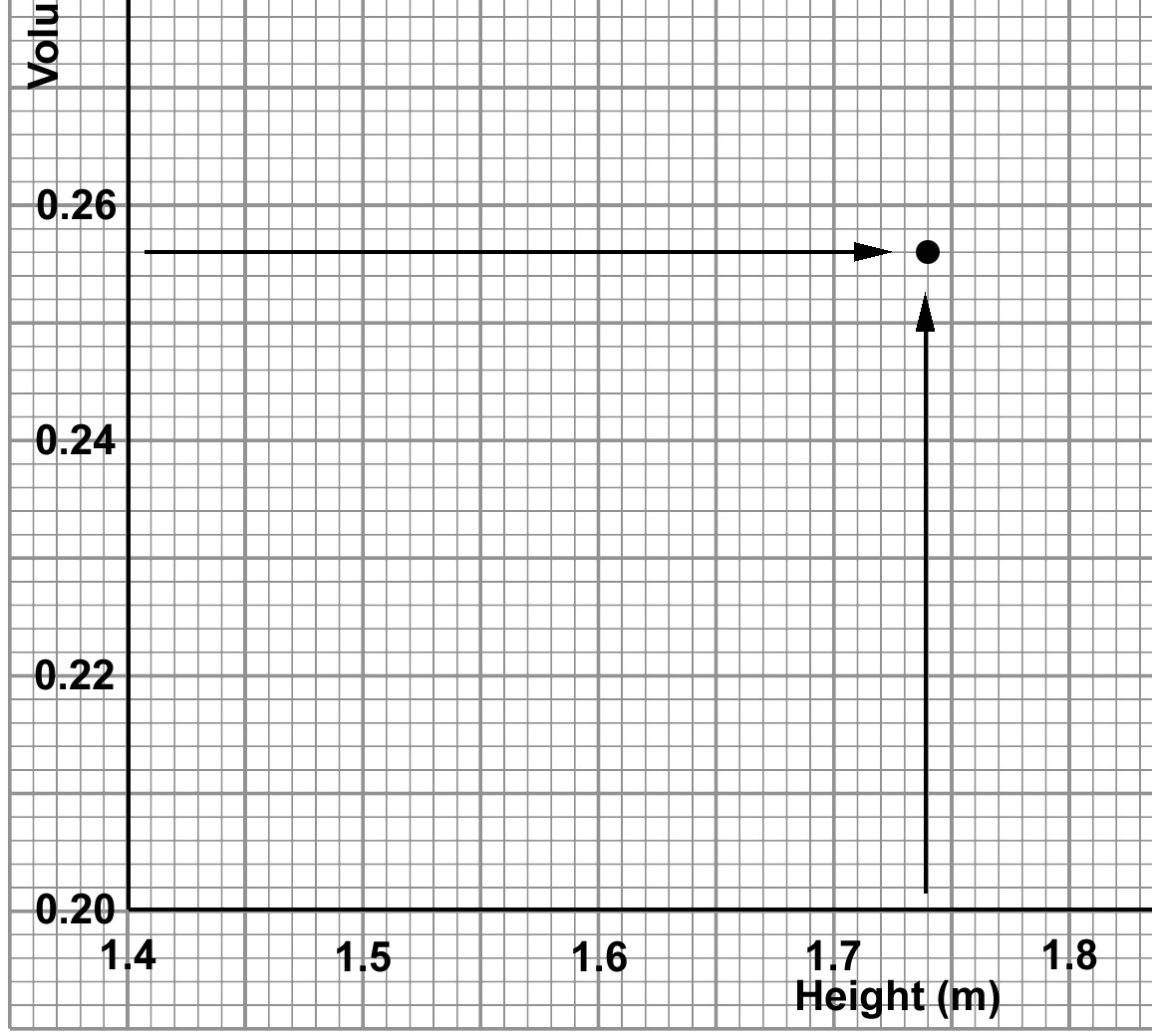
Now you have the two pieces of information you need to successfully plot this data point on your graph. Track across the graph with your finger from the Y axis position, and up the graph from the X axis position, and where the two meet, mark the position with a point.

