The Motion of the Sky

What will you learn in this Lab?

How long is a day? Do you know? Do you really know? This lab is going to address that question and let you figure out how long a day is. It will also help you figure out why your initial answer may not be right, and why. This lab will also draw on earlier observations you’ve made this semester to study how the sky changes over longer periods of time. You’ll be doing two sets of observations – one set outside if the weather permits, and one set inside. You’ll be using some of your new measurement and accuracy skills to find out how well you can measure the length of the day and where your sources of error might be.

What do I need to bring to the Class with me to do this Lab?

For this lab you will need:

- A copy of this lab script
- A pencil
- A calculator
- Your Northern and Southern Sky Sketches from the two previous Naked Eye labs
- Audubon Sky Guide
- SC sky maps (both of them)
- Star wheel
- Red Flashlight

Introduction:

This lab exercise focuses on how the night sky moves and changes with time of year and during the course of a night. The purpose of the first part of the exercise is to determine the length of the sidereal day, i.e., the time it takes the earth to rotate 360º on its axis. We will use two methods and compare their relative accuracy. In the second part of the lab, you will study the sketches you have made of the night sky in previous naked eye labs. By analyzing these sketches, you will become familiar with the annual motion of the sky and attempt to determine what causes it.

PART I: Measuring the Sidereal Day
Observations:

The first part of this lab involves arriving at a strategy that would allow you to observationally determine the length of a day. How would you do this? Think about what you see every day around you, and how you know what time of day it is right now (e.g. morning, afternoon, etc.). The TA will lead the class in a Q&A session. Together you will then determine what is the best course of action to pursue. Start your observations and then move on to the next part of the lab, remembering to return to finish your observations before the end of the class.

Determining the Length of the Sidereal Day from Your Visual Observations:

Using your observations you need to determine the length of the sidereal day. There are certain questions you need to address in completing this task.

- In the course of your observations, how much have objects in the sky moved – i.e. what is the angular change in position of the objects you have observed. How are you going to determine this quantity? How accurate is this method? Remember to assess the uncertainty in your measuring technique. Should you measure this quantity using one or many objects? Why?

- How much time has passed during your observations? How do you determine this? What is your uncertainty is this amount? Remember that to include time in any calculation, the quantity needs to be expressed in decimal units (e.g. NOT hours and minutes).

- Using these two quantities you should be able to calculate the length of an entire day – remember that the definition of a sidereal day is how long it takes the same object to return to the same exact place in the sky the following day. How might you calculate this length of time? What is your uncertainty going to be?

- Given that the known length of a sidereal day is 23^{h} 56^{m}, calculate the percentage error in your final estimate. Is this consistent with the uncertainty you have estimated with your method? If not, why not?

PART II. Measuring the Sidereal Day from Photographic Observations

Introduction:

In this part of the lab exercise you will use a photograph to determine the length of the sidereal day, or P. The long-exposure photograph provided was taken with a still camera mounted on a tripod. The camera was pointed toward the North Celestial Pole so the picture shows the sky in the direction of Polaris (α Ursa Minoris) and Ursa Minor. Because the earth turned during the exposure, all of the stars are seen as trails of starlight.

The photograph was made by opening the shutter on a camera for 15 minutes, covering the shutter for 5 minutes, and then opening the shutter again for 90 minutes more. The interruption in the star trails represents the 5 minute time period when the shutter was closed. The TOTAL EXPOSURE TIME = 110 minutes.

Determining the Length of the Sidereal Day from the Photograph:

- From looking at the photograph, locate the NCP. Choose several stars to measure in the photograph and label them – the farther out the better.

- Using a protractor, measure the angular distance traveled by the stars in the picture.

- Using the known time for the photograph, calculate the length of the sidereal day. What is the accuracy of this method? As before calculate the percentage error in your estimate. Does it compare well with your estimate of the accuracy?

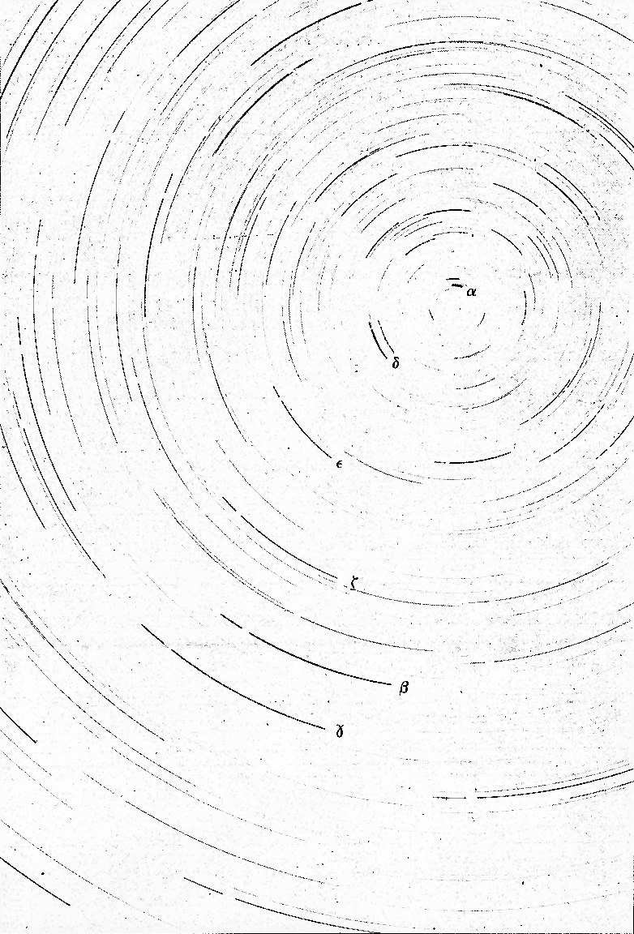
PART III – Motion of the Night Sky during the Semester

Introduction

This part of the lab compares how the night sky looks tonight compared to how it looked earlier in the semester. You should make this comparison using sketches of the night sky made in earlier labs. You will start by having a short presentation on the motion of the sky in the Planetarium.

Observations

Go out to the roof and make another set of North and South sky sketches, remembering to include bright stars and label constellations that you identify in the sky. For each of your sketches, estimate the angular distance of the previously defined southern reference star from the western horizon. For example, if the reference star was directly south in the sky at the time of your sketch, it is 90° from the western horizon. If it was somewhat east of south, it was more than 90°; if it was west of south, it was less than 90° from the western horizon. Record each of the three numbers (one for each sketch).

Analysis

- Using your sketches and considering the dates they were made, can you make some statement about which direction the sky has appeared to move over the course of the semester? Explain why the motion you see between your different sketches cannot be caused by the rotation of the Earth on its axis every 24 hours.

- Since each sketch was made at around the same time of night, then the angular distance of the Sun below the western horizon is roughly the same for each sketch. Therefore, what can you say about the angular distance between reference star and the Sun? Explain why the separation changes, and whether this represents any real change in the actual distance between the two stars. Include a diagram to help in your explanation.

Rate of motion of the sky

It should be clear that things in the sky have moved; you made your sketches at the same time each night, but the constellations are in different locations in each sketch. But how fast is the motion?

You can calculate the rate at which the sky appears to rotate with the use of your sketches of the northern sky. First find and label the previously defined northern reference star on each of your three sketches. Transcribe the positions of Polaris and the reference star onto the next page making sure to keep the edges of the page parallel and the cardinal directions the same. This diagram will indicate how the position of the reference star changed from sketch to sketch relative to the horizon and Polaris.
Southern sky sketch Name:
Date: Time:
Instructor verification:

South
Northern sky sketch Name:
Date: Time:
Instructor verification:

Motion of Northern Reference Star



1st/2nd 2nd/3rd

Difference in position angle: _________ degrees _________ degrees

Difference in date: _________ days _________ days

Rate of motion of northern reference star: _________ degrees/day _________ degrees/day

- Make an estimate of how the angular position changed from night to night relative to the edge of the page and using the center of rotation marked by Polaris.

- By considering the dates when the 3 sketches were made, make an estimate of the average rate of motion of the sky in degrees per day. Make an estimate of the uncertainty in your measurement.

- You should know what the answer really is based on how long it takes the Sun to move all the way around the sky relative to the stars. Compare this number to your answer. Is the real number consistent with your estimate? Include a percentage error estimate. Be sure to explain any sources of error.

- How does the motion of the stars in the northern sky differ from the motions of the stars in the southern sky. Why are they different?

Questions:

- If you face North, in which direction (clockwise or counterclockwise) did the sky appear to rotate during the night? What about during the semester?

- What causes the constellations to move during the night? What causes the constellations to move over many nights?

- Is Polaris directly at the North Celestial Pole? Explain how can you tell this from the photograph.

- Which method of determining the length of the sidereal day gave an answer closer to the true value? Explain why you think that value was more accurate. How did this accuracy compare to that of measuring the rate of motion of the night sky during the semester?

- We use the solar day (24^{h} 00^{m}) as our standard of time on clocks and watches. The length of the solar day differs from the sidereal day (23^{h} 56^{m}) by four minutes. Explain why the two are not equal and why the solar day is longer (a diagram may help in this explanation).

- Calculate the number of sidereal days in a calendar year, and compare this value with the number of solar days in a calendar year.

- If you observed the same objects you used in Part 1, but 6 months from now, predict where they would be in the sky at the same time of night. Explain the reasoning that led to your answer.

Conclusion:

