AST 114 Score _____/50
Name:__________________________________

Date:___________________________________

OPEN CLUSTERS QUIZ

- Do all stars in the Pleiades have the same apparent magnitude?
- Do all stars in the Pleiades have the same B-V color?
- Does the B-V value indicate brightness or temperature of the star?
- Were there any red giants in the Pleiades? Explain your answer.
- How would intervening dust affect the age determination to a cluster?
- How would intervening dust affect the distance determination to a cluster?
- Explain how the main sequence turnoff point allows you to determine the age of a cluster.
- Were there any white dwarfs in the Pleiades?
- Was the turnoff easy to find for the Pleiades?
- Label where the main sequence, white dwarfs, and red giants are on the following HR diagram. (Note: this is NOT for the Pleiades)
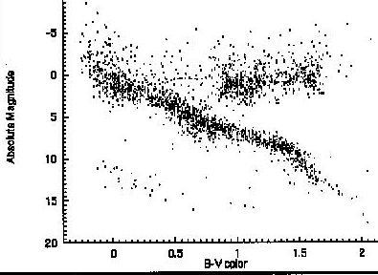

- The following diagram is the H-R diagram for the Pleiades. If our Sun (B-V = 0.62) were located in the Pleiades, what would its apparent magnitude be?

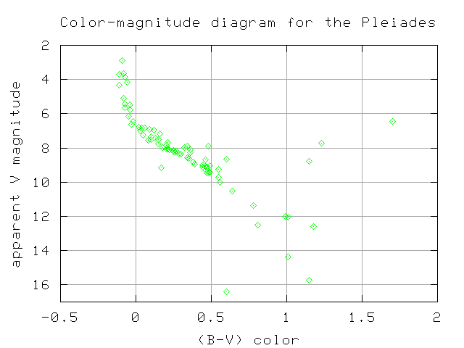

- How far away is the Pleiades? Calculate by comparing the absolute and apparent magnitudes for a star with a B-V color = 1.0, using the data from the two provided H-R diagrams.

Possibly Useful Information

