Parallax and Proper Motion

What will you learn in this Lab?

We will be introducing you to the idea of parallax and how it can be used to measure the distance to objects not only here on Earth but also in the nearby Universe. This is a very important tool used by astronomers and can be used to check other methods for measuring distances to the stars. It does have limitations and you will be finding those out. You will be asked to think about some interesting ideas using parallax. You will then use the computers to measure the apparent proper motion and space velocities of some well-known stars.

What do I need to bring to the Class with me to do this Lab?

For this lab you will need:

- A copy of this lab script
- A pencil
- A calculator

Introduction

Determining the distances to stars and galaxies is one of the most important, but also one of the most difficult, measurements in astronomy. Think about looking at a star in the night sky, and comparing it to the way the Sun looks in the daytime. The Sun is big and bright, the stars small and dim. They look completely different, and until the last few hundred years everyone believed that they were different. The ancient Greeks believed that the Sun and the stars were all about the same distance from the Earth; not an unreasonable conclusion, given that both rise and set in the sky in roughly the same way. Because they believed that the stars and the Sun were at the same distance from us, they also necessarily believed that the Sun was fundamentally very different from the stars; after all, their appearance is quite different. We now know that the Sun is in fact just another star, similar to many of the stars you can see with your own eyes on any clear night. The reason the Sun appears different to us, of course, is simply that it is much closer than any other star. Similarly, since the late 1960s we have learned that some objects which appear to be stars (called “quasi-stellar objects,” or quasars), are in fact vastly farther away than the stars in our own galaxy, and correspondingly emit trillions of times more light than a single star.

Thus, determining distances to stars is very important for understanding their physical properties. But how do you find the distance to something so far away? The most direct method is called parallax. The basic idea behind this method is simple: when an object is viewed from two different places, it seems to shift position more if it is nearby than if it is far away. To see an example of this, hold a finger up at arm’s length in front of you. Close one eye, and line up your finger with a distant object. Now look at your finger with your other eye—it will no longer be lined up with the distant object. As you close one eye and then the other, your finger seems to move back and forth. This shift is called parallax. Your finger is not really moving; rather, the position which you view it from is changing (by an amount equal to the distance between your eyes), making it appear to move.

An everyday example of parallax that you have probably experienced is the fact that the moon seems to follow you as you are driving or riding in a car. The nearby scenery (mountains, buildings, etc.) move by as you drive along, but the moon stays in exactly the same position. When you experience this, you are seeing the parallax shift of nearby objects (the nearby scenery) relative to distant ones (the moon).

What does this have to do with the stars? As the Earth moves around the Sun, we view the stars from a continuously changing position. Thus, nearby stars appear to change positions compared to distant stars (Figure 1).

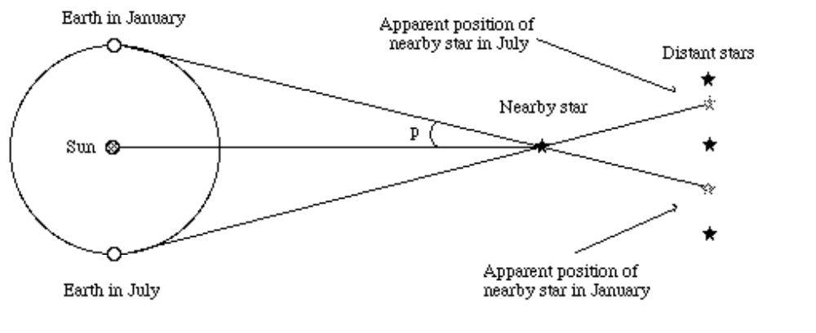
Figure 1. Parallax shift of a nearby star. As seen from Earth, the nearby star seems to change position when compared to the more distant stars.

The angle p in Figure 1 shows the parallax angle, defined as half of the apparent shift of the nearby star during the six month period shown. (The reason that only half the angle is used will be explained later.)

In order to understand how to use the shift illustrated above to measure distances, we first need to discuss the relationship between distance and angular size. Figure 2 shows this relationship.
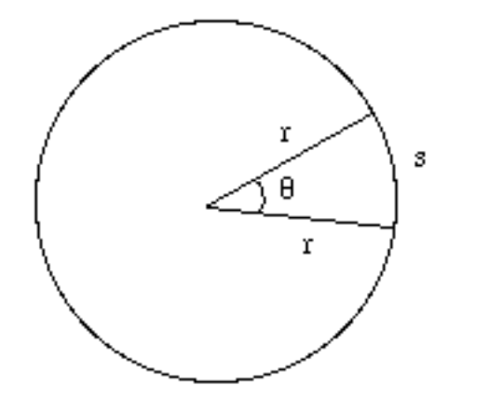
Figure 2. Relationship between angular size and distance: s = rθ

The expression s = rθ gives the relationship between distance to an object (r), the linear size of the object (s), and the angular size of the object (θ). This equation holds true if s and r are measured in the same units, and θ is given in a special unit of angle called a radian. A radian is simply defined as a unit of angle where 360° = 2π radians, so one radian ≈ 57°. Another way of understanding the definition of a radian is shown in Figure 3; it is simply the angle for which the length of the arc equals the radius of the circle.

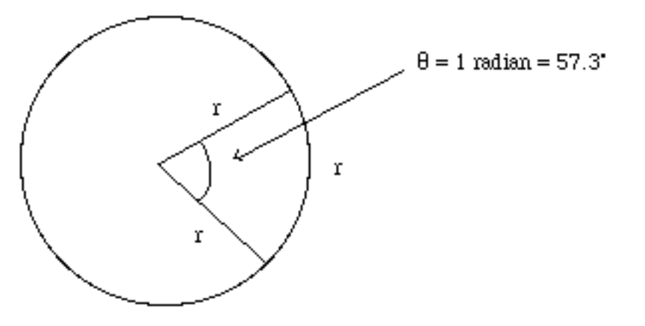
Figure 3. The definition of a radian.

In this course we will mostly measure angles in degrees, so another way of stating the same relationship is

where θ is in degrees.

One final complication with our formula is that the object we are measuring the size of (the arc s) is curved rather than straight. Since most objects we will be measuring are not curved, will our formula work? The answer is, close enough. For small angles, the length of the arc s is very close to the length of the straight cord at the same distance (Figure 4). Thus we can use this formula for distant objects whose angular sizes will be fairly small.
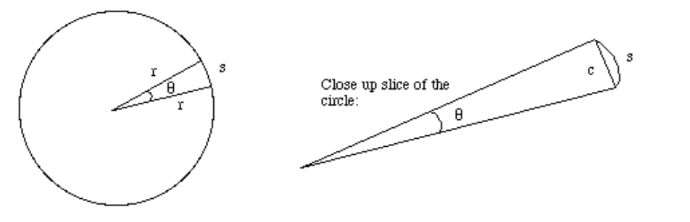
Figure 4. The length of the straight object c is roughly equal to the length of the curved arc s as long as the angle θ is small.

I. Measuring distance using parallax

You are now ready to use the parallax shift of a nearby object to measure its distance. You will find the distance to your lab partner by measuring his or her shift compared to a distant object as you move back and forth.

Procedure:

You will be taken outside by your TA to a space large enough to draw several lines in the ground in chalk, and with a clear view of distant objects. Select one distant object as your reference. Using the schematic below, place your lab partner in a certain spot (mark that spot with the chalk), and draw a baseline using chalk. This line should be a certain distance from your partner (this is the distance you’ll be trying to measure!) and should be oriented perpendicular to the line between the distant object and your partner (see below). Your partner should line up with the middle of your baseline. Measure the length of your baseline.

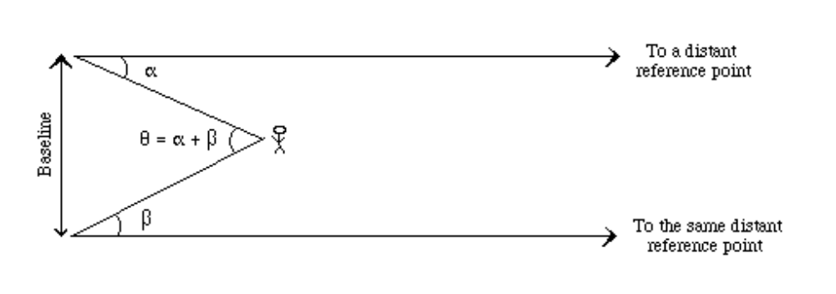Figure 5. Measuring the parallax shift of your lab partner.

Go to one end of your baseline and measure angle α using a protractor held horizontally at eye level. Place the origin at your eye. Go to the other end of the baseline and measure angle β the same way. Do the measurements several times to get an accuracy. Change places with your partner and let them do the procedure themselves.

Looking at Figure 5, you can see that the geometry of the measurements you just made is the same as that shown in Figure 2. The distance between you and your partner corresponds to the radius r, the baseline between your two measurements is the length s, and the angle θ is given by the sum of your two measured angles.

Thus, we can take the equation 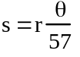 and rearrange it to find the distance r:

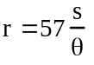
Calculate the distance between the baseline and the place where each of you stood. What uncertainty in your result is there? Using a meter rule, measure the true distance between your baseline and your lab partner. How far off were you? How can you account for the discrepancy? How reliable do you find the method? What are its failings? Calculate the percentage error in your measurement.

Footnote: Parallax in astronomy

The measurements you have just made are quite similar to those made by astronomers in order to measure the distances to nearby stars. Figures 5 and 6 show a comparison of the two situations. The big difference is that even the nearest stars are quite far away compared to the diameter of the Earth’s orbit (the 2 AU baseline shown in Figure 6).

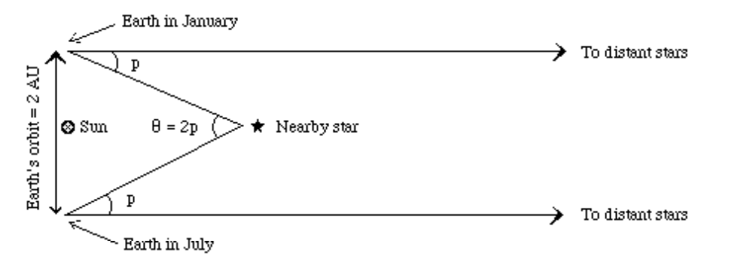Figure 6. Measuring the parallax of a nearby star; compare with the previous figure.

Because the stars are so far away, the parallax angle of even the nearest star is extremely small. One of the nearest stars, Alpha Centauri, has a parallax angle of only 0.75" (arcseconds), only 1/4800 of a degree! Using such small angles in the formula we used above (which is designed to use degrees) is somewhat cumbersome. Thus, astronomers have created a special unit, the parsec, for working with the distances to stars. A parsec is the distance at which a star will have a parallax shift of exactly one arcsecond as observed from Earth; it is also about 3.26 light years. Using the units of parsecs (for distance) and arcseconds (for parallax angle) allows us to rewrite the distance formula in a particularly simple way:

d = 1/p

where d is the distance to the star in parsecs and p is the star's parallax angle in arcseconds. (The definition of parsec in this way is the reason we use only the angle p, and not the full parallax shift 2p, when we talk about parallax angle.) Thus, if a star has a parallax shift of 0.5", its distance is simply d = 1/0.5 = 2 parsecs.

II. Proper Motion of Stars

The other cause of annual change in the position of a star is the actual real motion of the star through space. This is called the proper motion of the star and is measured as an angular speed in arcseconds per year, or since the shifts are so small, milliarcseconds per year. Of course, the speed you would measure in the night sky is only the perpendicular part of the velocity of the star: if the star were coming straight at you, you would not perceive it to be moving! Thus the actual speed of a star is usually more than what you would measure from proper motion.

We will use the computers to measure these types of apparent motion in the night sky so you can make some estimate of the real space velocities of the stars in question. Start up Starry Night and make sure that the sky and horizon is turned off. Also make sure the Equatorial coordinate grid is on, and that under Settings, you have set the Orientation to Equatorial. This will remove the effects of latitude and day/night on what you see.

Use the Selection -> Find function to locate the following objects, one at a time. For each object, set the field of view large enough that you can see nearby stars in the same field. You may need to crank up the software to show all the stars in its database. Do this using Settings -> Star Magnitudes and slide the bar for number of stars to the maximum shown.

Now you’re ready to get started. Find each object, and measure the distance between that object and a nearby star using the Measuring Tool. Record those separations – make a sketch of the relative positions, and names, of the stars so you don’t get confused. Now advance time by several years, but remember to note by how many. Now measure the separations of the stars again. By how much has the star moved? What is its apparent proper motion – and in what direction?? Given the distance to each star (provided by the program) what is the actual space velocity you’re measuring perpendicular to your line of sight? Express your answer in km/sec. Also express your answer in parsecs/year.

Once you are done with all the objects listed, go find 1 more of your own that you’d like to find out the speed of. Record it in the space provided and do the same analysis.

Star | Measured Proper  Motion (“/yr) | Distance (l.y.) | Velocity (km/s) | Velocity (pc/yr)
Sirius
Alpha Centauri
Procyon
Aldebaran
Castor
Pollux
Capella
Regulus

Remember that a speed of 1 light year per year is the same as 300,000 km/s. For the fastest star you find, calculate how long it would take that star to orbit the Galaxy – an estimated distance of about 48,200 parsecs at the orbital radius of our Sun. [Departure: Compare this timescale to the length of typical geologic periods in Earth’s history. Do you think the two might be related? Why and how?]

In your lab write up you should discuss the relative effects of parallax and proper motion on our coordinate system for stars. Why do you see celestial coordinates quoted using a specific epoch, e.g. 2000.0? What’s the one other big factor that contributes to this problem [Hint: the Earth rotates].
Questions

Your lab report should include answers to these questions:

- Given the parallax to Alpha Centauri from the lab script, what is the distance to that star in parsecs?
- The satellite Hipparcos was launched in 1989 to measure very accurate parallax angles of stars; it has provided the most accurate parallax measurements ever obtained. The smallest parallax angle it can measure is 0.002". What is the most distant star to which Hipparcos can find the distance?
- The center of our Galaxy is about 8500 parsecs from Earth. What would be the parallax angle of a star near the center of the Galaxy? Could this angle be measured with current technology?
- If you built a telescope on Mars and measured the parallax angle of a nearby star, how would your measurement compare to the parallax angle of the same star as measured from Earth? Draw a picture and explain in words. If you answered that the parallax angle would be different, exactly how many times bigger or smaller would it be?
- Figure 1 shows a view of the solar system from directly above the Sun’s north pole. Instead of looking down from above as the picture does, imagine yourself on the Earth, viewing the parallax shift of the star shown. How would the star appear to move during the year? Draw the position of the star (as seen from Earth) in January, April, July, and October. Now consider the parallax shift of a star that is directly above the north pole of the Sun (i.e. directly above the paper in the drawing in Figure 1). Again, draw the position of the star as seen from Earth in January, April, July, and October. Explain why your drawing here is different from your drawing in the previous part.
- Compare the size of the parallax we see from Alpha Centauri and the proper motion it exhibits. Which is the larger? What does this tell you about how easy it is to measure distances to stars unambiguously using parallax in this way?
- Was it generally true that the more distant stars showed a smaller proper motion? Were there any exceptions? Why do you think this was so?

One astronomical unit, or AU, is the average distance from the Earth to the Sun.
This is part of the reason that the idea of an Earth-centered universe persisted as long as it did. The ancient Greeks knew that stars should show parallax shifts if the Earth moved, but Greek astronomers’ best measurements showed no parallax shifts. Therefore, they concluded that the Earth was not moving.
The word “parsec” is a combination of the words parallax and arcsecond, revealing its origin in working with stellar parallaxes.

