Parallax and Proper Motion

What will you learn in this Lab?

We will be introducing you to the idea of parallax and how it can be used to measure the distance to objects not only here on Earth but also in the nearby Universe. This is a very important tool used by astronomers and can be used to check other methods for measuring distances to the stars. It does have some limitations though, as you will discover in this exercise. In the first part of the lab you will explore apparent change in the position of stars in our night sky due to parallax, and then you will use computers to measure the apparent proper motion and space velocities of some well-known stars.

What do I need to bring to the Class with me to do this Lab?

For this lab you will need:

- A copy of this lab script
- A pencil
- A calculator

Introduction

Determining the distances to stars and galaxies is one of the most important, but also one of the most difficult measurements in astronomy. Think about looking at a star in the night sky, and comparing it to the way the Sun looks in the daytime. The Sun is big and bright, the stars small and dim. They look completely different, and until the last few hundred years everyone believed that they were different. The ancient Greeks believed that the Sun and the stars were all about the same distance from the Earth; not an unreasonable conclusion, given that both rise and set in the sky in roughly the same way. Because they believed that the stars and the Sun were at the same distance from us, they also necessarily believed that the Sun was fundamentally very different from the stars; after all, their appearance is quite different. We now know that the Sun is in fact just another star, similar to many of the stars you can see with your own eyes on any clear night. The reason the Sun appears different to us, of course, is simply that it is much closer than any other star. Similarly, since the late 1960s we have learned that some objects which appear to be stars (called “quasi-stellar objects,” or quasars), are in fact vastly farther away than the stars in our own galaxy, and correspondingly emit trillions of times more light than a single star.

Thus, determining distances to stars is very important for understanding their physical properties. But how do you find the distance to something so far away? The most direct method is called parallax. The basic idea behind this method is simple: when an object is viewed from two different places, it seems to shift position more if it is nearby than if it is far away. To see an example of this, hold a finger up at arm’s length in front of you. Close one eye, and line up your finger with a distant object. Now look at your finger with your other eye—it will no longer be lined up with the distant object. As you close one eye and then the other, your finger seems to move back and forth. This shift is called parallax. Your finger is not really moving; rather, the position which you view it from is changing (by an amount equal to the distance between your eyes), making it appear to move.

An everyday example of parallax that you have probably experienced is the fact that the moon seems to follow you as you are driving or riding in a car. The nearby scenery (mountains, buildings, etc.) move by as you drive along, but the moon stays in exactly the same position. When you experience this, you are seeing the parallax shift of nearby objects (the nearby scenery) relative to distant ones (the moon).

What does this have to do with the stars? As the Earth moves around the Sun, we view the stars from a continuously changing position. Thus, nearby stars appear to change positions compared to distant stars.

I. Measuring distance using parallax

Consider the diagram to the right.

- Imagine that you are looking at the stars from Earth in January. Use a straightedge or a ruler to draw a straight line from Earth in January, through the Nearby Star (Star A), out to the Distant Stars. Which of the distant stars would appear closest to Star A in your night sky in January? Circle this distant star and label it “Jan”.

- Repeat Question 1 for July and label the distant star “July”.

- In the box below, the same distant stars are shown, as you would see them in the night sky. Draw a small X to indicate the position of Star A as seen in January and label it “Star A Jan”.

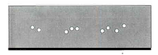

- In the same box, draw another X to indicate the position of Star A as seen in July and label it “Star A July”.

- Describe how Star A would appear to move among the distant stars as Earth orbits the Sun counterclockwise from January of one year, through July, to January of the following year.

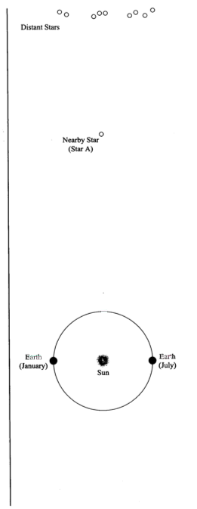

The apparent motion of nearby objects relative to distant objects, which you just describe, is called parallax.

- Consider two stars (C and D) that both exhibit parallax. If Star C appears to move back and forth by a greater amount than Star D, which star do you think is actually closer to you? If you’re not sure, just take a guess. We’ll return to this question later in this activity.
_________
II: What’s a parsec?

- Starting from Earth in January, draw a line through Star A to the top of the page.

- There is now a narrow triangle, created by the line you drew, the dotted line provided in the diagram, and the line connecting the Earth and the Sun. The small angle, just below Star A, formed by the two longest sides of this triangle is called the parallax angle for Star A. Label this angle “p_{A}”.

Knowing a star’s parallax angle allows us to calculate the distance to the star. Since even the nearest stars are still very far away, parallax angles are extremely small. These parallax angles are measured in “arcseconds” where an arcsecond is 1/3600 of 1 degree.

To describe the distances to the stars, astronomers use a unit of length called the parsec. One parsec is defined as the distance to a star that has a parallax angle of exactly 1 arcsecond. The distance from the Sun to a star 1 parsec away is 206,265 times the Earth-Sun distance or 206,265 AU. (Note that the diagram to the right is not drawn to scale.)

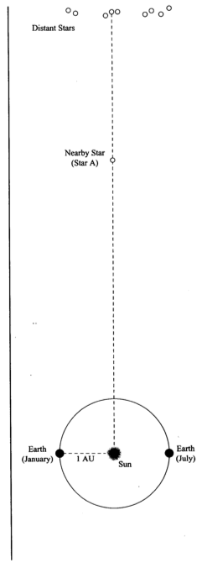

- If the parallax angle for Star A (p_{A}) is 1 arcsecond, what is the distance from the Sun to Star A? (Hint: Use parsec as your unit of distance.) Label this on the diagram.

- Is a parsec a unit of length or a unit of angle? It can’t be both.

Note: Since the distance from the Sun to even the closest star is much, much greater than the distance from the Earth to the Sun (1 AU), we can consider the distance from Earth to a star and the distance from the Sun to that star to be approximately equal.

Parallax in astronomy

The measurements you have just made are quite similar to those made by astronomers in order to measure the distances to nearby stars. The figure below shows how parallax is measured in astronomy. The big difference is that even the nearest stars are quite far away compared to the diameter of the Earth’s orbit (the 2 AU baseline shown).

Measuring the parallax of a nearby star.

Because the stars are so far away, the parallax angle of even the nearest star is extremely small. One of the nearest stars, Alpha Centauri, has a parallax angle of only 0.75" (arcseconds), only 1/4800 of a degree! Using such small angles in the formula we used above (which is designed to use degrees) is somewhat cumbersome. Thus, astronomers have created a special unit, the parsec, for working with the distances to stars. A parsec is the distance at which a star will have a parallax shift of exactly one arcsecond as observed from Earth; it is also about 3.26 light years. Using the units of parsecs (for distance) and arcseconds (for parallax angle) allows us to rewrite the distance formula in a particularly simple way:

d = 1/p

where d is the distance to the star in parsecs and p is the star's parallax angle in arcseconds. (The definition of parsec in this way is the reason we use only the angle p, and not the full parallax shift 2p, when we talk about parallax angle.) Thus, if a star has a parallax shift of 0.5", its distance is simply d = 1/0.5 = 2 parsecs.

III: Finding Stellar Distance Using Parallax

Consider the star field drawing shown in Figure 1. This represents a tiny patch of our night sky. In this drawing we will imagine that the angle separating Stars A and B is just 1/2 of an arcsecond.
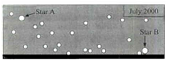

Fig. 1

In Figure 2 (page 7) there are drawings of this star field taken at different times during the year. One star in the field moves back and forth across the star field (exhibits parallax) with respect to the other, more distant stars.

- Using Figure 2, determine which star exhibits parallax. Circle that star on each picture in Figure 2.

- In Figure 1, draw a line that shows the range of motion for the star you saw exhibiting parallax in the drawings from Figure 2. Label the end points of this line with the months when the star appears at those end points.

- How many times bigger is the separation between Stars A and B compared to the distance between the end points of the line showing the range of motion for the star exhibiting parallax?

- Recall that Stars A and B have an angular separation of 1/2 of an arcsecond in Figure 1. What is the angular separation between the end points that you marked in Figure 1 for the star exhibiting parallax (in arcseconds).

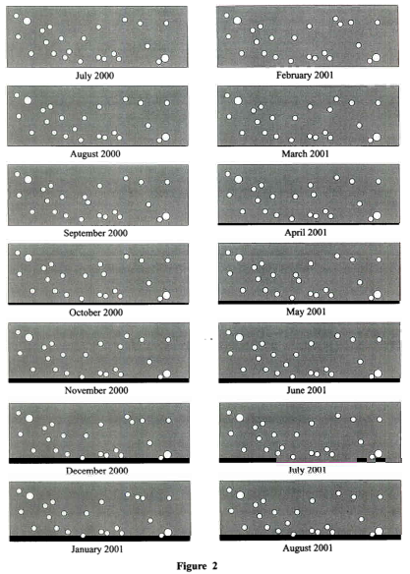

Note: We define a star’s parallax angle as half the angular separation between the end points of the star’s angular motion.

- What is the parallax angle for the nearby star exhibiting parallax from Question 4?

- What is the distance (in parsecs) for this star? What is this distance in AU (remember 1 AU is the average distance between the Earth and the Sun)?

II. Proper Motion of Stars

The other cause of annual change in the position of a star is the actual real motion of the star through space. This is called the proper motion of the star and is measured as an angular speed in arcseconds per year, or since the shifts are so small, milliarcseconds per year. Of course, the speed you would measure in the night sky is only the perpendicular part of the velocity of the star: if the star were coming straight at you, you would not perceive it to be moving! Thus the actual speed of a star is usually more than what you would measure from proper motion.

We will use the computers to measure these types of apparent motion in the night sky so you can make some estimate of the real space velocities of the stars in question. Start up Starry Night and make sure that the sky and horizon is turned off. Also make sure the Equatorial coordinate grid is on, and that under Settings, you have set the Orientation to Equatorial. This will remove the effects of latitude and day/night on what you see.

Use the Selection -> Find function to locate the following objects, one at a time. For each object, set the field of view large enough that you can see nearby stars in the same field. You may need to crank up the software to show all the stars in its database. Do this using Settings -> Star Magnitudes and slide the bar for number of stars to the maximum shown.

Now you’re ready to get started. Find each object, and measure the distance between that object and a nearby star using the Measuring Tool. Record those separations – make a sketch of the relative positions, and names, of the stars so you don’t get confused. Now advance time by several years, but remember to note by how many. Now measure the separations of the stars again. By how much has the star moved? What is its apparent proper motion – and in what direction?? Given the distance to each star (provided by the program) what is the actual space velocity you’re measuring perpendicular to your line of sight? Express your answer in km/sec. Also express your answer in parsecs/year.

Once you are done with all the objects listed, go find 1 more of your own that you’d like to find out the speed of. Record it in the space provided and do the same analysis.

What time step did you use for your measurements?

Write your measurements in the table found in the last page. Remember that a speed of 1 light year per year is the same as 300,000 km/s. Here is a quick description on how to find the column values.

- Initial and Final angular separation in arcseconds: Use the Measuring Tool.
- Measured proper motion (“/yr) = |Final ang. separation – Initial ang. separation| / time step
- Measured proper motion (rad/yr) = Measured proper motion (“/yr) / 206,265
- Distance (ly): Use the pointer tool and point at the star in question
- Velocity (ly/yr) = Distance (ly) * Measured proper motion (rad/yr)
- Velocity (km/yr) = Velocity (ly/yr) * 9.461 x 10¹²
- Velocity (km/s) = Velocity (ly/yr) * 300,000
- Velocity (pc/yr) = Velocity (km/yr) / 3.086 x 10¹³

- For the fastest star you find, calculate how long it would take that star to orbit the Galaxy – an estimated distance of about 48,200 parsecs at the orbital radius of our Sun. Remember that t=d/v. Is this reasonable? If not, why not?

- Why do you see celestial coordinates quoted using a specific epoch, e.g. 2000.0? There are several things that contribute to this effect. What are they? [Hint: the Earth rotates].
Questions

- Given the parallax to Alpha Centauri from the lab script, what is the distance to that star in parsecs?

- The satellite Hipparcos was launched in 1989 to measure very accurate parallax angles of stars; it has provided the most accurate parallax measurements ever obtained. The smallest parallax angle it can measure is 0.002". What is the most distant star to which Hipparcos can find the distance?

- The center of our Galaxy is about 8500 parsecs from Earth. What would be the parallax angle of a star near the center of the Galaxy? Could this angle be measured with current technology?

- If you built a telescope on Mars and measured the parallax angle of a nearby star, how would your measurement compare to the parallax angle of the same star as measured from Earth? Draw a picture and explain in words. If you answered that the parallax angle would be different, exactly how many times bigger or smaller would it be?

- Was it generally true that the more distant stars showed a smaller proper motion? Were there any exceptions? Why do you think this was so?

Conclusion:

One astronomical unit, or AU, is the average distance from the Earth to the Sun.
This is part of the reason that the idea of an Earth-centered universe persisted as long as it did. The ancient Greeks knew that stars should show parallax shifts if the Earth moved, but Greek astronomers’ best measurements showed no parallax shifts. Therefore, they concluded that the Earth was not moving.
The word “parsec” is a combination of the words parallax and arcsecond, revealing its origin in working with stellar parallaxes.

