Name:_____________________________ Score:_____/50

Spectroscopy Lab Quiz

1. Use Wien’s law to calculate the surface temperature of the star Betelgeuse. The peak wavelength (λ_{peak}) of the star is 0.806 μm. Show your work.
T =_________________

2. REDDER light has LONGER Wavelengths and HIGHER Frequencies T F

3. A spectrum is the outcome of separating light into its components according to wavelength. T F

4. Electrons can only exist in discrete energy levels. T F

5. What kind of spectrum is this? _____________________

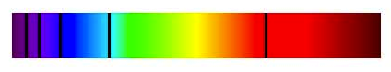
6. If the star is too hot and therefore its radiation is highly energetic, what happens to the atoms? And what is this process called?

7. What kind of spectrum do we see when we look at the Sun?
a. an emission b. an absorption c. a continuum

8. Name two elements you identified in the gas tubes:
_________________________ _________________________

9. What kind of spectrum did you see when you looked at the gas tubes with the spectroscope?
a. an emission b. an absorption c. a continuum

10. What kind of spectrum do you observe when looking through the spectroscope at the incandescent bulb?
a. an emission b. an absorption c. a continuum

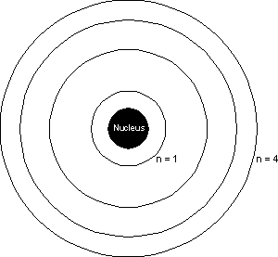
A
C
B
D

11. From the diagrams above, which one represents an absorption line?
a. A c. C
b. B d. D

12. From the diagrams above, which one represents an emission line?
a. A c. C
b. B d. D

13. From the diagrams above, which one represents ionization?
a. A c. C
b. B d. D

