AST 114 Score _____/50
Name:__________________________________

Date:___________________________________

VARIABLE STARS QUIZ

- Why are variable stars such as RR Lyrae and Cepheids so important in astronomy?
- Variable stars can be used to measure distance. Which type of variable star – RR Lyrae or Cepheids – is more useful in measuring distances to a faraway galaxy? Justify your answer.
- Assume that you have determined the light curve of an eclipsing binary system. Which of the following cannot be determined from its light-curve?
  - Apparent magnitude
  - Relative size of star
  - Period
  - Distance

- What is a common characteristic of all variable stars?
  - A star that varies in mass
  - A star that varies in size
  - A star that varies in brightness
  - A star that varies in temperature

- Variable stars such as RR Lyrae and Cepheids lie on the main sequence.
  - True
  - False

- Which of the following variable stars has the shortest period of variability?
  - RR Lyrae
  - Cepheids

- Which of the following types of variable stars always has about the same absolute magnitude?
  - RR Lyrae
  - Cepheids

- What is a variable star? Do they tend to be young or old stars? On or off the main sequence?
- What is the period of the following Cepheid variable star?

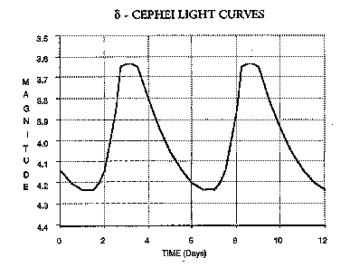
- Use the period-luminosity relationship provided to determine the absolute magnitude of the Cepheid variable above. Assume it is a Type I Classical Cepheid.
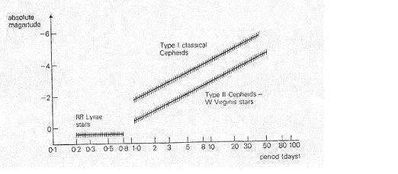
- Use the distance modulus to calculate the distance to the Cepheid variable above. Show your work.

Possibly useful information

