ARCHAEOASTRONOMY

What will you learn in this Lab?

How did ancient civilizations measure the passage of the year? What do archaeologists know about the astronomical significance of ancient buildings? This lab exercise will give you a feeling for the study of archaeoastronomy, the search for astronomical significance of archaeological sites. You will examine two sites, in Utah and Wyoming, for possible use as ancient astronomical observatories.

What do I need to bring to the Class with me to do this Lab?

For this lab you will need:

- A copy of this lab script
- A pencil
- Scientific calculator

Introduction:

In today’s society, we tend to be well-insulated from the passage of the seasons and unaware of the motions of the Sun, Moon, planets, and stars in the sky. Unless a person is living or working on a farm, the growing season has little meaning. To hunter-gatherer and farming societies, however, the seasons were important because they affected the plants and animals that those people depended on for food. Observations of the events in the sky were crucial in marking the changing seasons. Later civilizations developed complex ceremonies around astronomical events, determined by observations of the sky. These ancient people left evidence of their astronomical observations as part of their buildings, artifacts, and stories. The field of archaeoastronomy has developed over the past century as a study of the astronomical significance of archaeological sites. This field is pursued by archaeologists as well as by astronomers.

In this lab, you will use techniques similar to those used by archaeoastronomers to uncover possible astronomical purposes of ancient structures in the western U.S. While there are a multitude of archaeological sites that have been proposed as astronomical observatories in the U.S., the alignments at many of these sites have been questioned due to the poor condition of the structure or ambiguous reconstructions by modern caretakers. Hovenweep Castle, built by the Anasazi people in southeastern Utah, and Bighorn Medicine Wheel, constructed by unknown Plains Indians in north-central Wyoming, are well-preserved sites that have not been reconstructed so they provide undisturbed examples of ancient observatories.

Of particular interest to ancient skywatchers were sunrise and sunset positions of the solstices. These dates marked the opposite ends of the annual seasonal cycle, the longest and shortest periods of daylight and the northernmost and southernmost extent of the Sun’s motion. The majority of ancient observatories were constructed to observe the motion of the Sun.

In addition to the motion of the Sun, ancient skywatchers used heliacal risings or heliacal settings of stars to mark dates on the calendar. As the Sun appears to move relative to the stars in the sky, a bright star may emerge from or disappear into the glare of the Sun. A heliacal rising refers to the first visible rising of a bright star before sunrise, and a heliacal setting refers to the last visible setting of a bright star after sunset. The diagram below illustrates a heliacal setting. By reversing the direction of the star’s motion, this same diagram describes a heliacal rising before sunrise in the eastern sky.
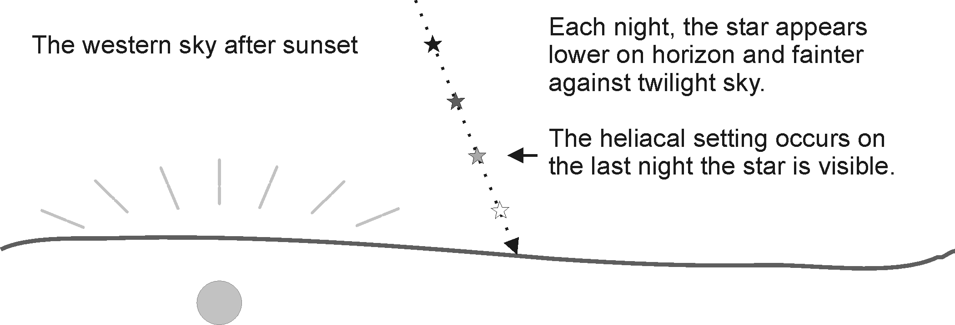
The heliacal observations of stars served an important calendar function to many civilizations around the world, since they provided additional fixed calendar dates at different times during the year. For example, the ancient Egyptians used the heliacal rising of the brightest star, Sirius, to mark the beginning of the annual flooding of the Nile.

From surveying the ground to surveying the sky:

Many ancient archaeoastronomical sites throughout the world are constructed to mark horizon sight-lines. These markings lead the eye to specific points on the horizon where a particular astronomical event of interest took place.

The first site in this lab, Hovenweep Castle in Utah, has two small windows that show portions of the western horizon. By standing on the side of this viewing room opposite these openings, an observer can see very specific portions of the sky on or near the horizon. In the image below, the viewing room with its doorway is visible on the left.
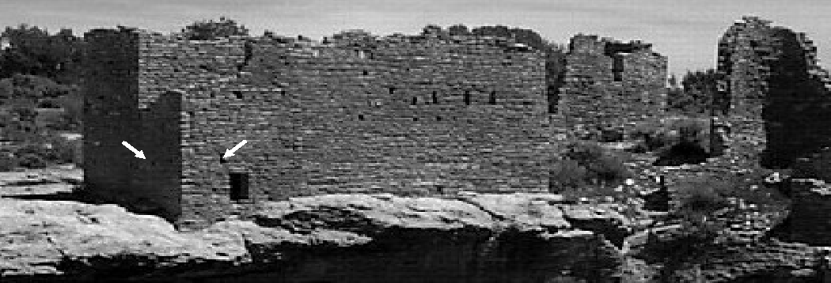

The second site, Bighorn Medicine Wheel in Wyoming, is very different from the first. It is made up of numerous large rocks arrayed in circles and lines on the ground. Sighting between pairs of the stone circles, or cairns, an observer can identify a specific point on the horizon. The image below shows the wheel as it appears to someone facing east (the cairns are labeled the same as in Part II).

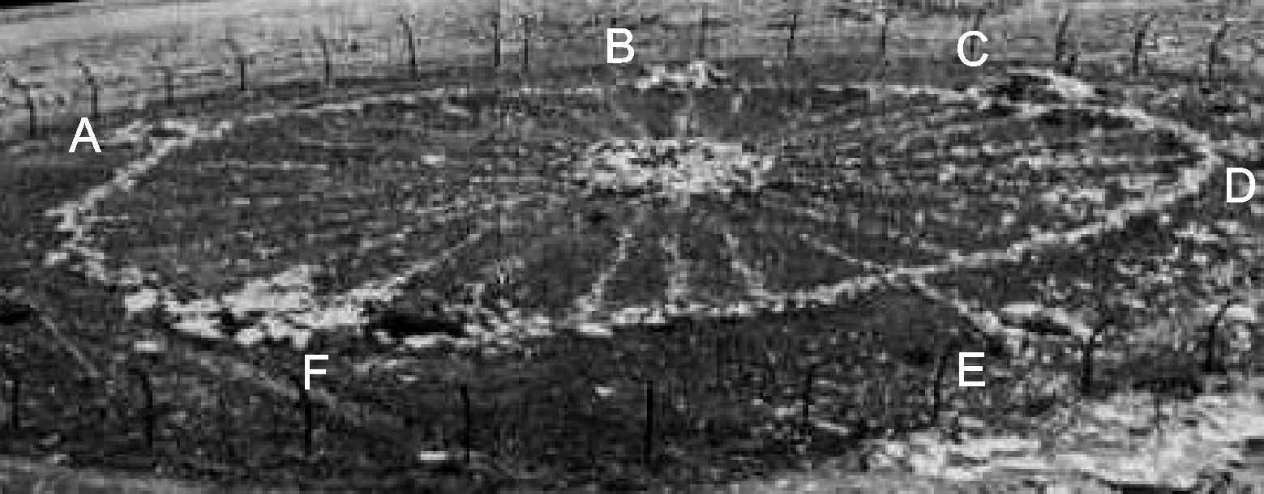

By using surveying equipment, one can measure the azimuth angle along each potential sight-line. The azimuth angle is measured between due north and the direction of the sight-line. Azimuth has a range of 0º to 360º, the full circle of the horizon – north is 0º azimuth, east is 90º azimuth, south is 180º azimuth, and west is 270º azimuth.

Instead of visiting both these sites throughout the year to observe potential astronomical events for each sight-line, you will be using the Starry Night program. Starry Night is a virtual planetarium, allowing you to observe from any place on Earth on any day of any year. By using this program to observe along a given azimuth you can determine the objects in the sky that make for the best alignment with each sight-line.

Hovenweep Castle and Bighorn Medicine Wheel were constructed and used around 800 years ago. Because the Earth’s axis precesses, or slowly changes its direction, some of the astronomical alignments we see today appear different than they would to the original builders. Starry Night allows you to observe the sky in the time of ancient skywatchers, making your determinations more accurate by observing in an appropriate year.

Finally, Starry Night calculates the visibility of stars during daytime, so you can use the program to determine heliacal risings and settings of bright stars.

The Starry Night program

Starry Night is a very powerful virtual planetarium program that can show the sky on any date in any year from any location. It has easy to use controls, a few of which are described below:

The Pointer tool allows you to point at an object in the sky and the program will give you information about that object, like what it is and precisely where it is.

The Pan tool allows you to “grab” the sky and move it around so you can display a different area.

The Magnify tool allows you to zoom in & out. To zoom in, click with the mouse on the area of interest. To zoom out, hold the Ctrl key and click with the mouse.

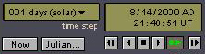
The Time Window shows you the current time and date for the sky being displayed. The box in the upper left shows the current time step. The box in the upper right shows the date and time for the sky. You can change any of the values in the time step or time and date windows by clicking and typing or by using the mouse. The “Now” button will reset the time and date to the current local time. The “Julian…” button will display the current Julian date (not necessary for this lab). The six buttons on the lower right act like movie controls: Back one time step, Backward at one time step per second, Stop, Forward at one time step per second, Forward at real time, Forward one timestep.

To use the pointer tool effectively for this lab, be sure that the labels show altitude and azimuth instead of celestial coordinates. This is done in the File:Preferences menu item. Choose File, then Preferences. Select Cursor Tracking (HUD) from the drop-down menu, check the Local Coordinates box, and uncheck the Right Ascension-Declination box. Now, when you point at an object with the Pointer, you will be shown Altitude and Azimuth. Another helpful device is the altitude-azimuth grid displayed on the sky. Toggle the grid with the button on the right side of the button bar..

As an example on how to use Starry Night, we will go through the steps to find an alignment for sight-line #6 of the Bighorn Medicine Wheel (see figure in Part II). First, we must change our location to the Bighorn Mountains of Wyoming, 44.8º north, 107.9º west. Your viewing location is changed with the Go:View Location menu item. Click the Set Location button to change to this new location and close the window.

Sight-line #6 has an azimuth of 142º. With the altitude-azimuth grid displayed, we can turn the sky with the Pan tool to face azimuth 142º. Next, turn daylight off so we can see the stars, even during the day. You can toggle daylight on/off with the button. Finally, change the year to 1200 AD in the Time Window.

Since this azimuth is in the east, change the time so that the Sun is near sunrise. Change the time step in the Time Window to 1 solar day and click the Forward button. Watch the Sun to see if it reaches either solstice within a few degrees of azimuth 142º. You should notice that the Sun will creep above or below the horizon as the days pass. The Sun appears to reach its furthest southern position, about 125º, around the beginning of December. Since this is 17º different from 142º, we can rule out the Sun as the alignment for sight-line #6 of the Wheel.

Next we should determine if any stars provide good alignments with this sight-line. With daylight still off, change the time step to 1 minute and hit the Forward button. Watch for bright stars that rise within a few degrees of azimuth 142º. You should see the bright stars Fomalhaut and Kaus Australis rise at this azimuth.

Next, we need to determine the dates of heliacal rising for Fomalhaut and Kaus Australis in morning twilight. Position one of the stars just above the horizon in the morning. Next, change the time step to 1 sidereal day. Click the Forward button and watch for the first date the star becomes visible through the morning twilight. This date should be around April 27th for Fomalhaut and January 7th for Kaus Australis. Given the altitude of this site, the wheel would be buried under snow in January. Was it accessible in April? Perhaps.

PART I: Hovenweep Castle, Utah
Introduction:

The Anasazi people of the twelfth and thirteenth centuries built some of the most recognizable structures of the ancient southwestern U.S. – Pueblo Bonito at Chaco Canyon in New Mexico, the cliff dwellings in Canyon de Chelly in Arizona, and the pueblos at Mesa Verde in Colorado, to name only a few. Despite the difficult life they led in the desert, these people built multi-story, multi-family houses, with the largest dwellings inhabited by hundreds of people. This civilization settled the lands of present-day northern New Mexico and Arizona, and southern Colorado and Utah. There is evidence that the Anasazi traded with neighboring people in southern Arizona and even the ancient Mexican civilizations far to the south.

Hovenweep Castle lies at 37.4º north, 109.0º west. This building was constructed around 1200 AD. You will investigate the two sight-lines summarized below for alignments with the Sun or the stars.
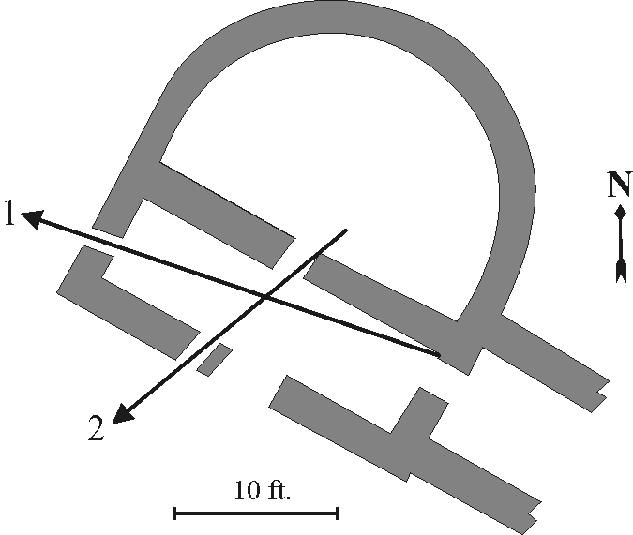

Sight-line | Azimuth
1 | 301º
2 | 239º

PART II: Bighorn Medicine Wheel, Wyoming

Introduction:

The Bighorn Medicine Wheel is located near the summit of Medicine Mountain in the Bighorn Mountains of north-central Wyoming. The wheel lies at an altitude of 9,600 feet, above the treeline and covered in snow all but several months of the year. This stone circle is one of hundreds scattered across the northern U.S. and southern Canada. Local Plains tribes recognize these stone circles as sacred places, but have little to say about the circles’ origins or the people that constructed them.

In 1972, astronomer John Eddy decided to investigate the possible astronomical significance of Bighorn Medicine Wheel. For this site you will investigate five sight-lines summarized below for possible solar or stellar alignments. This site lies at 44.8º north, 107.9º west. It was constructed and used sometime around 1200 AD.
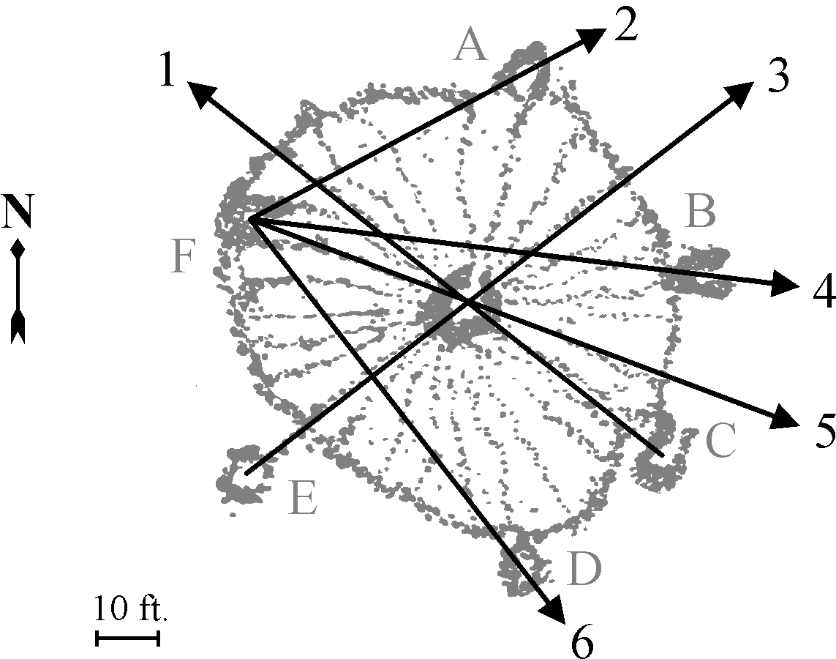

Sight-line | Azimuth
1 | 309º
2 | 65º
3 | 55º
4 | 99º
5 | 115º
Questions:

- What objects did you find aligned with each of the sight-lines for Hovenweep Castle? On which dates did these alignments occur?

- What objects did you find aligned with each of the sight-lines for Bighorn Medicine Wheel? On which dates did these alignments occur?

- Were Hovenweep Castle or Bighorn Medicine Wheel used only for solar or only for stellar observations, or a combination of both? What times of the year do you think Hovenweep Castle and Bighorn Medicine Wheel were used based on the dates you gave? Do you think these sites were inhabited at a specific time of year or year-round? Support your conclusions with the measurements you made.

- Why does the Sun appear to move relative to the stars during the course of the year? (A diagram might be helpful in your answer.)

- If someone asked you to investigate the astronomical significance of an archaeological site, what issues, besides the astronomical alignment, would you need to take fully into account for your analysis to be believed?

- It has been suggested that since the number of spokes in the Bighorn Medicine Wheel is 28, this proves it served an astronomical function. What is astronomically significant about the number 28 and to what object in the sky does this number relate?

Conclusion:

