AST 114 Score _____/50
Name:__________________________________

Date:___________________________________

GALAXY MORPHOLOGY QUIZ

- (25 pts total) Determine the Hubble morphological types of the galaxies in the table below.
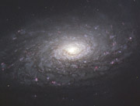 | Sa or Sc? Justify your answer.
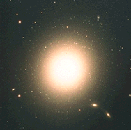 | E0 or E7? Justify your answer.
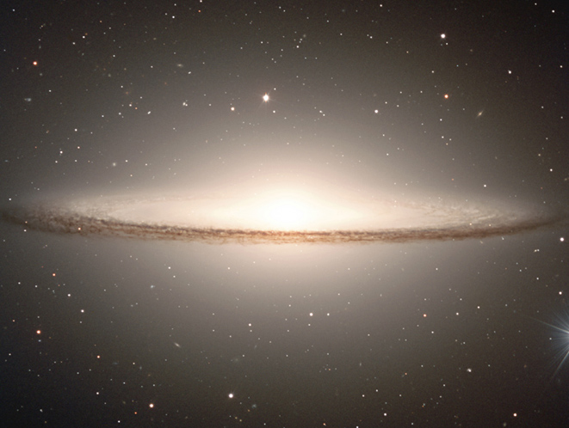 | Sa or Irr? Justify your answer.
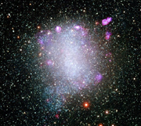 | E5 or Irr? Justify your answer.
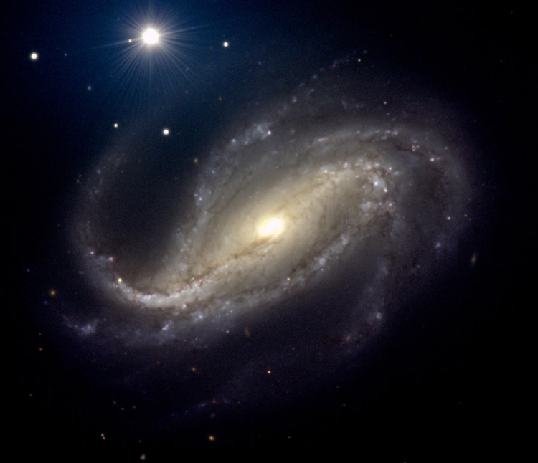 | Sb or SBb? Justify your answer.

- Which type of galaxy, spiral or elliptical, exhibits little evidence for ongoing star formation? Justify your answer.
- Which of the following Hubble morphological types contains very little gas and dust?
  - E3
  - Sa
  - SBc
  - Irr

- What is the definition of a galaxy?
- In which type of galaxy is there least likely to be ongoing star formation? Explain your answer.
- Which type of galaxy (elliptical or spiral) would be most likely to have the oldest population of stars? Explain your answer
- Which galaxies were more red in color?
- Which type of galaxies (spiral or elliptical) contains dark dust clouds/large regions of gas and dust?

