Hubble Expansion Quiz

A figure below is the example of Hubble diagram for Type Ia Supernovae.

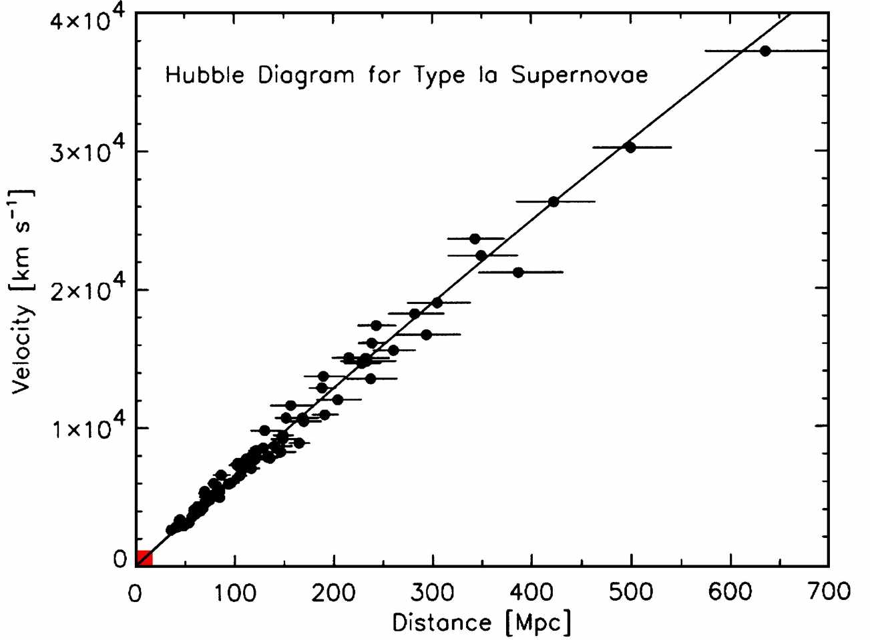
- (10pts) Hubble’s expansion law is expressed by the equation v = H₀×D, with the Hubble constant H₀ (slope of the diagram), the distance D to an object and its velocity v. Find the Hubble constant from the diagram. Mark the data point you use to calculate it on the diagram. Show your work.

- (10pts) The true value of the Hubble constant is 73 km/sec/Mpc. What is the percentage error in your calculation from question 1? Show your work.

- (15pts) What is the Age of the Universe? Use your Hubble constant from question 1. Follow the steps below.
  - H₀ = ______________ km/sec/Mpc/(3×10¹⁹ km/Mpc) = _______________ sec⁻¹
  - T (sec) = 1/ H₀ = ________________seconds
  - T (Gyr) = ________________ sec / 3.156×10¹⁶sec = __________________Gyr

- (10pts) The currently adopted best value for the Age of the Universe is 13.7 Gyr. What is the percentage error in your age determination? Show your work.

- (5pts) What is the name of the famous space telescope running for almost 20 years?

