Introduction to the Telescope

What will you learn in this Lab?

For a few of the labs this semester, you will be using an 8-inch Celestron telescope to take observations. This lab will introduce you to the telescope itself and some properties of a telescope. Observations will be made to illustrate the different telescope properties.

What do I need to bring to the Class with me to do this Lab?

For this lab you will need:

- A copy of this lab script
- A pencil
- Your flashlight
- Your star planisphere
- Your Audubon field guide
- Scientific calculator

I. Introduction:

In this lab exercise you will become familiar with the parts of a telescope and how to use one. You will also become familiar with some telescope properties and use observations to illustrate these properties.

Remember, telescopes are precision instruments; be careful using them. Ask your instructor for help when you are in doubt about what to do.

II. Parts of a Telescope:

Primary Mirror: This is the large mirror at the telescope's lower end that 'collects' and focuses the light so that we can see fainter stars than with our 'naked' eyes. ASU presently has 20 8-inch telescopes. This means the diameter of the primary mirror is 8 inches. These are called reflecting telescopes.

Mounting: The mounting supports the telescope and allows it to be moved in two directions (or axes): one in the same sense as the Earth rotates (right ascension) and the other in a north/south direction (declination).

Telescope Tube: The telescope tube holds the optical parts (eyepiece, primary, and secondary mirrors for reflecting telescopes) in the correct position.

Clock Drive: The clock drive turns the telescope at the same rate as the Earth turns, but in the opposite direction so that the telescope stays pointed at one particular location in the sky (i.e., a star).

Setting Circles: These are dials that help you tell where the telescope is pointed. There is a setting circle on the right ascension axis whose units are in hours and minutes of time. There is a second setting circle on the declination axis that reads in degrees and minutes of arc. Once the telescope is properly aligned, these setting circles can be used to point the telescope at any object whose right ascension and declination are known. Move the telescope by holding it at its base or by its tube; never use the eyepiece as a `handle'!

Clamps: Each telescope has two clamps, one for the declination axis and the other for the right ascension axis. These are kept locked, except when the telescope is being moved. Loosen them before trying to move the telescope. Once unclamped, a telescope is free to swivel in both the declination and right ascension motion. Be sure to hold the main body of the telescope tube while either of the clamps is free. Tighten the clamps after you have positioned the telescope.

Finder Telescope: The 'finder' telescope is a smaller telescope with less magnification and a larger field of view (see p 6). It is attached to the side of the main telescope and 'looks' in the same direction as the main telescope. The larger field of view makes it easy to initially locate a star in the finder telescope, hence the name finder. After a star is centered on the `cross hairs' in the finder, it will also be visible in the eyepiece of the main telescope.

Slow Motion Controls: The slow motion controls help you center an object by allowing you to move the telescope slowly for small angular distances. They are mainly used for centering the object in the eyepiece of the large telescope.

Eyepiece: The eyepiece is the part you look through. Each eyepiece is identified by its focal length, which is stamped in white letters on the eyepiece casing (e.g., 18 mm, 25 mm, etc.).

Focus Adjustment: Once you have the star in the main eyepiece, focus on it sharply. It may help to remove your glasses. Make your focus adjustments quickly and smoothly. If you are observing faint objects, try using averted vision. That is, look at the object out of the corner of your eye. This works because the light detecting cells used by averted vision are more sensitive than those used by direct vision. It also will help to turn all the lights out and wait a few minutes for your eyes to become 'dark adapted'.

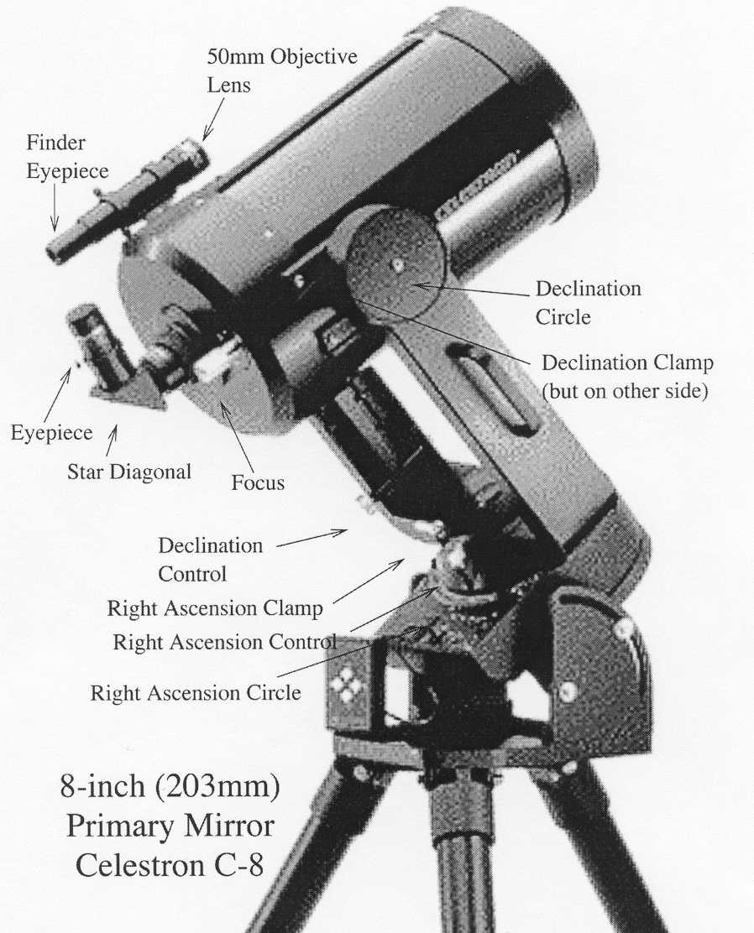
(2032 mm)
III. Properties of a Telescope:

Light Gathering Power: The primary function of an astronomical telescope is to collect light. The light gathering power of a telescope is measured by the area of the light collector (either a lens or a mirror). A telescope's size is always specified by the diameter
of its primary mirror. The area of a circular primary mirror is given by:

A = π(D/2)²
where:

A = the area of the mirror
D = the diameter of the mirror

Thus, comparing the light gathering power of a 14-inch and 8-inch telescopes, we find the 14-inch has 3.06 times greater light gathering power.

Focal Length: For a simple mirror, the focal length is the distance between that mirror and the place where the image is formed. In a telescope with more than one
optical element (or mirror), the effective focal length is often longer than the telescope tube itself. It is useful to know the focal length of the telescope or eyepiece that you are using. The focal lengths of the ASU telescopes are:

focal length = 2000mm, for the 8-inch Celestron telescopes

The focal lengths of ASU eyepieces are stamped on the viewing end of each eyepiece. Typical eyepiece focal lengths are 40mm (lowest power), 24mm, 18mm, etc.

Magnification of a Telescope: The magnifying power of a telescope is determined by the focal length of both the telescope and the eyepiece used. A shorter focal length eyepiece gives greater magnification.

magnification of telescope = (telescope focal length) ÷ (eyepiece focal length)

Field of View of a Telescope: The angular size of the piece of sky seen through a telescope is called its field of view (i.e., its FoV). The size of the FoV depends on both the telescope and the eyepiece used. Since the FoV is an angle, it is measured in degrees (º), arcminutes (‘), or arcseconds (“). For a given telescope:

the greater the eyepiece focal length, the greater the Field of View (FoV)

If you choose an eyepiece with double the focal length, you also double the FoV
(i.e., the angular size of the area of sky you can see).

Resolving Power: The resolving power (also called angular resolution) is the ability of a telescope to separate two close images or to see fine detail in an image. Greater magnification will not resolve two images that are closer than the resolution of a telescope. The limit, called the Rayleigh criterion, depends on the diameter of the telescope's primary mirror (D) and the color (or wavelength) of the light observed. For visible light, the minimum separation of two objects which can just be resolved is:

α = 4.56/D
where:
α = angular separation of two stars (in arcseconds)
D = diameter of the telescope's primary mirror (in inches)

Thus, for example, the resolving power for the 8-inch telescopes is α = 0.57”. However, you may not actually be able to see two images this close together because of atmospheric conditions ("seeing"), relative brightness of the objects, etc.

Scale of a Telescope: The scale at the focus of any astronomical telescope is the ratio of the angular size of an object in the sky to its image size with that telescope (e.g., how large the object would look if you were to photograph it with that telescope). The scale is constant for a particular telescope and depends only on the focal length of the primary mirror. The scale is usually expressed in units of degrees per millimeter (º/mm) or arcseconds per millimeter (“/mm).
Examples:
scale = 57.3º / focal length of telescope's primary mirror
scale = 206265” / focal length of telescope's primary mirror

Exercise 1: Looking at Resolving Power

Your TA will set up a light box in the corridor with 4 stars etched into a mask on the front of it. You will use your naked eye from the end of the corridor to determine whether you think each star is a double star or not – mark “Single” or “Double” in the corresponding star-position for the “eye” section of the left-box below. Then, use binoculars from the same position and record your observations. Next, walk slowly towards the box until you see one additional pair of stars. Record your observations in the box to the right and measure the distance to the light box.

End of corridor Closer distance ________ inches

eye eye

binoc

- In light of your observations, what was the limiting resolution of your eyes? Your TA will give you the linear separations of the double stars on the mask. Use a triangle to work out the angle you could resolve (θ = separation of double stars / distance to mask. When you can just resolve two stars at the shorter distance, that is your eyes’ resolution. SHOW YOUR WORK and watch Units!

Separation of double star: _________ inches (use number from your TA for the smallest separation you can see at the distance recorded above)

- Compare this to what you calculate with the Rayleigh criterion (α) that your eye should be able to resolve (if your eyes were perfect). Work out what this angle is when you use binoculars (diameter = 2.25 in). How much better are the binoculars than your eyes at resolving things (assume a diameter of 0.2 in)?

Exercise 2: Determining the Size of the Field of View:

In this exercise, you will determine the angular size of the field of view of the 8-inch telescope. That is, how large a piece of sky can you see in the telescope? You will also find out how changing eyepieces alters the size of the field of view.

For this exercise, you will need to measure how long it takes for a star near the celestial equator to pass across the region viewed through the eyepiece when the telescope drive motor is turned off. Convert that time into an angle, which is equal to the diameter of the field of view.

Your TA will have the telescope pointed towards a star for you. Be sure to find out which star you are observing. You will first need to unplug the motor and watch through the eyepiece to see in which direction the star appears to 'drift'.

- Compare this direction to how the stars move through the sky when you look at it with your eyes. Is the motion in the same direction? Why is it or isn’t it?

Then move the telescope, placing the star just outside the field of view on the eastern edge. This will cause the star to appear in the field of view when the motor is turned off.

When the star reappears in your eyepiece, start the stopwatch and record the starting time. When it passes out of view on the opposite side, stop the stopwatch and record the transit time of the star. Make a few (more than one) measurements and compute the average. Remember, this reduces your measurement error.

Convert the transit time of the star into an angular distance traveled using the conversions below. Your answer is the size of the field of view of this telescope/eyepiece combination.
TIME |  | ANGLE
24 hours | = | 360º (degrees)
1 hour | = | 15º (degrees)
1 minute | = | 15’ (arcminutes)
1 second | = | 15” (arcseconds)

Repeat these observations using a second eyepiece with a different focal length. Be sure to put your measurements and calculations into the data table below.

Eyepiece 1 = ______ mm
Time 1 (s) | Time 2 (s) | Average Time | Angle
Eyepiece 2 = ______ mm
Time 1 (s) | Time 2 (s) | Average Time | Angle

- Is the field of view greater with a shorter or longer focal length eyepiece? Why?

- Would the Moon be completely visible in either of the eyepieces you used (the moon is 30 arcmins in diameter)? How do you know? Show work.

- Your transit time was for a star near the celestial equator. How would the transit time change for a star at a higher declination (closer to the celestial pole, think about a record)?

Exercise 3: Looking at Magnification and Light Gathering Power

For this part of the lab, you will be examining how the magnification and light gathering power changes depending on different focal lengths of the eyepieces and the telescopes. You will be observing an object given to you by your TA with an 8-inch telescope, as viewed through the eyepiece and the finderscope. The telescopes you will be using will have different eyepieces in them so be sure to record the telescope number, focal length, and eyepiece used. You may need to look through each instrument multiple times.

- In which instrument do you see fainter stars – with the finderscope or through the eyepiece?

- Which device has the greater light gathering power? Draw what you see in the circles. Record differences in how the objects look in each instrument.
Telescope Number ____
Finderscope
Notes:
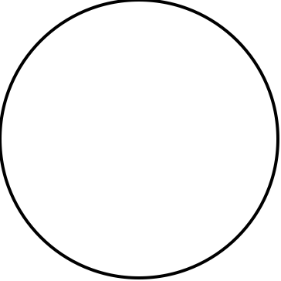
Telescope Number ____
Eyepiece: ______ mm
Notes:

Next, you will be looking through the two designated 8-inch telescopes, only looking at magnification differences.

- Again, record the telescope and eyepiece data and comments for each telescope. Also draw what you see in the circles.

Telescope Number ____ Telescope Number ____
Eyepiece: _____ mm Eyepiece: ______ mm
Notes: Notes:

- Now rank the two telescopes and finderscope according to the faintest star you can see - these should be ordered one through three, with one corresponding to the telescope with the faintest star. Also attempt to name the faintest star you see in each case using your Field Guide. You may need to look through each of the telescopes again before you can precisely assign an order.

- How does decreasing the focal length of the eyepiece (but not the telescope) change the magnification of the system?

- Can you see fainter objects with a different (higher or lower) magnification?

- Calculate the magnifications for the system for each of the eyepieces you used for exercise 3.

- What differences in the appearance of the faint object did you notice between the 8-inch telescope and its finderscope? What are the causes of the differences?

Exercise 4: Looking at Resolving Power - again

For this exercise, you will be observing more objects designated by your TA, using your eyes, binoculars, and an 8-inch telescope. Be sure to make careful note of what the star looks like in each of these cases.

Your first observation should be with your eyes. Use your field guide or planisphere to locate the star and find it in the sky. Record the brightness and color of the star compared to the surrounding stars in the constellation. Also, record whether you think this is a single star or a double star.
Naked Eye Observations
Star Brightness = __________________________
Color = __________________________________
Single or Double? _________________________

Next you should look at the star through the binoculars and the telescope. Again, record brightness, color and whether the star looks like a single star or a double star.
Binocular Observations
Star Brightness = __________________________
Color = __________________________________
Single or Double? _________________________

Telescope Observations
Star Brightness = __________________________
Color = __________________________________
Single or Double? _________________________

- What differences in the appearance of the star did you notice between the 8-inch telescope and the binoculars? What are the causes of the differences?

- If the separation of two stars is 5’ 37”, which of these methods (eyes (the pupil diameter of a dark-adapted eye is 0.2 inches), binoculars, or telescope) should have resolved the stars? Did they? If not, why?

Conclusion:

Indoor Exercise:

You will be examining two photos of NGC 7635 (the Bubble Nebula) and answering the questions regarding FOV and magnification below. These do not have to be answered in complete sentences unless specified.

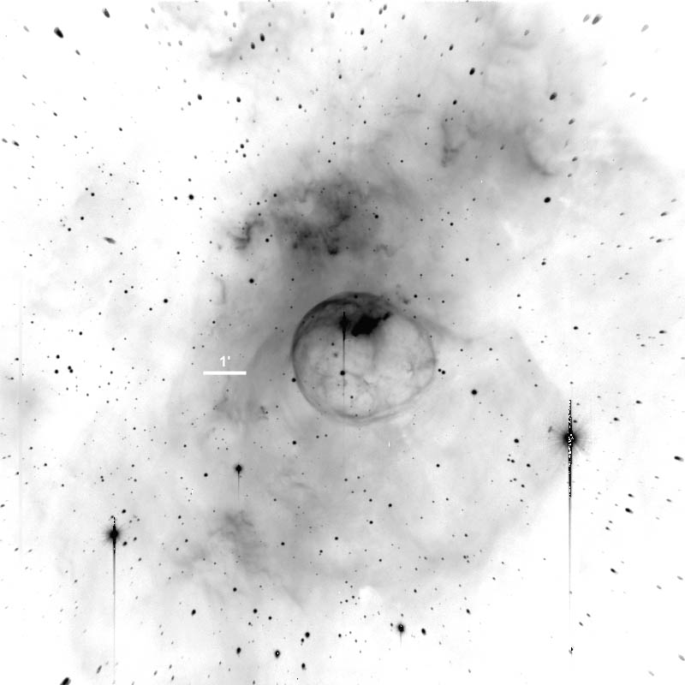

This image was taken using the Mt. Palomar 60” telescope using a CCD camera that rendered the image at a scale of 1.2”/pixel. On the image you will see a bar that marks the length of 1 arcminute on the image at this scale.

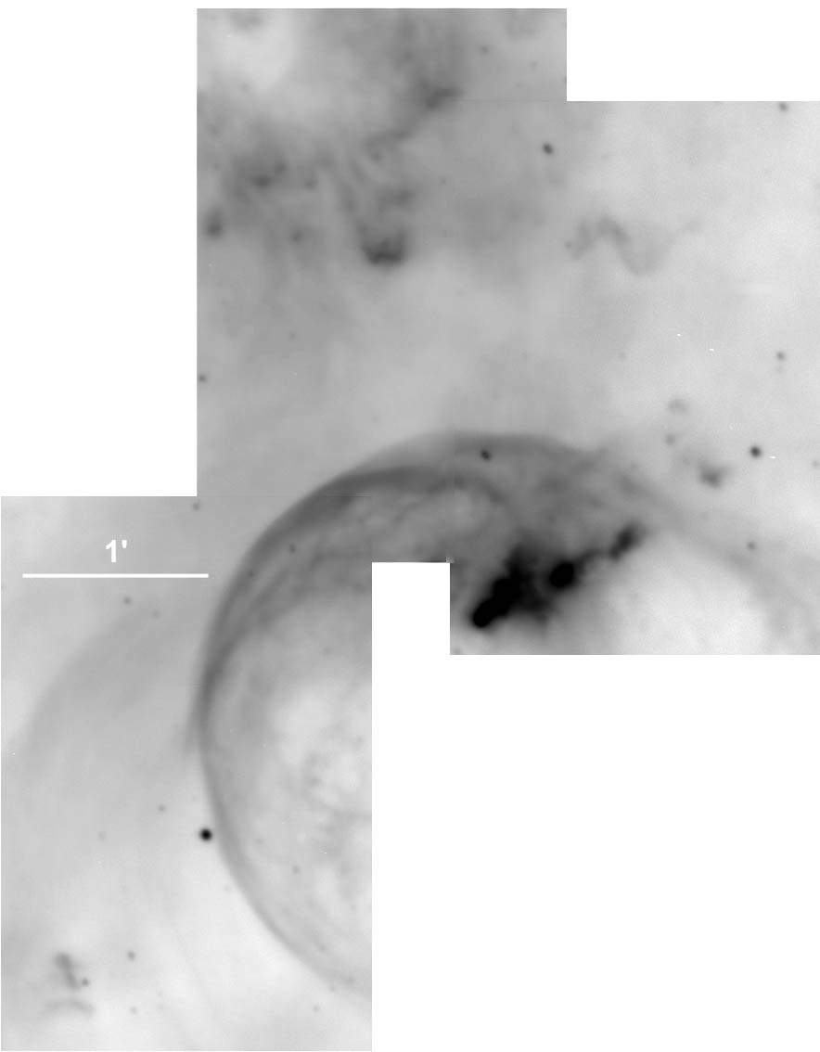

This image was taken using the Steward Observatory 90” telescope on Kitt Peak with a CCD camera that rendered the image at a scale of 0.3”/pixel.

- Which of the telescopes gave a higher apparent magnification or resolution?

- Which one gave the widest field of view or angle shot?

- Calculate the scale ratio of the two photographs. What does that tell you?

- Which telescope would you use to take images of the structure inside a very large nebula?

- Which one would you use to image an extremely distant galaxy?

- Now, there have been arguments made that the above two answers should cite the same telescope. Give reasons, using complete sentences, as to what may have inhibited the telescope from producing the deepest (most in-depth, highest resolution) image possible.

- In light of these issues, which telescope would you actually use to image a massive nebula and a distant galaxy? Why? Complete sentences.

