Motion of the Sky Prelab

- What is the definition of a Sidereal Day? How does this differ from a Solar Day? What are the lengths of the two in hours and minutes? Include a diagram to illustrate the difference.

- In this lab you will be using sketches from two other labs (Introduction to the Night Sky and Coordinate Systems) to measure how much the sky moves from month to month. What additional observational evidence do you have that it does this?

MotionS of the NigHT Sky

What will you learn in this Lab?

How long is a day? Do you know? Do you really know? This lab is going to address that question and let you figure out how long a day is. It will also help you figure out why your initial answer may not be right, and why. This lab draws on earlier observations you’ve made this semester to study how the sky changes over longer periods of time. You’ll be doing two sets of observations – one set outside if the weather permits, and one set inside. You’ll be using some of your new measurement and accuracy skills to find out how well you can measure the length of the day and where your sources of error might be.

What do I need to bring to the Class with me to do this Lab?
For this lab you will need:
- A copy of this lab script
- A pencil
- A calculator
- Your Northern and Southern Sky Sketches from your previous Intro to the Night Sky lab exercise
- Audobon Sky Guide
- Red Flashlight

Introduction:

In astronomy the word "day" refers to two different concepts. One is the commonly-used definition, the 24-hour solar day, or the time it takes the Sun to travel 360º around the sky. But astronomers also refer to the sidereal day, which is the time it takes the background stars to travel 360º around the sky, or for the Earth to rotate precisely 360º on its axis. The sidereal day is a little bit shorter than a solar day. But why? Shouldn't they be the same length? If all motions in the sky are actually caused by the Earth's movement, what else could be going on to cause the stars and the Sun to travel at slightly different speeds across the sky?

This lab exercise focuses on how the night sky moves and changes with time of year and during the course of a night. The first goal of the exercise is to determine the length of the sidereal day, i.e., the time it takes the earth to rotate 360º on its axis. We will use two methods and compare their relative accuracy. The second goal of the lab is to compare sketches you have made of the night sky in previous labs in order to become familiar with the annual motion of the sky and to determine what causes it.

PART I: Naked Eye Observations (Beginning of Lab)

A: Measuring the Sidereal Day:

As in the coordinate system lab, your TA will give you a short list of bright stars. (Note to TAs: Preferably not stars that are setting in the west....) Use the sextants provided to measure the altitude and azimuth of the objects. Record these naked eye observations as Az(1) and Alt(1) in TABLE 1: OBSERVATIONS AND CALCULATIONS. Make sure to record the time of your observations on the table!

B: Motion of the sky during the semester:

At the beginning of the semester we made a set of North and South sky sketches during the Intro to the Night Sky lab. If you have brought those with you, tear off the extra two copies of the Northern and Southern sky sketches (pages 17 and 18) and attach your original drawings in their place. Before going to the roof, make a note which constellations you included.

Now go to the roof and redo your North and South sky drawings (pages 15 and 16) to reflect the new positions of the constellations. Label the visible constellations and bright stars, including any new constellations that were not originally visible at the beginning of the semester.

Are the constellations and bright stars in the same places in the sky as they were at the beginning of the semester? If not, which direction have they moved?

Are any of the constellations or bright stars you originally drew no longer visible? Which ones? Are there any new bright constellations in the sky that were not visible at the beginning of the semester?

PART II. Starry Night Measurements

The Starry Night program

To login to your computer press ctrl-alt-delete, then replace "ASURITE" with your ASURITE login and PASSWORD with your usual myASU password:

Login: asuad\ASURITE
Password: PASSWORD

Make sure to use the backwards slash "\" when typing the login.

Once you have a Windows desktop, please go ahead and boot up Starry Night Pro. (NOT Starry Night Pro 6!!!) Begin by setting your latitude and longitude to Phoenix, AZ, (33º N, 112º W). If you delete the degree symbol, hold down the ALT key and type 0176 in the numeric keypad to make a new one. Click "Set Home Location." If Starry Night prompts you for a registration number, simply click "OK".

You should already be a little familiar with the Starry Night from the Orbital Motions lab. Around the main window you will see a variety of buttons. The ones along the top of the main window change various aspects of the display. You can change coordinate systems, you can turn the horizon on and off (try it!) and even turn off daylight so you can see what the sky would look like if we had no atmosphere. Each button has a floating label that appears after a second or two when you leave the cursor over it without pushing the mouse button.

The panel on the upper left of the main window is the main control palette. You’ll be using this most so let’s have a closer look at it. Each button turns on a specific mode.

The pointer mode allows you to point at certain objects in the main window, and the computer will tell you what they are, where they are, and other information.

The pan mode allows you to “grab” the display you’re looking at and move it one way or the other so you can see what it is next to, above or below the current view.

The magnify mode allows you click in any position in the main window and “zoom in” on that part of the sky to get a better look.

The constellation button will show you which constellation you’re in as you move the cursor around in the visible part of the sky.

The measuring tool allows you to accurately measure the separation and direction between two points in the main window.

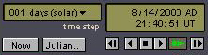
The Time Window shows you the current time and date for the sky being displayed. The box in the upper left shows the current time step. The box in the upper right shows the date and time for the sky. You can change any of the values in the time step or time and date windows by clicking and typing or by using the mouse. The “Now” button will reset the time and date to the current local time. The “Julian…” button will display the current Julian date (not necessary for this lab). The six buttons on the lower right act like movie controls: Back one time step, Backward at one time step per second, Stop, Forward at one time step per second, Forward at real time, Forward one timestep.

Be sure that the labels show altitude and azimuth in addition to celestial coordinates. This is done in the File:Preferences menu item. Choose File, then Preferences. Select Cursor Tracking (HUD) from the drop-down menu, Click the Display tab, check the Altitude/Azimuth box. Now, when you point at an object with the Pointer, you will be shown Altitude and Azimuth as well as Right Ascension and Declination.

You can also turn on a "local" Altitude-Azimuth coordinate grid by clicking the button on the right side of the button bar. Turn on the constellations and labels from the Guides: Constellations drop-down menu: select Guides, then Constellations, then Labels.

Turn on bright star labels by selecting Sky, then Labels, then Stars. Return to Guides, select Constellations again, and then Constellation Settings. In the Constellation Settings menu and click "Stick Figures".

You are now ready to do the computer portion of the exercise.

A: Measuring the Sidereal Day:

- Make sure that the date in the Time Window is correct for tonight's date. Set the time to match the time you recorded for your first naked eye observations on the roof.

- Use the pan mode "hand" (see above) to grab the sky and move it around until you find the stars in your list.

- Switch back to the pointer tool, and hold the cursor over the star until its coordinates appear. Record the Altitude/Azimuth and RA/Dec in the appropriate shaded columns in TABLE 1.

- Repeat for all the stars on your list.

B: Motion of the sky during the semester:

If you did not bring your Intro to the Night Sky lab script with you, you can use Starry Night as a time machine to reconstruct the night sky from early September. In the Time Window, reset the date to Sept. 1 of this year. Make sure the time is still identical to the time of your first naked eye observation tonight.

- Use the "hand" tool to pan around until you are looking at the northern horizon (or click the "N" button). Draw the three or four of the major constellations surrounding Polaris on your extra Northern Sky sketch sheet. (page 17)

- Pan around to the southern horizon (or click the "S" button). Draw three or four of the constellations in the south, ideally bright ones that you recall your TA pointing out to your during the course of the semester. (page 18)

PART III. Photographic Observations

In this part of the lab exercise you will use a long-exposure photograph to determine the length of the sidereal day. The photograph provided was taken by a camera mounted on a tripod with the shutter left open. The camera was pointed toward the North Celestial Pole, so the picture shows Polaris (α Ursa Minoris) and the surrounding stars. Because the earth turned during the exposure, all of the stars are seen as trails of starlight.

The TOTAL TIME ELAPSED FROM THE BEGINNING OF THE PHOTOGRAPH UNTIL THE END = 115 MINUTES. The interruption in the star trails represents a brief period when the shutter was accidentally closed.

Determining the Length of the Sidereal Day from the Photograph:

- Looking at the photograph, locate the true North Celestial Pole. Place a dot at the NCP.

- Choose three bright star trails that do not run off the edges of the image. They do not have to be already labeled, but generally ones farther from the North Celestial Pole work better than ones closer in. Mark the starting and end points of your three star trails with short lines. Like this:

|_____ ___________________________| β

Except that the actual star trails will be curved, of course. Now draw a pair of straight lines from these starting and ending marks to Polaris.

- Center your protractor on the North Pole. The center is the middle of the ruler portion of the protractor---if your protractor doubles as your sextant, this is the tiny hole where the string is tied.

- Measure the angular distance from the starting and end mark for each star trail. Take the average for your three stars:

1. ___________

2. ___________

3. ___________

AVERAGE:____________

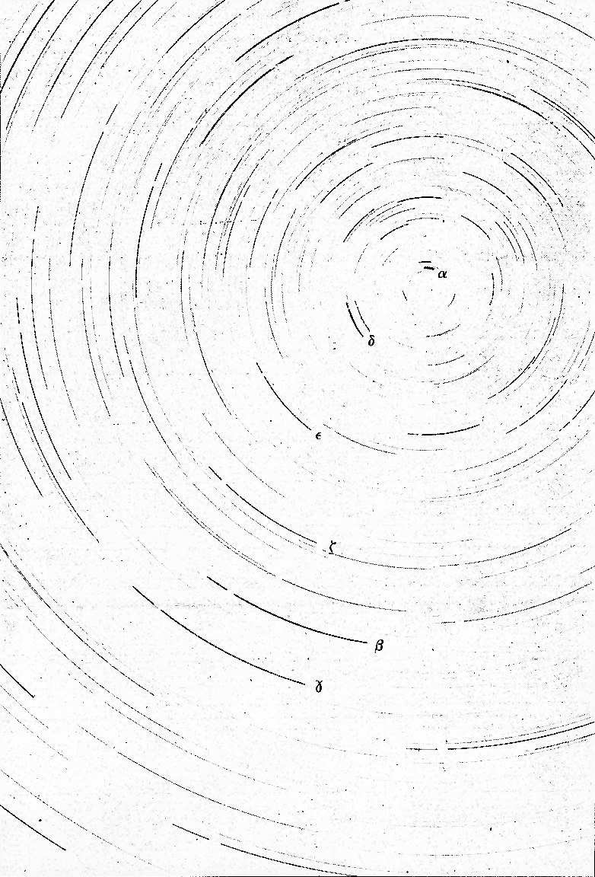
- Using the start ingand ending times for the photograph with your average angular distance to calculate the length of the sidereal day.

- In your opinion, should this method be more or less accurate than the measurements you made on the roof with the sextants? Why?

- The true length of the sidereal day is 23^{h} 56^{m}. Use this to calculate the percentage error in your estimate. Does it compare well with your estimate of the accuracy?

PART IV – Naked Eye Observations (End of Lab)

A: Measuring the Sidereal Day from Visual Observations:

If at least an hour has elapsed since your first naked eye observations, you may return to the roof for the second set. Redo the measurements of Altitude and Azimuth, and enter the new values as Alt(2), Az(2) in TABLE 1. Again, make sure to record the time of your observations on the table!

Make sure the Time Window in Starry Night is set to today's date and the time of the new set of naked eye observations. Use the hand tool and pointer tool to measure the coordinates of the same stars again in Starry Night.

- What is the average level of error between your naked-eye measurements with the sextant and the "true" values from Starry Night? (You don't have to use the error formula a dozen times, just give a general estimate.)

- How did the RA and Dec change between the Time 1 measurements and the Time 2 measurements? Why?

Now use the observations in TABLE 1 with the following formulas to calculate the values in TABLE 2. Calculate ΔTime in minutes to obtain the length of the sidereal day in minutes, then divide by 60 to obtain hours.

ΔAlt = Alt(2) - Alt(1)

ΔAz = Az(2) - Az(1)

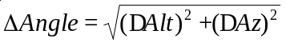

ΔTime = Time 2 - Time 1

Length of Sidereal Day = (ΔTime /ΔAngle) x 360º

- Is there a difference in the change in angle ΔAngle and estimated sidereal day as calculated from stars near the North Celestial Pole vs. stars near the Celestial Equator? Which do you suppose is more accurate?

- Given that the known length of a sidereal day is 23^{h} 56^{m}, calculate your percentage error. Is this consistent with the error from the star trails method? Which method is more reliable, in your opinion? Why?

B: Motion of the sky over the semester:

Set the time window in Starry Night back to today's date and the time of your first set of observations. Compare your naked eye North and South sky sketches from tonight to the northern and southern horizon view in Starry Night the same time on the same night. How did you do? How do the errors in your drawings compare with the errors in your sextant measurements from the previous section?

Referring to your sketches and considering the dates they were made, which direction has the sky appeared to move over the course of the semester? Explain why the motion you see between your different sketches cannot be caused by the rotation of the Earth on its axis every 24 hours.

Choose a reference star other than Polaris that is visible in both of your Northern sky sketches. Since each sketch was made at around the same time of night, the angular distance of the Sun below the western horizon is roughly the same for each sketch. Therefore, what can you say about the angular distance between reference star and the Sun? Explain why the separation changes, and whether this represents any real change in the physical distance between the Sun and the reference star. Include a diagram to help in your explanation.

It should be clear that things in the sky have moved; you made your sketches at the same time each night, but the constellations are in different locations in each sketch. But how fast is the motion? You can calculate the rate at which the sky appears to rotate with the use of your sketches of the northern sky....

- First find and label the previously defined northern reference star on both of your North sky sketches. Find and label Polaris.

- On both sketches use a straight edge to draw a line straight up and down through Polaris. What is this line called?

- On both sketches draw another straight line from Polaris to the reference star. Use the protractor to measure the position angle (angle from north) between the two lines.

Position angle (Aug/Sept): _________ degrees

Position angle (Nov/Dec): _________ degrees

Change in position angle: _________ degrees

Days elapsed between: _________ days

Using the time elapsed between when the two sketches were made, make an estimate of the average rate of motion of the sky in degrees per day.

The true rate is based on the time it takes the Sun to move all the way around the sky relative to the stars. What is the true rate? Compare this number to your answer. Is the real number consistent with your estimate? Calculate a percentage error estimate.

How does the motion of the stars in the northern sky differ from the motions of the stars in the southern sky. Why are they different?

Questions:

- If you face North, in which direction (clockwise or counterclockwise) did the sky appear to rotate during the night? What about during the semester?

- What causes the constellations to move during the night? What causes the constellations to move over many nights?

- Is Polaris directly at the North Celestial Pole? Explain how can you tell this from the photograph.

- Which method of determining the length of the sidereal day gave an answer closer to the true value? Explain why you think that value was more accurate. How did this accuracy compare to that of measuring the rate of motion of the night sky during the semester?

- We use the solar day (24^{h} 00^{m}) as our standard of time on clocks and watches. The length of the solar day differs from the sidereal day (23^{h} 56^{m}) by four minutes. Explain why the two are not equal and why the solar day is longer (a diagram may help in this explanation).

- Calculate the number of sidereal days in a calendar year, and compare this value with the number of solar days in a calendar year.

- If you observed the same objects you used in Part 1, but 6 months from now, predict where they would be in the sky at the same time of night. Explain the reasoning that led to your answer.

Conclusion:

TABLE 1: OBSERVATIONS AND MEASUREMENTS | Time 2 = | Starry Night | Az(2)
TABLE 1: OBSERVATIONS AND MEASUREMENTS | Time 2 = | Starry Night | Alt(2)
TABLE 1: OBSERVATIONS AND MEASUREMENTS | Time 2 = | Naked Eye Obs. | Az(2)
TABLE 1: OBSERVATIONS AND MEASUREMENTS | Time 2 = | Naked Eye Obs. | Alt(2)
TABLE 1: OBSERVATIONS AND MEASUREMENTS | Time 1 = | Starry Night | Dec
TABLE 1: OBSERVATIONS AND MEASUREMENTS | Time 1 = | Starry Night | RA
TABLE 1: OBSERVATIONS AND MEASUREMENTS | Time 1 = | Starry Night | Az(1)
TABLE 1: OBSERVATIONS AND MEASUREMENTS | Time 1 = | Starry Night | Alt(1)
TABLE 1: OBSERVATIONS AND MEASUREMENTS | Time 1 = | Naked Eye Obs. | Az(1)
TABLE 1: OBSERVATIONS AND MEASUREMENTS | Time 1 = | Naked Eye Obs. | Alt(1)
TABLE 1: OBSERVATIONS AND MEASUREMENTS |  |  | Object | 1. | 2. | 3. | 4.

TABLE 2: CALCULATIONS | Starry Night: | Sidereal Day
TABLE 2: CALCULATIONS | Starry Night: | ΔAngle
TABLE 2: CALCULATIONS | Starry Night: | ΔAz
TABLE 2: CALCULATIONS | Starry Night: | ΔAlt
TABLE 2: CALCULATIONS | Naked Eye Observations: | Sidereal Day
TABLE 2: CALCULATIONS | Naked Eye Observations: | ΔAngle
TABLE 2: CALCULATIONS | Naked Eye Observations: | ΔAz
TABLE 2: CALCULATIONS | Naked Eye Observations: | ΔAlt
TABLE 2: CALCULATIONS |  | Object | 1. | 2. | 3. | 4.

Southern sky sketch Name:
Date: Time:
Instructor verification:

South
Northern sky sketch Name:
Date: Time:
Instructor verification:



Southern sky sketch Name:
Date: Time:
Instructor verification:

South
Northern sky sketch Name:
Date: Time:
Instructor verification:

