The Motion of the Sky Teaching Notes

Equipment Needed:

- Rulers
- Protractors

Part I

The start of this part should include a deliberately free-form roundtable discussion about what a Sidereal Day is and how you would best measure it. Then re-ask the question in terms of how they should measure it in a 2.5 hour long lab class! Nudge them in the right direction of taking two sets of data some hours apart (the further the better) and then send them out to do that. You will probably need to go over uncertainty estimating and how to derive a percentage error. For reference:

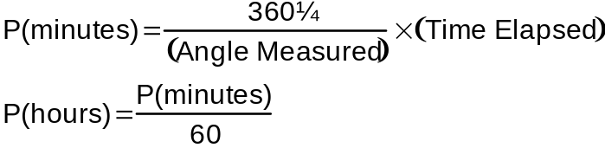

Part II

This part of the lab will require use of rulers and protractors. Some students get very hung up on the fact that the same angle is measured for all three stars – tell them that its not a big deal and its what you expect – ask them how well they can measure the same angle three times – they should quantify their estimate. See the above equation again. Make sure the students are recording their data clearly in tabular form. Impress upon them the value of note-taking for lab report writing at a later date.

Part III

This part is pivotal on the quality (and presence!) of their previous sketches from the earlier Naked Eye labs. If they didn’t bring the sketches with them, they can still make the 3rd observation and complete the work at home when writing up the lab report. Again emphasize the value of estimating uncertainties and see whether the value derived from one year (0.986º/day) does fall within their predicted range of values. Make yourself available to discuss the questions posed at the end – but don’t give the answers away!

Foul Weather
In all parts of this lab, in the event of bad weather you have the option of letting them make the remaining observations on their own, another night, from home or using the Planetarium to do it. The sketches of the Northern and Southern sky could be done using the diagrams in the Audubon Guide on plates 21-68.

