Orbital Motion

What will you learn in this Lab?

You will be using some special software to simulate the motion of planets in our Solar System and across the night sky. You will be asked to try and figure out Kepler’s Third Law using observations you make of the planets using this software. Having worked out the nature of the Law, you will then be asked to make broader statements about how orbital motion is governed and about the general properties of bodies in orbit about each other.

What do I need to bring to the Class with me to do this Lab?

For this lab you will need:

- A copy of this lab script
- A pencil
- Scientific Calculator
- 2 pages of graph paper

Introduction

The planets, and indeed all gravitationally bound objects, move in a very specific way as they orbit the object they are bound to. In the case of the planets, they are bound to the Sun through the force of gravity because of the Sun’s huge mass. Johannes Kepler worked out the details of this orbital motion from painstaking observation of the motion of the planets in the night sky. In this lab, we’ll be trying to do the same thing, but with the aid of the computer, we will have control of not only our viewing position but also the rate at which time passes.

Using the Computer – an Introduction to Starry Night

In this lab exercise you will be using a piece of software called Starry Night. This is a very sophisticated planetarium package that can not only show us what the sky looks like at any time, from anywhere on Earth, but it can also transport us to other places in the solar system and even other stars!

Before you can conduct the exercise, we’ll go over the basic functionality of the software so you are more comfortable using it to obtain data for your experiment. The software is display-driven, i.e. the software’s main product is a picture of where you are and what you can see under the current conditions. This is not surprising given that astronomy is primarily a visual science. When you start the software, the display will show you what the current sky looks like, right now, facing towards the southern horizon. The scrollbars on the side of the window allow you to change your altitude and azimuth of where you’re looking. Play with it to get used to what your “world” looks like.
Around the main window you will see a variety of buttons. The ones along the top of the main window change various aspects of the display. You can change coordinate systems, you can turn the horizon on and off (try it!) and even turn off daylight so you can see what the sky would look like if we had no atmosphere. Each button has a floating label that appears after a second or two when you leave the cursor over it without pushing the mouse button.

The panel on the upper left of the main window is the main control palette. You’ll be using this most so let’s have a closer look at it. Each button turns on a specific mode.

The pointer mode allows you to point at certain objects in the main window, and the computer will tell you what they are, where they are, and other information.

The pan mode allows you to “grab” the display you’re looking at and move it one way or the other so you can see what it is next to, above or below the current view.

The magnify mode allows you click in any position in the main window and “zoom in” on that part of the sky to get a better look.

The rotate or roll button allows you to roll your position so “up” is in a different direction. This is less useful when you’re standing on Earth, but very useful when you’re floating out in space looking around.
The constellation button will show you which constellation you’re in as you move the cursor around in the visible part of the sky.

The measuring tool allows you to accurately measure the separation and direction between two points in the main window.
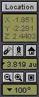
In addition to these function buttons, there are two other sets of tools that allow you to determine where and when you are at any given instant. The first of these is the location window. This will show you your X,Y and Z coordinates in a variety of units, so you know how far from your start point you are. By default, you will start in Phoenix, Arizona. The two rockets will raise or lower your altitude of observation. The house button takes you back to your “home” location (Phoenix, unless you redefine it). The distance window shows you how far from your home location you currently are. The magnifying glass buttons zoom the view in and out. The field window shows you how big your field of view is (which is related to the zoom).
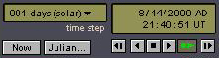
The time window shows you the current time and date. You can set the time step in the upper left box to whatever value you choose, and then set time in motion by hitting the play button. You can move one step at a time by using the buttons at either end of the button panel. The button shown as selected will change the display real time – i.e. one second per second. The stop button halts any display updates. This will be your most useful tool for this lab exercise. Get used to using it. A useful tool is the “Julian” button that will return the Julian date of the current view and epoch. This is particularly useful for measuring elapsed times in days between two snapshots.

If you have any questions at any time, please don’t hesitate to ask your TA. It is very important that you understand how to manipulate your environment before you move on to the exercise itself.

The Task – Verification of Kepler’s Third Law

One of Kepler’s Laws states that the period of a planet’s orbit is directly related to the size of that orbit through a simple relation. We are going to test that assertion and attempt to determine the simple relationship involved.

The first two laws state some simple properties of orbital motion. Kepler’s First Law states that any body in orbit about another moves in an elliptical orbit with the central mass at one of the foci. In the case of the planets in our Solar System, these ellipses are very circular looking and are not very eccentric like the orbits of comets or asteroids.

Kepler’s Second Law goes one step further to point out that in moving around this elliptical orbit, when the orbiting body is close to the central mass, it moves faster, and when it is further away it moves slower. This produces the so-called law of equal areas, that an orbiting body sweeps out equal areas in equal times (see figure below).

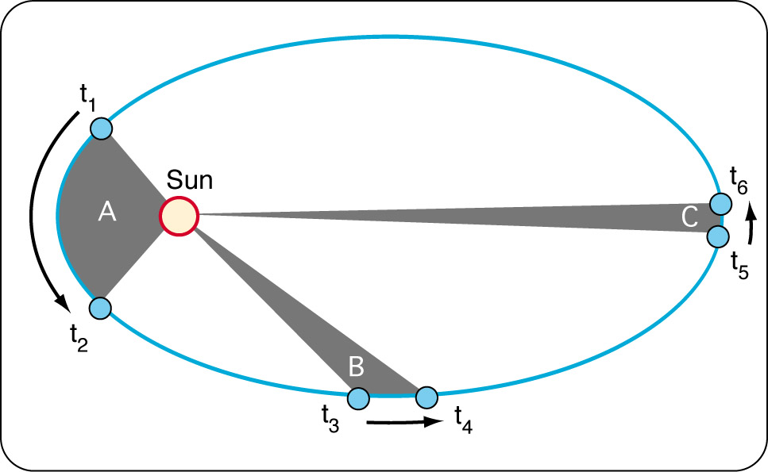

Kepler’s Third Law is related to both of these two laws but goes one step further. This is what we are intent on understanding better.

Observations

Using the Starry Night software, we are going to measure the orbital periods of the planets in our Solar System and attempt to derive the functional form of the relation that describes Kepler’s Third Law.

Use the software to present a view of the Inner Solar System (under the “Go” menu). Using the time tools, and the various tools that change your view of the motion of the planets, measure the period of each inner planet and fill in the table at the end of this lab script with the following data: name of planet, period of orbit, average radius of the orbit. Perihelion is marked on each orbit, so your distance should be the average of perihelion and aphelion. Next, repeat the process but with the Outer Solar System. Add these data to your table. An added complication is that the real-time distances are not displayed for the outer solar system – so you’ll need to use the measuring tool to estimate the distances between each of the planets and the Sun.

In what units did you measure your periods and orbital radii? It is typical to measure orbital periods in Earth years, and orbital radii in Astronomical Units (AU’s – which is the average radius of the Earth’s orbit). Make certain that you list the period in years and the average distance in AUs in your data table. In order to help with graphing the data, calculate the logarithm of the period and average radius and also include these in the data table.

We know that Kepler’s Third Law “simply” relates period and orbital radius. What one person refers to as simple may differ dramatically from what another person terms simple. In this case, simple means that the two quantities are related, but each term is raised to some power, ie. period cubed, or radius to the 5th power.

A very simple way to determine these power terms is to use the logarithm of the data. For example, if the following equation holds:

yª = x^{b}

Then by taking the logarithm, the equation becomes a lot simpler to graph:

With your data, use a similar approach to determine the exponents used in Kepler’s Third Law. Graph the logarithm of period versus the logarithm of orbital radius, and measure the slope of the resulting line.

The resulting slope will tell you the exponents needed in the simple relation between the two variables. Here are the decimal values of some common simple exponent ratios:

Ratio | Decimal Value
5/2 | 2.5
4/2 | 2.0
3/2 | 1.5
2/2 | 1.0
5/3 | 1.66
4/3 | 1.33
3/3 | 1.0
2/3 | 0.66
1/3 | 0.33
5/4 | 1.25
4/4 | 1.0
3/4 | 0.75
2/4 | 0.5
1/4 | 0.25

- What expression do you get for Kepler’s Third Law?

- What does it tell you about the period of a small orbit, versus the period of a large orbit? Does this make sense when you refer to Kepler’s Second Law?

Assume that the orbits are circular and calculate the average orbital speed (distance traveled divided by the time traveled) for each planet. Express the velocities in km/s (1 AU = 1.50x10⁸ km) and include these in the data table at the end of the lab script.

Plot each planet’s velocity against its orbital radius. Draw a smooth curve through the data points. This curve is called a Keplerian rotation curve and is used to look for protoplanetary disks around other stars. If the material around a star is seen to move with the same distribution, then we know the material is bound to the star as the planets are bound to the Sun.

- What fundamental force governs the motion of bodies in orbit about each other? In light of what you have calculated here, does this force get stronger or weaker when the two orbiting bodies get closer together? Why? Think about the analogy of whirling a ball on a string around your head and consider your orbital speeds from above. Explain your reasoning.

As a last exercise, move yourself back to the Earth’s surface and look at the sky. Turn off the sky so you can see the planets, and turn on their orbits so you can their paths in the sky. You can now see how the plane of the Ecliptic is defined – it’s the plane of the orbits of the other bodies (and us) in a disk about the Sun. Move time forward to see how the planets’ motion changes with time. This is the way Kepler originally worked out his Laws of orbital motion.

- Is this method harder or easier than the previous method you used? Why? What problems would you encounter with this method?

- What are epicycles? Why do they occur?

In addition to the previous questions in the lab script, please answer the following questions:

- When you observed the motion of the planets in the inner and outer solar system, did the radius of the orbit stay the same as the planet moved? Why? Did the point of closest approach to the Sun (perihelion) occur at the same place in the orbit each time? If not, take a guess why not.

- The planets’ orbits are very close to circular – did you perceive any change in orbital speed as the planets moved around their orbits?

- The final form of Kepler’s Third Law is a remarkable formula and makes some very simple predictions. Do you expect this Law to be obeyed outside the Solar System? Why? Explain your reasoning.

- In addressing epicycles (and retrograde motion) in your report, name the planets that perform epicycles in our night sky over the course of time, and which do not. Why?

Conclusion:

.
Data Table | Period (years) | Ave orbital radius (AU) | Log (Period) | Log (orbital radius) | Orbital Speed (km/s)
Mercury
Venus
Earth
Mars
Jupiter
Saturn
Uranus
Neptune
Pluto

Please use space below for calculations.

