Orbital Motion Quiz

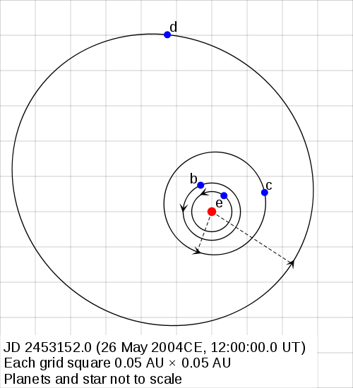
Gleise 581 is a star system 20 light years from Earth. It has recently been discovered to have a planetary system with at least 4 planets, including some colder and some hotter than Earth. This diagram shows a possible configuration of the planetary orbits in the Gleise 581 system. (The star is the center dot, and the planets are listed as b,c,d,e, in order of descending mass)
X Periastron
(closest to star)
X Apastron
(furthest from star)

- Some of the planets are not in circular orbits. What is the geometrical shape of these orbits?

- Imagine you are the pilot of a small spacecraft, and wish to land on planet D while it is moving as slow as possible. Where in its orbit should you choose to land?

- On the surface, you meet some alien astronomers who have been comparing the orbital periods and radii of these planets. Help them out by completing the exponents below:

Period^{(_____)} = Radius^{(_____)}

- What is this law known as to earthlings?

- What force is responsible for the motion of planets?

