EXPLORING THE SUN PRELAB
The first place to look for answers is in the lab script!

- Define using complete sentences:

Differential Rotation:

Synodic Period:

Sidereal Rotation Period:

Prominences:

Answer the following questions:

- How long is the sunspot cycle? Explain the sunspot cycle.

- How many observations of sunspots do you have to record? How many days apart?

- What is the purpose of an H-Alpha filter

- What part of the sun are you observing when you look through the Maylan filter? H-alpha filter?
exploring the Sun

The purpose of this exercise is to observe the Sun and some of its visible features. You will determine both the synodic and sidereal rotation periods of the Sun. You will also examine the differential rotation of the Sun and look at features of the Sun through an H-alpha filter. Never look directly at the Sun!

Introduction:

The most noticeable solar surface features are sunspots. They were discovered telescopically by Galileo in 1611 and there are earlier references to them in Chinese records. We will observe them in a safe manner by projecting the image of the Sun. Individual sunspots can last 1 to 100 days and typical large sunspot groups are visible for a month. The sunspots go through an 11-year cycle. This cycle has two aspects. First the number of sunspots changes. Early in the cycle there are few or no sunspots. As the cycle gets closer to 11 years of age there are more and more sunspots. Second, at the beginning of the cycle, sunspots appear at middle latitudes and as the cycle ages toward solar maximum the sunspots move closer to the equator (see butterfly diagram in most astronomy text books).

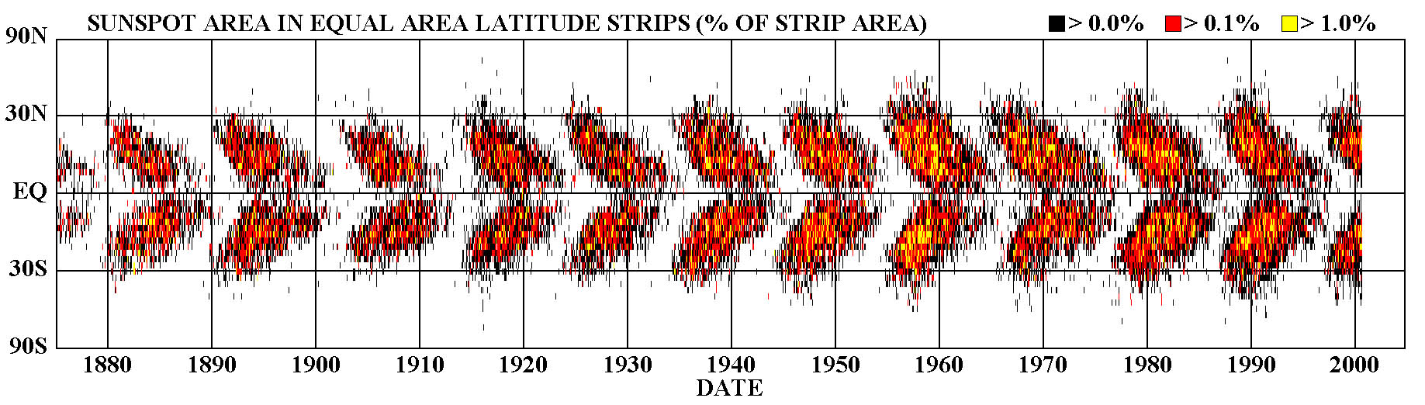
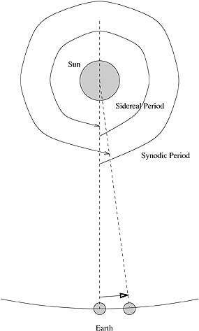
The Sun does not rotate as a solid body. It undergoes what is called differential rotation. It rotates at a different rate near the center than at higher latitudes. This is simply due to the Sun lacking a solid surface. For reference, the synodic period of the Sun is defined as being the length of time it takes for the same feature to rotate all the way around the Sun, and return to the same place on the disk of the Sun as seen from the Earth. The sidereal rotation period of the Sun is defined as being the time it takes the Sun to rotate once on its axis relative to the stars (i.e. 360º). The two times are not the same since the Earth moves on in its orbit during a solar rotation, so our point of view changes.

PART I: Visual Observations
Observations:

The first part of this lab involves two observations to be taken during the day with the ASU
“solar” telescope. One of the 8 in telescopes will have a solar projection screen located 40cm behind the eyepiece. This will enlarge the image and provide an opportunity to view the solar image in an INDIRECT manner. Using ONLY this special equipment, you will make a drawing of sunspots on two different days, 4 days apart.

To make your first observation:

- Mount your solar drawing paper (page 6) with paperclips on the inside of the projection screen. Focus the telescope so that the solar image (primarily the edge of the Sun) appears sharp. Mark N and E on your drawing so that you can determine the orientation of the drawing for your second observation as well as the direction of sunspot motion. A TA will be there to help you with any questions you have.

- Draw the outline of the Sun and ALL visible sunspots. Look especially carefully at the limb of the Sun for sunspots that have just rotated into view.

- Record both the time and date and have the TA initial your observation.

4 days later:

- Make a second observation using the same observing sheet – use a different colored pencil.

Now that you have two observation of the position of sunspots you can determine the synodic period of the Sun and the direction of solar rotation. You will use a graphical method to determine the angle through which the sunspots moved across the Sun during your observations

- Mark all sunspot groups and determine which groups were observed on both days.

- Choose your best sunspot group that appeared on both days of your observations. Draw a line connecting the two sunspot groups. This line will be a line of constant solar latitude. Using this line, you will determine the true orientation of the solar latitude and longitude (i.e. where true solar N, S, E and W are).

- You will now bisect the chord you have drawn connecting your sunspots – i.e. bisect the line that passes through your sunspots where it crosses the solar limbs. This bisecting line is the N/S line of the Sun.

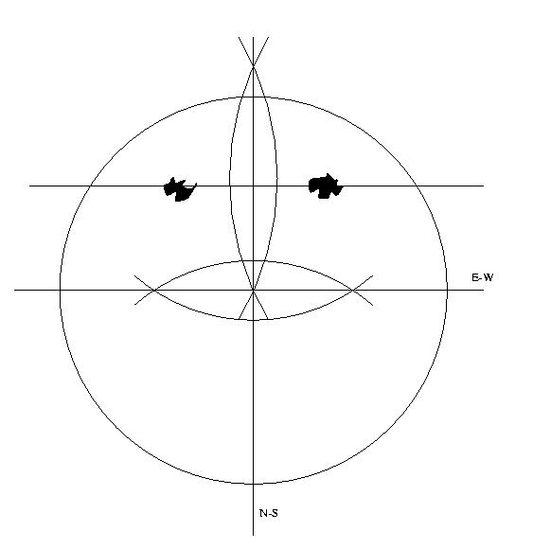

Figure 1 – How to determine the N-S and E-W lines from your observations

- Bisecting, again, the N/S line will show you the solar equator’s location.

- You will use Figure 2 to find the angular distance each sunspot has moved between the two observations. Overlay this equatorial projection of the Sun by aligning it with your determination of the longitude and latitude system. Determine the latitude and longitude of each of the sunspot groups you saw, and the change in longitude between the two observations. From the longitude change what is the synodic period of the Sun? You need to use a ratio to determine this period.

Synodic period = 360º Synodic Period = 360º x Period btw obs.
Period btw obs. Change in longitude Change in longitude

- Why have we determined the synodic and not the sidereal period?

FYI the known synodic period of the Sun ranges from 26.87 days at the equator to 29.65 days at a latitude of 40º.

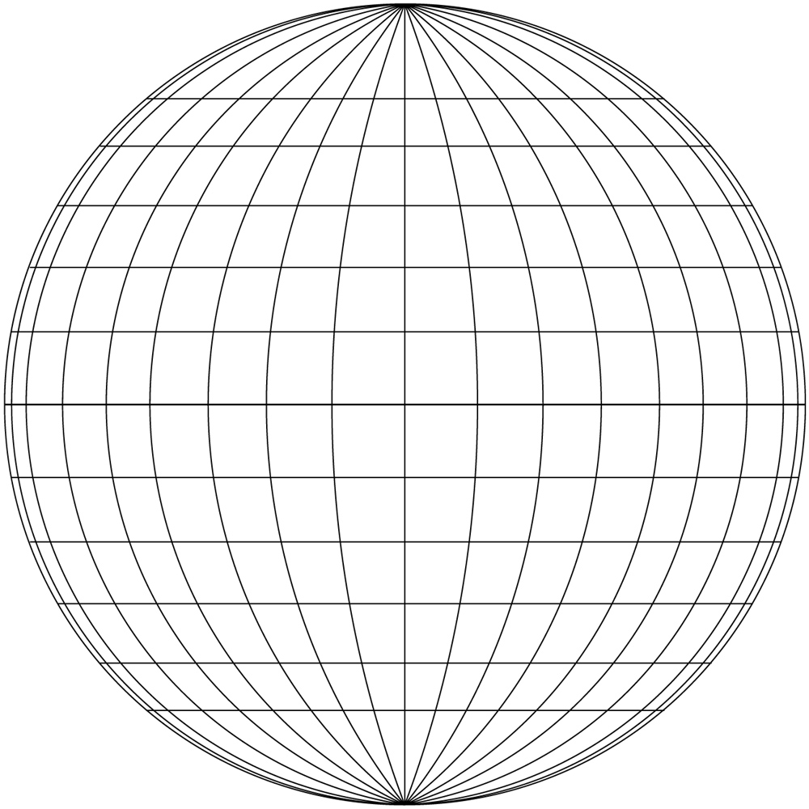

Figure 2 – latitude and longitude grid to use for your observations. Each line is 10º apart from its neighbor

- How would you determine the sidereal period of the Sun? Hint: One can either fix the periods or the distances the objects moved. If you use periods, you take the synodic period and determine what fraction of the Earth's orbital period that is. Then remove that fraction out of the synodic period. Write this out in equation form.

- Determine the sidereal period of the Sun.

- How far from the known sidereal period at that latitude is your answer?

The sidereal period of the Sun ranges from 24.97 days at the equator to 27.75 days at a latitude of 40º.
Observations of Sunspot Positions

Name: ____________________
Date: Obs #1 ____________________
Time: Obs #1 ____________________
Date: Obs #2 ____________________
Time: Obs #2 ____________________
Outline the image of the Sun
Draw all of the sunspots you see
Indicate North and East on your drawing
Use a different color pencil for the 2nd observation

TA verification: Obs #1 _____________________ Obs #2 _______________________
PART II. Sunspot structure and limb darkening

In this part of the lab exercise you will be looking at 2 regions of the Sun with to telescopes that have been fitted with a Mylar solar filter. It is safe to look through the eyepiece when such a filter is in use. Using a pencil draw what you see in the field of view on the circles below. (Note: the circle you see represent the entire field of view. If you think an area of the Sun is darker then use your pencil to shade the darker area.)

Sunspot drawing

Limb drawing

Part III. H-Alpha Observations

In this part of the lab you will look at the Sun through a different telescope with an H-Alpha filter on it. Unlike continuum “white light” observations of the sun, observing the chromosphere, the second of the three main layers in the Sun’s atmosphere, requires a very narrow bandwidth filter centered on the Hydrogen Alpha spectral line (6562.8 Angstroms), which not only reduces the intensity of the sunlight to a safe level, but eliminates much of the photosphere’s contribution to the image.

A prominence is a large, bright, gaseous feature extending outward from the Sun’s surface, often in a loop shape. A typical prominence extends over many thousands of kilometers. When a prominence is viewed from a different perspective so that it is against the sun instead of against space, it appears darker than the surrounding background. This formation is instead called a solar filament. A plage is a bright region in the chromosphere of the Sun.

On the circle representing the sun below, sketch all features on the Sun that you see through the telescope. Label each one with which type of feature it is, prominence, plage, or filament. Make these observations twice. Use a different color pencil to mark movement or differences between the two observations.

H-Alpha questions:

- Which type of feature did you see most of? Fewest?

- Which type of feature was the easiest to observe? Hardest?

- Were all the same features there during your second observation?

- Were any of the features near the same location as sunspots? Which one(s)?

Sunspot Questions:

1. How much did the sunspots move?

2. Did the sunspots change shape or orientation?

3. Did they move parallel to each other? If so, why would you expect this?

4. What are the sidereal and synodic periods of the Sun?

5. How is sunspot latitude related to rotation period of the Sun?

6. Measure the size of a sunspot (in cm) with a ruler (using the drawing on page 6). The diameter of the Sun is 1,391,000 km and the scale of you drawing is 114,959 km/cm. How big are sunspots?

7. How big are sunspots compared to Earth? The diameter of Earth is 12,756.2 km.

CONCLUSION:

INDOOR ALTERNATIVE (in case of cloudy weather).

Provided Observations

This part should only be done in the event of bad weather or a lack of daytime observations.

Introduction:

In this part of the lab exercise you will use a photograph to determine the synodic and sidereal period of Sun. You will also determine how the rotation period of the Sun changes with latitude. Finally you will measure the motion of a coronal mass ejection. The data provided is from the SOHO (Solar and Heliospheric Observatory) satellite that has been imaging the Sun daily since 1995. Your TA will provide you with images for this part.

Sunspot Measurements.

- Using the two images of the Sun and the solar grid provided determine the latitude and longitude of each of the group of spots on the Sun in a method similar to that used in Part I.

- Calculate the synodic and sidereal periods of the Sun for each of the sunspot groups.

- Plot the sidereal period of the Sun as a function of latitude. Is there a correlation? Does the Sun appear to rotate differentially?

