exploring the Sun

What will you learn in this Lab?

You will learn the difference between synodic and sidereal rotation periods on the Sun. You will also examine the differential rotation of the Sun and examine coronal mass ejections.

What do I need to bring to the Class with me to do this Lab?

For this lab you will need:

- A copy of this lab script
- A pencil (a colored pencil will be provided)
- A scientific calculator
- Compasses will also be provided by the instructor
- Your two solar observations

Introduction:

The purpose of this exercise is to observe the Sun and some of its visible features. You will determine both the synodic and sidereal rotation periods of the Sun. You will also look at the Sun’s differential rotation and measure the velocity and acceleration of a Coronal Mass Ejection (CME).

The most noticeable solar surface features are sunspots. They were discovered telescopically by Galileo in 1611 and there are earlier references to them in Chinese records. We will observe them in a safe manner by projecting the image of the Sun. Individual sunspots can last 1 to 100 days and typical large sunspot groups are visible for a month. The sunspots go through an 11-year cycle. This cycle has two aspects. First the number of sunspots changes. Early in the cycle there are few or no sunspots. As the cycle gets closer to 11 years of age there are more and more sunspots. Second, at the beginning of the cycle, sunspots appear at middle latitudes and as the cycle ages toward solar maximum the sunspots move closer to the equator (see butterfly diagram in most astronomy text books).

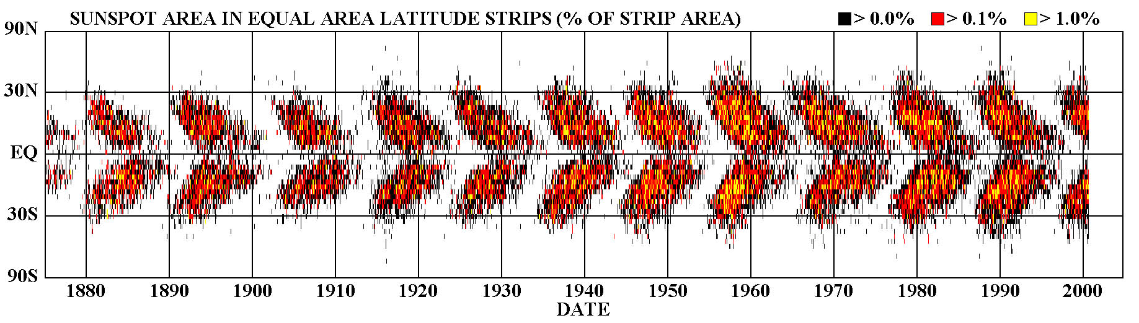
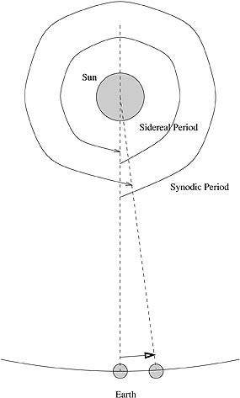
The Sun does not rotate as a solid body. It undergoes what is called differential rotation. It rotates at a different rate near the center than at higher latitudes. This is simply due to the Sun lacking a solid surface. For reference, the synodic period of the Sun is defined as being the length of time it takes for the same feature to rotate all the way around the Sun, and return to the same place on the disk of the Sun as seen from the Earth. The sidereal rotation period of the Sun is defined as being the time it takes the Sun to rotate once on its axis relative to the stars (i.e. 360º). The two times are not the same since the Earth moves on in its orbit during a solar rotation, so our point of view changes.

The Sun does not just give light out into the solar system, but particles are constantly emitted. Sometimes the particle emissions occur in a violent fashion called a Coronal Mass Ejection. It is these events that cause the most spectacular aurorae, which occasionally knock out power and disrupt satellites and communication here at Earth.

PART I: Visual Observations
Observations:

The first part of this lab involves two observations to be taken during the day with the ASU
“solar” telescope. One of the C8 telescopes will have a solar projection screen located 40cm behind the eyepiece. This will enlarge the image and provide an opportunity to view the solar image in an INDIRECT manner. Using ONLY this special equipment, you will make drawing of sunspots on two different days 2 to 4 days apart.

To make your first observation:

- Mount your solar drawing paper (page 6) with paperclips on the inside of the projection screen. Focus the telescope so that the solar image (primarily the edge of the Sun) appears sharp. Mark N and E on your drawing so that you can determine the orientation of the drawing for your second observation as well as the direction of sunspot motion. A TA will be there to help you with any questions you have.

- Draw the outline of the Sun and ALL visible sunspots. Look especially carefully at the limb of the Sun for sunspots that have just rotated into view.

- Record both the time and date and have the TA initial your observation.

2 to 4 days later:

- Make a second observation using the same observing sheet – use a different colored pencil.

Now that you have two observation of the position of sunspots you can determine the synodic period of the Sun and the direction of solar rotation. You will use a graphical method to determine the angle through which the sunspots moved across the Sun during your observations

- Mark all sunspot groups and determine which groups were observed on both days.

- Choose your best sunspot group that appeared on both days of your observations. Draw a line connecting the two sunspot groups. This line will be a line of constant solar latitude. Using this line, you will determine the true orientation of the solar latitude and longitude (i.e. where true solar N, S, E and W are).

- You will now bisect the chord you have drawn connecting your sunspots – i.e. bisect the line that passes through your sunspots where it crosses the solar limbs. This bisecting line is the N/S line of the Sun.

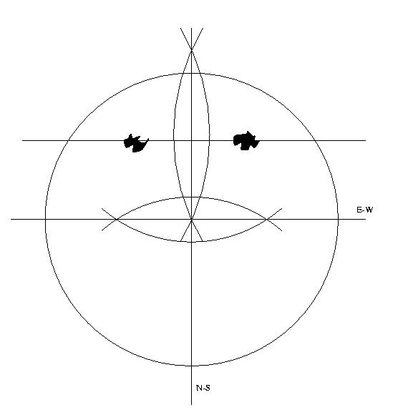

Figure 1 – How to determine the N-S and E-W lines from your observations

- Bisecting, again, the N/S line will show you the solar equator’s location.

- You will use Figure 2 to find the angular distance each sunspot has moved between the two observations. Overlay this equatorial projection of the Sun by aligning it with your determination of the longitude and latitude system. Determine the latitude and longitude of each of the sunspot groups you saw, and the change in longitude between the two observations. From the longitude change what is the synodic period of the Sun? Why have we determined the synodic and not the sidereal period?

FYI the known synodic period of the Sun ranges from 26.87 days at the equator to 29.65 days at a latitude of 40º.

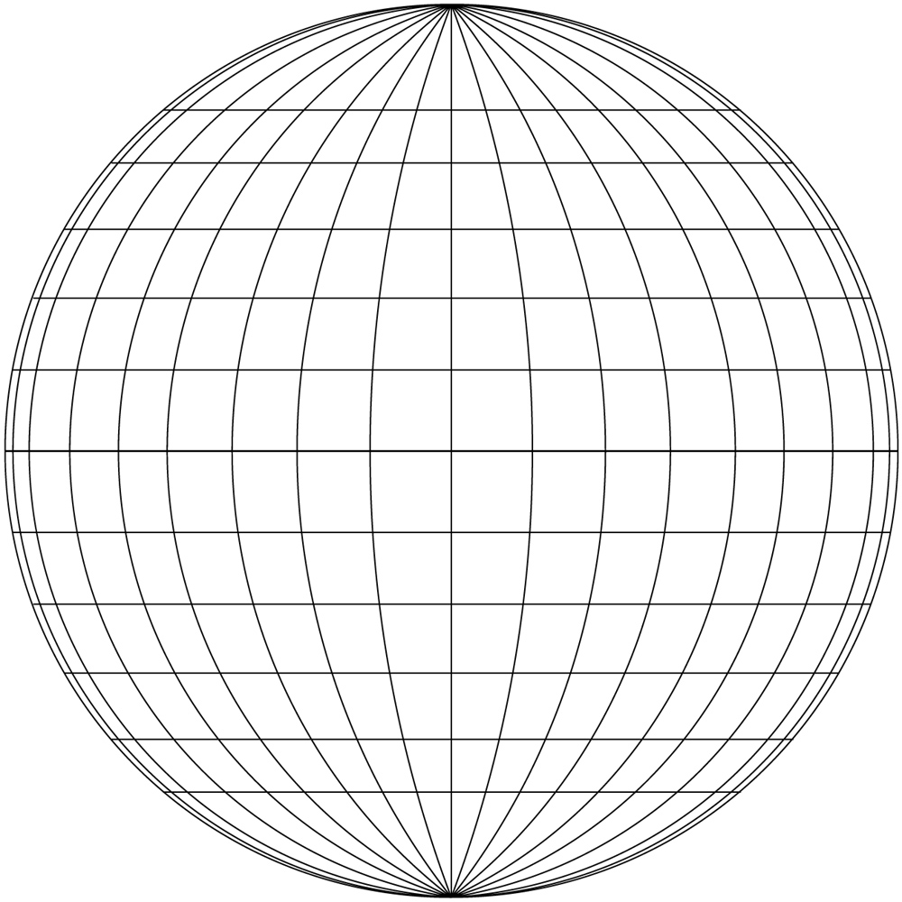

Figure 2 – latitude and longitude grid to use for your observations. Each line is 10º apart from its neighbor

- How would you determine the sidereal period of the Sun? Determine the sidereal period of the Sun. How far from the known sidereal period at that latitude is your answer?

The sidereal period of the Sun ranges from 24.97 days at the equator to 27.75 days at a latitude of 40º.

Observations of Sunspot Positions

Name: ____________________
Date: Obs #1 ____________________
Time: Obs #1 ____________________
Date: Obs #2 ____________________
Time: Obs #2 ____________________
Outline the image of the Sun
Draw all of the sunspots you see
Indicate North and East on your drawing
Use a different color pencil for the 2nd observation

TA verification: Obs #1 _____________________ Obs #2 _______________________
PART II. Provided Observations

This part should only be done in the event of bad weather or a lack of daytime observations.

Introduction:

In this part of the lab exercise you will use a photograph to determine the synodic and sidereal period of Sun. You will also determine how the rotation period of the Sun changes with latitude. Finally you will measure the motion of a coronal mass ejection. The data provided is from the SOHO (Solar and Heliospheric Observatory) satellite that has been imaging the Sun daily since 1995.

Sunspot Measurements.

- Using the two images of the Sun and the solar grid provided determine the latitude and longitude of each of the group of spots on the Sun in a method similar to that used in Part I.

- Calculate the synodic and sidereal periods of the Sun for each of the sunspot groups.

- Plot the sidereal period of the Sun as a function of latitude. Is there a correlation? Does the Sun appear to rotate differentially?

PART III. Coronal Mass Ejections

In this part of the lab exercise you will calculate the velocity and acceleration of a coronal mass ejection based on its position in a series of images from the LASCO instrument on SOHO. Scientists do not yet really understand why CMEs occur and how to predict them. One important part of the ongoing research is to measure the velocity of CMEs and trace their acceleration as they leave the surface of the Sun. This is done by tracking individual features in the CME and measuring their position as a function of time.

The CMEs observed in this exercise were observed with a coronagraph. This is an instrument which blocks out the intensely bright light from the Sun so that faint features such as the corona can be seen.

Look at the images of the CME provided. The white circle shows the size and location of the Sun. The black disk is the occulting disk which blocks out the photosphere and inner corona of the Sun. The times listed on the image are the UT (hours and minutes) at which the image was taken. How does the CME change through the provided images?

- Select at least 2 features visible in all the images. Measure their positions in each image. From where should you measure the position? Why should you measure it from here? Calculate the distance of the feature from the Sun in km.

- You can now calculate the average velocity of the CME between each image. You can also determine the acceleration by determining the change in velocity between each image. Remember acceleration = change in velocity/time. Tabulate your data. Graph your values for velocity versus time. What accelerations do you infer graphically versus those you calculated by hand? Are these velocities and accelerations definitely the true velocities and accelerations? Why might they be different?

- Were the velocities and/or accelerations of the different features measured the same? Would you expect them to be?

- What kind of forces might be acting on the CME? Does this make sense in light of your data?

Questions:
These questions should be addressed in your lab report for this lab.

1. How much did the sunspots move?

2. Did the sunspots change shape or orientation?

3. Did they move parallel to each other? If so, why would you expect this?

4. What are the sidereal and synodic periods of the Sun?

5. How is sunspot latitude related to rotation period of the Sun?

6. How big are sunspots?

7. How fast do coronal mass ejections move?

8. How does their velocity change with time?

9. How big are CMEs?

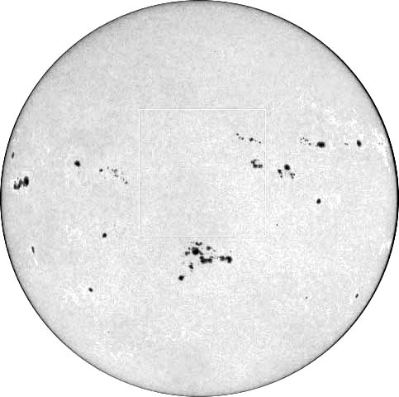

Figure 3 – First SOHO observation – made July 20, 2000 at 1:36 UT
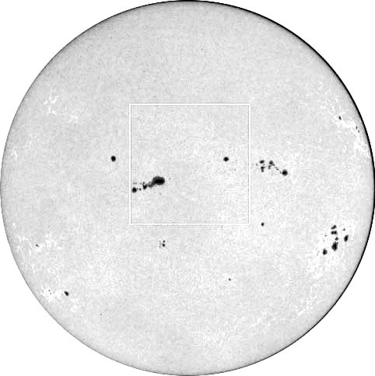

Figure 4 – second SOHO observation – made July 24, 2000 at 0:00 UT
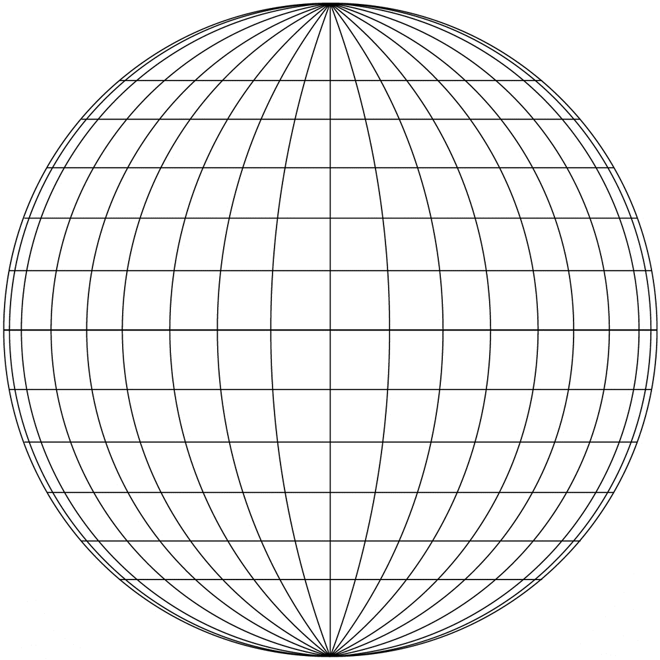

Figure 5 – latitude/longitude grid for use with SOHO data
