Triton Watch

What will you learn in this lab?

The Southwest Research Institute (SwRI) of Boulder, CO is observing Triton, a moon of Neptune, for sudden changes in color. Previous observations of Triton showed the moon suddenly turned red for a short period of time while over longer periods of time the moon became more blue. The reason for Triton's color change is currently unknown, but because of Triton's orbital inclination (157°) regions of Triton's southern hemisphere that have not been in sunlight for more than 350 years should change at the start of this "major summer.'' The time between Triton summers can be as short as 40 years, or as long as 350 years. A "major summer'' starts at the end of the 350 year period. As sunlight begins to warm these regions, material from the surface will sublimate into Triton's atmosphere, thus changing its color. SwRI's Triton Watch group is currently asking astronomers to obtain photometry (measurement of the properties of light, especially brightness) of Triton in hopes the moon will be "caught in the act.'' Tonight, we will use the Braeside telescope to observe Triton to obtain measurements of the color.

What do I need to bring to the Class with me to do this Lab?

- A copy of this lab script
- Pencil and eraser
- Scientific calculator

Introduction:

Uranus was discovered in 1781 by British astronomer William Herschel. Uranus marked the first discovery of a planet too faint to be seen with the naked eye. Inconsistencies in the astrometry (the scientific measurement of the positions and motions of celestial bodies) of the predicted location and the observed location were noticeable several years later. Astronomers theorized that something massive was perturbing the motion of Uranus, evidence for an 8th planet. The position of the 8th planet was calculated and searched for by John Couch Adams in England and Urbain Leverrier in France. Neptune went undiscovered until German observer Johann Gottfried Galle found Neptune in its predicted location on September 23, 1846. By October 10 of that year, a 14th magnitude moon was discovered in orbit around Neptune. The moon was named Triton. Quickly, astronomers realized that Triton was not a regular moon because it orbited Neptune in a retrograde motion (Triton's orbital motion is opposite of the planet's). A second moon, Nereid, was not discovered until 1949. Nereid is much smaller in size and has a highly inclined and elliptical orbit around Neptune. After the discovery of rings around Uranus and Jupiter in the 1970's, astronomers theorized Neptune should also have rings. Several occultations (passage of a celestial body across a line between an observer and another celestial object, as when the Moon moves between Earth and the sun in a solar eclipse) of Neptune in the early 1980's showed Neptune had no rings, except for an occultation in 1984 showed evidence that Neptune's ring system was made of ring arcs or incomplete rings. Before Voyager 2 even the greatest telescopes on Earth could only show Neptune as a featureless blob of light, and Triton as a small dot.

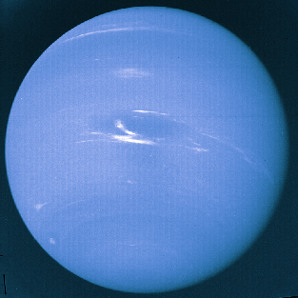
In 1989, Voyager 2 showed Neptune (left) as a large blue planet with giant storms; the largest was called the Great Dark Spot (GDS) similar to the Great Red Spot on Jupiter. Neptune also has small high level white cirrus clouds near the storms. Surrounding Neptune were four thin, complete rings and six more very small moons that have closer, more circular orbits.
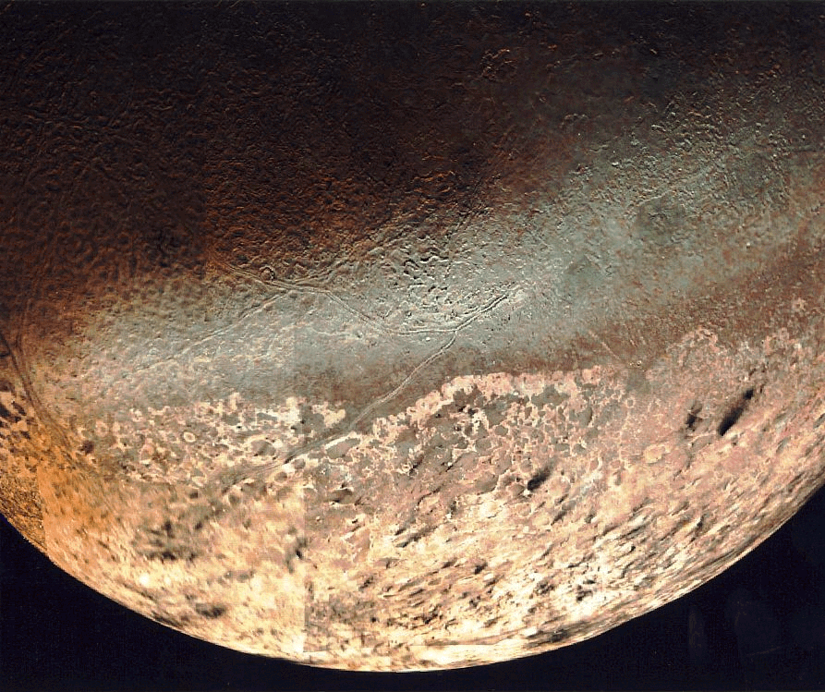

Photographs of Triton (right) showed regions of the surface were similar to that of a cantaloupe. Around the sunlit regions black streaks pointing in one direction mark the surface, the result of geyser activity. The geysers erupt nitrogen frost with some hydrocarbons that turn black due to solar ultraviolet radiation. The material is carried 8 km vertically and then abruptly blown downwind for 150 km. The sudden change in the direction of the material shows that there is a thin atmosphere on Triton. Observations showed the surface temperature of Triton is <42 K (-230°C), making Triton one of the coldest planetary bodies in our solar system. Useful information about Neptune and Triton is listed in Table 1.

Table 1 | Neptune | Triton
Orbit | 30 AU from Sun | 354,760 km from Neptune
Radius of object | 24,766 km | 1350 km
Mass | 1.0247 × 10²⁶ kg | 2.14 × 10²² kg
Period of revolution | 164.79 years | 5.877 days
Inclination of orbit | 1.774° | 157°
Eccentricity of orbit | 0.001 | 0

After the Voyager 2 encounter, advances in astronomical instruments and techniques have allowed astronomers to continue observing Neptune and Triton. Views from HST show the GDS has disappeared while the white cirrus clouds constantly come and go. Observations show the chemical composition and surface pressure on Triton has changed since the Voyager 2 flyby. The change supports the idea that Triton is changing as the southern hemisphere is starting a "major summer.''

Part I: Observations – Remote Use of Braeside Observatory

The Braeside telescope is a 16-inch telescope located in Flagstaff, AZ. At the end of the telescope where normally the eyepiece goes is an instrument called a CCD. A CCD, or Charged Coupled Device, converts the light that enters the telescope into the digital image. The CCD camera used on the Braeside telescope is called a SITe 512×512 CCD. This means that inside the CCD is a chip with 512×512 pixels. Each pixel is a light sensitive instrument that measures the amount of light falling on it. The plate scale for the camera is 0.858 ''/pixel. The CCD camera has several filters. Each filter selects out a region of light known as a passband. The filters are used to measure the color of astronomical objects such as stars and planets. If an object emits more light in the blue than in green (known as visual light) then the object will appear brighter in the B filter than in the V filter. The filter wheel has 8 slots open for filters that are described in Table 2.

Table 2 | Filter name | Wavelength (nm) | Description
#1 | Open | - | No filter
#2 | U | 365 ± 66 | Near ultraviolet
#3 | B | 445 ± 94 | Blue
#4 | V | 551 ± 88 | Visual
#5 | R | 658 ± 138 | Red
#6 | I | 806 ± 149 | Near infrared
#7 | Open | - | No filter
#8 | Open | - | No filter

Part II: Procedure

Tonight you will be using the Braeside telescope to observe Triton. The program "XBOBS'' (X-based Braeside OBserving System) was specifically written to operate the telescope, dome and camera.

Go to the region marked "Telescope Control'' and change the "Dome/Tel'' setting to "Auto Open'' to begin using the telescope. Use a star near Triton from the library of objects listed in "Catalogs,'' for example Fomalhaut. The RA and Dec of the object should appear in the respective windows in the "Target Acquisition and Pointing'' panel. Tell the telescope to "Go There'' by pressing the button in the same region. Take an exposure of less than 1 second. If the star is not centered in the field then press the "Recenter Image'' button, go to the window and press the mouse on the center of the star. This shifts the star into the center. Take another image to check the centering. Once the object is centered, reset the coordinates of the telescope by hitting "Reset Curr to Dest'' which will update the RA and Dec of the telescope.

If the star looks like a doughnut, then you will need to focus the telescope. Go to "Focus'' in the "Observing Interface'' panel and adjust the focus by short amounts, press "Set'' and take short exposures in between changes. If the star looks in focus, check the "seeing'' estimate of the field stars by pressing "Seeing Estimate'' in the image display panel. The seeing will decrease until you are at the best focus possible. Continue to get estimates of the seeing while you are observing. Record the focus and seeing estimate on the observers log sheet in the comments column (Table 3).

Once the above is all set, you will need to obtain 3 images of Triton in the B, V, \& R filters (9 images in total). Go to the Triton field by entering the provided RA and Dec in the target windows, press "Go There'' and obtain a 10-second exposure. Match the pattern of the stars in the frame with the provided finder chart. North is to the top, and east is to the right of the image. If you do not find Neptune in the first image you may need to move the telescope. Estimate the offset by using the provided finder chart and press the "N, S, E or W'' buttons to move the telescope small amounts. Take another short image when you think you have arrived at the right location. Neptune is likely to be the brightest image in the frame. Get Neptune/Triton close to the center of the frame by following the same centering procedure as above.

Once you have centered Neptune and Triton, set the filter wheel to B and obtain an exposure. Get an image where the counts inside Neptune are between 50,000-60,000. Check the counts for each image. You can check the number of counts by hitting the "Track'' button in the image window panel. The mouse position (x and y) and counts (flux) will be displayed while you are moving the mouse over the image. Click the right mouse button to automatically move the mouse to brightest local pixel. You must click the left mouse button to deactivate tracking before proceeding. You can zoom in the image by pressing the "Zoom'' button and clicking the left mouse button over the image which will open a window with greater magnification.

If the counts for Neptune are too low, for example 10,000 in 5 seconds, you can use the fact CCDs respond linearly, that is, if you want 60,000 counts, then extend your exposure time by a factor of 6 for an exposure time of 30 seconds. Images where the counts reach near 65,536 are no good and cannot be used in the reduction. These images are considered saturated, similar to an overexposed photograph. Finding a good exposure time may take several trials. If you cannot obtain the above range of counts before the image trails, then use the longest exposure time possible before trailing occurs. It is likely the counts for Triton will be around 1,000--2,000 before trailing is noticeable.

Note the approximate x, y coordinates of Triton for the usable images. Then repeat this process for the V and R filters. What differences do you notice in the images as the filters are changed? What changes do you have to make between filters for the observations. In which filter do these images look brightest? Faintest? Why do you think this is?

When you have finished obtaining data then return the telescope to its home position by selecting "Home'' in the "Telescope Control'' panel.

Part III: Analysis

To process the data you will use the Braeside Photometry Tool which was also specifically written for the telescope. Open this program in IDL by typing "photwid.''

In the upper left corner is a panel titled "Calibration and Image Files,'' you need to supply the file names for the flat field, bias, dark and image frame as well as the directory name if you are not running IDL in the directory where the data is located. Compile a median image of all the calibration files by hitting the "Compile Median'' button to the right of the file frame. You only need to compile medians once for the bias and dark, and once for each filter used for the flat. Before applying the calibration files to the image, you can display the image for inspection by hitting the "Display.'' Apply the calibration files by pressing the "Apply'' button which will automatically update the display window to the right. The small upper window is a zoomed in version of the larger window. You can change the region of interest by clicking the mouse button in the main display window. To the right of the three display windows are several regions. You can modify the maximum and minimum pixels displayed, and track the location of the cursor and the image value.

After proper calibration files have been applied, check the coordinates of Triton. Typically, you should assume the pixel with the highest counts is the center of the object. In the "Display Aperture'' panel, use the object's coordinates and estimate a radius (in pixels) for the object for which all the light from that object (and only that object) is contained. Draw the aperture. Is the aperture centered on the target? If not, why do you think this is so? You can draw as many apertures on the frame as you would like. If the frame gets too crowded with misplaced apertures, you can erase all of them by hitting "Refresh'' in the "Calibration and Image Files'' panel. Use the coordinates of the best fit aperture in the "Get Photometry'' panel.

If you are observing Triton on a night when the object is in front of or close to Neptune or either Neptune or Triton is close to a star, you will need to follow this discussion; otherwise, you may skip to the next paragraph. Since Triton orbits around Neptune, there will be some nights when Triton will be in front of or too close to Neptune to clearly draw an aperture around the two objects and there may be other nights when they are both close to a star. You will need to remove the offending object from the image by entering its coordinates into the "Remove Objects'' panel. The function approximates how stars and planets appear in the image and removes them. Since this function involves building a model image and subtracting that from the real image, trailed and out-of-focus images cannot be modeled well, resulting in a poor removal of the object. Because use of this function is time-consuming for the computer, only do this if necessary. Examine the results. Was the object removed successfully? Do you see any evidence that the object was there? If so, what does this look like? How might this affect your results?

Finally, use the coordinates for your object in the "Photometry'' panel. Use the same coordinates and radius as you used to display the aperture. In addition you will need to specify 2 radii far from the objects to obtain the amount of sky flux. The inner radius should be about 5 times larger than the aperture for the object. After these fields are set, hit "Apply'' to obtain the total flux from the object and sky. You will need to change flux to flux per second by dividing by your exposure time and then convert the flux per second into an instrumental magnitude by using the following equation:

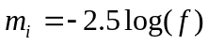

where f is the flux per second from the object and m_{i} is the instrumental magnitude.

Propagate the errors by doing the following:

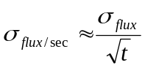

where σ_{flux} is that given by the program, and t is the exposure time.

Convert the errors in flux into an error in magnitude by doing the following:

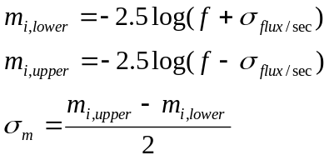

where σ_{m} is the error in the magnitude.

Examine your results. Why do you think makes this an instrumental magnitude and not just a magnitude? How do you think you can reduce the errors in the magnitude?

Getting Colors

Color is defined as the difference in magnitudes of the same object in two different filters. Let the instrumental visual magnitude be V, and the instrumental blue magnitude be B, thus the color of the object is defined as B-V. In astronomy it is always the bluer filter (shorter wavelength) magnitude minus the redder filter (longer wavelength) magnitude. A positive results means the object is red, and negative result means the object is blue. When comparing two observations, where for example, object A has a B-V=0.4, and object B has a B-V=0.8, then object B is said to be redder than object A (or A is bluer than B). Make such calculations using the instrumental magnitudes from above to continue the previous results given in Table 4.

Questions:

Be sure to address the commentary questions above as well as the following three questions in your lab report.

- What is the B-V color of Triton tonight? The V-R color? Make a plot of color vs. time for Triton. Compare your results to what is given in the lab (Table 4). Have there been any changes in the color of Triton? Do you see a trend?

- What is the resolving power of the telescope (HINT: Review the "Introduction to Telescope Lab'', if necessary). Compare this to tonight's "seeing.'' What differences do you see? What causes this difference?

- What are the angular sizes of Triton and Neptune? You may use the opposition distance of Neptune for the distance of the system. (HINT: Review the "Introduction to Telescope Lab'', if necessary). What can you say about the size of these objects compared to the "seeing?''

Bad Weather Alternative

In the event of bad weather, or cloudy skies, you should still be able to answer the questions posed using the data given in Table 4.

Table 3 – Observer's log sheet
Image # | Extension | Filter | Object | Exposure time | Comments | X | Y
1 | 022 | V | Triton | 30 s | Focus good, weather clear | 330 | 285

Table 4 – Previous results. The mean time is given in decimal days since October 14, 2001 0:00 UT. Universal time is always 7 hours ahead of MST.
Date | Time(UT) | Filter | Instrumental magnitude | Mean magnitude | Color | Mean time
10/14/2001 | 03:34:54 | B | -5.77 ± 0.06 | -5.75 ± 0.08 | (B-V) = 0.84 ± 0.10 | 0.15
 | 03:37:25 | B | -5.72 ± 0.06 | -5.75 ± 0.08 | (B-V) = 0.84 ± 0.10 | 0.15
 | 03:41:22 | V | -6.57 ± 0.04 | -6.59 ± 0.06 | (B-V) = 0.84 ± 0.10 | 0.15
 | 03:45:31 | V | -6.62 ± 0.04 | -6.59 ± 0.06 | (V-R) = 0.14 ± 0.08 | 0.16
 | 03:47:34 | R | -6.72 ± 0.04 | -6.73 ± 0.05 | (V-R) = 0.14 ± 0.08 | 0.16
 | 03:49:38 | R | -6.75 ± 0.04 | -6.73 ± 0.05 | (V-R) = 0.14 ± 0.08 | 0.16
10/19/2001 | 05:12:46 | B | -5.20 ± 0.09 | -5.24 ± 0.15 | (B-V) = 1.08 ± 0.16 | 5.22
 | 05:15:11 | B | -5.12 ± 0.09 | -5.24 ± 0.15 | (B-V) = 1.08 ± 0.16 | 5.22
 | 05:18:13 | B | -5.36 ± 0.08 | -5.24 ± 0.15 | (B-V) = 1.08 ± 0.16 | 5.22
 | 05:23:15 | V | -6.30 ± 0.05 | -6.33 ± 0.07 | (B-V) = 1.08 ± 0.16 | 5.22
 | 05:24:47 | V | -6.36 ± 0.05 | -6.33 ± 0.07 | (V-R) = 0.30 ± 0.09 | 5.23
 | 05:29:11 | R | -6.63 ± 0.04 | -6.64 ± 0.06 | (V-R) = 0.30 ± 0.09 | 5.23
 | 05:30:47 | R | -6.64 ± 0.04 | -6.64 ± 0.06 | (V-R) = 0.30 ± 0.09 | 5.23
10/29/2001 | 04:25:24 | B | -5.43 ± 0.10 | -4.94 ± 0.29 | (B-V) = 0.48 ± 0.56 | 15.19
 | 04:27:26 | B | -4.94 ± 0.16 | -4.94 ± 0.29 | (B-V) = 0.48 ± 0.56 | 15.19
 | 04:31:14 | B | -3.97 ± 0.43 | -4.94 ± 0.29 | (B-V) = 0.48 ± 0.56 | 15.19
 | 04:33:33 | V | -5.37 ± 0.25 | -5.41 ± 0.48 | (B-V) = 0.48 ± 0.56 | 15.19
 | 04:34:53 | V | -5.23 ± 0.28 | -5.41 ± 0.48 | (B-V) = 0.48 ± 0.56 | 15.19
 | 04:36:31 | V | -5.30 ± 0.25 | -5.41 ± 0.48 | (V-R) = 0.24 ± 0.51 | 15.19
 | 04:37:58 | V | -5.70 ± 0.16 | -5.41 ± 0.48 | (V-R) = 0.24 ± 0.51 | 15.19
 | 04:39:30 | R | -5.70 ± 0.11 | -5.66 ± 0.19 | (V-R) = 0.24 ± 0.51 | 15.19
 | 04:41:07 | R | -5.51 ± 0.13 | -5.66 ± 0.19 | (V-R) = 0.24 ± 0.51 | 15.19
 | 04:42:15 | R | -5.75 ± 0.10 | -5.66 ± 0.19 | (V-R) = 0.24 ± 0.51 | 15.19

