Triton Watch

What will you learn in this lab?

The Southwest Research Institute (SwRI) of Boulder, CO is observing Triton, a moon of Neptune, for sudden changes in color. Previous observations of Triton showed the moon suddenly turned red for a short period of time while over longer periods of time the moon became more blue. The reason for Triton's color change is currently unknown, but because of Triton's orbital inclination (157°) regions of Triton's southern hemisphere that have not been in sunlight for more than 350 years should change at the start of this "major summer.'' The time between Triton summers can be as short as 40 years, or as long as 350 years. A "major summer'' starts at the end of the 350 year period. As sunlight begins to warm these regions, material from the surface will sublimate into Triton's atmosphere, thus changing its color. SwRI's Triton Watch group is currently asking astronomers to obtain photometry (measurement of the properties of light, especially brightness) of Triton in hopes the moon will be "caught in the act.'' Tonight, we will use the Braeside telescope to observe Triton to obtain measurements of the color.

What do I need to bring to the Class with me to do this Lab?

- A copy of this lab script
- Pencil and eraser
- Scientific calculator
- Graph paper

Introduction:

Uranus was discovered in 1781 by British astronomer William Herschel. Uranus marked the first discovery of a planet too faint to be seen with the naked eye. Inconsistencies in the astrometry (the scientific measurement of the positions and motions of celestial bodies) of the predicted location and the observed location were noticeable several years later. Astronomers theorized that something massive was perturbing the motion of Uranus, evidence for an 8th planet. The position of the 8th planet was calculated and searched for by John Couch Adams in England and Urbain Leverrier in France. Neptune went undiscovered until German observer Johann Gottfried Galle found Neptune in its predicted location on September 23, 1846. By October 10 of that year, a 14th magnitude moon was discovered in orbit around Neptune. The moon was named Triton. Quickly, astronomers realized that Triton was not a regular moon because it orbited Neptune in a retrograde motion (Triton's orbital motion is opposite of the planet's). A second moon, Nereid, was not discovered until 1949. Nereid is much smaller in size and has a highly inclined and elliptical orbit around Neptune. After the discovery of rings around Uranus and Jupiter in the 1970's, astronomers theorized Neptune should also have rings. Several occultations (passage of a celestial body across a line between an observer and another celestial object, as when the Moon moves between Earth and the sun in a solar eclipse) of Neptune in the early 1980's showed Neptune had no rings, except for an occultation in 1984 showed evidence that Neptune's ring system was made of ring arcs or incomplete rings. Before Voyager 2 even the greatest telescopes on Earth could only show Neptune as a featureless blob of light, and Triton as a small dot.

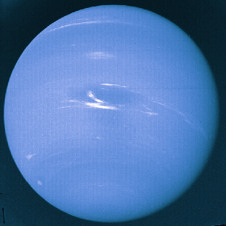
In 1989, Voyager 2 showed Neptune (left) as a large blue planet with giant storms; the largest was called the Great Dark Spot (GDS) similar to the Great Red Spot on Jupiter. Neptune also has small high level white cirrus clouds near the storms. Surrounding Neptune were four thin, complete rings and six more very small moons that have closer, more circular orbits.
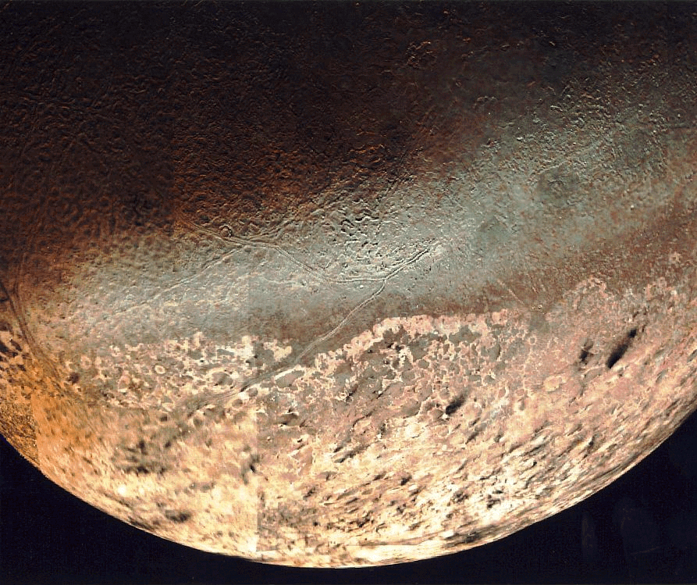

Photographs of Triton (right) showed regions of the surface were similar to that of a cantaloupe. Around the sunlit regions black streaks pointing in one direction mark the surface, the result of geyser activity. The geysers erupt nitrogen frost with some hydrocarbons that turn black due to solar ultraviolet radiation. The material is carried 8 km vertically and then abruptly blown downwind for 150 km. The sudden change in the direction of the material shows that there is a thin atmosphere on Triton. Observations showed the surface temperature of Triton is <42 K (-230°C), making Triton one of the coldest planetary bodies in our solar system. Useful information about Neptune and Triton is listed in Table 1.

Table 1 | Neptune | Triton
Orbit | 30 AU from Sun | 354,760 km from Neptune
Radius of object | 24,766 km | 1350 km
Mass | 1.0247 × 10²⁶ kg | 2.14 × 10²² kg
Period of revolution | 164.79 years | 5.877 days
Inclination of orbit | 1.774° | 157°
Eccentricity of orbit | 0.001 | 0

After the Voyager 2 encounter, advances in astronomical instruments and techniques have allowed astronomers to continue observing Neptune and Triton. Views from HST show the GDS has disappeared while the white cirrus clouds constantly come and go. Observations show the chemical composition and surface pressure on Triton has changed since the Voyager 2 flyby. The change supports the idea that Triton is changing as the southern hemisphere is starting a "major summer.''

Part I: Observations – Remote Use of Braeside Observatory

The Braeside telescope is a 16-inch telescope located in Flagstaff, AZ. At the end of the telescope where normally the eyepiece goes is an instrument called a CCD. A CCD, or Charged Coupled Device, converts the light that enters the telescope into the digital image. The CCD camera used on the Braeside telescope is called a SITe 512×512 CCD. This means that inside the CCD is a chip with 512×512 pixels. Each pixel is a light sensitive instrument that measures the amount of light falling on it. The plate scale for the camera is 0.858 ''/pixel. The CCD camera has several filters. Each filter selects out a region of light known as a passband. The filters are used to measure the color of astronomical objects such as stars and planets. If an object emits more light in the blue than in green (known as visual light) then the object will appear brighter in the B filter than in the V filter. The filter wheel has 8 slots open for filters that are described in Table 2.

Table 2 | Filter name | Wavelength (nm) | Description
#1 | Open | - | No filter
#2 | U | 365 ± 66 | Near ultraviolet
#3 | B | 445 ± 94 | Blue
#4 | V | 551 ± 88 | Visual
#5 | R | 658 ± 138 | Red
#6 | I | 806 ± 149 | Near infrared
#7 | Pinhole | - | No filter
#8 | Neutral density | - | No filter

Part II: Procedure

Tonight you will be using the Braeside telescope to observe Triton. The program "XBOBS'' (X-based Braeside OBserving System) was specifically written to operate the telescope, dome and camera.

Go to the region marked "Telescope Control'' and change the "Dome/Tel'' setting to "Auto Open'' to begin using the telescope. Use a star near Triton from the library of objects listed in "Catalogs.'' The RA and Dec of the object should appear in the respective windows in the "Target Acquisition and Pointing'' panel. Tell the telescope to "Go There'' by pressing the button in the same region. Take an exposure of less than 1 second. If the star is not centered in the field then press the "Recenter Image'' button, go to the window and press the mouse on the center of the star. This shifts the star into the center. Take another image to check the centering. Once the object is centered, reset the coordinates of the telescope by hitting "Reset Curr to Dest'' which will update the RA and Dec of the telescope.

If the star looks like a doughnut, then you will need to focus the telescope. Go to "Focus'' in the "Observing Interface'' panel and adjust the focus by short amounts, press "Set'' and take short exposures in between changes. If the star looks in focus, check the "seeing'' estimate of the field stars by pressing "Seeing Estimate'' in the image display panel. The seeing will decrease until you are at the best focus possible. Continue to get estimates of the seeing while you are observing. Record the focus and seeing estimate on the observers log sheet in the comments column (Table 3).

Once the above is all set, you will need to obtain 3-5 images of Triton in the B, V, and R filters (9-15 images in total). Go to the Triton field by entering the provided RA and Dec in the target windows, press "Go There'' and obtain a 10-second exposure. Match the pattern of the stars in the frame with the provided finder chart. North is to the top, and east is to the right of the image. If you do not find Neptune in the first image you may need to move the telescope. Estimate the offset by using the provided finder chart and press the "N, S, E or W'' buttons to move the telescope small amounts. Take another short image when you think you have arrived at the right location. Neptune is likely to be the brightest image in the frame. Get Neptune/Triton close to the center of the frame by following the same centering procedure as above.

Once you have centered Neptune and Triton, set the filter wheel to B and obtain an exposure. Get an image where the counts inside Neptune are between 50,000-60,000. Check the counts for each image. You can check the number of counts by hitting the "Track'' button in the image window panel. The mouse position (x and y) and counts (flux) will be displayed while you are moving the mouse over the image. Click the right mouse button to automatically move the mouse to brightest local pixel. You must click the left mouse button to deactivate tracking before proceeding. You can zoom in the image by pressing the "Zoom'' button and clicking the left mouse button over the image which will open a window with greater magnification.

If the counts for Neptune are too low, for example 10,000 in 5 seconds, you can use the fact CCDs respond linearly, that is, if you want 60,000 counts, then extend your exposure time by a factor of 6 for an exposure time of 30 seconds. Images where the counts reach near 65,536 are no good and cannot be used in the reduction. These images are considered saturated, similar to an overexposed photograph. Finding a good exposure time may take several trials. If you cannot obtain the above range of counts before the image trails, then use the longest exposure time possible before trailing occurs. It is likely the counts for Triton will be around 1,000-2,000 before trailing is noticeable.

Note the approximate x, y coordinates of Triton for the usable images. Then repeat this process for the V and R filters. What differences do you notice in the images as the filters are changed? What changes do you have to make between filters for the observations. In which filter do these images look brightest? Faintest? Why do you think this is?

When you have finished obtaining data then return the telescope to its home position by selecting "Home'' in the "Telescope Control'' panel.

Part III: Analysis

To process the data you will use the Braeside Photometry Tool that was also specifically written for the telescope. Open this program in IDL by typing "photwid, /lab'' at the IDL prompt.

In the upper left corner is a region titled "Image File.'' You need to supply the file names for your images in the "Image:'' field. You can find the files by hitting the "Browse'' button and going to the specified directory where the files you acquired are located. In the row below the "Image file" and "Browse" buttons are two option buttons. The first, "Sky Opt:'' determines the method used to calculate the brightness of the sky. The default, "Calc'', is for the program to calculate the brightness, which is what you should use. The second option, "Norm'', is the normalization. The files are normalized by the exposure time, that is, a 30 second exposure has been divided by 30 so the flux seen is in counts/sec and one can directly compare results of different exposure lengths. The next row is the "Set/Calc Val:'', which, if the sky option above is set to "calculate" (by default), will be filled with the value for the sky brightness and an error bar in units of flux. By pressing the "Apply'' button, the specified image will be opened and displayed in the large window to the right. The smaller windows at the bottom show a zoomed-in version (left) and full version (right) of the image. You can change the region of interest in the zoom window by clicking the mouse button in the main display window. Below the "Apply'' button are two fields for the displayed maximum and minimum that become active when the image is opened. You can change the range of the display by modifying the maximum and minimum fields and hitting "Apply Stretch.'' Next to this is a button marked "Print Image.'' Select a good image to print and include in your report. Discuss what you see in the image.
Under the heading "Photometry Input'' are several buttons and fields that will be used to specify your photometry parameters. First, if you hit the "Set Obj. Pos.'' then you must go to the window and click on the center and outer radius of the object. Once this is done a circle (the aperture) will appear around the target. If you are unsatisfied with the aperture, you may specify the x, y location and radius by filling in the fields below the button and clicking on "Draw Aperture.'' In addition to the target location, you must also specify the sky location. Here you have two options. At the button marked "Measure Sky:", you can specify to measure the sky brightness at a new location where there are few stars ("New Sky Pos.'') or centered at the target location ("Sky Near Obj.''). Once you have selected the function, you again must go to the window and click on the locations for the sky region. In addition, the outer radius of the sky region cannot exceed 100 pixels. Each function should give similar results, so you may want to try both of them for consistency. Illustrate the typical radius or range in radii used for Triton on your printed image. Also mark the location where your estimates for the sky come from. Discuss why you picked this region. The regions marked "Center:'' and "Radii:'' will be filled once you have specified the sky region. You may also manually specify the regions by supplying the values in those fields and hitting draw to mark the region. All apertures can be removed by hitting the "Refresh'' button and desired apertures can be redrawn with the two draw buttons. Below these fields are two option lists. First is the "Method'' used for the photometry. This should be set to "Std.'' to follow the standard method. Next you must specify the units the results will be displayed in. If it is set to "Flux'' then you will need to convert the values into magnitudes (m = -2.5 log(f)). If set to "Mag'' the results are in magnitudes. (Note: You cannot add magnitudes. You can only add fluxes.)

Once the parameters are set, press the "Apply Photometry'' button to obtain the magnitude of the object and sky. The results will appear in the "Object'' and "Sky'' fields. If this is done in flux units, then the value for the sky should be around zero (since it was subtracted earlier). You do this as a check to see the sky was not over-subtracted, resulting in a negative sky value. (Note: Negative values for the sky in magnitude units will result in the error "NAN".) If you are unfamiliar with the magnitude system, you should review p. 24 of the Audobon Field Guide.

The information you obtain can be written to a file by using the field marked "File:'' to the right of the "Sky'' field. You are free to make up the name of the file, but make sure it has the suffix ".dat'' at the end. You can examine and edit the information that goes into the file by pressing the "Edit File Info'' button. The useful fields are set by default. Each time you have results you wish to save to the file, you must press the "Add Line'' button. Unfavorable lines that happen to be saved cannot be deleted. You will have to denote this in your lab report. When you are done you can hit the "Save File'' button to save it and then print the file with the "Print File'' button. Use these results in your report.

Getting Colors

Color is defined as the difference in magnitudes of the same object in two different filters. Let the instrumental visual magnitude be V, and the instrumental blue magnitude be B, thus the color of the object is defined as B-V. In astronomy it is always the bluer filter (shorter wavelength) magnitude minus the redder filter (longer wavelength) magnitude. A positive results means the object is red, and negative result means the object is blue. When comparing two observations, where for example, object A has a B-V=0.4, and object B has a B-V=0.8, then object B is said to be redder than object A (or A is bluer than B). Make such calculations using the instrumental magnitudes from above to continue the previous results given in Table 4.

Questions:

Be sure to address the commentary questions above as well as the following three questions in your lab report.

- What is the B-V color of Triton tonight? The V-R color? Make a plot of color vs. observed longitude for Triton. Compare your results to what is given in the lab (Table 4). Have there been any changes in the color of Triton? Do you see a trend? Do any of the data points suggest a color change?

- What is the resolving power of the telescope (HINT: Review the "Introduction to Telescope Lab'', if necessary). Compare this to tonight's "seeing.'' What differences do you see? What causes this difference?

- What are the angular sizes of Triton and Neptune? You may use the opposition distance of Neptune for the distance of the system. (HINT: Review the "Introduction to Telescope Lab'', if necessary). What can you say about the size of these objects compared to the "seeing?''

Bad Weather Alternative

In the event of bad weather, or cloudy skies, you should still be able to answer the questions posed using the data given in Table 4 and provided data from a previous night.

Table 3 – Observer's log sheet
Image # | Extension | Filter | Object | Exposure time | Comments | X | Y
1 | 022 | V | Triton | 30 s | Focus good, weather clear | 330 | 285

Table 4: Previous Observations of the Colors of Triton
Date | B-V | B-V error (±) | V-R | V-R error (±) | Observed Longitude (°)
2002/05/21 | 0.942 | 0.035 | 0.098 | 0.025 | 123
2002/05/23 | 0.970 | 0.025 | 0.202 | 0.020
2002/05/24 | 1.066 | 0.026 | 0.304 | 0.018 | 300
2002/05/28 | 1.004 | 0.015 | 0.310 | 0.008 | 55
2002/06/08 | 1.018 | 0.014 | 0.735 | 0.012 | 103
2002/06/11 | 0.955 | 0.013 | 0.289 | 0.010 | 279
2002/06/12 | 0.909 | 0.008 | 0.143 | 0.006 | 218
2002/06/18 | 0.920 | 0.007 | 0.134 | 0.005 | 211
2002/06/19 | 0.901 | 0.006 | 0.203 | 0.005 | 150
2002/06/21 | 0.980 | 0.025 | 0.201 | 0.018 | 29
2002/10/08 | 0.980 | 0.034 | 0.227 | 0.025 | 205
2002/10/09 | 0.948 | 0.009 | 0.200 | 0.007 | 145
2002/10/10 | 1.133 | 0.011 | 0.109 | 0.007 | 85
2002/10/11 | 1.027 | 0.016 | 0.273 | 0.012 | 24
2002/10/17 | 1.055 | 0.013 | 0.165 | 0.010 | 20

