**NAME:_______________________**

**Coordinate Systems**

**What will you learn in this Lab?**

This lab is designed to introduce you to some of the coordinate systems used by astronomers. The coordinate systems to be introduced are Longitude and Latitude, Horizon Coordinate System, Equatorial Coordinate System and the Ecliptic Coordinate System.

**What do I need to bring to the Class with me to do this Lab?**

For this lab you will need:

* A copy of this lab script
* A pencil
* SC 001/002 star charts
* Audubon Guide
* Star Wheel
* Red Flashlight

# I. Introduction:

This lab is introduces some of the coordinate systems used by astronomers. First, we will review the coordinate system used here on the Earth, using longitude and latitude. Then, we will investigate two of the coordinate systems applied to astronomical maps. The coordinate systems to be introduced are: (1) the Horizon Coordinate System, measuring the sky in altitude and azimuth from the location of the observer; and (2) the Equatorial Coordinate System, measuring the right ascension and declination coordinates fixed to the stars.

# II. Maps of the Earth:

As a starting point for finding your way in the night sky, we first review maps of the Earth and how they were established. A coordinate reference frame is essential so that the location of remote places can be identified, such as islands at sea, cities, towns, mountain tops, etc. On the Earth the coordinate system employs **latitude** and **longitude**.

## Latitude:

Latitude is measured in *degrees*, *arcminutes* and *arcseconds*, *north* or *south* of the Earth’s Equator. The zero point in latitude is naturally established by how the Earth rotates on its axis. The Earth’s Equator is at a latitude of 0º, while the north pole is at a latitude of 90º N (aka +90º). Similarly, the south pole is at a latitude of 90º S (aka -90º). Tempe, Arizona is at a latitude of +33º.

## Longitude:

Longitude is also measured in *degrees*, *arcminutes* and *arcseconds*, but unlike latitude there is no natural or physical characteristic of the Earth from which to set the zero point in longitude. As a result of global navigation, and what is now history, the British established a zero point in longitude in Greenwich, England at the Greenwich Royal Observatory.

The Royal Observatory at Greenwich was established along the Thames River in 1676 for purposes of worldwide navigation. A ship’s navigator on the Thames checked the time from clocks at the Royal Observatory as the ship set out to sea. While out at sea, the navigator measured the position of the sun at noon (according to the shipboard clock). For a westward-moving ship, the navigator calculated the angular distance between the sun (to the east) and the local meridian[1] at noon to determine the ship’s longitude west of Greenwich.

Historically various countries established their own zero point of longitude, which is given the name: zero meridian. National observatories were established in Paris, London, Berlin, Leningrad, Madrid, and other major capitols with the purpose of determining longitude. By 1889, through international agreement, most countries adopted the *Greenwich Meridian* as a standard of longitude.

# III. Maps of the Sky: Horizon Coordinate System

Before introducing the principal celestial coordinate system, it is useful to discuss a more local coordinate system. This coordinate system is *established with natural reference to the observer and his/her location* and has two coordinates – both measured in *degrees*, *arcminutes* and *arcseconds*.

## Azimuth:

Azimuth is the angular distance measured along the horizon from 0º to 360º, just like a clock. An azimuth of 90º corresponds to the east point on the horizon (3 o’clock), while 270º points towards the west point on the horizon (9 o’clock).

## Altitude:

Altitude is measured as an angular distance from the horizon toward the point directly overhead, called the ***zenith***. Thus the zenith is at an altitude of 90º, whereas the horizon is at an altitude of 0º. Since we cannot use linear dimensions on the sky, all positions must be measured as angles.



**Figure 1**

## Estimating Distances

You can use your hands to estimate angular distances in the sky. Make your hand into a fist, and hold it far away from your body, toward the sky. The angular distance your hand spans on the sky is about 10º. So, if a star appears just to the left side of your fist and another star appears just to the right of your fist, those stars are approximates 10º angular distance from each other on the sky. Here are some other distance estimates which may help you in tonight’s lab[2]:

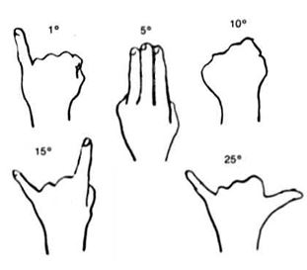

**Figure 2**

## Changing Locations

Unfortunately, we cannot use altitude and azimuth coordinates to find the same object in the sky every night. The Earth rotates on its axis and revolves around the Sun, and consequently, we cannot map positions on the sky as simply as we would map positions on the Earth. Since the Earth gradually orbits around the Sun, the direction that we look out from the Earth into the night sky gradually shifts day by day, changing by about 1º per day. This corresponds to about 4 minutes of time. In the course of a year, the Earth moves through 360º. Most of the newly built large telescopes use this system for pointing and use fast computers to make sure the telescope moves in the correct direction at the correct rate of motion.

It is all about the *reference point* of the coordinate system. In the Horizon System, the observer is the reference point. The position of the sky changes with respect to the observer, so the location of the stars in altitude and azimuth also changes.

# IV. Maps of the Sky: Equatorial Coordinate System

Unlike the Horizon Coordinate System, which is established by the reference point of the observer, the **Equatorial Coordinate System** is fixed to the stars. As an extension of our Earth-based coordinate system, the Equatorial Coordinate System is a similar set of coordinates on the sky. The **Celestial Equator** is a projection of the Earth’s equator onto the sky, but where the Earth’s equator is fixed to the Earth, the Celestial equator if fixed to the stars. Similarly, directly above the Earth’s north pole is the **north celestial pole** (NCP), while directly “below” the Earth’s south pole is the **south celestial pole** (SCP). The celestial coordinates that are analogous to latitude and longitude (on Earth) are called declination and right ascension (on the sky).

## Declination (Dec)

Declination (**Dec**) is similar to the Earth-based system of latitude. Like latitude, Dec is measured in *degrees*, *arcminutes* and *arcseconds*, *north* or *south* of the Celestial equator. The Celestial equator is at a declination of 0º, while the north celestial pole (Polaris!) is at a declination of 90º N (aka +90º). Similarly, the south celestial pole is at a declination of 90º S (aka -90º). In Tempe, Arizona, if you were to point to your zenith, you would be pointing to a declination of +33º on the sky.

## Right Ascension (RA)

Right ascension **(RA)** is measured in units of time: *hours*, *minutes* and *seconds*. RA is measured in an eastward direction, starting at 0 hrs and going through a full circle to 24 hrs. In 1 hr of time, the sky moves through 1 hr of right ascension. Similarly, in 4 min of time the sky moves through 4 min of RA. On the celestial equator, 4 min of RA corresponds to a 1º movement of the sky. Similarly, 1 hr of RA corresponds to a 15º movement of the sky, and 24 hrs of RA corresponds to a full 360º rotation of the Earth when measured at the celestial equator.

The zero point of RA is established by the point where the **Ecliptic**[3] crosses the celestial equator. Because the Earth is tilted with respect to the Sun, the Sun does not to follow a straight path through the sky. Instead, it moves northward from December to June and southward from June back to December. In June, the Sun reaches a Dec of +23.5º (the Tropic of Cancer). In December, the Sun reaches a Dec of -23.5º (the Tropic of Capricorn). On March 21st (the spring equinox) and September 21st (the fall equinox), the Sun passes over the Celestial equator, where the declination is 0º. We define the zero point of right ascension as the point in the sky where the Sun crosses the Celestial equator in the spring – when the Sun crosses the celestial equator moving northward.

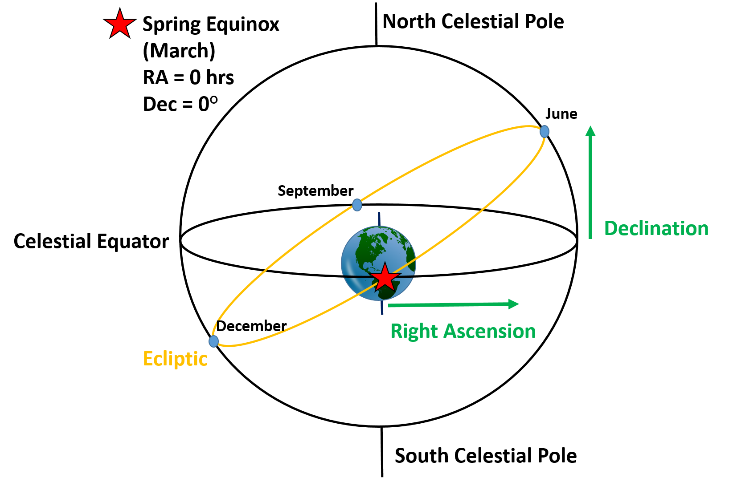

**Figure 3**

## Fixed Locations

Because RA and Dec are coordinates fixed to the sky, stars and other distant objects will keep their location in right ascension and declination throughout the year (just like we stay at the same latitude and longitude here in Tempe). Take, for example, the star Betelgeuse, in the Orion constellation. Betelgeuse has Equatorial coordinates of approximately (RA = 6h and Dec = +7.5°). Because Equatorial coordinates are fixed to the stars, Betelgeuse will always have these coordinates. The RA and Dec of the stars do NOT change throughout the year. This is different from the Horizon System, where the altitude and azimuth of the stars will change over the course of the night. This difference is inherently a question of *reference point*. In the Equatorial Coordinate System, the coordinates are fixed *relative to the stars*. While our view of the stars may change over the course of the night or over the course of the year, the location of those stars in the sky remain fixed with respect to the other stars. This means that the right ascension and declination of the stars will also stay fixed throughout the year!

# V. The Experiment: Outdoor Observations

## Marston Theater – 3D Planetarium

During this lab, we will visit the **Marston Theater** in Interdisciplinary Building IV (ISTB4). The Marston Theater is ASU’s 3D Planetarium Theater, and the wonderful folks who run the planetarium will explain these coordinate systems by drawing critical lines and axes on the virtual 3D sky for you to visualize. Then you can hold these in your mind’s eye when you subsequently look at the night sky outside.

## Part 1: Observing Stars in the Horizon Coordinate System

Page 11 has a table in which you should record your observations.

There are a variety of methods to measure the altitude and azimuth of stars and distant objects. In this lab, you will use a protractor and a plumb-bob to measure altitudes and knowledgeable estimation to measure the azimuths. (Remember that you can make estimates using your hands!)

* With one of the protractors, look along the long flat edge of the protractor and line it up with the object that you are looking at. Hold down the location of the string and read off the larger angle given by the protractor – **THEN SUBTRACT 90o**, this will be the altitude of the object.

Note: You CANNOT use the protractor to measure altitudes greater than 90°, and you MUST read the larger angle.

* Record the name of the object, the time of the observation, and the measured altitude in the table on page 11.
* The method to measure azimuth takes advantage of the fact that you already know the specific azimuths of the 4 cardinal directions. First, locate due north (which is 0o), then locate the point on the horizon directly below the object you are interested in. From this point, use your hands to estimate the azimuthal angle of your star. For example, if the position directly below the star is two hand-widths eastward of due north, then the azimuth is 50°. Remember that north is 0° azimuth; east is 90° azimuth; south is 180° azimuth; and west is 270° azimuth.

Alternate clock method: If you prefer, you can use the “clock method” of determining your azimuth. In this method, north is 0° or 12 o’clock. Locate the point on the horizon directly below the object you are interested in. What “time” your object is closest to, to the nearest “hour”? Multiply that number by 30o and that is your azimuth. (Example: A star looks to be at 4 o’clock from due north, so the azimuth is 120o).

* Record the azimuth of the object in the table on page 11.
* **Repeat!** Measure the altitude and azimuth of several more objects in the sky, until you have the Horizon Coordinate System measurement for 5-10 bright objects (the number of objects will be determined by your TA).
* The **meridian** is an imaginary line passing from the North Pole to South Pole through your zenith. Any star at your zenith is also on the meridian. On your table, use an asterisk (*) to markthe stars near the meridian.

1. The altitude and azimuth of your observed objects will change over the course of the night. Why is this?

* In the table on page 11, predict the movement of your objects. Mark whether you think the altitude and azimuth will increase, decrease, or stay the same.

1. Which stars will change their position most – ones near the Celestial equator or ones near the pole? Explain.

## Part 2: Finding Stars in the Equatorial Coordinate System

Inside of the classroom, using your SC charts, determine the right ascension and declination for each of the stars you observed.

Record the RAs and Decs for each of these stars in the table on page 11.

1. Will the RAs and Decs of your observed objects change tonight? Why or why not?
2. Now we’re going to think about how much a star will move in a given time and why RA has units of time. Choose a star that was near your meridian.
   1. What is the **RA** of this star to the nearest **hour**? At what **time** did you make your observation to the nearest **half hour**?
   2. At what time will the star move to a position 45° away from the meridian? *Hint: Remember that 1hr of RA is equal to 15° on the sky.*
   3. At this new time, what will be the RA of the stars now at the meridian? How did you determine your answer?
   4. In 5 more hours, what will be the RA of the stars at the meridian? How far (to the nearest degree) will your original star be from the meridian at this point in time?

On your long star chart, you will notice a sinusoidal (curvy) line going through the middle. This is the **ecliptic**, which traces out the path of the Sun through the course of the year. Unlike the other stars in the sky, which are far away, the Sun is not at a fixed position in the Equatorial Coordinate System. Because the Sun is closer to us than the stars, its movement is faster, and the Sun’s position in RA and Dec changes throughout the year. Look at the Sun’s path through the star chart and answer the following questions in complete sentences.

1. How many RA-hours does the Sun travel through per year?
2. By how many RA-mins does the position of the Sun change per day? *Hint: Take the previous answer and convert (calculation)*
3. Why are the Moon and planets not located on the SC charts or star wheel? That they are not stars is NOT an answer!
4. What is the RA and Dec of the Sun at the time of the spring equinox? During the fall equinox?
5. What is the RA and Dec of the Sun at the time of the summer solstice? During the winter solstice?
6. **Zodiacal constellations** are constellations along the ecliptic, near the path of the Sun. What was the zodiacal constellation on the meridian at 8 pm tonight? *Hint: You may find your star wheel helpful.*

## Part III: Observing Stars (Again!) in the Horizon Coordinate System

An hour after your first observation, measure the altitudes and azimuths of the same 5-10 stars you measured earlier. Record these measurements in the table.

1. How well did your new altitudes and azimuths follow your predictions? If there were stars whose altitude or azimuth changed in a way you did not predict, explain what happened to cause this movement. If all the stars followed the path you expected, explain how you were able to accurately predict their movement.

# VI. Conclusion:

Summarize the concepts you learned about in tonight’s lab. What did you learn about each of these concept? Summarize the experiment. How did this experiment help you understanding of the concepts?

|  |  |  |  |  |  |  |  |  |  |
| --- | --- | --- | --- | --- | --- | --- | --- | --- | --- |
| **2nd Obs. Time:** | **Az(2)** |  |  |  |  |  |  |  |  |
| **Alt(2)** |  |  |  |  |  |  |  |  |
|  | **DEC** |  |  |  |  |  |  |  |  |
|  | **RA** |  |  |  |  |  |  |  |  |
| **Predicted Movement** | **Az** |  |  |  |  |  |  |  |  |
| **Alt** |  |  |  |  |  |  |  |  |
| **1st Obs. Time:** | **Az(1)** |  |  |  |  |  |  |  |  |
| **Alt(1)** |  |  |  |  |  |  |  |  |
|  | **Object** | 1. | 2. | 3. | 4. | 5. | 6. | 7. | 8. |

# V. The Experiment: Indoor Alternative

## Marston Theater – 3D Planetarium

During this lab, we will visit the **Marston Theater** in Interdisciplinary Building IV (ISTB4). The Marston Theater is ASU’s 3D Planetarium Theater, and the wonderful folks who run the planetarium will explain these coordinate systems by drawing critical lines and axes on the virtual 3D sky for you to visualize.

## Part 1: Horizon Coordinate System

Answer the following questions about the Horizon Coordinate System.

1. The altitude and azimuth of the stars will change over the course of the night. Why is this?
2. In the table below, we have listed the altitude and azimuth of several made-up stars. Assume these observations were made at 8pm tonight. For each of the stars below, state whether the altitude and azimuth will increase, decrease, or stay the same if we were to measure them again at 10pm. *Hint: They may not all be the same! How each coordinate changes depends on where the object began.*

|  |  |  |  |  |
| --- | --- | --- | --- | --- |
|  | **Measured Coordinates** | | **Predicted Change (Increase, Decrease, Same)** | |
| **Star** | **Alt** | **Az** | **Alt** | **Az** |
| **A** | 45° | 90° |  |  |
| **B** | 45° | 270° |  |  |
| **C** | 33° | 0° |  |  |
| **D** | 33° | 180° |  |  |
| **E** | 0° | 45° |  |  |
| **F** | 10° | 330° |  |  |
| **G** | 80° | 120° |  |  |
| **H** | 5° | 230° |  |  |

1. For the stars in the table above, justify why you chose increase, decrease, or stay the same for each of these stars.
2. Looking at the stars in the chart above, will these measured value for altitude and azimuth be the same from another location on Earth? Why or why not? At what latitude on Earth would you need to be to see each of these stars at the zenith?
3. Which stars will change their position most – ones near the Celestial equator or ones near the pole? Explain.

## Part 2: Equatorial Coordinate System

Your TA will give you the name of 5-10 stars or objects in the sky. Using your SC charts, determine the right ascension and declination for each of these objects.

Record the RAs and Decs for each of these stars in the table on page 11.

1. Will the RAs and Decs of these objects change over the course of a night? Over the course of a year? Why or why not?
2. The **meridian** is an imaginary line passing from the North Pole to the South Pole through your zenith. By this definition, any star at your zenith is also on the meridian. On your star wheel, the meridian can be found by drawing an imaginary line connecting the north and south directions of your chart. Use your star wheel and find a bright star near the meridian tonight at 8pm.
   1. What is the RA of this star to the nearest **hour**?
   2. At what time will the star move to a position 45° away from the meridian? *Hint: Remember that 1hr of RA is equal to 15° on the sky.*
   3. At this new time, what will be the RA of the stars at the meridian? How did you determine your answer?
   4. In 5 more hours, what will be the RA of the stars at the meridian? How far (to the nearest degree) will your original star be from the meridian at this point in time?
3. Consider Hercules and Ophiuchus. Both constellations have an RA approximately equal to 17 hr. Hercules has a declination of about +30°, while Ophiucus has a declination of about 0°. Which of these constellations will get closer to the zenith in Tempe? How do you know?

On your long star chart, you will notice a sinusoidal (curvy) line going through the middle. This is the **ecliptic**, which traces out the path of the Sun through the course of the year. Unlike the other stars in the sky, which are far away, the Sun is not at a fixed position in the Equatorial Coordinate System. Because the Sun is closer to us than the stars, its movement is faster, and the Sun’s position in RA and Dec changes throughout the year. Look at the Sun’s path through the star chart and answer the following questions in complete sentences.

1. How many RA-hours does the Sun travel through per year?
2. By how many RA-mins does the position of the Sun change per day? *Hint: Take the previous answer and convert (calculation)*
3. Why are the Moon and planets not located on the SC charts or star wheel? That they are not stars is NOT an answer!
4. What is the RA and Dec of the Sun at the time of the spring equinox? During the fall equinox?
5. What is the RA and Dec of the Sun at the time of the summer solstice? During the winter solstice?
6. **Zodiacal constellations** are constellations along the ecliptic, near the path of the Sun. What was the zodiacal constellation on the meridian at 8 pm tonight? *Hint: You may find your star wheel helpful.*

## Part III: All Together!

In the space below, draw a dome like that shown in Figure 1 to represent the view from here in Tempe.

* Label the cardinal directions (N,E,S,W)
* Mark the position of Polaris. *Hint: Tempe’s latitude is +33°.*
* Draw the Celestial equator onto your dome. Draw a star on your Celestial equator.
* Think about how the stars will move over the course of the night. Mark this direction with an arrow.
* Circle which star (Polaris or the star on the Celestial equator) which moves the *least* over the course of the night.
* Box which star (Polaris or the star on the Celestial equator) which moves the *most* over the course of the night.

1. Which coordinate system uses the *observer* as the reference point? Do the coordinates of the stars change over the course of a night in this system?
2. Which coordinate system uses the *stars* as the reference point? Do the coordinates of the stars change over the course of the night in this system?

# VI. Conclusion:

Summarize the concepts you learned about in tonight’s lab. What did you learn about each of these concept? Summarize the experiment. How did this experiment you’re your understanding of the concepts?

1. A meridian is a circle on the Earth’s surface that has its center at the center of the Earth and passes through the north and south poles.
2. This image borrowed from the One Minute Astronomer.   
   <http://oneminuteastronomer.com/860/measuring-sky/>
3. The ecliptic is the apparent path of the Sun, Moon, and planets as seen from the Earth. In another sense, the ecliptic is the path of the Earth’s orbit projected onto the sky. The orbits of the Earth and most of the other planets move in a relatively flat plane around the Sun.