**Exploring Impact cratering**

**What will you learn in this Lab?**

There are four major geologic processes that affect planetary surfaces – impact cratering, volcanism, tectonics, and erosion. Impact cratering is the most pervasive surface process on all planetary bodies. In this lab, you will:

* Investigate the processes that shape airless world surfaces
* Investigate how craters are formed
* Correlate the size of craters with impactor properties, including impactor mass and velocity
* Quantify the age of lunar surfaces based on crater counts
* Relate early solar system formation processes to modern cratered surfaces
* Identify the differences between the Moon and Mercury in regard to cratering

**What do I need to bring to the Class with me to do this Lab?**

For this lab you will need:

* A copy of this lab script
* A computer with internet access
* A scientific calculator

# I. Introduction

Impact cratering occurs when a planetesimal - usually debris from a comet, asteroid, or meteoroid - crashes into the surface of a terrestrial body (solid surfaced planets). Throughout the solar system's history, planetesimals have heavily bombarded all the terrestrial bodies. On Earth, and even Venus and Mars, erosion, volcanic resurfacing, and tectonic activity continually erase craters, leaving very few large craters left on the surface. However, the Moon and Mercury have not erased this bombardment because the other geologic processes on these bodies stopped millions of years ago. In this lab, we investigate the different type of craters, how they form, and what we can learn from them.

# II. Impact Craters

## Crater Basics

After a planetesimal impacts the surface of a terrestrial body, a crater is left behind. The original projectile vaporizes on impact due to tremendous pressures and temperatures involved with the impact. The typical speed at which a projectile hits a planetary body is 10 to 30 km/s. That’s 22,000 to 67,000 MPH! This produces a crater that is 10 to 20 times larger in diameter than the physical size of the impacting object. The shape of the crater is usually circular, but if the impact is at an oblique angle, the crater is asymmetric and usually oval.

Some terminology:

Debris from the blast, called **ejecta**, is deposited in the area surrounding the crater. Close to the crater, the ejecta typically forms a thick, continuous layer, while at larger distances the ejecta may fall as discontinuous clumps of material. When large ejected blocks fall back down to the surface, they may form secondary craters or secondary impacts. Ejecta that disrupt the surface to create long, bright streaks or lines that radiate from a crater are called rays.

Rocks that are formed from other rock fragments cemented together by the high pressure and temperature of impact or the inclusion of impact melt are called **breccias**.

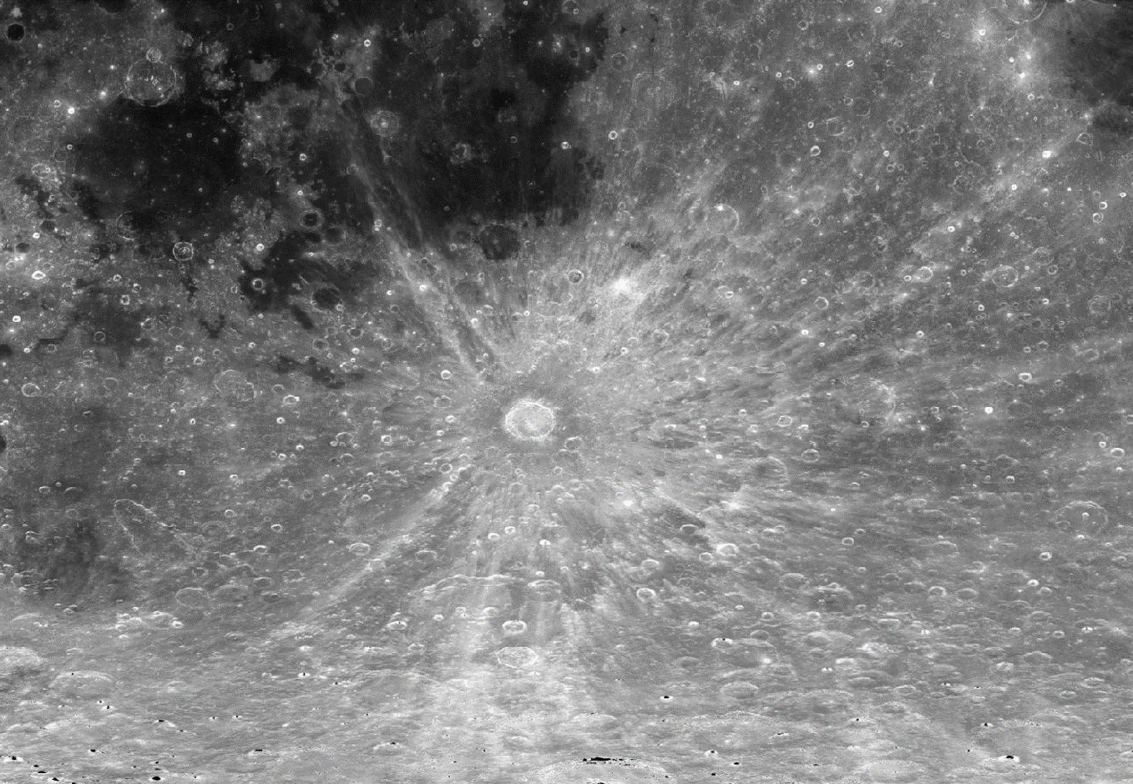

**Figure 1:** Shows an example of a crater on the Moon showing rays. The crater at the center of the image, where the rays appear to originate, is named Tycho. See Figure 4 for a more detailed image of the same crater. This image was taken by the Lunar Reconnaissance Orbiter Camera (LROC) onboard the Lunar Reconnaissance Orbiter. Image Credit: NASA Goddard Space Flight Center/Arizona State University.

## Crater Types

There are three different kinds of craters: simple craters, complex craters, and multi-ring basins.

Simple craters are bowl shaped depressions and are formed by small sized impactors.

Complex craters typically have shallow, relatively flat floors, central uplifts, and terraces on the inner wall of the crater. Central peaks are formed from a rebound (uplift) of material and a subsequent collapse back into the crater floor. As impactors get larger, the uplift can become more extensive, creating a second class of complex crater – those with **peak rings**. These have a characteristic ring of mountains on the crater floor.

Multi-ring basins are the third and largest class of crater. These are the result of very high-energy impacts.

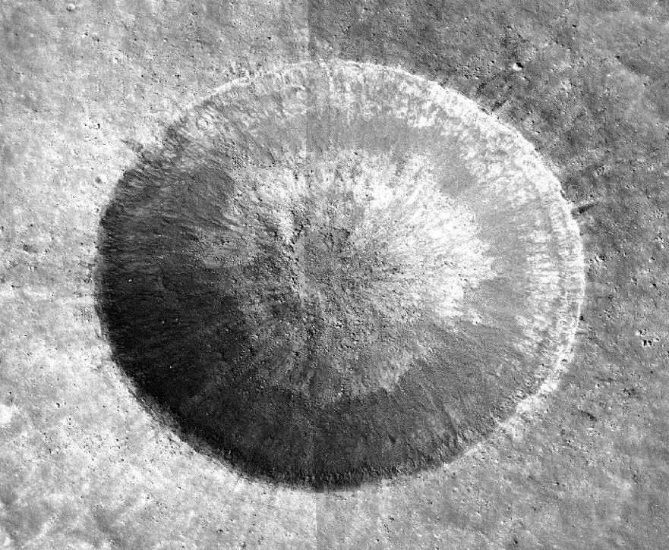

**Figure 2:** Example of a simple crater on the Moon. This crater is named Linné and it is ~2 km in diameter. Notice the sharp rims and the bowl shaped depression. This image was also taken by LROC. Image Credit: NASA Goddard Space Flight Center/Arizona State University.

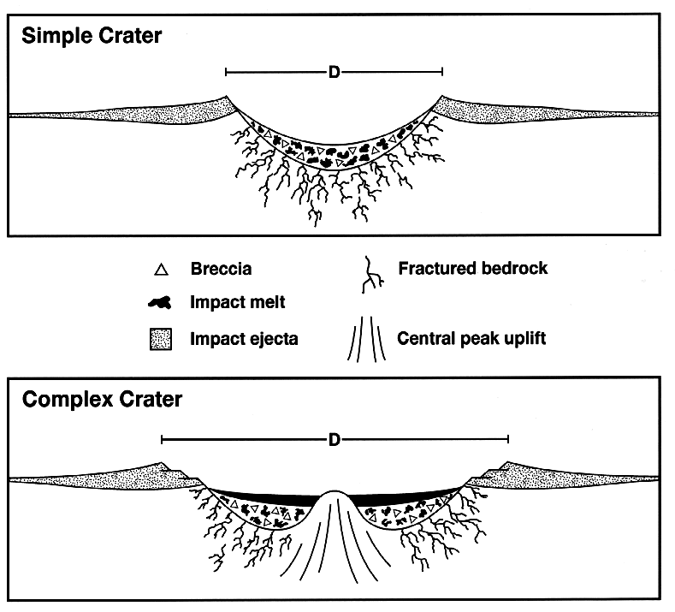

Figure 3: Cross-section of a simple and complex crater

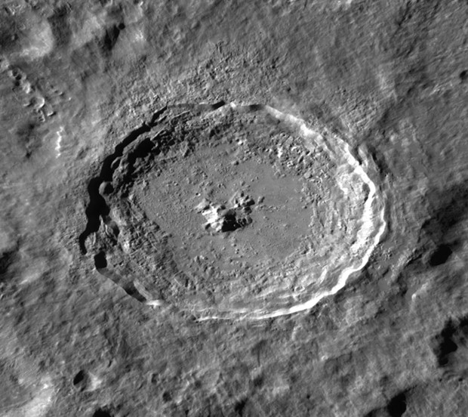

Figure 4: A detailed view of Tycho. This is a complex crater that is ~85 km in diameter. Note the central peak and the flat floor of the crater as opposed to the bowl shaped depression for the simple crater, which is distinctly not flat. Also note the terraces on the crater wall. This image was also taken by LROC. Image Credit: NASA Goddard Space Flight Center/Arizona State University.

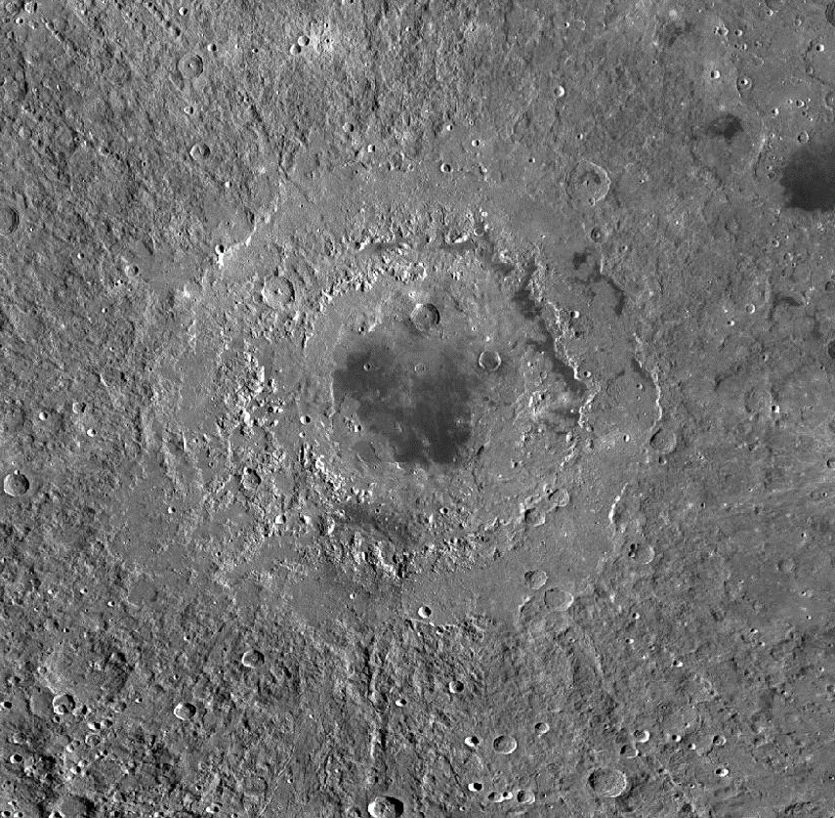

**Figure 5:** This is the Orientale basin on the Moon. It is a multi-ring basin that is ~950 km in diameter. This image was also taken by LROC. Image Credit: NASA Goddard Space Flight Center/Arizona State University.

Check out <http://lroc.sese.asu.edu/> for the Lunar Reconnaissance Orbiter Camera’s website for the amazing research being done by scientists at ASU. They’ve also got some really cool images of the Moon

## Mass, Velocity, and Kinetic Energy

As an asteroid falls towards a terrestrial body, it gains kinetic energy. That energy is released when the asteroid impacts the ground and excavates the material around the impact site. The volume of material excavated, and thus the diameter (*d*) of the crater, is proportional to the kinetic energy of the impactor. The mass and velocity both play a role in determining the kinetic energy of an impactor when it hits a terrestrial body. The **free-fall velocity** is given by

(Eq. 1)

where g = 9.81 m/s2 is the acceleration due to gravity on Earth and *h* is the height of the fall. This equation assumes the object starts at rest and gains speed as it falls toward the Earth. **Kinetic energy** is the energy of a moving object, and depends on the object’s mass, *m*, and the object’s velocity, *v*

(Eq. 2)

or

(Eq. 3)

In this lab you will investigate how crater diameters vary with the size, mass, and velocity of the impactor.

# III. Volcanic Craters

Impact craters will have ejecta and crater floors at a lower elevation than the surrounding area. They can be simple or complex, but the environment will show signs of having been impacted. Volcanic craters, on the other hand, will be at a higher elevation than the nearby terrain, and though they may show signs of lava flows, the ejecta characteristic of impact craters does not appear near volcanic craters. A **caldera** is a volcanic crater formed by the collapse of an empty magma chamber.

# IV. Relative Dating and Superposition

**Absolute time** refers to the exact time or date of an event (e.g. the dinosaurs died approximately 65 million years ago). For the Moon absolute time was determined by radioactive dating of lunar rocks brought back by the Apollo Moon missions.

However, we do not always have samples available to absolute date for terrestrial bodies. Instead, we use **relative dating** to determine the ages of events. Relative dating compares events against other events to determine the order in which they occurred. With relative dating, no exact date is identified (e.g., you might posit that WWI occurred before WWII without knowing the date for either event). Most often, relative dating is determined using the **law of superposition**. The law of superposition states that the top layer is *younger* than the bottom layer. When looking at craters, when we see one crater underneath another we know the bottom one was created first. This provides a relative timeline for when the impacts occurred.

# V. The Experiment

You will be investigating the concepts introduced in this lab script in the online Smart Sparrow lab Airless Worlds. Your TA will provide instructions on how to access and complete this lab in the Smart Sparrow platform.