**Mapping the Surface of Mars Prelab**

1. Explain in your own words what you think a "geologic history" for a planet or moon is?
2. Describe some of the major features seen on the Martian surface by various spacecraft missions over the past 30 years. Include observations from Mariner 1, Viking 1 & 2, Pathfinder/Sojourner, Mars Global Surveyor, etc...
3. Describe the similarities between Mars and Earth. Describe the differences. Why is Venus often called Earth's sister planet while Mars is not?
4. What evidence has been found that suggests water was once on Mars? Is there evidence for water on Mars today?

**MAPPING THE SURFACE OF MARS**

**What will you learn in this lab?**

How can we determine the geologic history of a planet or satellite without travelling to the planetary body? In this lab you will create a simple feature map of a region of Mars in a similar way used by photogeologists. Using this map of the surface you will hypothesize a geologic history of a part of the Martian surface.

**What do I need to bring to the Class with me to do this Lab?**

• A copy of this lab script

• Pencil and eraser

• Scientific calculator

**Introduction:**

What is a **geologic history**? When looking at a planetary body a scientist wants to know how certain features were developed, what the sequence of events was, the age of certain features, etc. After gathering facts, data, and evidence, a geologic scientist can piece together a geologic history of the planet. A geologic history is just a story of how a planetary body formed from beginning to end.

A geologic history can include many different things. It can include a geologic map of the planet similar to a map of Arizona that tells us where things are and what things might look like. The history can also include a geologic timeline that includes both relative time and absolute time. **Relative time** is where one determines the ages of events by comparing them against other events. The events are then ordered by when they

occurred. With relative dating no exact date is identified (e.g. WWI and WWII). **Absolute time** is where the exact time or date of an event can be identified (e.g. 65 million years ago). A geologic history can also include pictures, fossils, practically anything that will help us determine the life story of the planet. What types of things would you include in a geologic history of the Earth? When geologists want to determine the geologic history of another planet what do they do? What instruments can be used?

If we had a geologic map of a planet this would give us a large amount of data and evidence and allow us to determine a geologic history. It would tell us how the planet looks in the present and from that we can arrive at hypotheses of how those features came to be. But how do we make geologic maps? Let's first think about how we would map the Earth’s surface. What instruments would we use? What information would we want to try to find?

Geologic maps are made of a planet or moon by looking at present day features – land masses, bodies of water, volcanoes, channels, impact craters, etc. This can be done both by using photographs taken by orbiting satellites and from human physical research of the surface. The maps can give geologic scientists a relative time for the planet - show if the features were formed earlier or later than each other - but not any absolute times (specific dates). For example, early in the solar system there was a heavy bombardment period when many of the largest craters were formed. Most of the smaller craters were formed later when only smaller bodies were left over from the debris disk that formed the planets. When geologic scientists just look at the appearance of features on a planet or moon without denoting the relative time on the map then they are looking at the geomorphology of the region. A map that only looks at the appearance of features is called a **geomorphic map**.

What happens if we can't travel to and physically stand on a planet’s surface to conduct research? So far in space travel we have only been able to stand on the Earth and the Moon. What can we use to tell us the geologic history of a planet like Mars or Venus? In such cases, all we can do is rely on the geologic map of the planet determined from images taken by orbiting satellites (**remote sensing**) or rovers that land on the surface for us. Photogeologists examine the images carefully and use all available data to make a representative map of the surface.

In this lab you will use images of the Chryse Planitia and Tiu Valles regions of Mars taken by the THEMIS Camera on the Mars Odyssey orbiter to make your own simple geomorphic map. You will need to distinguish between and identify a few different features: **craters** and **channels**. The images and descriptions in the following sections define examples of these features.

**Part I: Looking at Mars Globally**

In this section, we will use the MOLA map (the large colorful map). The MOLA (Mars Orbiter Laser Altimeter) map shows the whole surface of Mars with colors representing **elevation**. Red and white colors indicate high elevation while blue and purple colors indicate low elevation. Like maps of Earth, Latitude is indicated by the numbers along the vertical axis while Longitude is indicated by numbers on the horizontal axis.

1. Look at the locations of craters on Mars.

a. Does the Northern or Southern Hemisphere have more craters?

b. Does the Northern or Southern Hemisphere have an older surface? Explain.

We can classify impact craters into three general categories or classifications based on their appearance. These three categories give clues about the history (or relative age) of the crater. We cannot identify the exact age of a crater on Mars, but relative ages for different craters can help us develop a sequential history.

Crater rim



I. Preserved Craters:

* Near perfect craters
* Raised rims
* Look new

Central peak (not all craters have a central peak.)

* Can sometimes see ejecta

blanket or central peak

* Young crater

Ejecta blanket (not all craters have ejecta blankets.)

II. Modified Craters:

* Craters that have been



changed or modified by:

* + Erosion (wind, water or lava)
  + Other impacts
* Sometimes crater ejecta is

visible but looks eroded

* Crater may have smooth

floor (partially filled in with

material or sediment)

* Middle-aged craters

III. Destroyed Craters:



* Look very worn away
* Rims are broken
* Have been severely changed

or modified

* Crater has been filled in

almost completely by sediment

* Very old craters

Scientists use two basic rules or principles to help determine the relative age of craters or other features on a surface. They are as follows:

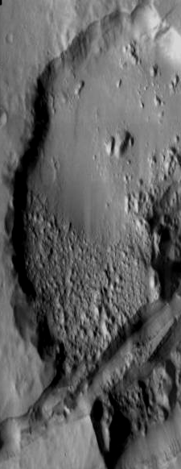

I. Cross-Cutting Relationships:

* A crater (or any other feature)

can be cut by another feature.

Crater shown here is older than the fracture (crack) that cut through it.

* The feature cut is older than

the feature that cut it.

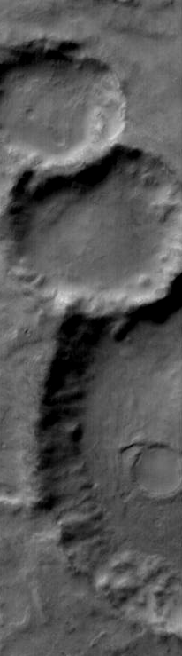

II. Principle of Superposition

* When one feature is on top

of another feature, the

3

feature on top is younger.

Crater #1 is partly covered by crater #2, so crater #1 is older

Crater #2 is partly covered by crater #3, which makes crater #2 older than #3.

By inference then, crater #1 is the oldest and crater #3 is the youngest.

* The feature on the bottom

is the older feature.

2

1

Based on the *Crater Classification* information sheet, classify the craters at the bottom of the page. Be sure to explain your reasoning for each classification.

|  |  |  |
| --- | --- | --- |
| **CRATER IMAGE** | **CRATER CLASSIFICATION (Preserved, Modified or Destroyed)** | **REASONS** |
| Crater A |  |  |
| Crater B |  |  |
| Crater C |  |  |
| Crater D |  |  |



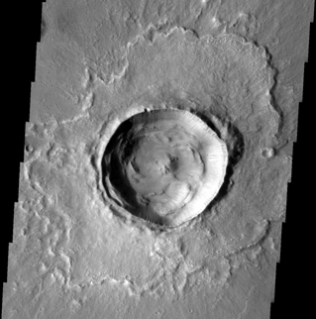

Crater A

Crater B





Crater D

Crater C

Based on the two relative age dating principles (cross-cutting relationships and superposition), write your interpretation of the relative ages of the features in the following images:



Oldest Feature: __________

A

Younger Feature: _________

B

Youngest Feature: _________

C

Please explain your answers:

Which principle(s) did you use to choose

your answer?

_________________________________

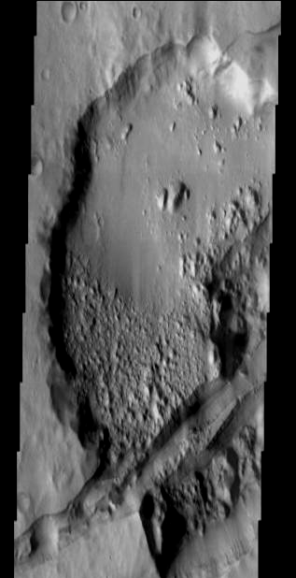

Oldest Feature: __________

B

Younger Feature: _________

Youngest Feature: _________

A

Please explain your answers:

Which principle(s) did you use to choose

your answer?

C

_________________________________

Now you know how to classify craters and are familiar with relative age dating principles. You can now create a feature map of your region of Mars that will help you interpret the geologic history.

In order to create your feature map, you will need to put a piece of transparency paper over your THEMIS mosaic image. Using paper clips, secure the THEMIS image and your paper together.

Using your observations and erasable markers, identify the features listed below to create your map. Keep in mind that some features may be too small to map. Use your best judgment to decide what may be too small to map and in determining how to the outline or color features. Outline or color the features as indicated below.

**Feature**

**Colored Feature**



1. Preserved Craters: Carefully outline the

rims and ejecta (if visible) of all preserved

craters in **BLACK**.



1. Modified Craters: Carefully outline the

uneven, or eroded rims and ejecta (if visible)

of the modified craters in **GREEN**.



1. Destroyed Craters: Carefully outline the

very eroded crater rims in RED.



1. Channels: Outline all channels

in BLUE.

Part II: Interpreting Your Geological Maps

Using the map you made of Chryse Planitia, answer the following questions.

1. Which is older – the channel(s) (blue) or the destroyed (red) craters? How do you know?

2. Which is older – the channel(s) (blue) or the modified (green) craters? How do you know?

3. Which is older – the channel(s) (blue) or the preserved (black) craters? How do you know?

4. Which are older – most larger craters or smaller craters? How do you know? Why do you think this is?

5. Which features are oldest, youngest, and of medium age?

Using the map you made of Tiu Valles, answer the following questions.

1. Which is older – the channel(s) (blue) or the destroyed (red) craters? How do you know?

2. Which is older – the channel(s) (blue) or the modified (green) craters? How do you know?

3. Which is older – the channel(s) (blue) or the preserved (black) craters? How do you know?

4. Which are older – most larger craters or smaller craters? How do you know? Why do you think this is?

5. Which features are oldest, youngest, and of medium age?

Part III: Examining Crater Sizes

Focus now on the craters only. Fill in the tables below with the number of craters that fall into each bin. Remember, a quick measurement to see which data bin your crater falls

into is all that is necessary. Precise measurements, in this case, are not important.

Chryse Planitia

|  |  |  |  |
| --- | --- | --- | --- |
| Crater  Diameter  (cm) | Preserved  (black) | Modified  (green) | Destroyed  (red) |
| 0.0 – 0.5 |  |  |  |
| 0.5 – 1.0 |  |  |  |
| 1.0 – 1.5 |  |  |  |
| 1.5 – 2.0 |  |  |  |
| 2.0 – 3.0 |  |  |  |
| 3.0 – 4.0 |  |  |  |
| 4.0 or larger |  |  |  |

Tiu Valles

|  |  |  |  |
| --- | --- | --- | --- |
| Crater  Diameter  (cm) | Preserved  (black) | Modified  (green) | Destroyed  (red) |
| 0.0 – 0.5 |  |  |  |
| 0.5 – 1.0 |  |  |  |
| 1.0 – 1.5 |  |  |  |
| 1.5 – 2.0 |  |  |  |
| 2.0 – 3.0 |  |  |  |
| 3.0 – 4.0 |  |  |  |
| 4.0 or larger |  |  |  |

Answer the following using the data from your tables:

1. Which crater type is most frequent?

2. Which crater type is the largest?

3. Which crater type is the smallest?

4. Which crater type is the youngest?

5. Which crater type is the oldest?

Now that you have information about the Martian regions you have mapped determine a geologic history for these regions. This should be a simple description of what happened, in what order, and how it affected the surrounding region. Be sure to state your evidence to support your hypothesis.

Geologic History for Chryse Planitia:

Geologic History for Tiu Valles:

Wrap-up questions:

1.a. Describe the process used to determine a geologic history for a terrestrial planet.

1.b. What steps does a scientist take?

1.c. What evidence does a scientist look for?

1.d. What instruments can help retrieve supporting data?

2.a. Using the latitude and longitude listed on the images of the Chryse Planitia and Tiu Valles, plot and label those locations on the MOLA map using the markers provided.

2.b. Describe the general area where these images were taken (include information about elevation and topography).

3.a. Do both regions (Chryse and Tiu) look similar?

3.b. Do they give a similar geologic history for Mars?

3.c. What are the similarities and differences?

3.d. Why might there be differences between the two regions you looked at?

3.e. Are these two regions the correct ones to use to make a global geologic history for Mars?

4. Was Mars a geologically active planet based on the two regions you mapped? Explain.

5.a. Out of the four geologic processes that affect the surface of a terrestrial planet (erosion, tectonic activity, impact cratering, & volcanism) which are evident in the regions you looked at?

5.b. How can you tell?

**Summarize what you have learned in tonight’s lab**: