**Name: _________________________________**

**Math refresher answer sheet**

(Note: Write all answers on this sheet and the following graph page.)

1. ______________________________

2. ______________________________

3. ______________________________

4. ______________________________

5. ______________________________

6. ______________________________

7. ______________________________

8. ______________________________

9. ______________________________

10. _____________________________

11. _____________________________

12. _____________________________

13. _____________________________

14. _____________________________

15. _____________________________

16. _____________________________

17. _____________________________

18. _____________________________

19. _____________________________

20. _____________________________

21. _____________________________

22. _____________________________

23. _____________________________

24. ______________________________

25. ______________________________

26. ______________________________

27. ______________________________

28. ______________________________

29. ______________________________

30. ______________________________

31. ______________________________

32. ______________________________

33. ______________________________

34. ______________________________

35. ______________________________

36. ______________________________

37 (a)___________(b)______________

37 (c)___________(d)______________

38. ______________________________

39. ______________________________

40. ______________________________

41. ______________________________

42. ______________________________

43. ______________________________

44. ______________________________

45. ______________________________

46. ______________________________

47. ______________________________



**Math refresher exercise**

**What will you learn in this Lab?**

This exercise is designed to assess whether you have been exposed to the mathematical methods and skills necessary to complete the lab exercises you will be given this semester. This is not a test. It is merely a tool to refresh your exposure to fundamental mathematical concepts to help you be prepared for the mathematical challenges this semester. You will have to complete a blackboard quiz based on this math refresher. It consists of 25 questions and is worth 50 points.

**What do I need to bring to the Class with me to do this Lab?**

For this lab you will need:

* A copy of this lab script
* A pencil
* A scientific calculator

# I. Introduction:

Mathematics is a language that scientists use to describe the world and universe around them. As such it is a vital and indispensable part of any science lab class, since the tools afforded to the experimenter by mathematics allow him or her to analyze the data and come to conclusions that just staring at the numbers would never reveal.

During this class you will be asked to carry out the type of routine mathematical procedures that you might use this semester to analyze your data. You need to work on this exercise in class where you have a TA to help.

# II. Order of Operation - PEMDAS

In mathematics, we (and your calculator) follow rules called “orders of operation”. Put simply, if you type in a long string of operations, your calculator will compute them in the following order: operations in **P**arentheses, **E**xponents/logarithms, **M**ultiplication / **D**ivision, **A**ddition / **S**ubtraction. A good acronym to remember this order is **PEMDAS** or “Please Excuse My Dear Aunt Sally,” if you prefer. Note that parenthese out-rank exponents, which out-rank multiplication and division. Multiplication and division are have the same rank, so they are done in order from left-to-right. The same is true of addition and subtraction.

## PEMAS Example:

(5 + 6 – 3) + 15 x 2 ÷ 30 + 3

Do the part in **P**arentheses first. Within these parentheses, there are no **E**xponents, **M**ultiplication/**D**ivision, so start with **A**ddition/**S**ubtraction. Addition and subtraction which have the same rank, so perform the operations from left to right: 5 + 6 – 3 🡺 11 – 3 🡺 8

**(5 + 6 – 3)** + 15 x 2 ÷ 30 + 3

8 + **15 x 2** ÷ 30 + 3

8 + **30** ÷ **30** + 3

**8 + 1** + 3

**9 + 3**

**Answer: 12**

## Solve These Problems:

Using what you now know about the order of operations. Solve the following problems. Write your answer in the appropriate space on the answer sheet. (Note: the only difference between #2 and #3 is the placement of the parentheses!)

1. 1546 + (645 – 123) + 789 =
2. 1634 - 67 × (185 – 23) =
3. 1634 - (67 x 185) - 23 =
4. 189 × 54 + 336 ÷ 24 =

# III. Scientific Notation

## Writing Scientific Notation

Many numbers we encounter in astronomy are either very large or very small, so it is convenient to express these numbers using scientific notation. With scientific notation, the leading number is between 1.00 and 9.99 and the exponent represents the number of places left (positive exponent) or right (negative exponent) that the decimal point must be moved to make it so.

## Examples:

Mass of the Sun = 2,000,000,000,000,000,000,000,000,000,000 kg

= 2 x 1030 kg

Mass of the hydrogen atom = 0.00000000000000000000000000167 kg

= 1.67 x 10-27 kg

Distance to the nearest star = 40,200,000,000,000,000 m

= 4.02 x 1016 m

## Arithmetic in Scientific Notation

To add and subtract using scientific notation, the numbers must be raised to the same power of 10.

**Example:**

200 + 20 = 220 = 2.2 x 102

What would this arithmetic look like in scientific notation?

2 x 102 + 2 x 101 = 2 x 102 + 0.2 x 102

= (2 + 0.2) x 102

= 2.2 x 102

To multiply (or divide) numbers expressed in scientific notation, you must multiply (or divide) the leading number, but *add (or subtract)* the exponent.

**Examples:**

2.5 x 108 × 3.0 x 102 = (2.5 × 3.0) x 10(8 + 2) = 7.5 x 1010

8.24 x 108 ÷ 2.00 x 103 = (8.24 ÷ 2.00) x 10(8 – 3) = 4.12 x 105

## Using Calculators for Scientific Notation

For the purpose of this course, you can complete these calculations with your calculator; the above information is a reminder of the process so that you understand what your calculator is doing. The standard calculator symbol for scientific notation is EE, and it will show as a single E on your calculator screen.

**Examples:**

2.2 x 106 = 2.2.E 6

5.97 x 1024 = 5.97 E 24

1.67 x 10-27 = 1.67 E -27

## Solve These Problems:

Using what you now know about writing scientific notation and performing arithmetic with scientific notation, solve the following problems. Write your answers (in scientific notation!) in the appropriate space on the answer sheet.

1. 65538.11 in scientific notation =
2. 0.0005521 in scientific notation =
3. 2.7718x105 + 3.8821x107 =
4. 5.2119x106 – 3.2764x105 =
5. 8.772x104 ÷ 5.339x106 =
6. 5.229x103 x 5.119x102 =

# IV. Significant Figures (SigFigs)

## Where do Significant Figures come from?

When conducting physical experiments in a laboratory setting, you need to be aware that your final answer **cannot be more accurate than your initial measurements**. For example, let’s say you have a ruler with markings as precise as 0.1 cm. At best, you might be able to *estimate* half way between those markings, as shown below.

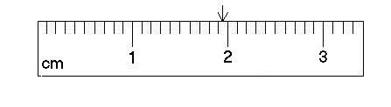

Using this ruler, you measure the length of a rectangle to be 3.45 centimeters (cm). You measure the width to be 5.65 cm. You also know that the area of a rectangle equals length times width.

3.55 cm x 5.50 cm = 19.525 cm2

But you know that your ruler cannot measure to thousandths of a cm. So the correct answer due to the accuracy of your measuring tool is **19.5 cm**. The answer needs to have the **same number of “significant figures”** as the initial measurements.

## Which Figures are Significant?

1. Non-zero digits are ALWAYS significant. (1, 2, 3, 4, etc.)
2. Zeros between significant digits are also significant. (203, 706, etc.)
3. In a decimal number, leading zeros are NOT significant, but every digit to the right of the first signifcant digit IS significant.

e.g., 0.00007820 and 1.030 both have 4 significant figures.

1. In a non-decimal number, trailing zeros are NOT significant.

e.g., 100 has 1 significant figure and 245,000 has 3 signifcant figures.

To write a number to a specified number of significant figures, you can round the number or use scientific notation.

884536 to 4 significant figures = 884500

0.00027745 to 3 significant figures = 2.77 x 10-4

## Solve These Probelms:

Using what you now know about significant figures, write the following numbers to the specified number of significant figures. Write your answers in the appropriate space on the answer sheet.

1. 3.72511x104 to 2 significant figures =
2. 0.0074221 to 4 significant figures =
3. 4.9211x105 to 2 significant figures =

**For all subsequent questions you should quote the answers to the same number of significant figures that are presented in the problem.**

# V. Logarithms and Exponents

The logarithm (or “log­”) of a number is the exponent to which 10 must be raised to equal that number; log (10x) = x. Much like division is the opposite of multiplication, logaritms are the mathematical funcation that sits opposite to base 10 exponents.

Let’s say you have an equation: 10X = 2. To determine what value of x will make this statement true, you take the logarithm!

10X = 2

log(10X) = log(2)

x = log(2) = 0.3

100.3 = 2

In the second step, the logarithm function reverses the exponent, much like a division reverses a multiplication or a subtraction reverses an addition.

Logarithms also act as shorthand for expressing extremely large or small numbers.

log(1,000) = log(103) = 3

log(0.0021) = log(2.1 x 10-3) = -2.7

*For the purpose of this course, you can complete these calculations with your calculator; the above information is a reminder of the process so that you understand what your calculator is doing.*

## Solve These Problems

1. log(2678834.11) =
2. log(0.0002663) =
3. 10(0.00277) =

# VI. Taking Roots and Raising Numbers to Powers

With logarithms, you are trying to find the exponent that will make the equality true. Wth roots, the exponent is known, but the base is not. To solve for the base, you simply take a root of the same power as the exponent. In the second step in the example below, the 3rd root reverses the 3rd power on the variable x.

**Example:**

## Solve These Problems:

In this course, you will simply need to know how to your calculators to calculate powers or take the root of a number. Using your calculators, solve these problems.

1. (3.4421)5 =
2. (0.0081)3 =
3. 
4. 

# VII. Trigonometry, Geometry and Angles

## Geometryu and Basic Angles

The two shapes we will use most often in this course are circles and triangles. All angles in a circle must sum to 360 degrees. All the angles in a half-circle and all the interior angles of a triangle must sum to 180 degrees. There is another unit, called radians, which can also be used to desribe angles, but we will not use them in this course. For all calculations, **make sure that your calculator is in degree mode (not radian mode)!** If you do not know how to check this, please ask for assistance.

## Trigonometry - SOACAHTOA

It will also be useful to manipulate triangles in our study of astronomy. It is necessary to recall the three trigonometry functions *sine*, *cosine*, and *tangent*. The definitions are shown below. You can use the acronym SOHCAHTOA (prounounced: sow-kah-tow-ah) to remember these trigonometric definitions.

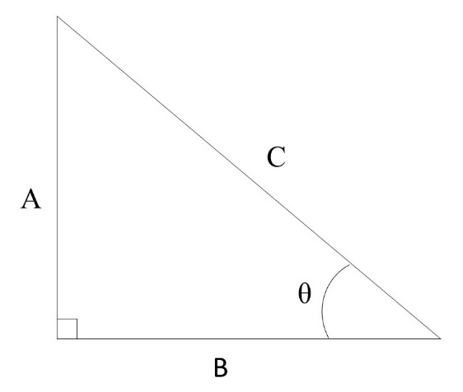

**SOH:**

**CAH:**

**TOA:**

**Pythagorean Theorm:** A2 + B2 = C2

## Solve These Problems:

Using what you now know about trigonometry, solve the following problems. Write your answers in the appropriate space on the answer sheet. Make sure your calculator is in degree mode! Give all angles in degrees.

1. Calculate X in Figure 1: 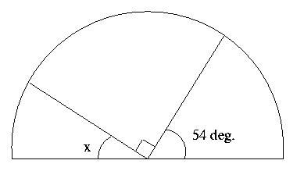

Figure 1.

1. Calculate X in Figure 2: 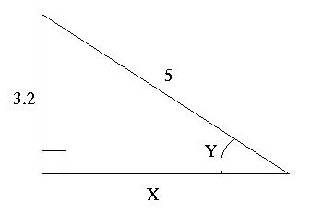

Figure 2.

1. Calculate Y in Figure 2.
2. tan(23°) =
3. Solve for y: cos(y) = 0.773
4. Solve for z: sin(z) = 0.0012
5. sin-1(0.472) =
6. Solve for y: tan-1(y) = 14º
7. Solve for z: cos-1(z) = 63.9º

# VIII. Time and Angles

Both time and angles can be subdivided into smaller units. Most people are familiar with the subdivisions of time, but angles also have “minute” and “second” divisions.

1 day = 24 hours

1 hour = 60 minutes

1 minute = 60 seconds

1 circle = 360 degrees = 360°

1 degree = 60 arcminutes = 60'

1 arcminute = 60 arcseconds = 60"

It is possible to use multiplication and division to convert between larger and smaller subdivisions. For example, to find how many seconds are in 2 days:

## Solve These Problems:

1. Express 2.1º in arcseconds(“):
2. Express 12.8854º in (º ‘ “):
3. Express 44º 23’ 12” in degrees (should be a single answer):
4. Express 23.24 hours in minutes:
5. Express 23.24 hours in days:

# IX. Calculating Percent Errors

In science, the term “error” does NOT mean “mistake.” Rather, it refers to the deviation of a result from some commonly agreed value that scientists take to be the “true” value. Usually, in our lab exercises, we shall want to compare the values we obtained experimentally with some known value. One way to calculate the error in our experiment is to obtain the “percentage error:”

Because “error” refers to a deviation from the average, you may also sometimes see this referred to as “percent difference.”

## Solve These Problems:

1. Known value = 54.3; Measured Value = 55.2; % error =
2. Known value = 633.2; Measured Value = 721.5; % error =
3. You are given an image of one of Jupiter’s moons, Callisto.
4. Measure the diameter of Callisto in *centimeters* using a ruler. Write your measurment on the answer sheet provided.

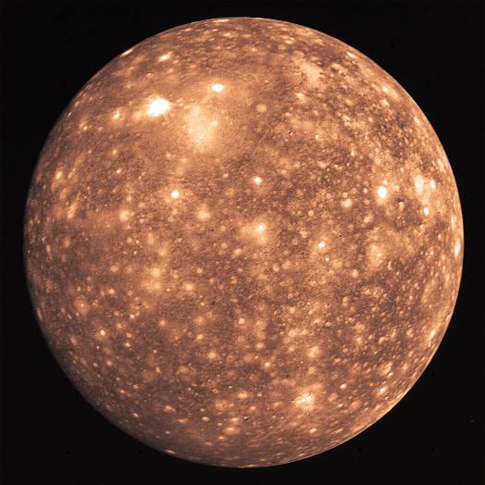

1. Make a 2nd measurement of the Callisto’s diameter in a different direction. Write your measurment on the answer sheet.
2. Make a 3rd measurement of Callito’s diameter.
3. Average your three values for the diameter of Callisto. (Taking measurements multiple times and using the average value decreases the uncertainty in your experiment.) Write down your average measurement.
4. If you printed this exercise on standard US Letter paper, one page per sheet, then the scale on the map is 1 cm = 630 km. Using this scale, convert your *experimental* value in cm to a value of the diameter of Callisto in km.
5. The diameter of Callisto is *known* to be 4800 km. What was the percent error in your experiment?
6. What assumptions were made that introduced error into this experiment?

# X. Algebra - Rearranging Formulae

At its core, algebra involves solving for a variable while keeping the equation balanced. When rearranging an equation, anything done to one side of the equation must also be done to the other side.

**Example:**

Solve the following equation for b.

## Solve These Problems:

Using what you now know about algebra, solve the following problems for the variable listed. Write your answers in the appropriate space on the answer sheet.

1. Solve for b:
2. Solve for *c*:
3. Solve for *c*:
4. Solve for *d*:
5. Solve for *d*:

# XI. Graphing Data

## Setting Up Your Graph

There are several things you need to do to ensure your graph turns out right.

* Graphs plot two variables. Usually the **measured quantity** is on the horizontal or **X-axis**, and the **derived quantity** is plotted on the vertical or **Y-axis**.
* Use the **entire graphing page** (the entire grid) to make an easy-to-read plot. This is especially important so the reader can accurately identify data points.
* For each variable determine the **minimum** and **maximum** value. Use these to determine the **range** of values to appear on the graph. If you measure heights from 1.4m to 2.0m, then your range is 0.6m.
* Count the number of major divisions across the page, and up the page. Divide the range by the number of major divisions to get your **step-size**.
  + - If there are 15 major divisions across the page (as in the graph paper provided), then you might use a step-size of (0.6/15 = 0.4) for the major divisions along the X-axis. You may need to round your step-size to gain a sensible value that still covers your range of data but is easier to plot on a graph. For a range of 0.6m, a more appropriate step-size for this graph paper might be 0.5m for each major division.
    - **You can never change scale once you have started plotting** – if you need to change the scale – start over.
* The origin of the graph need not be (0,0). It should be the minimum value needed for both sets of data.
* Add labels for each axis and include units. In addition to labelling each axis, you also need to title the graph.

## Plotting Data Points

When plotting your data you need to make sure you’re reading your own graph correctly! Let’s say you need to plot a data point at (1.74, 0.256). You need to find where these data values occur on your two axes. Data points are quoted as (x, y).

First let’s look at the X value. The value of 1.74 is clearly going to be between 1.7 and 1.8 – so you need to find that part of the X-axis (shown). Then you need to count the number of minor divisions between these two end points, in this case 10. Each minor division in this example is equal to (1.8-1.7)/10 = 0.01. The position of 1.74 = 1.7 + (4x0.01): 4 minor divisions past 1.7, as indicated by the arrow.

**X-Axis Y-Axis**

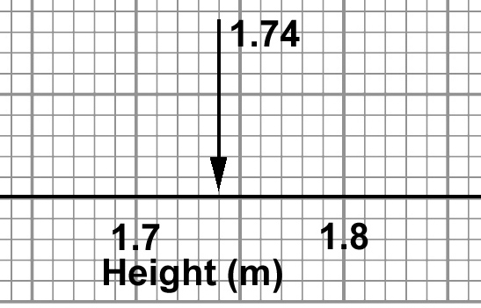 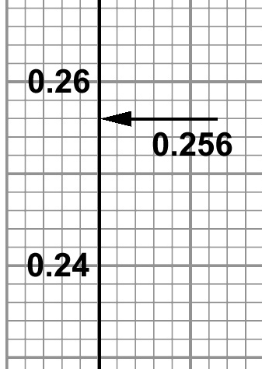

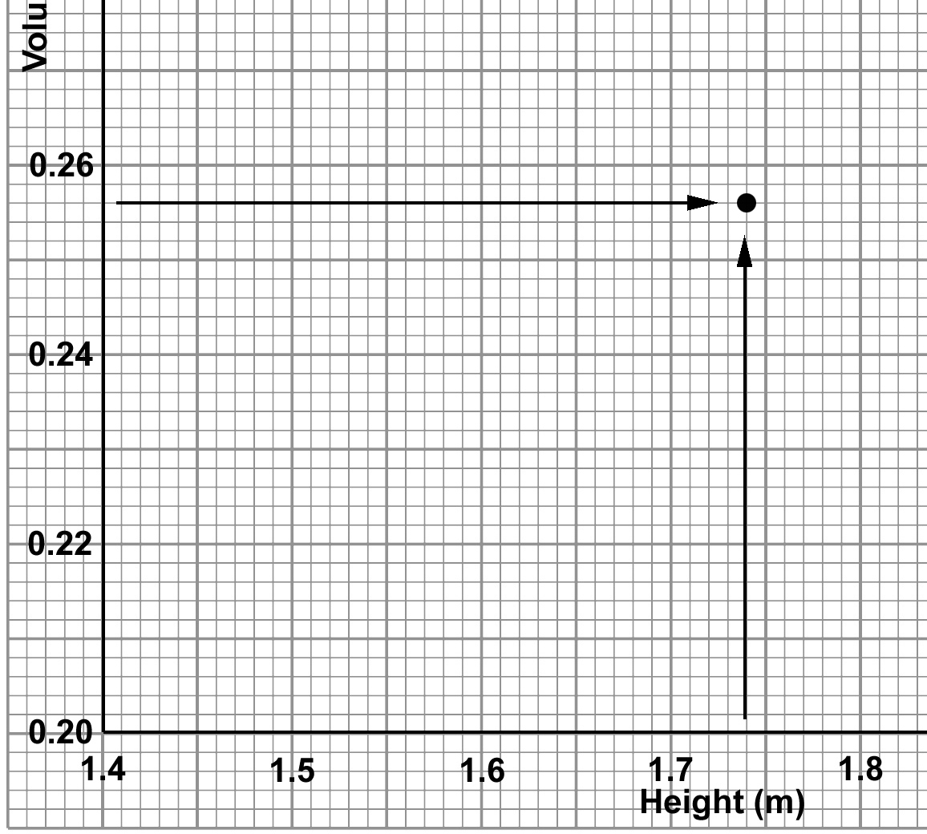

Next, let’s look at the Y-axis value. Again 0.256 is going to be between 0.24 and 0.26 on the axis. This time the minor divisions correspond to a different value: (0.26-0.24)/10 = 0.002. This means that 0.256 = 0.240 + (8x0.002): 8 minor divisions past 0.24, as indicated by the arrow.

Now you have the two pieces of information you need to successfully plot this data point on your graph. Track across the graph with your finger from the Y axis position, and up the graph from the X axis position, and where the two meet, mark the position with a point, as shown above.

**Never “connect the dots”!** Once you have plotted all your points, draw a straight line (if a line is appropriate) through the entirety of your data points in a way is a close to as many points as possible.

## Solve These Problems:

1. Graph the following table of information on the provided graph paper. Don’t forget to format your graph before you start plotting your points!

|  |  |
| --- | --- |
| X value: Distance (m) | Y value: Velocity (m/s) |
| 12.2 | 3.49 |
| 14.3 | 4.22 |
| 16.1 | 5.19 |
| 18.4 | 6.33 |
| 20.1 | 7.88 |
| 24.3 | 9.11 |
| 29.6 | 13.2 |

1. On the same graph, draw the best curve or line that fits this data. Which part of the graph has the thickest cluster of data points? This will be the best measured or the best sampled part of the graph.