**Name: _________________________________ Score: ________/50**

**Math refresher answer sheet**

(Note: Only this answer sheet and the following graph page will be evaluated)

1. ________________________ 23. _________________________

2. ________________________ 24. _________________________

3. ________________________ 25. _________________________

4. ________________________ 26. _________________________

5. ________________________ 27. _________________________

6. ________________________ 28. _________________________

7. ________________________ 29. _________________________

8. ________________________ 30. _________________________

9. ________________________ 31. _________________________

10. _______________________ 32. _________________________

11. _______________________ 33. _________________________

12. _______________________ 34. _________________________

13. _______________________ 35. _________________________

14. _______________________ 36. _________________________

15. _______________________ 37. _________________________

16. _______________________ 38. _______________________(3)

17. _______________________ 39. _________________________

18. _______________________ 40. _________________________

19. _______________________ 41. _________________________

20. _______________________ 42. _________________________

21. _______________________ 43. _________________________

22. _______________________

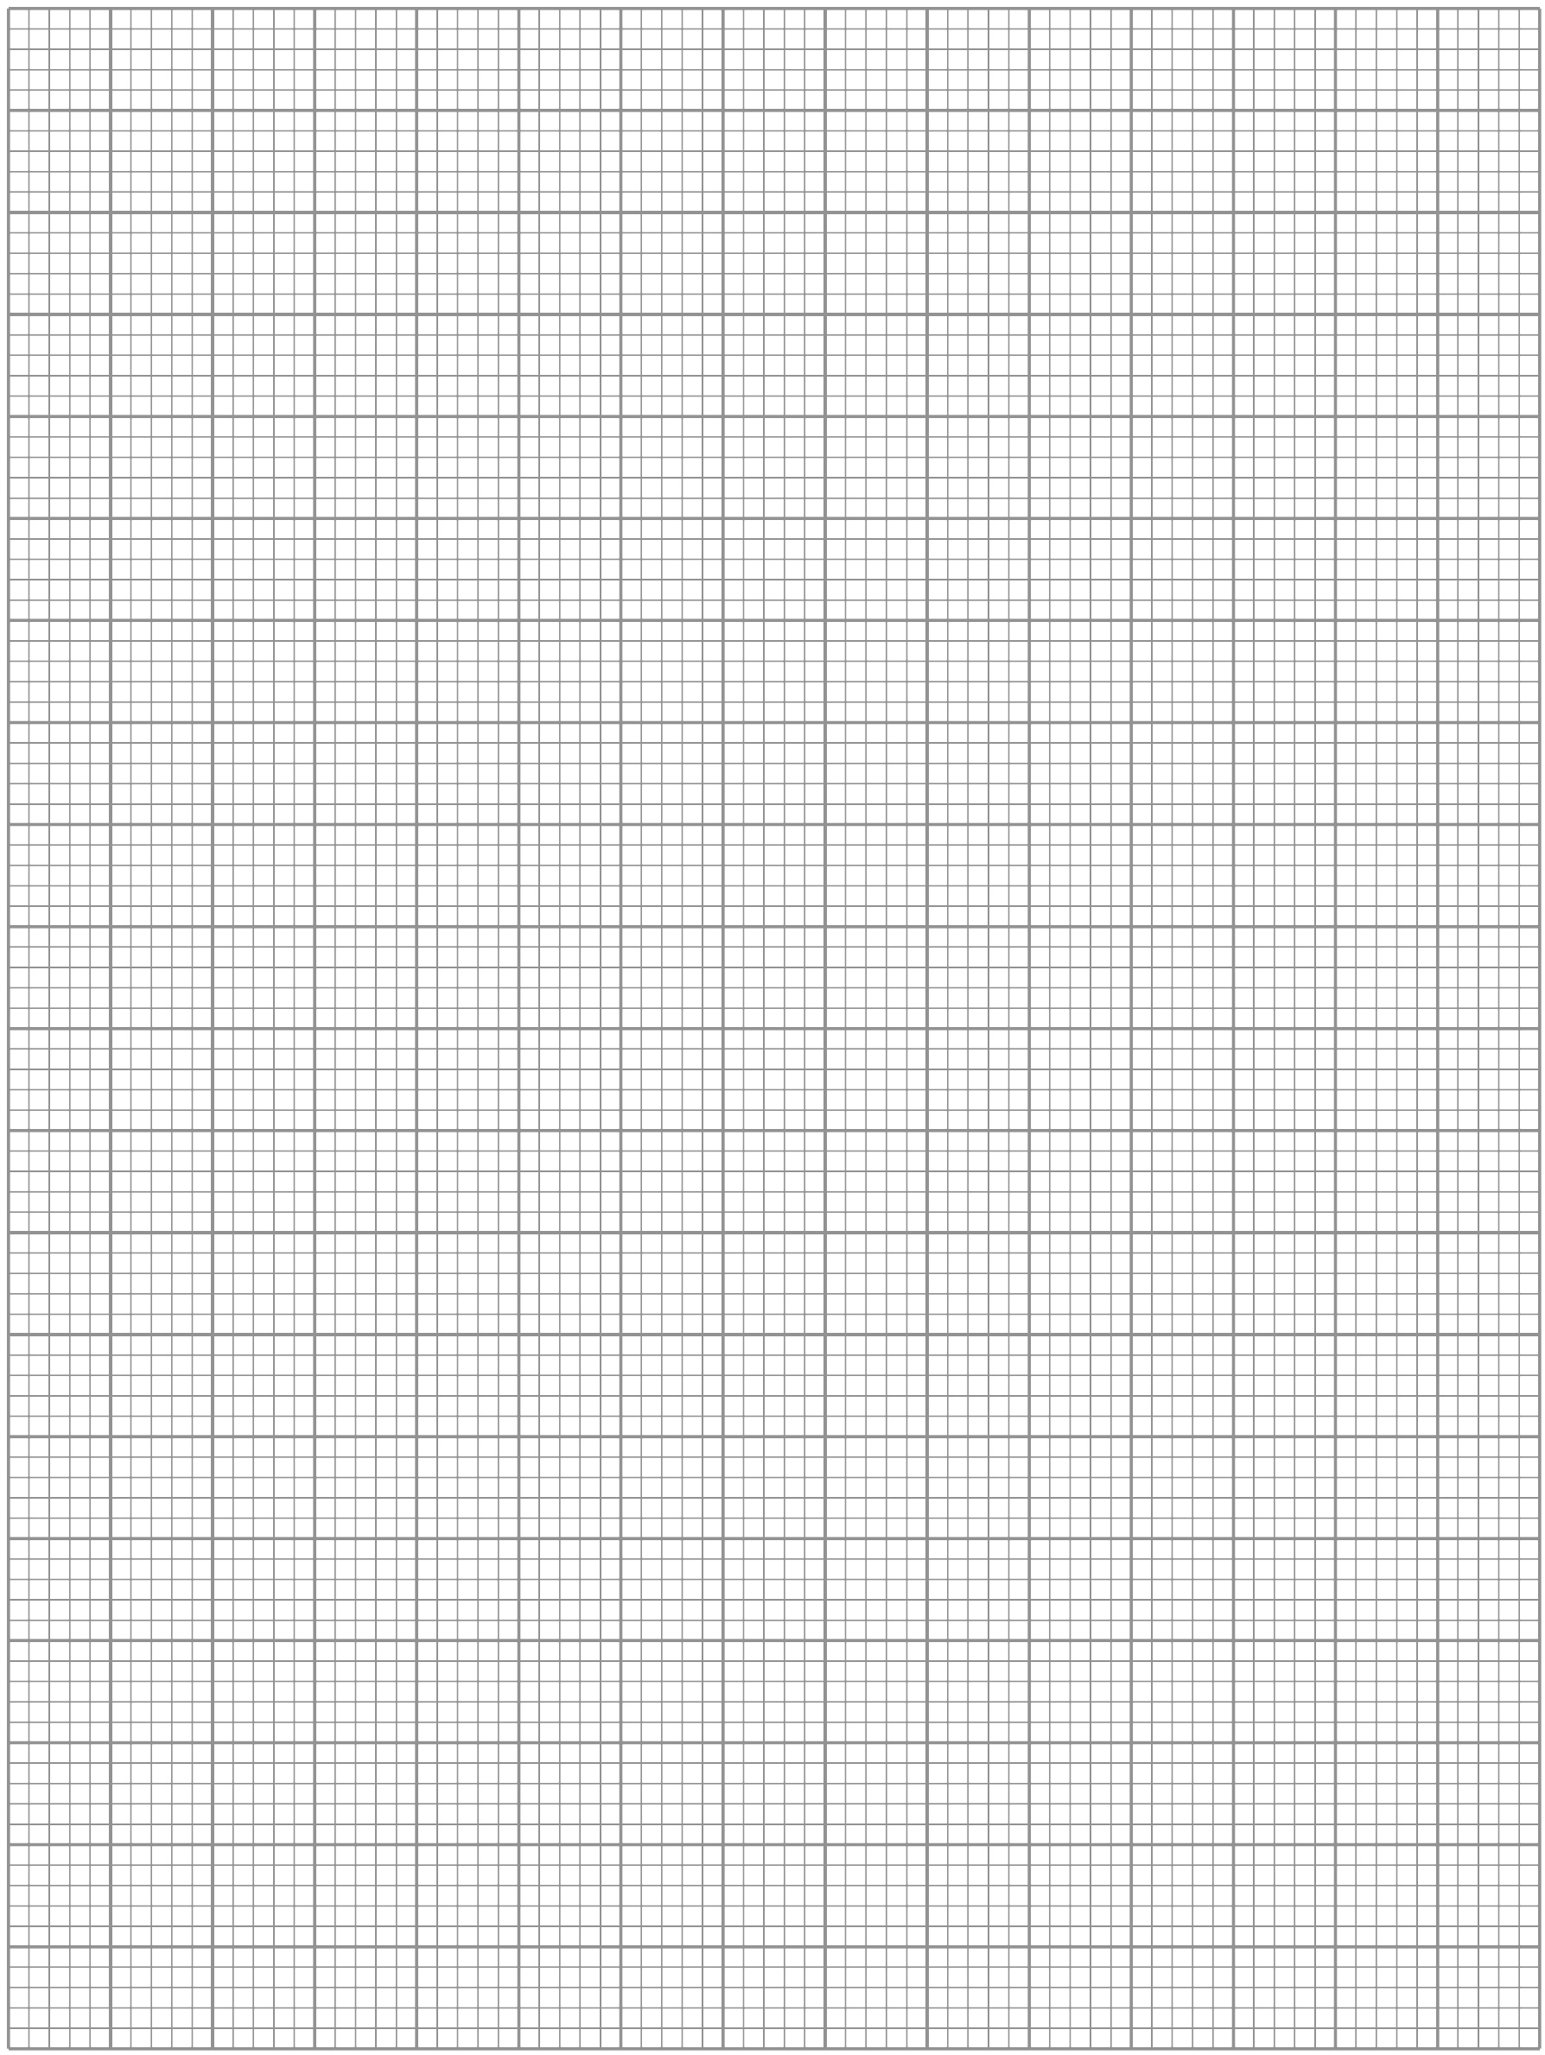

**Math refresher exercise**

**What will you learn in this Lab?**

This exercise is designed to assess whether you have been exposed to the mathematical methods and skills necessary to complete the lab exercises you will be given this semester. This is not a test. It is merely a tool to refresh your exposure to fundamental mathematical concepts to help you be prepared for the mathematical challenges this semester. The outcome will minimally feature in your final grade (25 possible points) but they are assigned based on completion so you should take the exercise seriously.

**What do I need to bring to the Class with me to do this Lab?**

For this lab you will need:

* A copy of this lab script
* A pencil
* A scientific calculator

**Introduction**:

Mathematics is a language that scientists use to describe the world and universe around them. As such it is a vital and indispensable part of any science lab class, since the tools afforded to the experimenter by mathematics allow him or her to analyze the data and come to conclusions that just staring at the numbers would never reveal.

During this class you will be asked to carry out the type of routine mathematical procedures that you might use this semester to analyze your data. You need to work on this exercise in class where you have a TA to help and will be allowed to complete it at home during the week, and hand it in next week.

**Addition, Subtraction, Precedence of Multiplication and Division**

Just as a reminder to you, your calculator follows rules called “orders of operation”. Put simply, if you type in a long string of operations, your calculator will compute them in the following order: operations in parentheses, exponents/logarithms, multiplication/division, addition/subtraction.

Answer the following problems:

1. 1546 + (645 – 123) + 789 =
2. 1634 - 67 × (185 – 23) =
3. 1634 - (67 x 185) - 23 =

(Note: the only difference between #2 and #3 is the placement of the parentheses!)

1. 189 × 54 + 336 ÷ 24 =

**Converting Numbers into Scientific Notation and Performing Arithmetic**

Many numbers that we will encounter in astronomy are either very large or very small, so it is convenient to express these numbers using scientific notation. Here are 3 examples:

Mass of the Sun = 2,000,000,000,000,000,000,000,000,000,000 kg = 2 x 1030 kg

Mass of the hydrogen atom = 0.00000000000000000000000000167 kg = 1.67 x 10-27 kg

Distance to the nearest star = 40,200,000,000,000,000 m = 4.02 x 1016 m

Notice that the leading number is between 1.00 and 9.99 and that the exponent represents the number of places left (positive) or right (negative) that the decimal point must be moved to make it so.

To add and subtract using scientific notation, the numbers must be raised to the same power of 10. For example,

200 + 20 = 2 x 102 + 2 x 101 = 2 x 102 + 0.2 x 102 = (2 + 0.2) x 102 = 2.2 x 102 = 220

To multiply (or divide) numbers expressed in scientific notation, you must multiply (or divide) the leading number, but add (or subtract) the exponent. Here are a few examples:

2.5 x 108 × 3.0 x 102 = (2.5 × 3.0) x 10(8 + 2) = 7.5 x 1010

8.24 x 108 ÷ 2.00 x 103 = (8.24 ÷ 2.00) x 10(8 – 3) = 4.12 x 105

**For the purpose of this course, you can complete these calculations with your calculator; the above information is a reminder of the process so that you understand what your calculator is doing.**

Express the answers to the following problems in scientific notation:

1. 65538.11 in scientific notation =
2. 0.0005521 in scientific notation =
3. 2.7718x105 + 3.8821x107 =
4. 5.2119x106 – 3.2764x105 =
5. 8.772x104 ÷ 5.339x106 =
6. 5.229x103 x 5.119x102 =

**Expressing Numbers to Significant Figures and Decimal Places**

When conducting physical experiments in a laboratory setting, you need to be aware that your final answer **cannot be more accurate than your initial measurements**. For example:

You measure the length of a rectangle to be 3.45 centimeters (cm). You measure the width to be 5.65 cm. You also know that the area of a rectangle equals length times width.

3.55 cm x 5.50 cm = 19.525 cm2

But you know that your ruler cannot measure to thousandths of a cm. So the correct answer due to the accuracy of your measuring tool is **19.5 cm**, because the answer needs to have the **same number of “significant figures”** as the initial measurements. Another example:

0.00027745 to 3 significant figures = 2.77 x 10-4

884536 to 4 significant figures = 884500

Answer the following problems:

1. 3.72511x104 to 2 significant figures =
2. 0.0074221 to 4 significant figures =
3. 4.9211x105 to 2 significant figures =

For all subsequent questions you should quote the answers to the **same** number of significant figures that are presented in the problem.

**Taking Logarithms and Exponents**

The logarithm (or “log­”) of a number is the exponent to which 10 must be raised to equal that number; or log (10x) = x. Logarithms are another shorthand for expressing extremely large or small numbers. For example:

log(1,000,000) = log(106) = 6

log(36,000,000) = log(3.6 x 107) = 7.6

log(0.0021) = log(2.1 x 10-3) = -2.7

**For the purpose of this course, you can complete these calculations with your calculator; the above information is a reminder of the process so that you understand what your calculator is doing.**

Answer the following problems:

1. log(2678834.11) =
2. log(0.0002663) =
3. 10(0.00277) =

**Taking Roots and Raising Numbers to Powers**

Use your calculators to answer the following problems:

1. (3.4421)5 =

1. (0.0081)3 =
2. 
3. 

**Trigonometric Mathematics, Geometry and Angles**

It will also be useful to manipulate triangles in our study of astronomy. It is necessary to recall the three trigonometry functions *sine*, *cosine*, and *tangent*. The definitions are shown below. Use these trig definitions to answer the following questions. **Make sure that your calculator is in degree mode (not radian mode).** If you do not know how to check this, please ask for assistance.

sin(θ) = A/C

θ

cos(θ) = B/C

tan(θ) = A/B

C

θ = sin-1(A/C)

A

θ = cos-1(B/C)

θ = tan-1(A/B)

A2 + B2 = C2 (Pythagorean theorem)

B

** It is also helpful to recall that the sum of the interior angles of a triangle equals 180°.

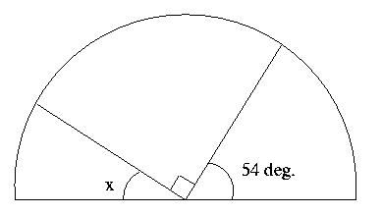

1. Calculate X in Figure 1:

Figure 1.

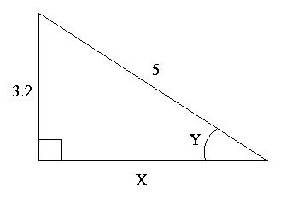

1. Calculate X in Figure 2:

Figure 2.

1. Calculate Y in Figure 2.

Answer the following problems, using your calculator. Give angles in degrees:

1. tan(23°) =
2. Solve for y: cos(y) = 0.773
3. Solve for z: sin(z) = 0.0012
4. sin-1(0.472) =
5. Solve for y: tan-1(y) = 14º
6. Solve for z: cos-1(z) = 63.9º

**Time and Angles**

Here are some basic definitions about angular measure.

1 circle = 360 degrees = 360°

1 degree = 60 arcminutes = 60'

1 arcminute = 60 arcseconds = 60"

Answer the following problems (and remember to use significant figures):

1. Express 2.1º in arcseconds(“):
2. Express 12.8854º in (º ‘ “):
3. Express 44º 23’ 12” in degrees (should be a single answer):
4. Express 23.24 hours in minutes:
5. Express 23.24 hours in days:

**Calculating Percentage Errors**

The term “error” means that a result deviates from some value known to be “true.” Usually, in our lab exercises, we shall want to compare the values we obtained experimentally with some known value. One way to calculate the error in our experiment is to obtain the “percentage error:”

Answer the following problems:

1. Known value = 54.3; Measured Value = 55.2; % error =
2. Known value = 633.2; Measured Value = 721.5; % error =
3. You are given an image of one of Jupiter’s moons, Callisto. Measure the diameter of Callisto in *centimeters* using a ruler. Write down your measurment.

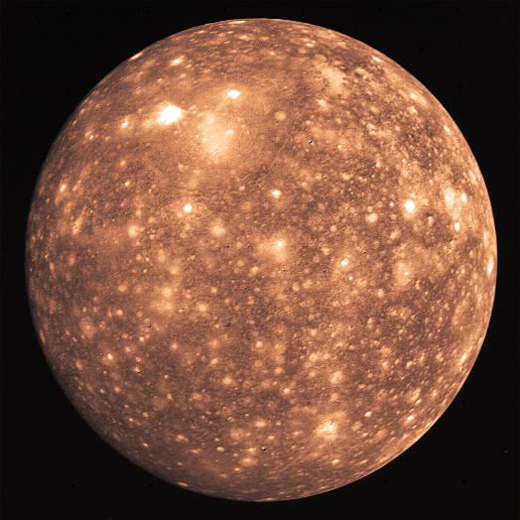

1. Make this measurement 2 more times. Write down your three measurements. Average your three values for the diameter of Callisto. (Taking measurements multiple times and using the average value decreases the uncertainty in your experiment.). Write down your average measurement.
2. If you printed this exercise on standard US Letter paper, one page per sheet, then the scale on the map is 1 cm = 630 km. Use this knowledge to calculate your *experimental* value of the diameter of Callisto.
3. The diameter of Callisto is *known* to be 4800 km. What was the percentage error in your experiment?
4. What assumptions did you make that introduced error into this experiment?

**Rearranging Formulae**

Solve the following equations for the variable listed:

1. Solve for :
2. Solve for :

**Graphing Data**

1. Graph the following table of information on the provided graph paper (read the Appendix below before you make the graph). This is a skill you will use almost every week.

|  |  |
| --- | --- |
| X value: Distance (m) | Y value: Velocity (m/s) |
| 12.2 | 3.49 |
| 14.3 | 4.22 |
| 16.1 | 5.19 |
| 18.4 | 6.33 |
| 20.1 | 7.88 |
| 24.3 | 9.11 |
| 29.6 | 13.2 |

1. On the same graph, draw the best curve or line that fits this data. Which is the best measured part of the graph?

**Appendix – Plotting Graphs**

When plotting a graph there are several things you need to do, in a specific order, to make sure the graph turns out right. **Learn how to do this** – you are going to do this a LOT this semester.

* You need to fill the grid as much as possible in order to interpret the data.
* A graph plots one variable against another. Usually the **measured quantity** is on the horizontal or **X-axis**. The **derived quantity** is usually plotted on the vertical or **Y-axis**.
* For each variable determine the **minimum** and **maximum** value for each. Use these values to determine the needed **range** of values to appear on the graph. For example, if your heights range from 1.4 to 2.0m, then your range is 0.6m. You may then round this number up to a sensible value that still covers your range of data but is easier to plot on a graph.
* Look at your piece of graph paper. Count the **number of major divisions** across the page, and up the page. If there were, as in the case of the page shown here, 15 major divisions across the page, then it would make sense to use 2.5 major divisions for each 0.1 (0.6=0.1x6) of the X-axis (15/6=2.5). When you **choose your scale** you need to make sure there’s enough room for labels, etc. Do the same exercise for the Y-axis. The origin of the graph **need not** be (0,0). It should be the **minimum value** needed for both sets of data. **Add labels** for each axis and **include units**. **Add a title** to the graph. You are now ready to start plotting your data. You can never change scale once you have started plotting – if you need to change the scale – start over.
* Never “connect the dots”!

When plotting your data you need to make sure you’re reading your own graph correctly! Let’s say you need to plot a data point at (1.74, 0.256). You need to find where these data values occur on your two axes.

First let’s look at the X value (the first number in a coordinate quoted this way). The value of 1.74 is clearly going to be between 1.7 and 1.8 – so you need to find that part of the X-axis (shown). Then you need to count the number of minor divisions between these two end points, in this case 10. So, each minor division is equal to (1.8-1.7)/10 = 0.01. The position of 1.74 = 1.7 + (4x0.01): 4 minor divisions past 1.7, as indicated by the arrow.

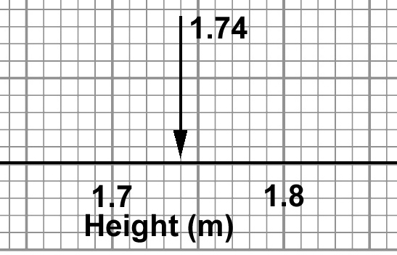

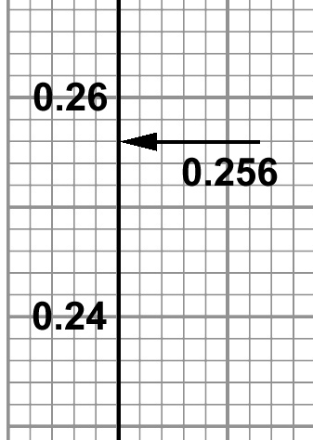

Next, let’s look at the Y-axis value. Again 0.256 is going to be between 0.24 and 0.26 on the axis. This time the minor divisions correspond to a different value: (0.26-0.24)/10 = 0.002. This means that 0.256 = 0.240 + (8x0.002): 8 minor divisions past 0.24, as indicated by the arrow.

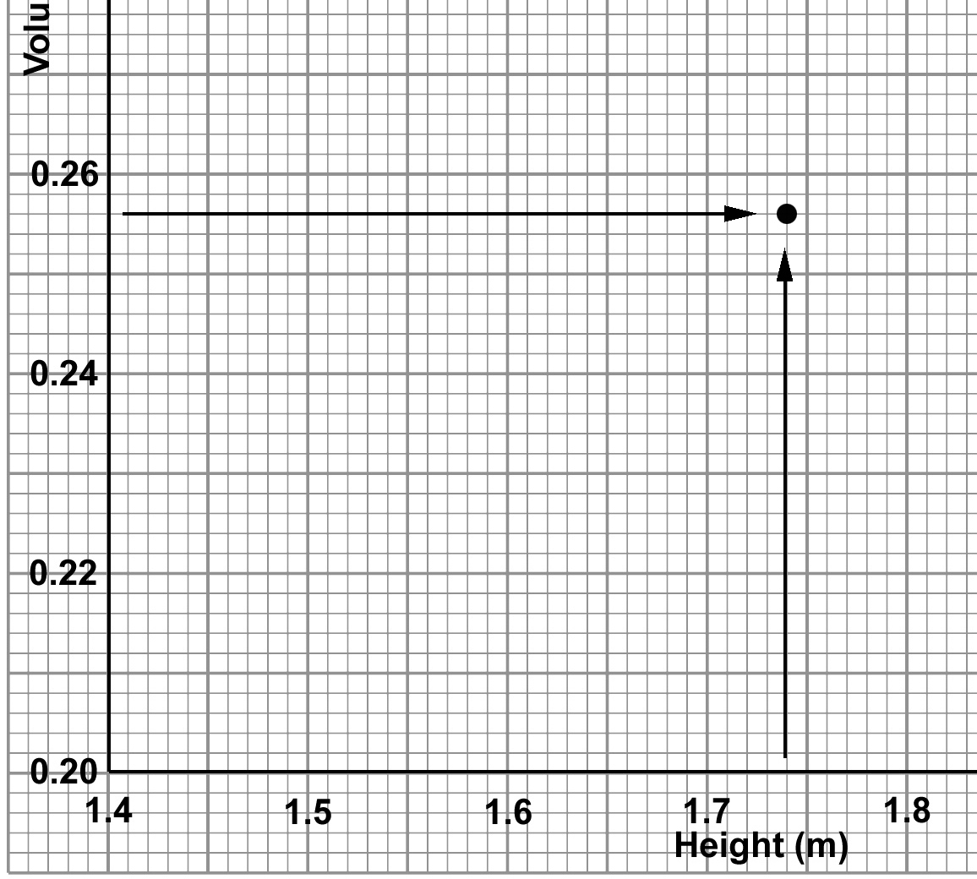

Now you have the two pieces of information you need to successfully plot this data point on your graph. Track across the graph with your finger from the Y axis position, and up the graph from the X axis position, and where the two meet, mark the position with a point.