**NAME:___________________________**

**Orbital Motion**

**What will you learn in this Lab?**

You will be using some special software to simulate the motion of planets in our Solar System and across the night sky. You will be asked to try and figure out Kepler’s 3rd Law using observations you make of the planets using this software. Having worked out the nature of the Law, you will be asked to make broader statements about how orbital motion is governed and about general properties of bodies in orbit around each other.

**What do I need to bring to the Class with me to do this Lab?**

For this lab you will need:

* A copy of this lab script
* A pencil and eraser
* A scientific calculator

# I. Introduction

The planets, and indeed all gravitationally bound objects, move in a very specific way as they orbit the object they are bound to. In the case of the planets, they are bound to the Sun through the force of gravity because of the Sun’s huge mass. Johannes Kepler worked out the details of this orbital motion from painstaking observation of the motion of the planets in the night sky. In this lab, we’ll be trying to do the same thing, but with the aid of the computer, we will have control of not only our viewing position but also the rate at which time passes.

# II. An Introduction to Starry Night

In this lab exercise you will be using a piece of software called Starry Night (SN) – be sure to use version Pro6. This is a very sophisticated planetarium package that can not only show us what the sky looks like at any time, from anywhere on Earth, but it can also transport us to other places in the solar system and even other stars!

Before you can conduct the exercise, we’ll go over the basic functionality of the software so you are more comfortable using it to obtain data for your experiment. The software is display-driven, i.e. the software’s main product is a picture of where you are and what you can see under the current conditions. This is not surprising given that astronomy is primarily a visual science. When you start the software, the display will show you what the current sky looks like, right now, facing towards the southern horizon. The scrollbars on the side of the window allow you to change your altitude and azimuth of where you’re looking. Play with it to get used to what your “world” looks like.

In the very upper-left corner is your tool selection tool. By default, SN opens in adaptive mode which allows you to click and drag around the scene, and brings up information when you hover over objects in the sky. You can play around with the other options. The most useful ones you’ll use in lab are:

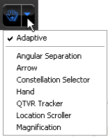Angular Separation – This tool lets you accurately measure the separation between two objects. Click on the first object, then drag to the second object. The angular separation between the two objects will be displayed, as well as the physical distance between them.

**Arrow** – Allows you to point at certain objects in the main window. SN will provide information about the object.

**Constellation** – As you pan across the sky, clicking will show constellation labels and art for the object you click on.

**Hand** – The hand tool lets you click and drag to pan around the main window.

**Magnification** – The magnification mode allows you to click anywhere in the main window and it will zoom in to that point. Alternatively, you can also click and drag a box around where you want to zoom to.

## Top Panel Information Display

**Time and Date**

Starry Night opens up to the current date/time. By clicking on any of the date/time elements you can enter a new value. You can also always reset it to the current time, sunrise, or sunset today by clicking on the buttons below the display.

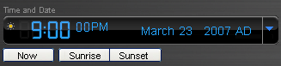

**Time Flow Rate**

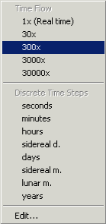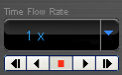By default SN advances at the same rate as real time, hence the 1x speed. Of course this is absurdly slow, so you can click on the arrow next to the rate to select a different speed. Or, you can even select a discrete time step so that SN plays forward 1 day at a time or other interval.

You can move one step at a time by using the buttons at either end of the button panel. The inner arrow buttons will change the display real time – i.e. one second per second. The stop button halts any display updates. This will be your most useful tool for this 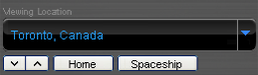lab exercise!

**Viewing Location**

By default, this should be set to Phoenix, AZ. But you can also pick a different location to see what the sky looks anywhere in the world! If you’re lost, the Home button will always take you back to Phoenix at the current time. The two arrow buttons next to Home will allow you change your viewing altitude.

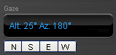**Gaze**

This displays the altitude/azimuth coordinates of where you’re looking.

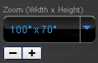**Zoom**

This shows your angular field of view. In general, you can zoom in and out by using the scroll wheel on your mouse. Or you can use the (-) or (+) buttons.

**Side Tab Menus**

Moreover, you also have a number of side panes that can allow you to pull up favorites, labels, or other information:



Clicking on a pane causes the pane to slide out, revealing a set of controls.

The most useful one for this lab, is under the Status pane. Click on the + next to Time layer to expand it. Here, you will see a more detailed view of the Time and Date display. But the most useful for this lab is the Julian date!

If you have any questions at any time, please don’t hesitate to ask your TA. It is very important that you understand how to manipulate your environment before you move on to the exercise itself.

# III. Kepler’s Laws

## Kepler’s 1st Law

Any body in orbit about another moves in an **elliptical** orbit with the central mass at one of the **foci**. In the case of the planets in our Solar System, these ellipses are very circular looking and are not very eccentric like the orbits of comets or asteroids.

## Kepler’s 2nd Law

When a body moves in an elliptical orbit, it moves faster when it is close to the central mass, and it moves slower when it is further away. This produces the so-called "law of equal areas", that an orbiting body sweeps out equal areas in equal times. In the figure below, areas A, B, and C will have the same area if the time intervals are also the same.

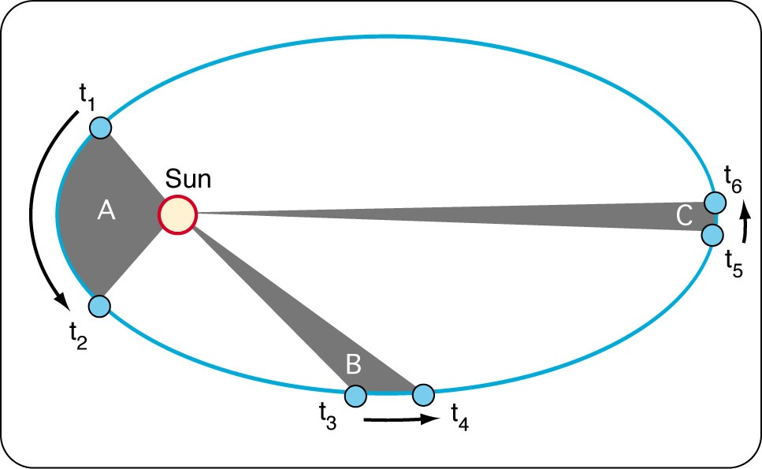

## Kepler’s 3rd Law

The first two laws state properties of orbital motion. Kepler’s Third Law is related to both of these laws but goes further and states that the **period** of a planet’s orbit is directly related to the **radius** of that orbit through a simple relation.

$${(\text{Period})}^{a}={(\text{Radius)}}^{b}$$

We are going to test that assertion and determine values for *a* and *b* which allow Kepler's Third Law to hold true for our solar system.

# IV. The Experiment

## Step 1: Measure Orbital Period of the Inner Planets

**Note:** Before beginning this section, download the Orbital Motion Spreadsheet from the location indicated by your instructor.

Using the Starry Night software, we are going to measure the orbital periods of the innner planets in our Solar System.

* Use the software to present a view of the Inner Solar System. From the side tab menu on the left-hand side of the screen, select:  
  Favourites 🡪 Solar System 🡪 Inner Solar System 🡪 Inner Solar System  
  You should now see the inner planets – Mercury, Venus, Earth, Mars – as well and their orbital paths.
* Tilt your view of the solar system until you can clearly see the entirety of each orbit from a top view. To do this, hold the SHIFT key and click and drag down. Release the SHIFT key and click and drag to re-center the image. Repeat until you have a good view of the orbits.
* Begin with Mercury. Using the time tools at the top of your screen, move Mercury until it lines up with the tick mark (not the arrow!) along the orbital path. This marks the position of Mercury at **perihelion** – the point in a planet's orbit where it is closest to the sun. Note the date and type it into the "Initial Date" box in the Orbital Motion Spreadsheet
* Allow time to move forward until Mercury has completed ONE complete orbit around the sun. Again, note the date and type it into the "Final Date" box in the Orbital Motion Spreadsheet.
* The spreadsheet with calculate the period for you in units of years. Enter this period into the table for Mercury.
* Repeat for Venus, Earth, and Mars

## Step 2: Measure Average Orbital Radius of the Inner Planets

Now, we will determine the orbital radius for each inner planet.

* From the tool selection menu in the upper left corner of SN, change the cursor to Angular Separation mode. (It looks like a small ruler.)
* Begin with Mercury. Use the scroll wheel of your mouse to zoom into the orbit of Mercury. Using the time tools, move Mercury until it is aligned with the tick mark denoting perihelion.
* With the cursor in Angular Separation mode, click on the Sun and drag the cursor to the location of Mercury at perihelion. A lot of information will be displayed when you do this. You are looking for the Sun-to-Mercury distance given in **Astronomical Units (AU)** – one AU is the average Earth orbital radius. When you find this distance, note it and type it into the Orbital Motion Spreadsheet in the box labeled "Perihelion."
* Using the time tools, move Mercury until it is **half way** through its orbit on the opposite side of perihelion. This location is known as **aphelion** – the point in a planet's orbit where it is furthest from the sun. Once again, click on the Sun and drag the cursor to the location of Mercury, now at aphelion. Note the distance between the Sun and Mercury and type it into the Orbital Motion Spreadsheet under "Aphelion.”
* The spreadsheet with automatically calculate the average of these two distances, which will the average orbital radius. Enter this radius into the spreadsheet for Mercury.
* Repeat for Venus, Earth, and Mars.

## Step 3: Repeat for the Outer Planets

Use the software to present a view of the Outer Solar System. From the side tab menu on the left-hand side of the screen, select:  
Favourites 🡪 Solar System 🡪 Outer Solar System 🡪 Outer Solar System

Repeat steps 1 and 2 with the Outer Solar System: Jupiter, Saturn, Uranus, and Neptune.

## Step 4: Determine Kepler’s 3rd Law

We will now use the measurements of orbital period and orbital radius to derive the functional form of Kepler's Third Law. We know that Kepler’s Third Law “simply” relates period and orbital radius. What one person refers to as simple may differ dramatically from what another person terms simple. In this case, simple means that the two quantities are related, but each term is raised to some power, i.e. period cubed, or radius to the 5th power.

A very simple way to determine these power terms is to use the logarithm of the data. For example, if the following equation holds:

$${(\text{Period})}^{a}= {(\text{Radius})}^{b}$$

Then by taking the logarithm, the equation becomes a lot simpler to graph:

$$\log_{10}\left(\text{Period}\right)=\left(\frac{b}{a}\right)\log_{10}{(\text{Radius})}$$

With your data, use a similar approach to determine the exponents used in Kepler's Third Law. The Orbital Motion Spreadsheet should have a tab showing a graph of the logarithm of period versus the logarithm of orbital radius.

1. What part of the graph gives you the ratio of the exponents (b/a)?

The ratio of the exponents will be given to you as a decimal. When you convert that decimal into a fraction, the numerator (top) will be the exponent *b*, and the denominator (bottom) will be the exponent *a* in Kepler's Third Law. Here are the decimal values of some common simple exponent ratios:

|  |  |
| --- | --- |
| Decimal Value | Ratio |
| 2.5 | 5/2 |
| 2.0 | 4/2 |
| 1.5 | 3/2 |
| 1.0 | 2/2 |
| 1.66 | 5/3 |
| 1.33 | 4/3 |
| 1.0 | 3/3 |
| 0.66 | 2/3 |
| 0.33 | 1/3 |
| 1.25 | 5/4 |
| 1.0 | 4/4 |
| 0.75 | 3/4 |
| 0.5 | 2/4 |
| 0.25 | 1/4 |

1. Which decimal most closely matches the value from your graph? What is the corresponding ratio (b/a) for this decimal?
2. What expression do you get for Kepler’s Third Law?
3. Solve Kepler's Third Law for the period. What does it tell you about the period of a small orbit, versus the period of a large orbit? Does this make sense when you refer to Kepler’s Second Law?

# V. Kepler’s Laws: Follow-up Questions

1. When you observed the motion of the planets in the inner and outer solar system, did the radius of the orbit stay the same as the planet moved? Where was the radius the shortest? Where was the radius the largest?
2. Did the point of closest approach to the Sun (perihelion) occur at the same place in the orbit for each planet? If not, take a guess why not.
3. The planets' orbits are very close to circular – did you perceive any change in orbital speed as the planets moved around their orbits?
4. At which point in its orbit should a planet be moving the fastest? At which point should it be moving the slowest?
5. The final tab on the Orbital Motion Spreadsheet shows a plot of each planet's velocity against its orbital radius. This curve is called a Keplerian rotation curve and is used to look for protoplanetary disks around other stars! If the material around a star is seen to move with the same distribution, then we know the material is bound to the star as the planets are bound to the Sun.
   1. Describe the shape of the rotation curve. Be specific.
   2. Which planet moves fastest around Sun? Which moves the slowest?
   3. Pluto is a dwarf planet orbiting the Sun at an average distance greater than the orbit of Neptune. How will the orbital period of Pluto compare to the 8 planets of the Solar System?
   4. What is the orbital velocity of Earth in kilometers per second?
   5. What is the orbital velocity of the Earth in miles per hour?  
      Conversions: 1 km = 0.62 mi  
       1 hr = 3600 sec
6. (Fill in the Blank): The fundamental force that governs the motion of   
     
   bodies in orbit is ___________________.
   1. (Circle One): The Sun pulls more (strongly / weakly) as objects move closer.

This force is governed by an equation that accounts for the mass of the central object (M), the mass of the orbiting body (m), and the radius between them (r). The constant G is known as the gravitational constant, and is a different number than the acceleration due to gravity (though the two are related!).

* 1. If you took Earth and moved it twice as far from the Sun, would the force get stronger or weaker? By how much?
  2. Which planets feels this force most strongly? Which planet feels this force most weakly?

1. The final form of Kepler's Third Law is a remarkable formula and makes some very simple predictions. Do you expect this Law to be obeyed outside the Solar System? Explain your reasoning.
2. Rank the planets by orbital radius, orbital period, and orbital velocity.

Smallest Orbital Radius Largest

Shortest Period Longest

Slowest Orbital Velocity Fastest

# VI. Additional Activity – Retrograde Motion

Some planets appear, at times, to move backward in the sky as seen from Earth. "Mars is in retrograde" is a common statement in astrology and horoscopes and is used by these groups to denote a change in the way the planets are influencing our lives. However, our favorite science (astronomy!) tells us that the planets continually orbiting around the Sun. They don't move backwards in space. So why do some planets go through **apparent retrograde**? It's because our perspective of the planets change through time!

The figure below shows the location of Earth and Mars at 7 points in their orbits, each taken at the same time. Point 1, for example, shows where Earth is in its orbit and where Mars would be in its orbit at that same moment.

* Using a ruler, draw a straight line connecting Earth and Mars. Extend this line outward (toward the stars) to determine where Mars would appear in the sky at each point.
* Mark a circle at the end of each line and number those dots 1, 2, 3, 4, etc, corresponding to the point of Earth and Mars in their orbits.
* Draw a line to connect the points in numeric order. This shows the path Mars appears to take in our night sky as we all orbit around the sun!

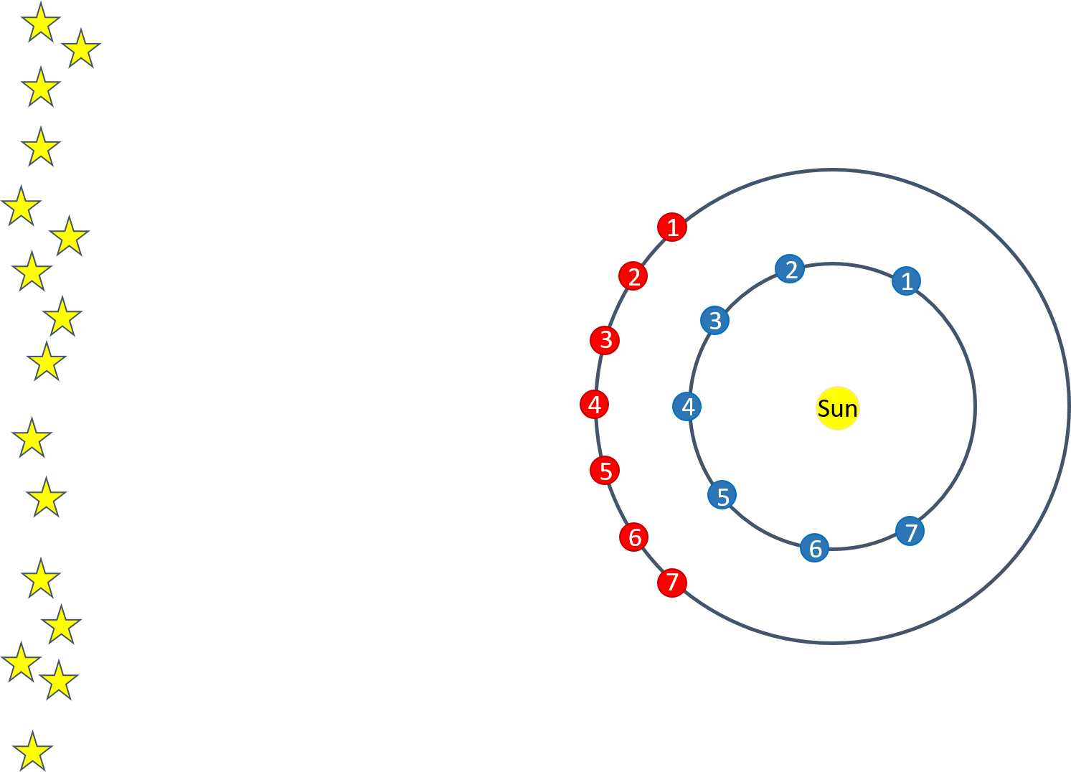

1. Explain the path Mars appears to take in the night sky. At what points in this path would Mars be in apparent retrograde?
2. Does Mars ever actually move backward in space? If not, why does it appear to move backwards in our night sky?

# Conclusion

Summarize the concepts you learned about in tonight’s lab. What did you learn about each of these concept? Summarize the experiment. How did this experiment help you understanding of the concepts?

# Appendix: Data Table

|  |  |  |  |
| --- | --- | --- | --- |
| Data Table | Period (years) | Avg orbital radius (AU) | Orbital Speed (km/s) |
| Mercury |  |  |  |
| Venus |  |  |  |
| Earth |  |  |  |
| Mars |  |  |  |
| Jupiter |  |  |  |
| Saturn |  |  |  |
| Uranus |  |  |  |
| Neptune |  |  |  |