**NAME:___________________________**

**Parallax and Proper Motion**

**What will you learn in this Lab?**

We will be introducing you to the idea of parallax and how it can be used to measure the distance to objects not only here on Earth but also in the nearby Universe. This is a very important tool used by astronomers and can be used to check other methods for measuring distances to the stars. It does have some limitations though, as you will discover in this exercise. In the first part of the lab you will explore apparent change in the position of stars in our night sky due to parallax, and then you will use computers to measure the apparent proper motion and space velocities of some well-known stars.

**What do I need to bring to the Class with me to do this Lab?**

For this lab you will need:

* A copy of this lab script
* A pencil
* A calculator

**Introduction**

Determining the distances to stars and galaxies is one of the most important, but also one of the most difficult measurements in astronomy. Think about looking at a star in the night sky, and comparing it to the way the Sun looks in the daytime. The Sun is big and bright, the stars small and dim. They look completely different, and until the last few hundred years everyone believed that they *were* different. The ancient Greeks believed that the Sun and the stars were all about the same distance from the Earth; not an unreasonable conclusion, given that both rise and set in the sky in roughly the same way. Because they believed that the stars and the Sun were at the same distance from us, they also necessarily believed that the Sun was fundamentally very different from the stars; after all, their appearance is quite different. We now know that the Sun is in fact just another star, similar to many of the stars you can see with your own eyes on any clear night. The reason the Sun appears different to us, of course, is simply that it is much closer than any other star. Similarly, since the late 1960s we have learned that some objects which appear to be stars (called “quasi-stellar objects,” or *quasars*), are in fact vastly farther away than the stars in our own galaxy, and correspondingly emit trillions of times more light than a single star.

Thus, determining distances to stars is very important for understanding their physical properties. But how do you find the distance to something so far away? The most direct method is called *parallax*. The basic idea behind this method is simple: when an object is viewed from two different places, it seems to shift position more if it is nearby than if it is far away. To see an example of this, hold a finger up at arm’s length in front of you. Close one eye, and line up your finger with a distant object. Now look at your finger with your other eye—it will no longer be lined up with the distant object. As you close one eye and then the other, your finger seems to move back and forth. This shift is called *parallax*. Your finger is not really moving; rather, the position which you view it from is changing (by an amount equal to the distance between your eyes), making it appear to move.

An everyday example of parallax that you have probably experienced is the fact that the moon seems to follow you as you are driving or riding in a car. The nearby scenery (mountains, buildings, etc.) move by as you drive along, but the moon stays in exactly the same position. When you experience this, you are seeing the parallax shift of nearby objects (the nearby scenery) relative to distant ones (the moon).

**Parallax in astronomy**

What does this have to do with the stars? As the Earth moves around the Sun, we view the stars from a continuously changing position. Thus, nearby stars appear to change positions compared to distant stars. The figure below shows how parallax is measured in astronomy. The big difference is that even the nearest stars are quite far away compared to the diameter of the Earth’s orbit (the 2 AU baseline shown).[1]



Measuring the parallax of a nearby star.

Because the stars are so far away, the parallax angle of even the nearest star is extremely small.[2] One of the nearest stars, Alpha Centauri, has a parallax angle of only 0.75" (arcseconds), only 1/4800 of a degree! Using such small angles in the formula we used above (which is designed to use degrees) is somewhat cumbersome. Thus, astronomers have created a special unit, the *parsec*, for working with the distances to stars.[3] A parsec is the distance at which a star will have a parallax shift of exactly one arcsecond as observed from Earth; it is also about 3.26 light years.

Using the units of parsecs (for distance) and arcseconds (for parallax angle) allows us to rewrite the distance formula in a particularly simple way:

d = 1/p

where d is the distance to the star in parsecs and p is the star's parallax angle in arcseconds. (The definition of parsec in this way is the reason we use only the angle p, and not the full parallax shift 2p, when we talk about parallax angle.) Thus, if a star has a parallax shift of 0.5", its distance is simply d = 1/0.5 = 2 parsecs.

## Part I. Measuring distance using parallax

Consider the diagram to the right.

1. Imagine that you are looking at the stars from Earth in January. Use a straightedge or a ruler to draw a straight line from Earth in January, through the Nearby Star (Star A), out to the Distant Stars. Which of the distant stars would appear closest to Star A in your night sky in January? Circle this distant star and label it “Jan”.
2. Repeat Question 1 for July and label the distant star “July”.
3. In the box below, the same distant stars are shown, as you would see them in the night sky. Draw a small X to indicate the position of Star A as seen in January and label it “Star A Jan”.

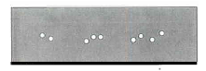

1. In the same box, draw another X to indicate the position of Star A as seen in July and label it “Star A July”.
2. Describe how Star A would appear to move among the distant stars as Earth orbits the Sun counterclockwise from January of one year, through July, to January of the following year.

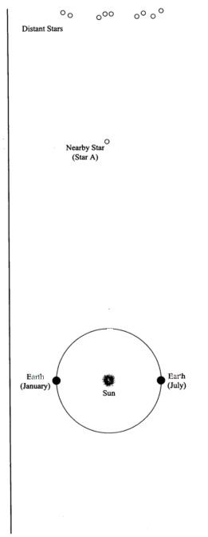

The apparent motion of nearby objects relative to distant objects, which you just describe, is called **parallax**.

1. Consider two stars (C and D) that both exhibit parallax. If Star C appears to move back and forth by a greater amount than Star D, which star do you think is actually closer to you? If you’re not sure, just take a guess. We’ll return to this question later in this activity.

_________

**What’s a parsec?**

1. Starting from Earth in January, draw a line through Star A to the top of the page.
2. There is now a narrow triangle, created by the line you drew, the dotted line provided in the diagram, and the line connecting the Earth and the Sun. The small angle, just below Star A, formed by the two longest sides of this triangle is called the **parallax angle** for Star A. Label this angle “**pA**”.

Knowing a star’s parallax angle allows us to calculate the distance to the star. Since even the nearest stars are still very far away, parallax angles are extremely small. These parallax angles are measured in “arcseconds” where an arcsecond is 1/3600 of 1 degree.

To describe the distances to the stars, astronomers use a unit of length called the **parsec**. One parsec is defined as the distance to a star that has a **par**allax angle of exactly 1 arc**sec**ond. The distance from the Sun to a star 1 parsec away is 206,265 times the Earth-Sun distance or 206,265 AU. (Note that the diagram to the right is not drawn to scale.)

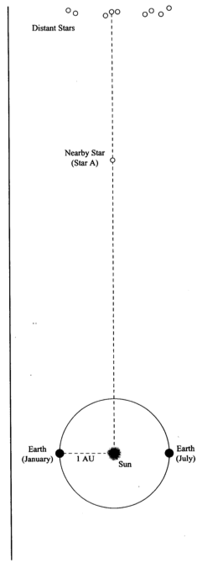

1. If the parallax angle for Star A (**pA**) is 1 arcsecond, what is the distance from the Sun to Star A? (Hint: Use parsec as your unit of distance.) **Label this on the diagram**.
2. Is a parsec a unit of length or a unit of angle? It can’t be both.

**Note**: Since the distance from the Sun to even the closest star is much, much greater than the distance from the Earth to the Sun (1 AU), we can consider the distance from Earth to a star and the distance from the Sun to that star to be approximately equal.

**Part II. Finding Stellar Distance Using Parallax**

Consider the star field drawing shown in Figure 1. This represents a tiny patch of our night sky. In this drawing we will imagine that the angle separating Stars A and B is just 1/2 of an arcsecond.

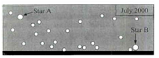

**Fig. 1**

In Figure 2 (page 6) there are drawings of this star field taken at different times during the year. One star in the field moves back and forth across the star field (exhibits parallax) with respect to the other, more distant stars.

1. Using Figure 2, determine which star exhibits parallax. Circle that star on each picture in Figure 2.
2. In Figure 1, draw a line that shows the range of motion for the star you saw exhibiting parallax in the drawings from Figure 2. Label the end points of this line with the months when the star appears at those end points.
3. How many times bigger is the separation between Stars A and B compared to the distance between the end points of the line showing the range of motion for the star exhibiting parallax?
4. Recall that Stars A and B have an angular separation of 1/2 of an arcsecond in Figure 1. What is the angular separation between the end points that you marked in Figure 1 for the star exhibiting parallax (in arcseconds).

**Note:** We define a star’s **parallax angle** as **half** the angular separation between the end points of the star’s angular motion.

1. What is the parallax angle for the nearby star exhibiting parallax from Question 14?

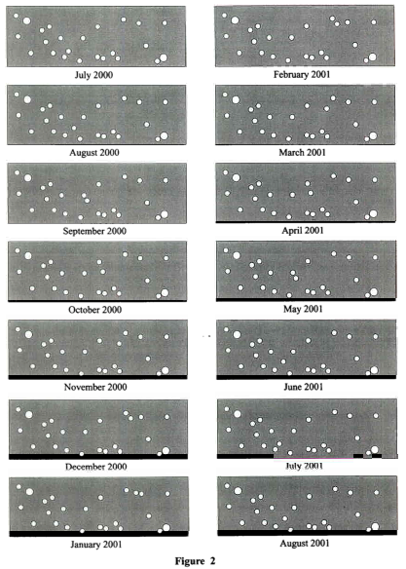

1. **a.** What is the distance (in parsecs) for this star?

**b.** What is this distance in AU (remember 1 AU is the average distance between the Earth and the Sun)?

**c.** What is this distance in Light-years?

**Part III. Additional Questions on Parallax**

1. Given the parallax to Alpha Centauri from the lab script, what is the distance to that star in parsecs?
2. The space observatory Hipparcos was launched in 1989 to measure very accurate parallax angles of stars; it has provided the most accurate parallax measurements ever obtained to date. The smallest parallax angle it can measure is 0.002". What is the most distant star to which Hipparcos can find the distance?
3. The space observatory Gaia was launched in 2013 as the successor to Hipparcos and is now starting to return data on its ambitious mission to catalog more than 1 billion stars’ three-dimensional position in our Milky Way. The smallest parallax angle it can measure, for stars of at least magnitude 12, is 0.000008”. What is the most distant star to which Gaia can measure parallax?
4. The center of our Galaxy is about 8,500 parsecs from Earth.
   1. What would be the parallax angle of a star near the center of the Galaxy?
   2. Could this angle be measured by Hipparcos?
   3. Could this angle be measured by Gaia?
5. If you built a telescope on Mars and measured the parallax angle of a nearby star, how would your measurement compare to the parallax angle of the same star as measured from Earth? Draw a picture and explain in words. If you answered that the parallax angle would be different, exactly how many times bigger or smaller would it be? (Mars’ distance from the Sun is 1.5 AU.)

**Part IV. Proper Motion of Stars**

The other cause of annual change in the position of a star is the actual real motion of the star through space. This is called the *proper motion* of the star and is measured as an angular speed in *arcseconds per year*, or since the shifts are so small, *milliarcseconds per year*. Of course, the speed you would measure in the night sky is only the perpendicular part of the velocity of the star: if the star were coming straight at you, you would not perceive it to be moving! Thus the actual speed of a star is usually more than what you would measure from proper motion.

We will use the computers to measure these types of apparent motion in the night sky so you can make some estimate of the real space velocities of the stars in question. The measurements you make will be recorded in the spreadsheet that can be found on the AST 114 website under tonight’s lab script. Download this spreadsheet on to your computer.

**General Information for operating the *Starry Night* program**

*Starry Night* is a very powerful virtual planetarium program that can show the sky on any date in any year from any location. It has easy to use controls, a few of which are described on the following two pages:

In the very upper-left corner is your tool selection tool. By default, SN opens in adaptive mode which allows you to click and drag around the scene, and brings up information when you hover over objects in the sky. For tonight’s lab you will want to use Angular Separation. You can play around with the other options. The most useful ones you’ll use in lab are:



**Angular Separation** – This tool lets you accurately measure the separation between two objects in the main window. Click on the first object, then drag to the second object. The angular separation between the two objects will be displayed, as well as the physical distance between them.

**Arrow** – Allows you to point at certain objects in the main window, and SN will tell you what it is, and information about the object.

**Constellation** – As you pan through the night sky, clicking will bring up the constellation label and art for the object you click on.

**Hand** – The hand tool lets you click and drag to pan around the main window.

**Magnification** – The magnification mode allows you to click anywhere in the main window and it will zoom in to that point. Alternatively, you can also click and drag a box, that you want to zoom to.

**The panel along the top functions as your information display.**

**Time and Date**

Starry Night opens up to the current date/time. By clicking on any of the date/time elements you can enter a new value. You can also always reset it to the current time, sunrise, or sunset today by clicking on the buttons below the display.



**Time Flow Rate**

By default SN advances at the same rate as real time, hence the 1x speed. Of course this is absurdly slow, so you can click on the arrow next to the rate to select a different speed. Or, you can even select a discrete time step so that SN plays forward 1 day at a time or other interval.

You can move one step at a time by using the buttons at either end of the button panel. The inner arrow buttons will change the display real time – i.e. one second per second. The stop button halts any display updates. This will be your most useful tool for this lab exercise!

**Viewing Location**

By default, this should be set to Phoenix, AZ. But you can also pick a different location to see what the sky looks anywhere in the world! If you’re lost, the Home button will always take you back to Phoenix at the current time. The two arrow buttons next to Home will allow you change your viewing altitude.

**Gaze**

This displays the altitude/azimuth coordinates of where you’re looking.



**Zoom**

This shows your angular field of view. In general, you can zoom in and out by using the scroll wheel on your mouse. Or you can use the (-) or (+) buttons.

Moreover, you also have a number of side panes that can allow you to pull up favorites, labels, or other information:



Clicking on a pane causes the pane to slide out, revealing a set of controls.

Click on the next to **Time** layer to expand it. Here, you will see a more detailed view of the Time and Date display. But the most useful for this lab is the Julian date!

**Specific instructions for use of Starry Night Pro 6 in tonight’s lab:**

1. Start up Starry Night Pro 6 from desktop or search for it on computer. Once opened you may get a couple of warning messages about licenses. We will ignore these by hitting Later, then Cancel.
2. Make sure that “Daylight” and “Horizon” are set to “Hide”. These two setting are found under the View tab and probably currently say “Hide Sky” and “Hide Horizon”. If you click on each one, they will hide these features. What we want is for Starry Night to show a consistently dark sky and no horizon so as to not interfere with our tracking of given stars.
3. Set to view in Galactic coordinates, found my starting at the Options tab and selecting: OPTIONS >> Orientation >> *Galactic*
4. Locate your first star on the Excel spreadsheet by simultaneously holding Ctrl+F in Starry Night (or command+F for Macs). This will pull up a find menu that will help you locate the object and center it on your screen.
5. Then, zoom in until your field of view is no more than 2 degrees. For certain stars your field of view may need to be much larger.
6. Using the Adaptive tool, grab and move the sky slightly to just barely off-center the star. Then, go to the upper-left corner to the tool selection tool and select Angular Separation. If you have trouble finding it, see instructions on page 8 for help.

We now want to get a sense of which direction our object will move with the passage of many years.

1. An easy way to accomplish this is to click on the year in the time bar, found in the upper left corner of the screen, to highlight it. Then, press the up-arrow button to advance time in one year increments. Many years may have to pass before you see movement in your target star relative to the surrounding stars.
2. To speed up the process, hold down the up-arrow button and the years will pass very quickly.
3. Now, identify a star that is directly in the path of your moving target star, but **does not get pass by the target star during the elapse time** and make a note of its position and name. This star will be your fixed background reference star.
4. Reset time to today’s date, and make your first measurement of angular separation between these two stars.
5. Angular measurement can be done by hovering the pointer over your target star, pressing and holding the left mouse button, and then dragging to your reference star. A red line traces as you move between the stars and displays the angular separation. Record this value in the given spreadsheet.
6. Then, advance time again by a requisite amount to move your target star a reasonable amount.
7. Make a second measurement of the angular separation and record this value in the appropriate cell of the spreadsheet. The spreadsheet only has one location for entering the elapsed time, so make sure **all stars are measured with the same elapsed time.**
8. From these measurements you can then calculate the proper motion of each star in radians per year.
9. You need one additional piece of information from Starry Night, and that is the distance to your subject star. You can see this piece of information by hovering the cursor over your star. Record this distance in the spreadsheet and now you can complete the rest of the calculations.
10. Once you are done with all the objects listed, go find one more star of your own that you’d like to find out the speed of. Record it in the space provided on the spreadsheet and do the same analysis.

The spreadsheet includes various calculated columns that you should review so that you understand how final velocities are determined. Remember that a speed of 1 light year per year is the same as 300,000 km/s. Here is a quick description on how to find the column values.

* Initial and Final angular separation in arcseconds: Use the Measuring Tool.
* Measured proper motion (“/yr) = |Final ang. separation – Initial ang. separation| / time step
* Measured proper motion (rad/yr) = Measured proper motion (“/yr) / 206,265
* Distance (ly): Use the pointer tool and point at the star in question
* Velocity (ly/yr) = Distance (ly) * Measured proper motion (rad/yr)
* Velocity (km/s) = Velocity (ly/yr) * 300,000 (km/s)
* Velocity (pc/yr) = Velocity (km/s) * 3.15 x 107 (s/yr) / 3.086 x 1013 (km/pc)

1. What is the actual space velocity you measured perpendicular to your line of sight for Sirius?

**a.** Express your answer in km/sec.

**b.** Also express your answer in parsecs/year.

1. **a.** For the fastest star you find, calculate how long it would take that star to orbit the Galaxy – an estimated distance of about 48,200 parsecs at the orbital radius of our Sun. Remember that t=d/v.

**b**. Is this reasonable? If not, why not?

1. **a.** Was it generally true that the more distant stars showed a smaller proper motion?

1. Were there any exceptions?
2. Why do you think this was so?

**Summarize what you have learned tonight:**

1. One astronomical unit, or AU, is the average distance from the Earth to the Sun.
2. This is part of the reason that the idea of an Earth-centered universe persisted as long as it did. The ancient Greeks knew that stars should show parallax shifts if the Earth moved, but Greek astronomers’ best measurements showed no parallax shifts. Therefore, they concluded that the Earth was not moving.
3. The word “parsec” is a combination of the words *parallax* and *arcsecond*, revealing its origin in working with stellar parallaxes.