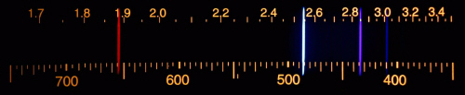EXAMPLE SPECTRA

Hydrogen

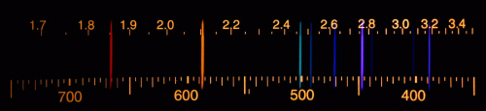

Helium

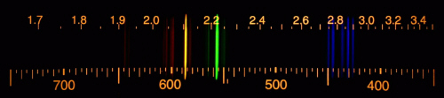

Krypton

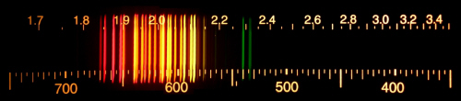

Neon

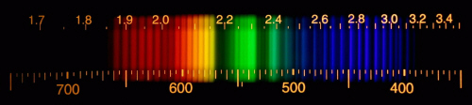

Nitrogen

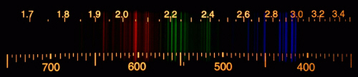

Argon

**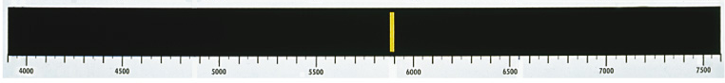\*Note the axis is inverted for the following 3 spectra**

Sodium

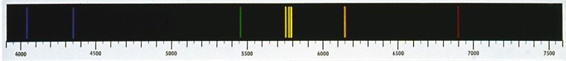

Mercury



Calcium