NAME: _________________________________

**SPECTROSCOPY**

**What will you learn in this Lab?**

This lab is designed to introduce you to spectra and how they are related to light and atoms. It will teach you the different types of spectra and their origins. It will also teach you how the spectrum of each star is like a fingerprint that can tell you about its temperature and chemical composition. With this knowledge you will be able to classify the spectral type of stars, and later in the semester their distance from Earth.

**What do I need to bring to the Class with me to do this Lab?**

For this lab you will need:

* A copy of this lab script
* A pencil
* Scientific calculator

# I. Light

The electromagnetic phenomena that we call “light” can be adequately understood by its wave-like properties. If you are unfamiliar with the physical description of waves, consider the following figure.

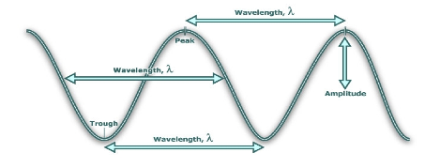

Fig. 1: Light wave

A wave can be defined by its **wavelength** and **amplitude**. The wavelength is the distance between two recurring points on the wave (peak-to-peak, trough-to-trough, rising slope to rising slope, etc.), while the amplitude is the distance between the point of equilibrium (the middle) and the peak or trough. In other words, the amplitude is half the peak-to-trough distance.

The **frequency** of a wave describes the number of successive peaks that cycle through every second. It can be described, mathematically, as



where *f* is the frequency in Hertz and *P* is the period of the wave in seconds. The **period** is simply the time it takes for the wave to cycle between successive peaks (or troughs, or any corresponding point in the waveform).

Light waves are manifestations of oscillations in electro-magnetic fields. For light waves, the relationship between wavelength/frequency and “color” of a wave is:

REDDER light has LONGER Wavelengths and LOWER Frequencies

BLUER light has SHORTER wavelengths and HIGHER Frequencies

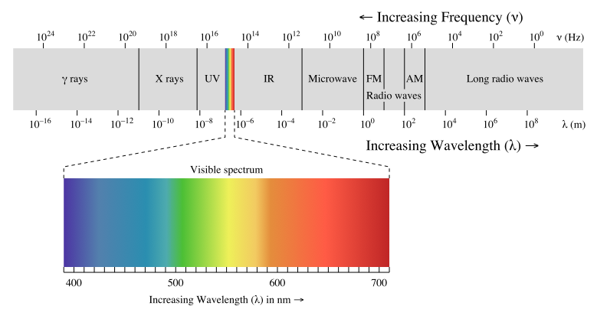

Fig. 2: Electromagnetic Spectrum

The speed of any wave is described by the multiplication of the wavelength (how long the wave is from peak-to-peak) and the frequency (how many peaks cycle through each second),

where the Greek letter lambda, λ, is wavelength and *f* is frequency. Unlike water waves or waves through other media, light is special because it always travels at the same speed – the speed of light!

# II. The Spectrum of Light

When you pass white light through a prism (Fig. 3) the light gets divided into its constituent colors. This happens because the prism “bends” or **refracts** the light at an angle that is dependent on the wavelength of light. Shorter, bluer wavelengths get refracted more (i.e., at a greater angle) than longer, redder wavelengths. Rainbows form when white sunlight refracts through raindrops, causing the colors to separate by wavelength.

A **spectrum** is the outcome of separating light into its components according to wavelength.

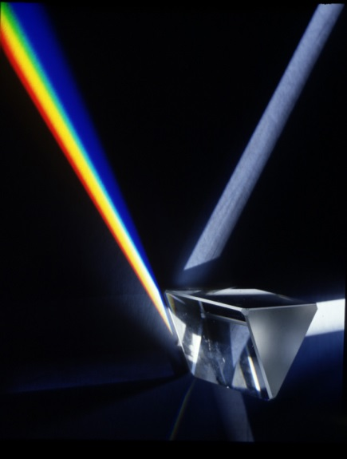 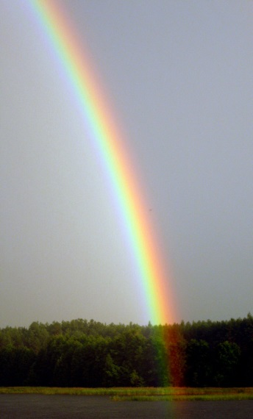

Fig. 3: (Left) Spectrum from a prism. (Right) Raindrops act like prisms forming rainbows.

In astronomy, we often do not see the complete spectra. Sometimes, we see only specific colors. In other situations, we see most of the spectra, but specific wavelengths (colors) of light are missing. Which wavelengths are showing and which are missing provide important information about our universe. To understand the spectra of astronomical objects we first need to understand how it is produced by looking at atoms and how they absorb or emit light.

Atoms form the basic building blocks of nature and are made up of **protons** (positively charged particles) and **neutrons** (neutral particles) in their cores. Surrounding the core are negatively charged **electrons**. These electrons can only exist in certain energy levels around the nucleus. The electrons can be excited into a higher energy level by **absorbing photons** or by colliding with other electrons and atoms. The electrons can then fall down to a lower energy level by **emitting a photon** and releasing the extra energy. In either case, the energy absorbed or emitted is equal to the difference in energy between the two energy levels.

The energy of a photon is related directly to the frequency of the light, and since the speed of light is constant, the energy is also related to the wavelength.

where *h* is the Planck’s constant (6.626 x 10-34 m2 kg/s).

Since electrons can only be in discrete energy levels, they can only emit photons with specific energies, and by the relation above, specific wavelengths. Different atoms have different numbers of electrons and different energy level distributions. **Because of this, different types of atoms (i.e. different elements) emit or absorb photons that are specific to the element they represent just like your fingerprints are specific to you. By measuring the wavelengths of these photons it is possible to identify the element that emitted them.**

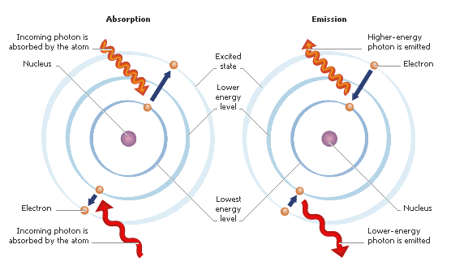

Fig. 4: Models of electrons in atoms absorbing and emitting light.

In some cases, the energy gained by absorbing a photon or through collision is too high. In these cases the electron can be ejected from the atom completely in a process called **ionization**. When an atom is fully ionized it has lost all its electrons, but it does not have to lose all its electrons to be called ionized. The resulting nuclear core of the atom (neutrons and protons) is called an **ion**. The ejected electrons, now moving around the ions, can reattach to the core if they lose energy. In cases when the temperature is too high, the electrons can never lose enough energy to reattach and therefore the atoms stay fully ionized. When this happens the electrons can no longer absorb the characteristic wavelengths of light for that element, and that element (though present) can no longer be observed.

# III. Types of Spectra

Astronomers label spectra depending on whether the entire spectrum is visible (like a rainbow) and whether light is emitted or absorbed by an atom or molecule. There are 3 types of spectra that we will talk about in this course: (i) continuous spectra, (ii) emission spectra, and (iii) absorption spectra.

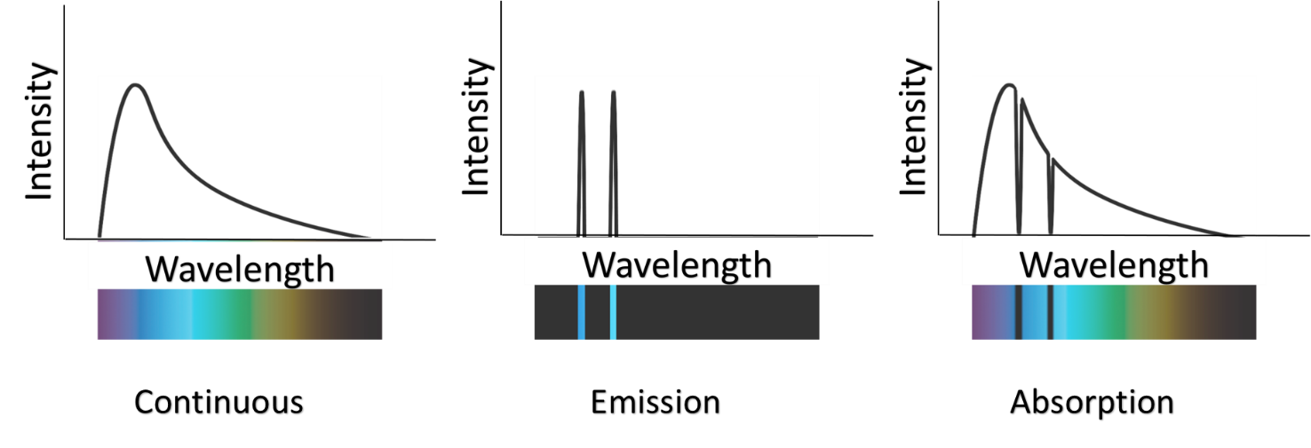Fig. 5: The three types of spectra.

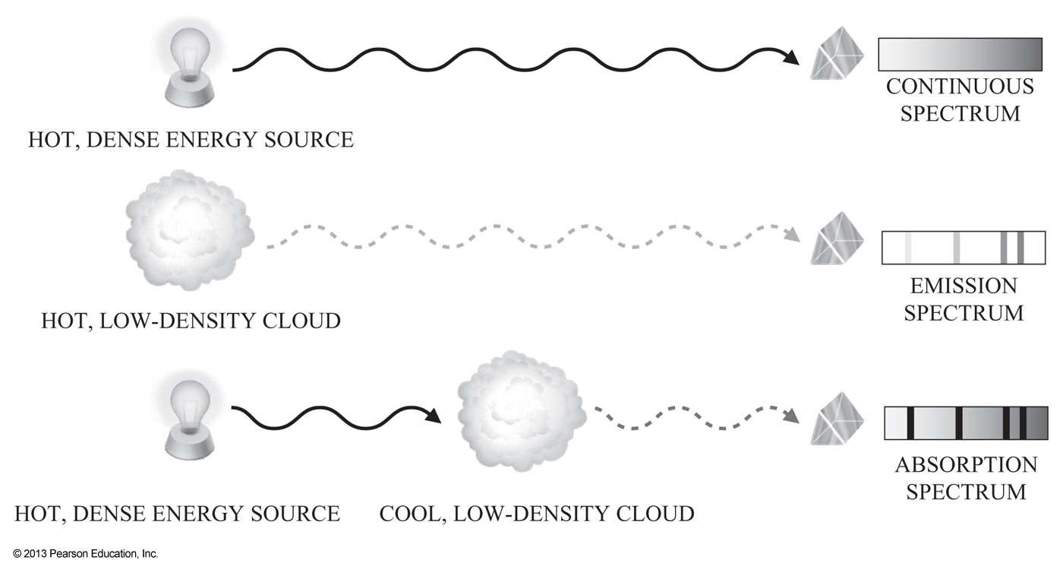

Fig. 6: Examples of how different types of spectra are produced.

**Continuous Spectrum:** These show emission over a wide range of wavelengths/frequencies, with the strength of emission at each wavelength and the wavelength of peak emission *determined by the temperature of the object*. Continuous spectra are seen when the source is a hot, dense object with nothing between the object and the observer. You, as a hot, dense object emit a continuous spectra in the infrared! Other examples of object that emit continuous spectra include an incandescent light bulb and a stove burner.

**Emission Line Spectrum:** Due to the discrete energy levels of electrons in the atoms of a hot gas, specific wavelengths of light can be emitted. These emission lines act as a distinct "fingerprint" for that gas; astronomers use this fact to identify the chemical composition of clouds of gas in deep space. Each different type of atom (hydrogen, helium, lithium, etc.) has its own signature set of specific colors that it emits. Emission spectra observed directly from hot, low-density gas.

**Absorption Line Spectrum:** The opposite of emission lines, absorption spectra are often due to cooler gas absorbing photons emitted from a hot source. An absorption line spectrum appears to be a continuum spectrum with emission lines taken out. Imagine a cloud of cooler interstellar gas nearer to you than a hotter source of continuum radiation; you will see the more distant object's continuum minus those specific energies absorbed by the intervening gas cloud.

# IV. The Experiment

## Part 1: Types of Spectra

Answer the following questions on how and why different types of spectra are produced.

1. What type of spectrum is produced when the light emitted directly from a hot, dense object passes through a prism?
2. What type of spectrum is produced when the light emitted directly from a hot, low-density cloud of gas passes through a prism?
3. Describe in detail the source of light and the path the light must take to produce an absorption spectrum.

** Source: Questions 1-9 are from *Lecture-Tutorials for Introductory Astronomy*, 3rd Ed., E.E. Prather, T.F. Slater, J.P. Adams, G. Brissenden.

1. There are dark lines in the absorption spectrum that represent missing light. What happened to this light that is missing in the absorption line spectrum?
2. Stars like our Sun have low-density, gaseous atmospheres surrounding their hot, dense cores. If you were looking at the spectra of light coming from the Sun (or any star), which type of spectrum would be observed? Explain your reasoning.
3. If a star existed that was only a hot, dense core and did NOT have a low-density atmosphere surrounding it, what type of spectrum would you expect this particular star to give off?
4. One way an atom emits light (photons) occurs when an electron drops down from a high energy level (also referred to as an excited state) to a lower energy level (the lowest energy level is referred to as the ground state.) Will an atom emit light if all of the atom's electrons are in the ground state? Explain your reasoning.
5. In which case does an atom emit more energy (circle one)? Explain your reasoning.

Case A: An electron drops from the first excited state to the ground state.

Case B: An electron drops from the third excited state to the ground state.

1. Use the hypothetical atom drawings (A-F) below to answer the next five questions. There is only one correct choice for each question. To help you answer the following questions, refer to Fig. 4.

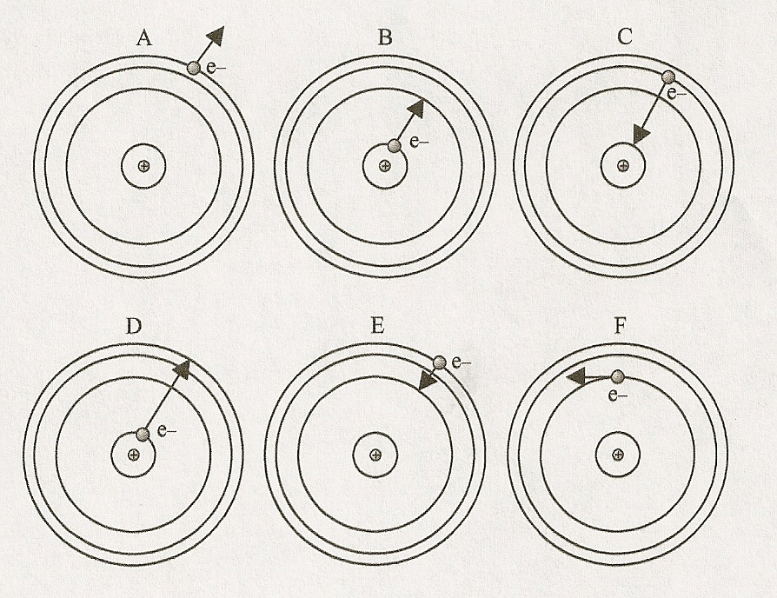

Fig. 7: Emission and absorption in atoms

* 1. Which shows the absorption of violet light? Explain your reasoning.
  2. Which shows the emission of blue light? Explain your reasoning.
  3. Which shows the absorption of green light? Explain your reasoning.
  4. Which shows the emission of orange light? Explain your reasoning.
  5. Which shows an electron being ejected from the atom? (ionization)

## Part II: The Sun’s Spectrum

The image below is the visible portion of the spectrum of the Sun. Answer the following questions using this image.

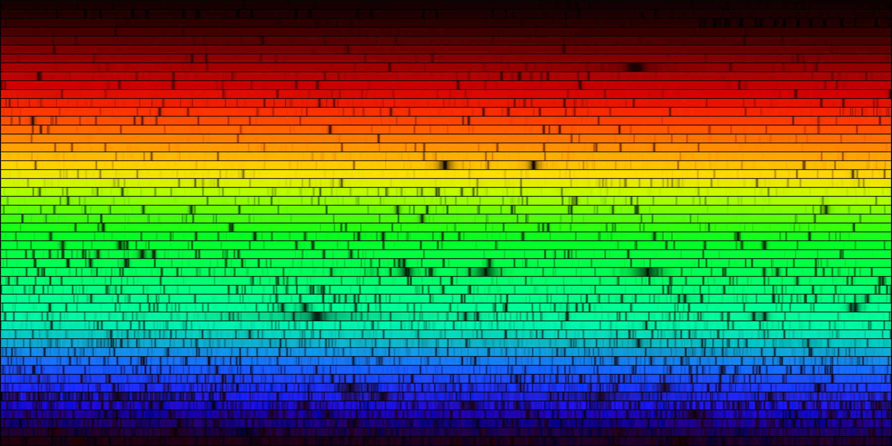

Fig. 8: Sun’s spectrum

1. What kind of spectrum is this?
2. How would you explain the origin of the dark lines in this spectrum? Recall that the Sun is a giant ball of hot gas and that gets hotter closer to the center.

The color of a star is related to its surface temperature, as defined by Wein’s Law,

where λpeak is the peak wavelength (aka color) of the star in units of *µm* (micrometers) and *T* is the temperature of the star in units of Kelvin.

1. The Sun’s surface temperature is 5780 K. What is the peak wavelength emitted by the Sun? SHOW YOUR WORK.

Here are approximate wavelengths associated with colors in the visible light region of the electromagnetic spectrum:

violet ≈ 0.35 - 0.39 μm indigo ≈ 0.39 - 0.42 μm blue ≈ 0.42 - 0.46 μm aqua ≈ 0.46 - 0.50 μm green ≈ 0.50 - 0.56 μm yellow ≈ 0.56 - 0.60 μm orange ≈ 0.60 – 0.65 μm red ≈ 0.65 - 0.75μm

1. What color does your answer for the previous question correspond to?

## Part III: Observing Spectra

We will be studying light through a spectroscope. A **spectroscope** (or spectrometer) separates light into its different color components. When you look through the spectroscope, you should notice several colored lines.

Look at the figures below. The correct orientation of the spectrometer is shown in the left image. To see the spectrum point the film transparency **slit** toward the light source and look through the diffraction grating. The spectrum will appear to the left on the calibrated scale.

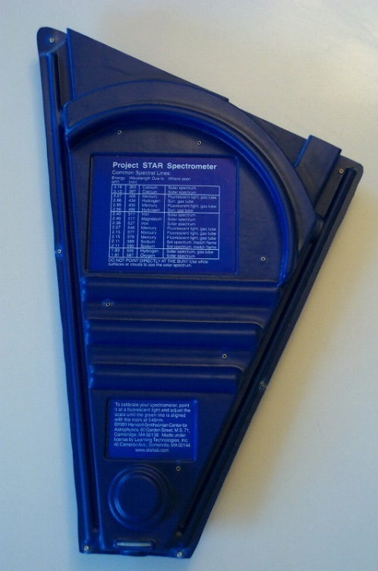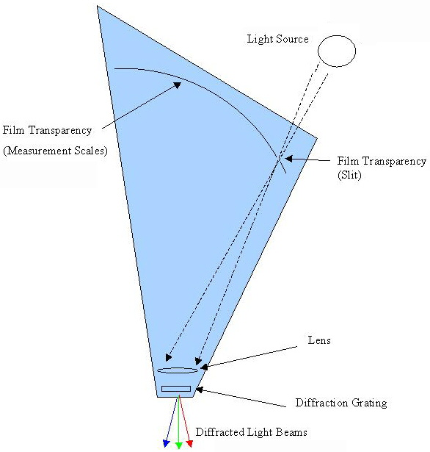

Fig. 9: Diagram of spectroscope you will use during the lab.

Obviously, light can be made up of a variety of different colors, both discrete and continuous. For instance, the white-light bulbs that you have at home and use everyday do **not** put out "white light" as is commonly believed; instead, light of many colors is emitted and the different colors combine to look like white light.

As we have already discussed, each element in the periodic table has a distinct atomic structure. Energy levels of the electrons in each kind of atom are a signature; we can use spectra to identify the source atoms.

In the next part of this lab you will look at the emission line spectrum of several different gas lamps — please do not touch the bulbs! By recording the emission lines you see and comparing them to a list of known emission spectra, you will identify six different gases seen in emission.

Fill in the emission lines you see on the charts below (make your best guess based on the number and general placement of the emission lines, according to the colors and wavelengths that have been given). Identify what element you have in each tube, based on the key of reference spectra provided. Use the provided color pencils.

**Practice Element:________________** : : : : | : : : : | : : : : | : : : : | : : : :

|  |  |  |  |
| --- | --- | --- | --- |
| 700 nm | 600 nm | 500 nm | 400 nm |
| red | yellow | green | Indigo |

|  |  |  |
| --- | --- | --- |
| **Tube #** | **Sketch of emission lines** | **Element** |
| 1 | : : : : | : : : : | : : : : | : : : : | : : : :    700 nm 600 nm 500 nm 400 nm  red yellow green indigo |  |
| 2 | : : : : | : : : : | : : : : | : : : : | : : : :    700 nm 600 nm 500 nm 400 nm  red yellow green indigo |  |
| 3 | : : : : | : : : : | : : : : | : : : : | : : : :    700 nm 600 nm 500 nm 400 nm  red yellow green indigo |  |
| 4 | : : : : | : : : : | : : : : | : : : : | : : : :    700 nm 600 nm 500 nm 400 nm  red yellow green indigo |  |
| 5 | : : : : | : : : : | : : : : | : : : : | : : : :    700 nm 600 nm 500 nm 400 nm  red yellow green indigo |  |
| 6 | : : : : | : : : : | : : : : | : : : : | : : : :    700 nm 600 nm 500 nm 400 nm  red yellow green indigo |  |

## Part IV: Everyday Applications

Look through the spectrometer at any fluorescent bulb (try the lights out in the hallway if the ones in the classroom are off). Make sure you can adequately see the component colors separated. Notice the colors that combine to make up the “white” light you see.

1. Draw the spectrum of the fluorescent bulb below using the spectrometer. What are the component colors of the fluorescent bulb?

: : : : | : : : : | : : : : | : : : : | : : : :

|  |  |  |  |
| --- | --- | --- | --- |
| 700 nm | 600 nm | 500 nm | 400 nm |
| red | yellow | green | indigo |

1. What kind of spectrum do you observe when looking through the spectrometer at a fluorescent bulb?
2. Several gaseous elements are used in a fluorescent bulb. Which elements can you identify from the spectrum?
3. What kind of spectrum do you observe when looking through the spectrometer at the incandescent bulb (light bulb in the desk lamp)?

## Part V: Astronomical Applications

Originally, stars were classified by their spectra. In the late 1890’s, scientists Edward C. Pickering and Williamina P. Fleming of Harvard University labeled stars according to the amount of hydrogen seen in the spectra of the star. Stars with the strongest hydrogen spectral lines were labeled as spectral class A, then B, C, D, etc. all the way down to N. Why did some stars showed strong hydrogen features while others did not? The physical significance was unclear.

In 1901 another scientist in the Harvard lab, Annie Jump Cannon, created her own spectral organization system by dropping some letters and rearranging the rest. The result is a straight-forward classification system that correlated the spectral class to the ***temperature*** of the star rather than by its spectra. Stars classified as O-type are the hottest, and M-type stars are the coolest. As you will learn this semester (or you may already know), the temperature of a star is also related to the star’s ***color***. The **hotter** the star, the **bluer** it is, and the **cooler** the star, the **redder** it is!

(Hottest / Blue) O B A F G K M (Coolest / Red)

Mnemonic: Oh, B A Fine Girl/Guy Kiss Me!

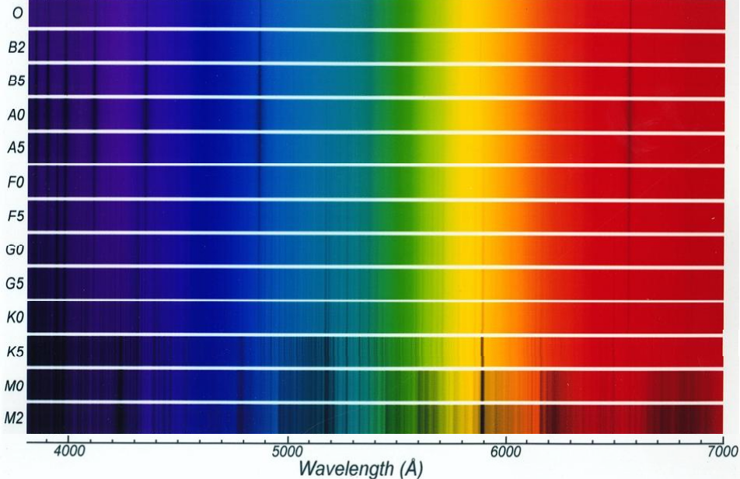

Hotter

Cooler

Fig. 10: The above are absorption spectra of different stars organized by the star’s spectral classification (O,B,A,F,G,K,M).

Using the information provided above, answer the following questions about stars and their spectra.

1. On the bottom axis of Fig. 10 (wavelength axis), **mark** the places where you saw hydrogen lines when you looked at the Hydrogen lamp. (Notice the axis is inverted and in Å. 1 Å=10nm).
2. What is the spectral type (O, B2, A0, etc.) of star that has the strongest hydrogen absorption features? The stronger hydrogen features will appear darker and wider than those seen in other spectral types.
3. If these were main sequence stars, which is the spectral type of the hottest stars? The coldest?
4. If the star is too hot, its radiation will result in highly energetic photons. In this case, what happens to the electrons in the atoms? (Think about how much energy the star is transferring into the electrons).
5. Why might we see weaker hydrogen absorption lines in O stars compared to A stars? (Hint: Think about how hot the two types of star are!)
6. In order for an absorption line to be formed, what has to happen to an electron in an atom? Be specific.
   1. Why are M stars almost devoid of hydrogen absorption lines? (Hint: think of the temperature of M stars.
   2. Even if we don’t see hydrogen absorption, why do we still see lots of other absorption features (other elements) in M stars?
   3. Is there still hydrogen in the star?
7. Fig. 8 shows the spectra of the Sun. The Sun is a G star. Is the Sun made up of just hydrogen? How can you tell?

# V. Conclusion:

Summarize the concepts you learned about in tonight’s lab. What did you learn about each of these concept? Summarize the experiment. How did this experiment help you understanding of the concepts?