**Spectroscopy Lab Quiz**

1. Use Wien’s law to calculate the surface temperature of the star Betelgeuse. The peak wavelength ($λ_{peak}$) of Betelgeuse is 0.806 $μm$. Show your work.

Wien’s Law: $T(K)=\frac{2900 μm⋅K}{λ_{peak}}$

Answer: T = _________________

*Questions 2 – 4: Complete each box with* ***a word*** *to make the statement correct.*

1. Redder light has ___________ wavelengths and ____________ frequencies than bluer light.
2. A spectrum is an outcome of separating light into its components according to __________.
3. Electrons can only exist in _______________ energy levels.

*Questions 5 – 7: Identify the type of the following spectrum and give one example of its source.*

1. 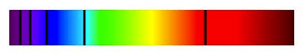

_________________________________________________________________________

1. 

_________________________________________________________________________

1. 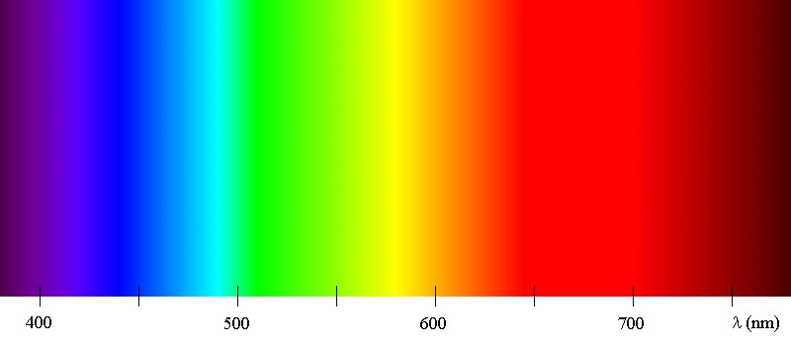

_________________________________________________________________________

*Question 8 – 10: Match the diagrams on the back of this quiz with the following phenomena.*

1. An absorption line ________________
2. An emission line ________________
3. Ionization ________________

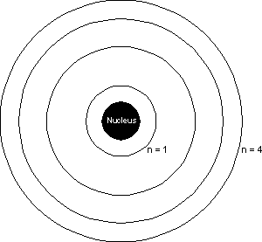

A

B



C

D