**Drupal Task one**

**6-Mar-2023 Monday**

Deadline: until 11:59 pm.

Every trainee should create content to:

1. Create Home Page that contain: blog for traditional Jordanian food and article for Drupal.

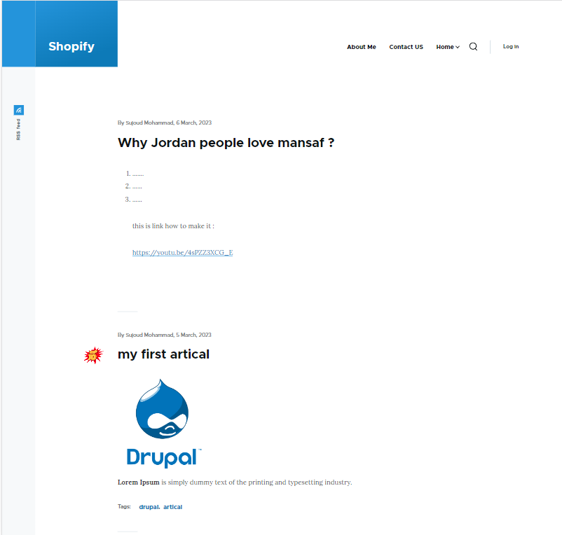

1. Create About Me page that contain: title, your name, image, major, age and favorite food.

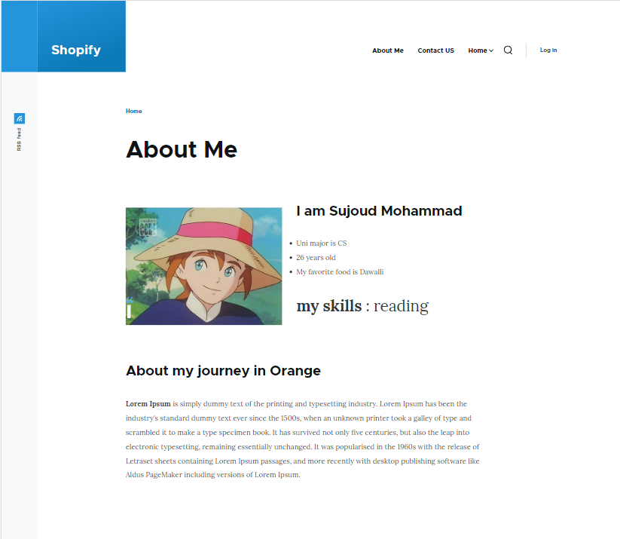

Good Luck 😊