 

# Placement Empowerment Program

***Cloud Computing and DevOps Centre***

# Day 12 – Recently Modified Files Reporter

Scan a directory and list all files modified in the last two days, saving the output to a report file.

Name: Subashini T Department: IT



# Introduction

In system administration and development environments, tracking recently modified files is crucial for monitoring changes,

troubleshooting, auditing, and backup planning. The **Recently Modified**

**Files Reporter** is a shell script that automates this task by scanning a specified directory and listing all files that have been modified within the last two days.

This Proof of Concept (PoC) empowers users to maintain better

visibility over active files and recent system activities, helping ensure accountability and awareness in shared or production environments.

# Overview

The **Recently Modified Files Reporter** is a lightweight shell script designed to scan a directory and identify all files that have been

modified within the last two days. It uses the Linux find command to

perform a recursive search and outputs the results to a timestamped log file.

This script is especially useful for:

✅Monitoring project files for recent changes

✅Tracking user activity on shared systems

✅Detecting unauthorized or unexpected file modifications

The script can be run manually or scheduled using cron to automate periodic file change reporting.

### Key steps in this PoC:

✅ **Open Terminal**

Start a terminal session on your Linux system.

### ✅ Create the Script File

Create a new shell script file **(e.g., recent_mod_report.sh)** using a text editor like nano.

### ✅ Write the Script Logic

Use the find command with **-mtime -2** to search for files modified in the last 2 days and redirect the output to a log file.

### ✅ Make the Script Executable

Use **chmod +x** to give the script permission to run.

### ✅Execute the Script

Run the script to generate the report of recently modified files.

### ✅View the Output Report

Open the generated **recent_files_report.log file** to see the list of recently changed files.

# Objectives :

### ✅Identify Recently Modified Files

Automatically detect and list all files modified in the last two days within a specified directory.

### ✅Improve System Monitoring

Enhance visibility into ongoing changes in files—useful for tracking development, user activity, or security concerns.

### ✅Generate an Organized Report

Save the output in a clear, timestamped log file for future review or audits.

### ✅Enable Automation

Allow the script to be scheduled via cron for hands-free daily or weekly file monitoring.

### ✅Support File Auditing

Assist developers, system admins, and auditors in verifying what files have been recently touched or changed.

# Importance:

### ✅Enhances File Activity Awareness

Helps users and system administrators stay informed about which files are being changed, added, or updated — crucial in shared environments or development teams.

### ✅Supports Security & Compliance

Detects unexpected file modifications which could indicate suspicious activity or policy violations.

### ✅Aids in Audit & Backup Planning

Useful for creating backup plans based on active files and for generating reports during audits.

### ✅Useful for Developers & Admins

Developers can track changes in project folders, while sysadmins can monitor configuration files or logs.

### ✅Saves Time with Automation

Instead of manually checking files, this script offers a quick and automated way to get recent activity, reducing manual workload.

# Step-by-Step Overview

## Step 1: Open Terminal

Open your Linux terminal to begin creating the script.

## Step 2: Create the Script File

Use a text editor to create a new shell script file:



## Step 3: Add Script Content

Paste the following code into the file:

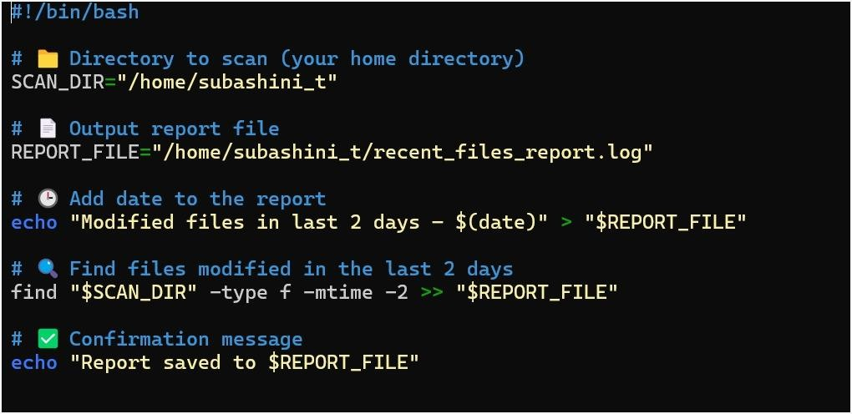

## Step 4:Save and Exit

Press Ctrl + O → Enter (to save) Press Ctrl + X (to exit)

## Step 5: Make the Script Executable

Run the following command to make the script runnable:



## Step 6: Run the Script

Now run the script:



## Step 7: View the Output

Check the generated log file:

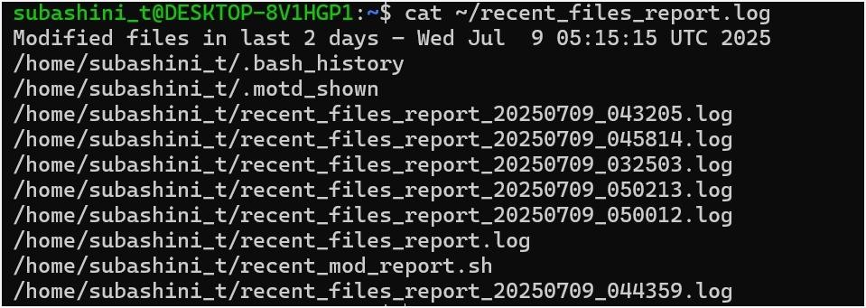

## Outcomes:

### ✅ Generated a Clear Report

Successfully created a recent_files_report.log file listing all files modified in the last 2 days within the target directory.

### ✅Built a Reusable Shell Script

Developed an executable script that can be reused or adapted for any folder or time range.

### ✅ Enabled Activity Tracking

Gained visibility into recent file changes — useful for audits, development monitoring, or security tracking.

### ✅ Demonstrated Automation Potential

The script is ready for automation via cron, enabling scheduled file monitoring without manual effort.

### ✅ Strengthened Shell Scripting Skills

Practiced essential Bash skills like file handling, use of find, redirection, permissions, and logging.