TWO TYPES OF ERROR IN CONFUSION MATRIX

Type 2 error is more dangerous than type 1 error as we predicted here something to be False but turned out to be True!.Depends on cases like in medical conclusions.

False negative – First word tells us about truth value of our prediction ,second one tells our prediction.

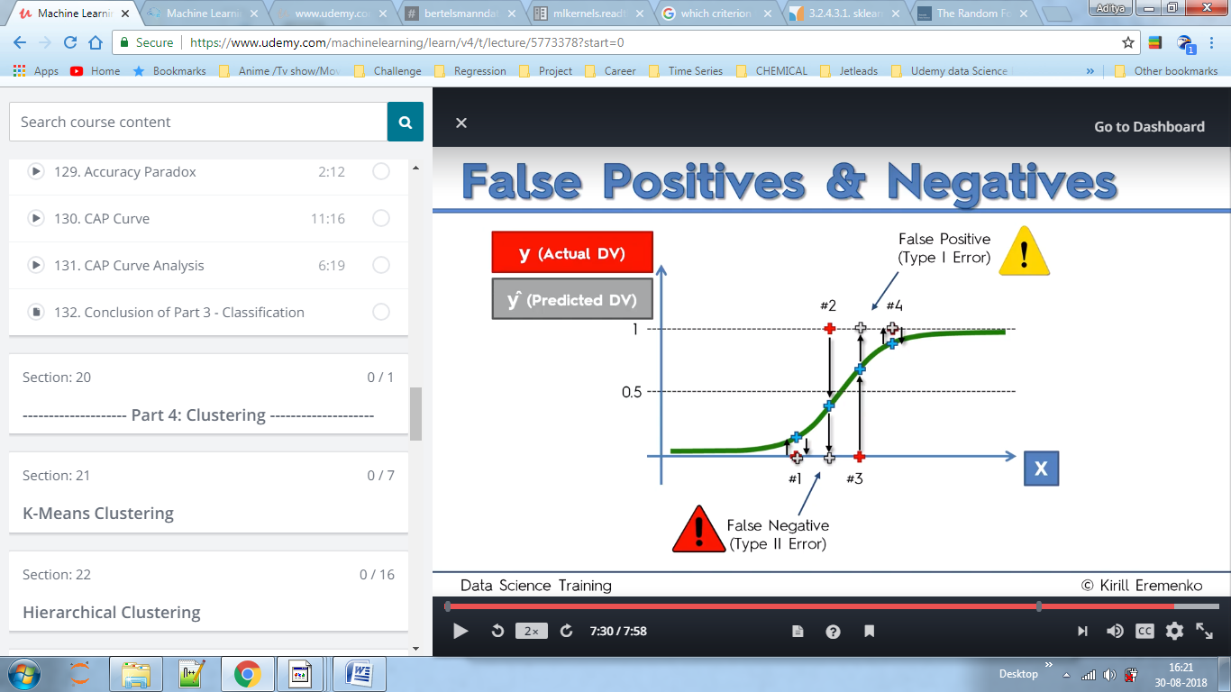

WHAT IS ACCURACY PARADOX?

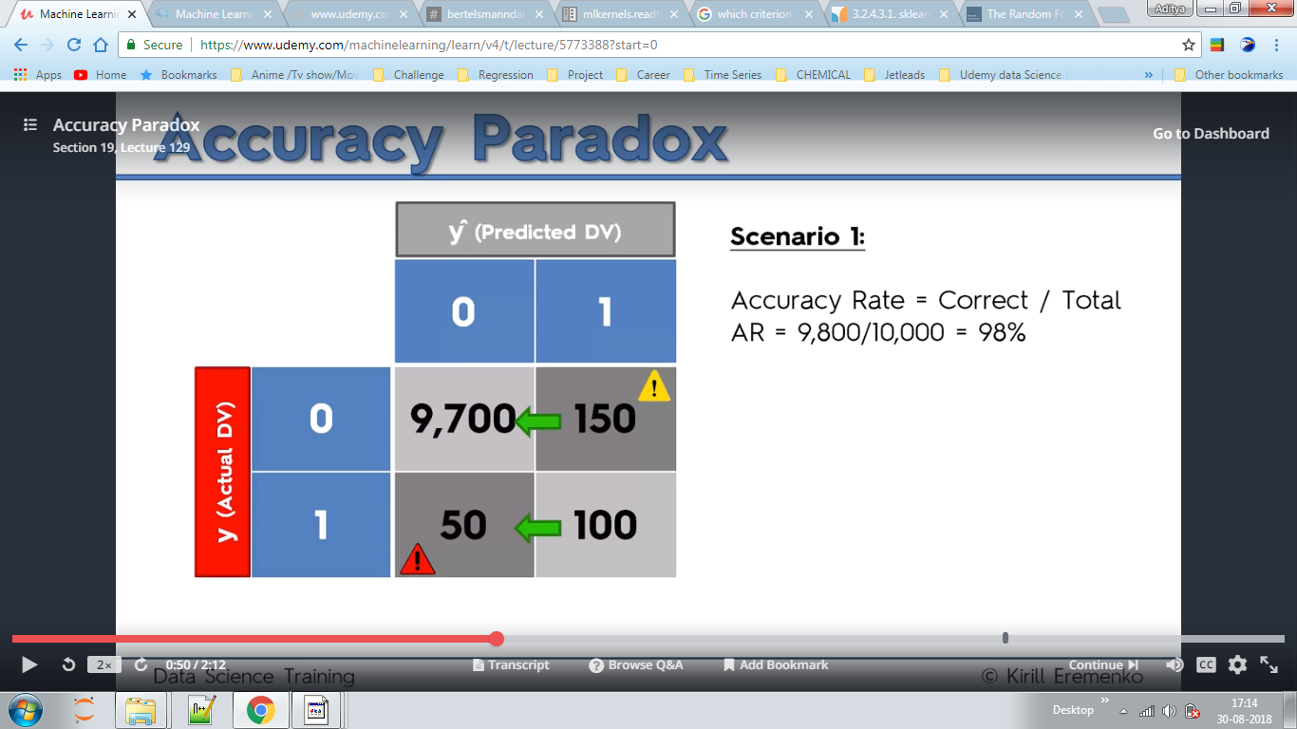

Here above we completely removed a model and only tried to predict values for 0 and then calculated the accuracy which in turn increased in scenario 2.

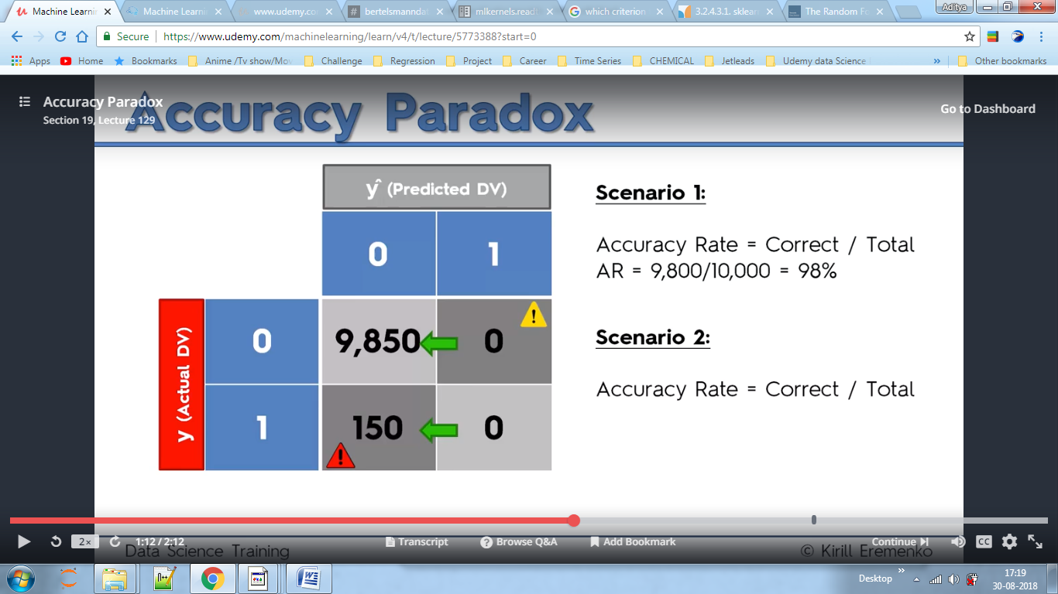

Here in our model we want to contact customers so that 10% of them (here 10k), will purchase our product.

Given is that no matter what we cannot increase customer contacting from 100000.Hence our aim is to reach our target of selling 10000 products by contacting minimum customers. We will use CAP to predict whether our model can do this or not.

WHAT IS CAP

CAP-Cumulative Accuracy Profile

EVALUTION-If our predicted line is below blue it is very poor, just discard the model.

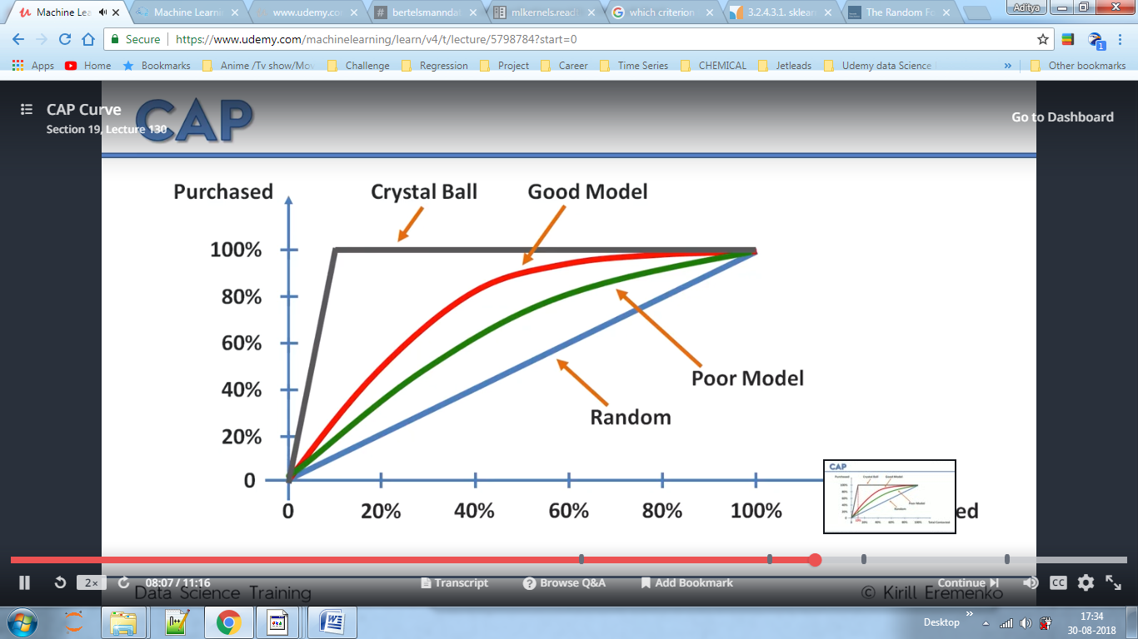

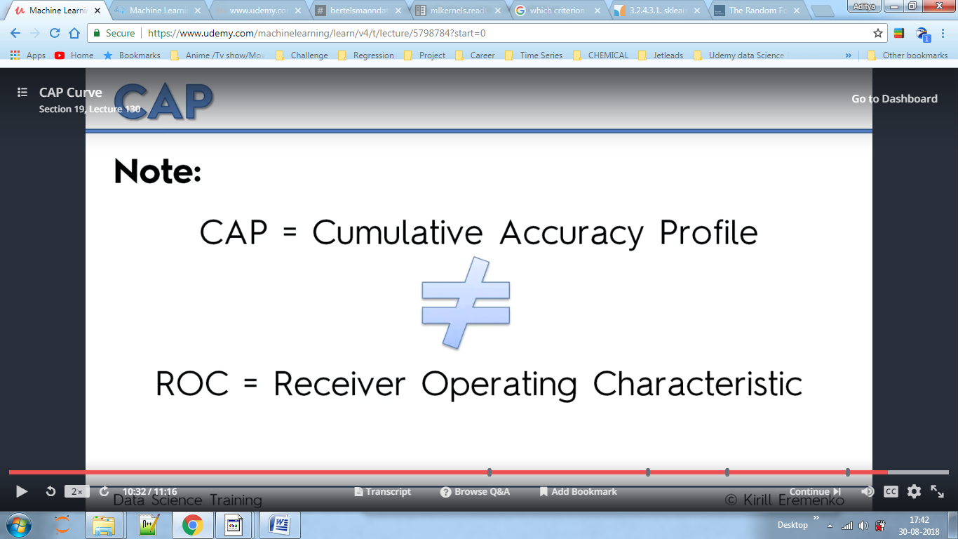

The area under the curves gives us how much it predicted.

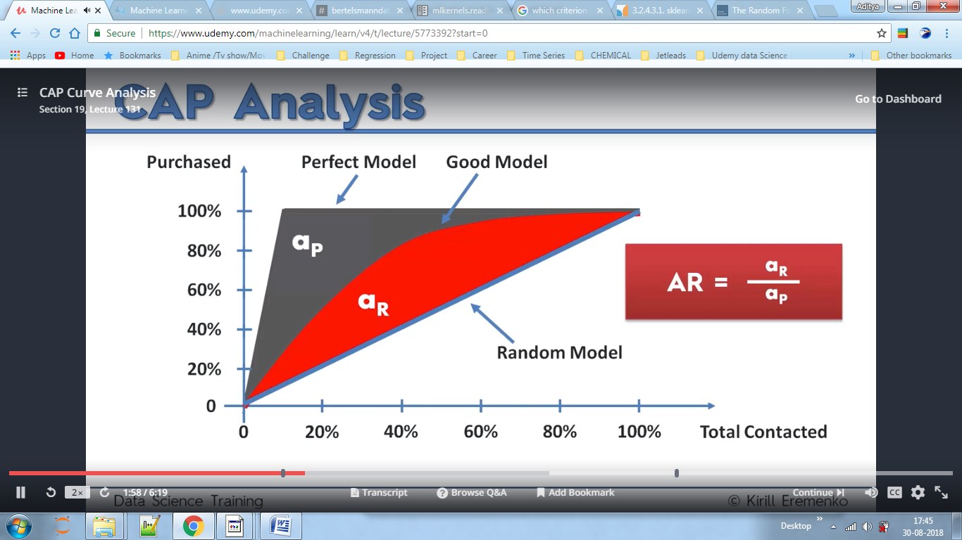

Here in Perfect model by contacting first 10000 customers (x=10%contacted,y-100% purchased)we achieved our goal.

