Two types of Hierarchical Clustering:-

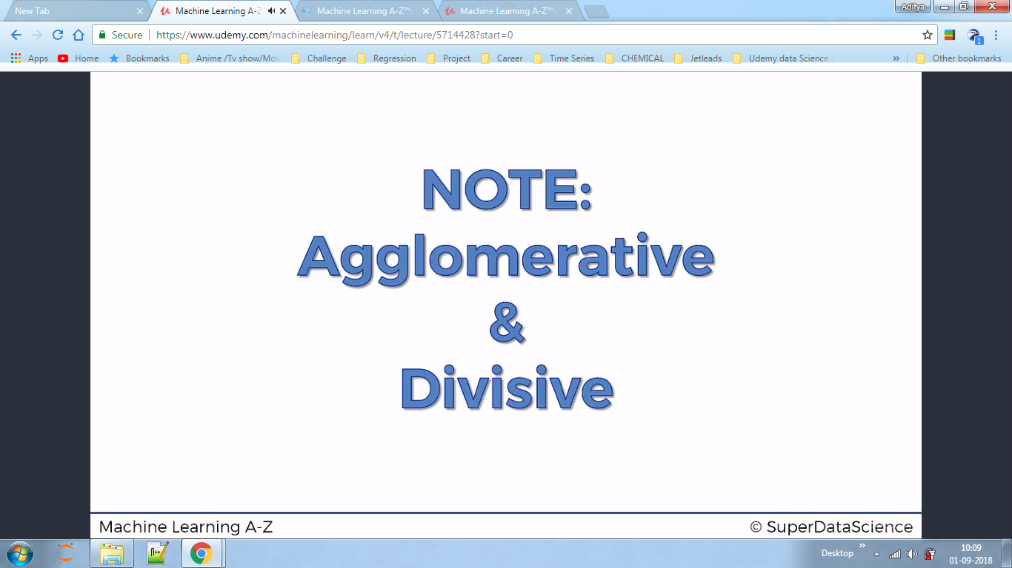

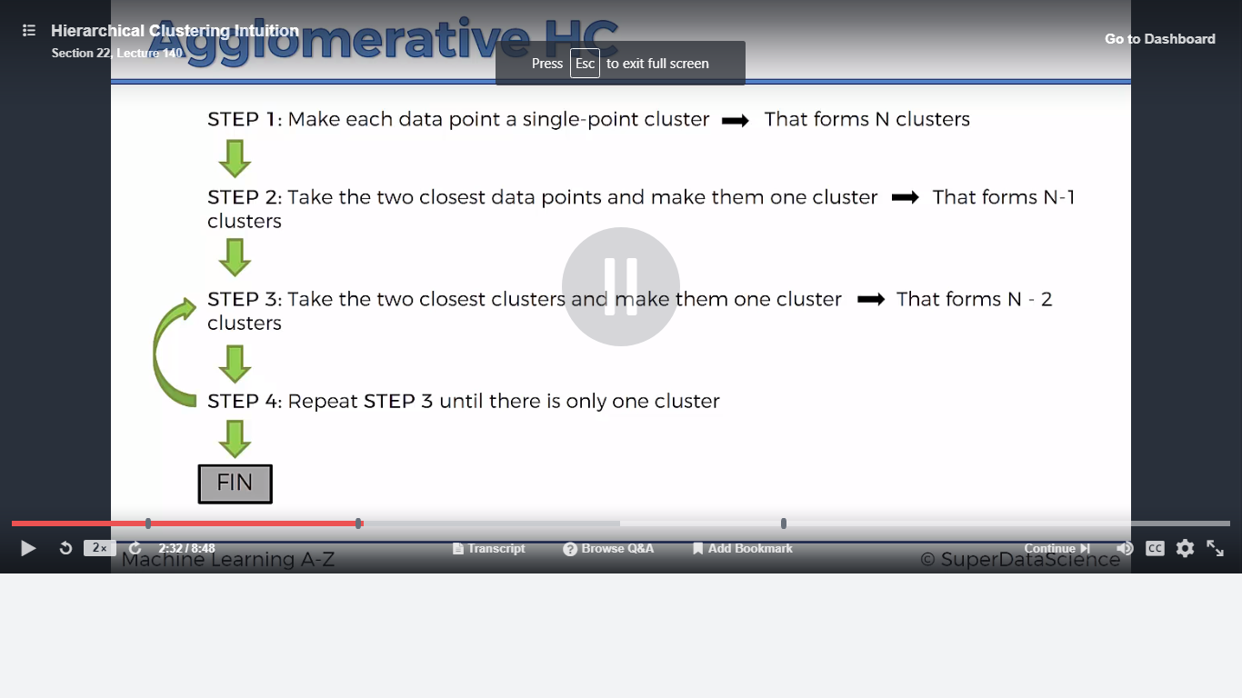

Dendograms trains the Hierarchical of the clusters.

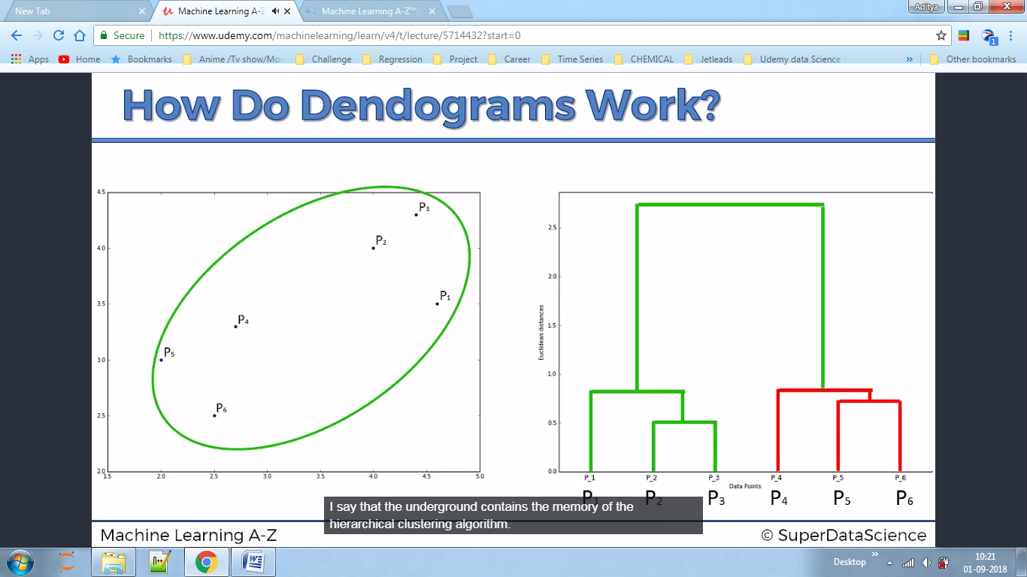

After this we set dissimilarity Ratio ie we will decide how many clusters we want.

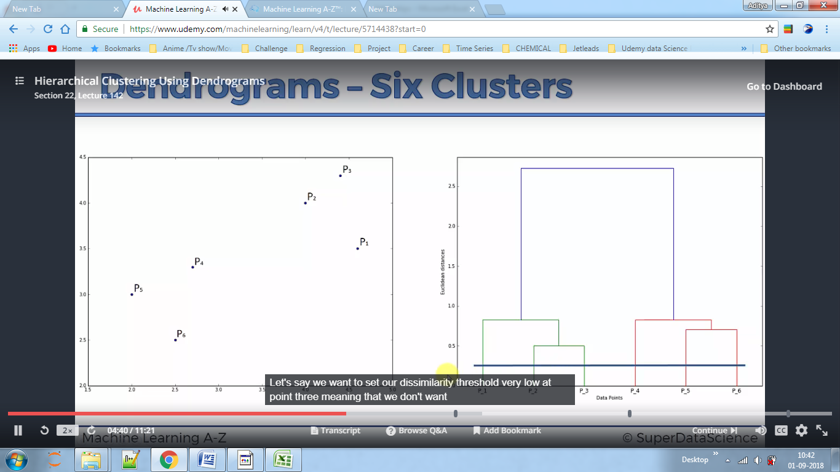

To deduce how many clusters we have to take ,we take largest distance ,considering no horizontal line should be present.

Example1

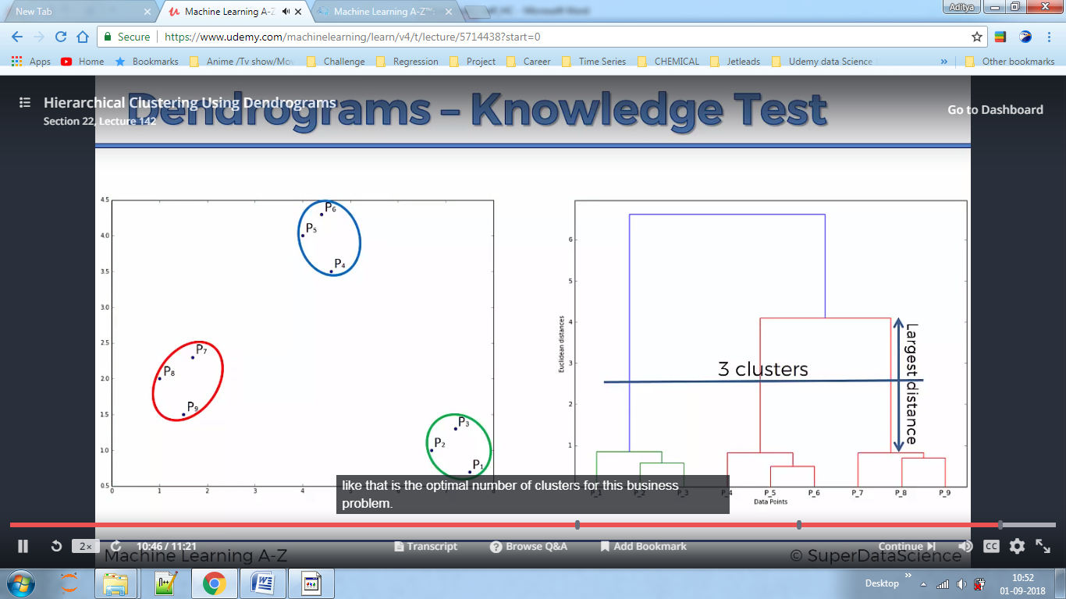

Example2

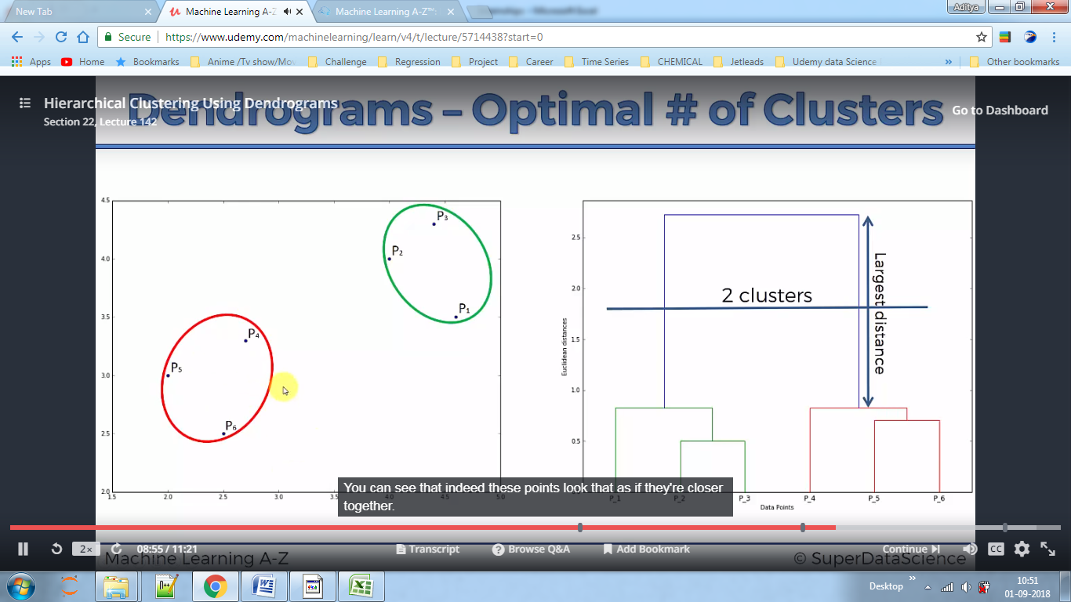

In the data set the business problem is clustering as the mall does not know how many customer groups should they have?,based on the spending score.

Here we use Dendograms to know about the line which decides number of clusters, this is same as the elbow method which we used to find no of cluster in k-means.

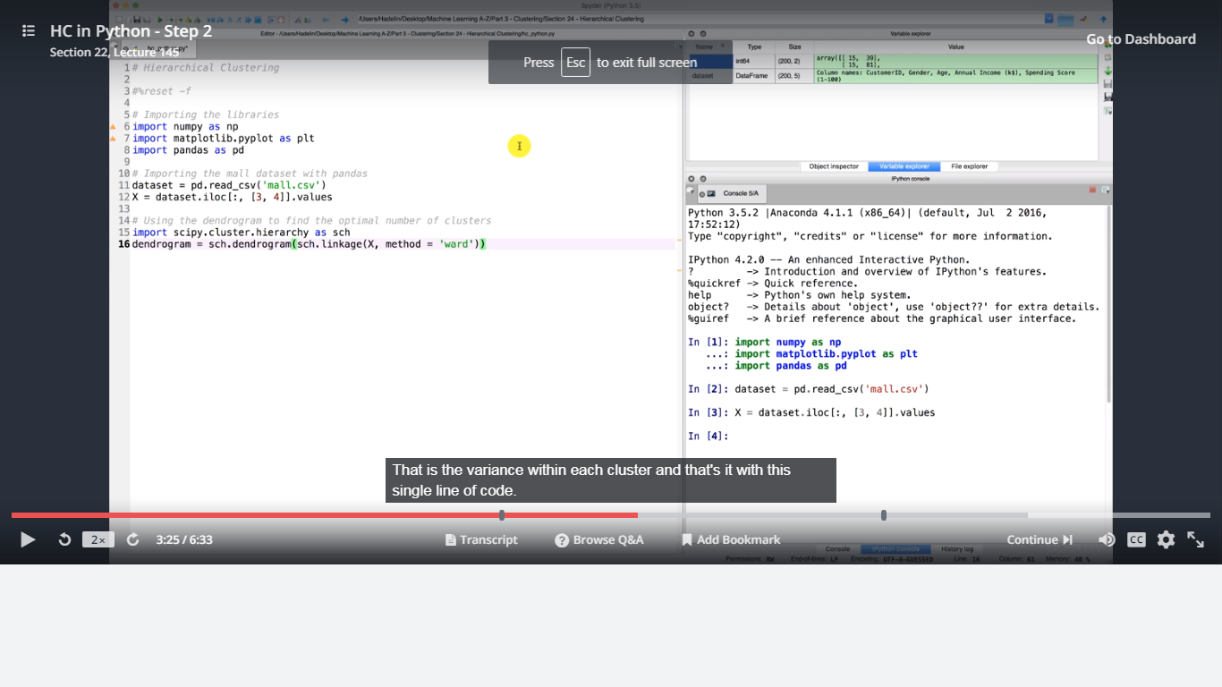

Above we are using ward method which is just like the WSCC,Here we are minimising the variance .

Now by plotting the graph with xaxis as no of customers and y axis as the Euclidean distance,we choose largest distance then move down until we find a horizontal line on that distance

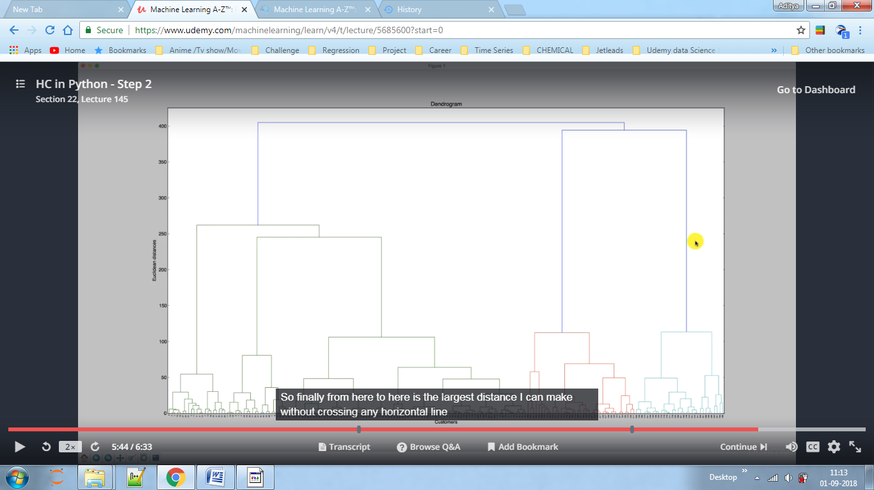

Here no of clusters is 5

Here we used same code for



**Hierarchical Clustering does not performs better than K-Means on large datasets**