We use Kernel SVM because data is not always linearly separable. We map data into higher dimension and make it linear separable

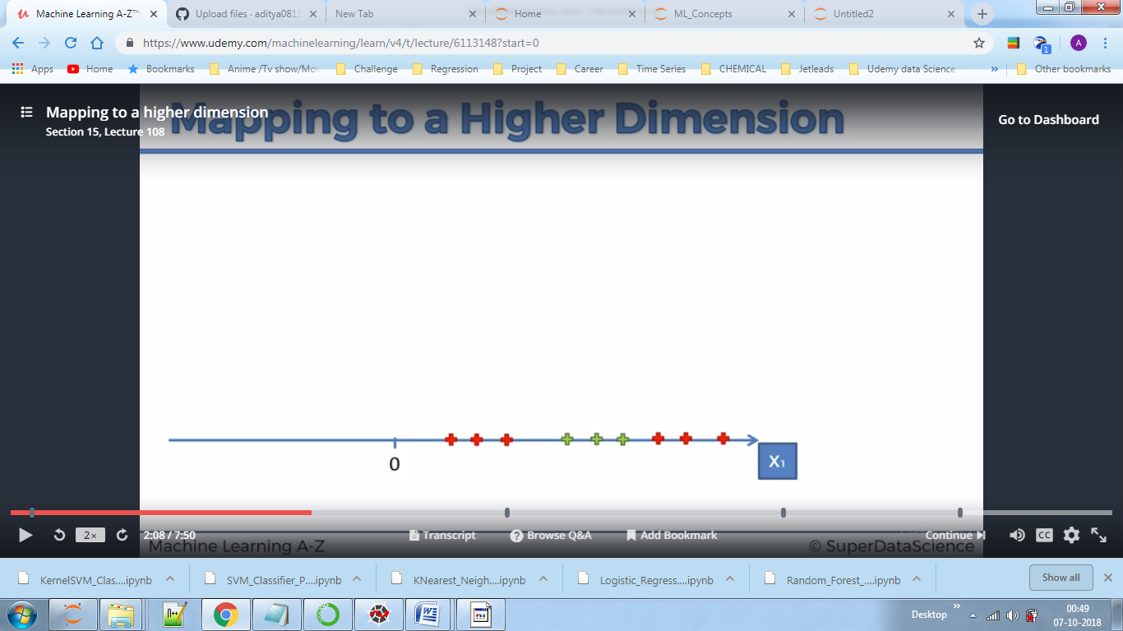

Converting 1D to 2D by using certain functions. Above data is not linearly separable.

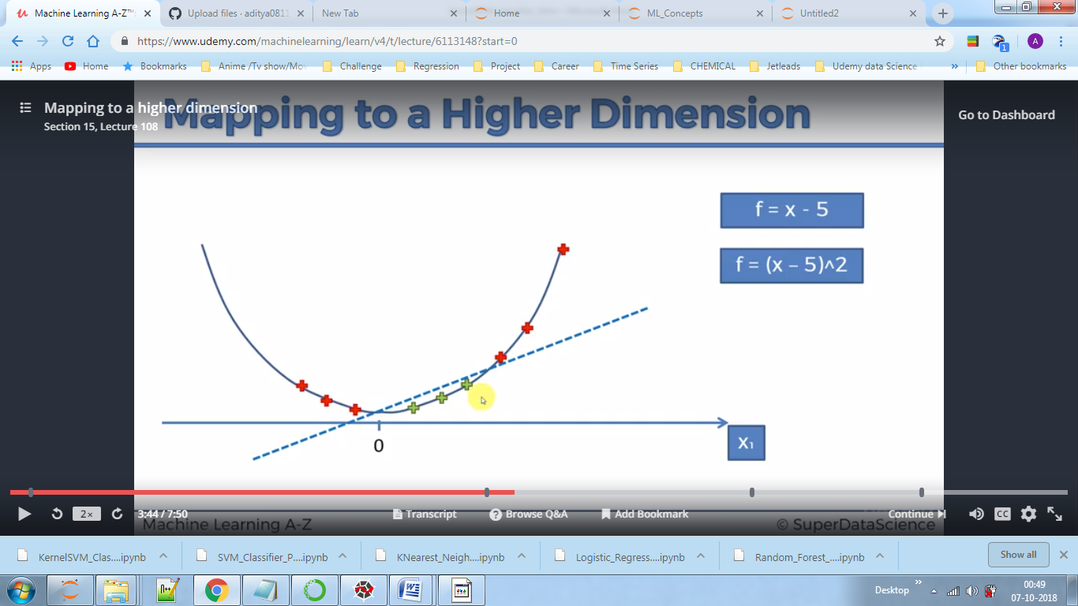

Now the data is linearly separable.

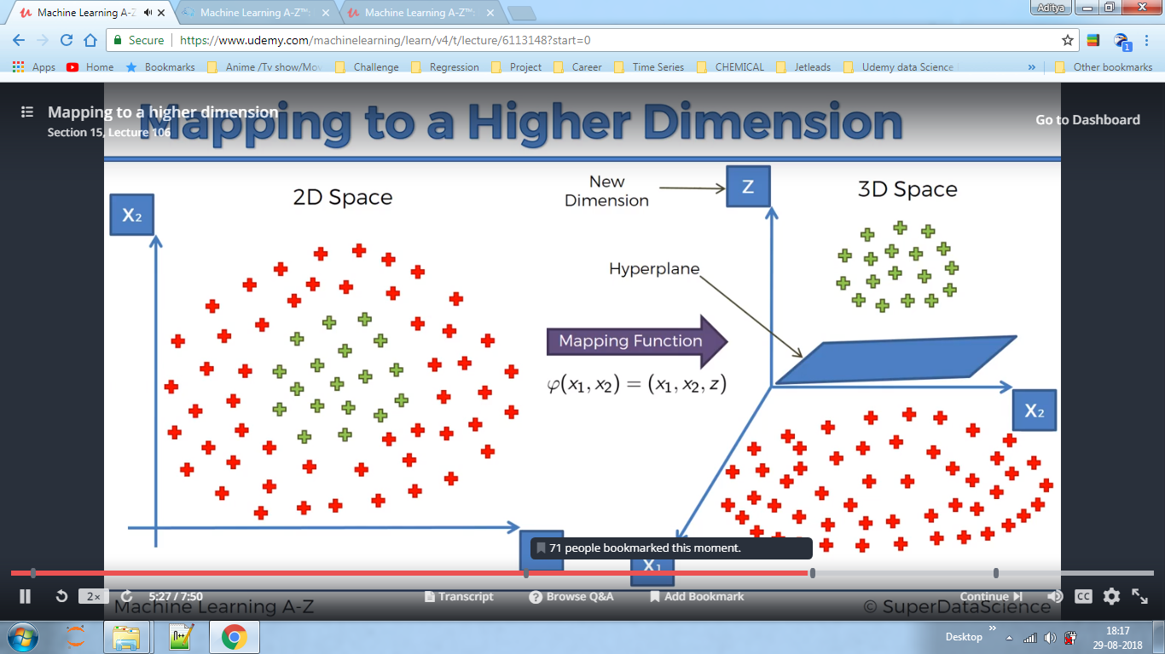

Above we converted 2D data to 3D data and hence now we can introduce plane.

Here we defined a hyper plane using mapping function. Mapping into High Dimensions requires huge computational power hence we use kernels to classify data on basis of boundaries by converting it back to 2D using kernel functions.

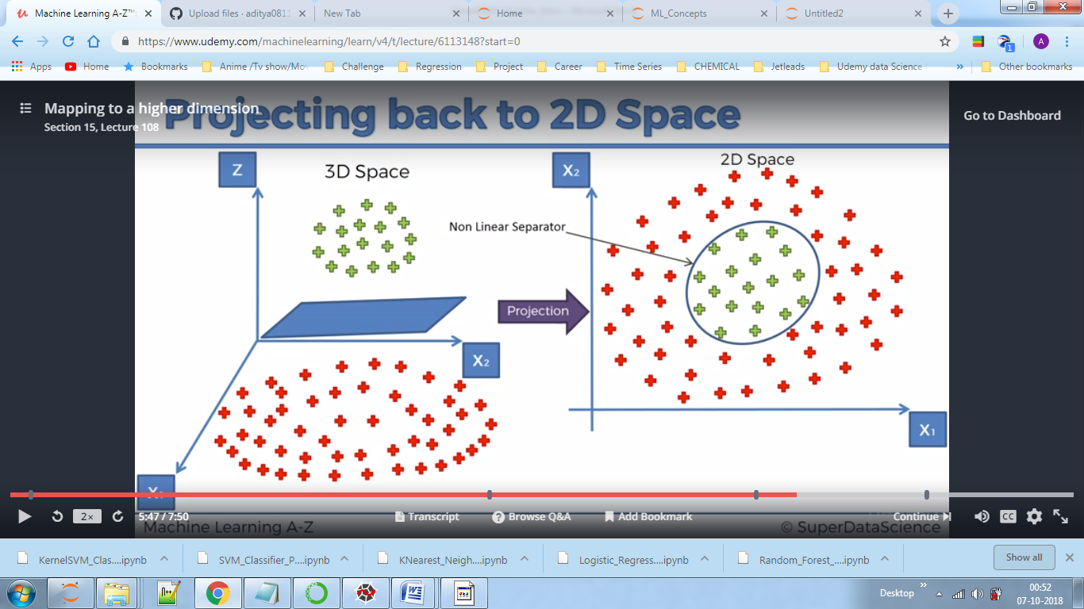

Gaussian distribution:-

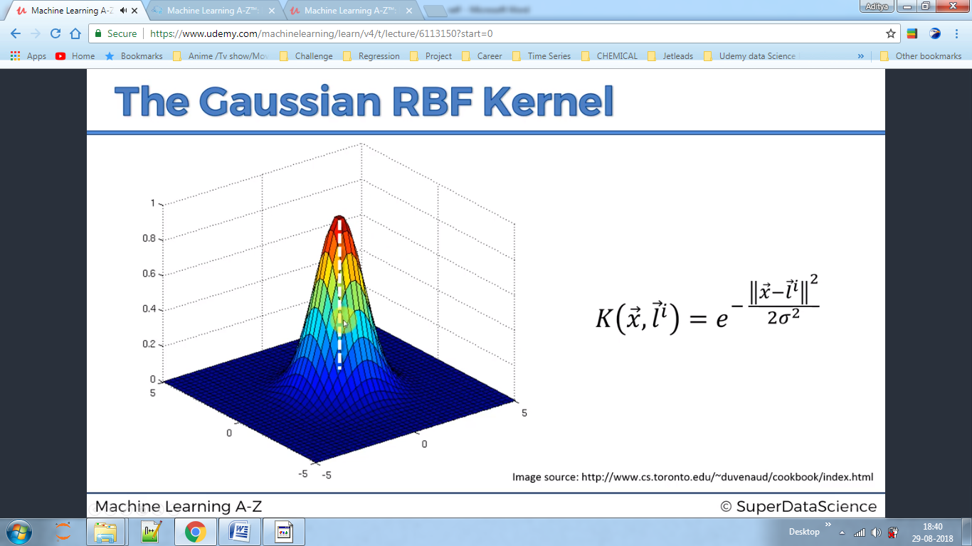

By finding right sigma we can classify one class from other.if we increase sigma green area will increase.

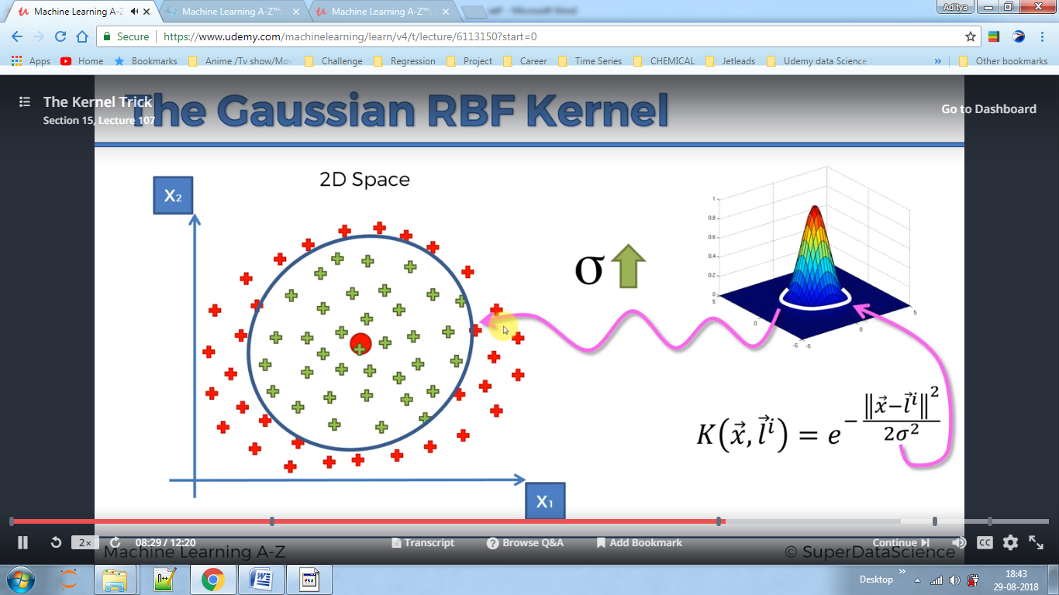

Simplified Formula – We are applying this kernel into two dimensions which saves us from computation power of converting everything into higher dimension:-

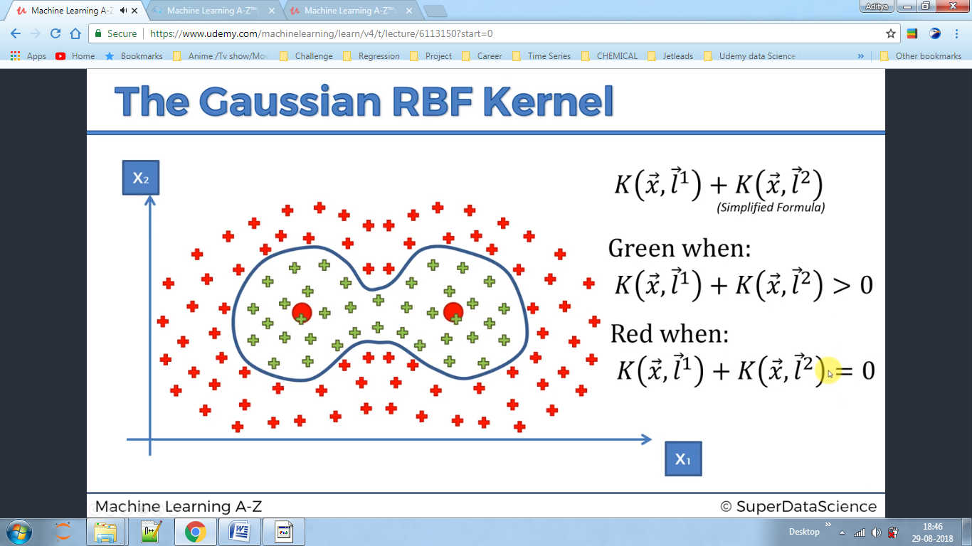

Types of kernel:-

Types of kernel:-

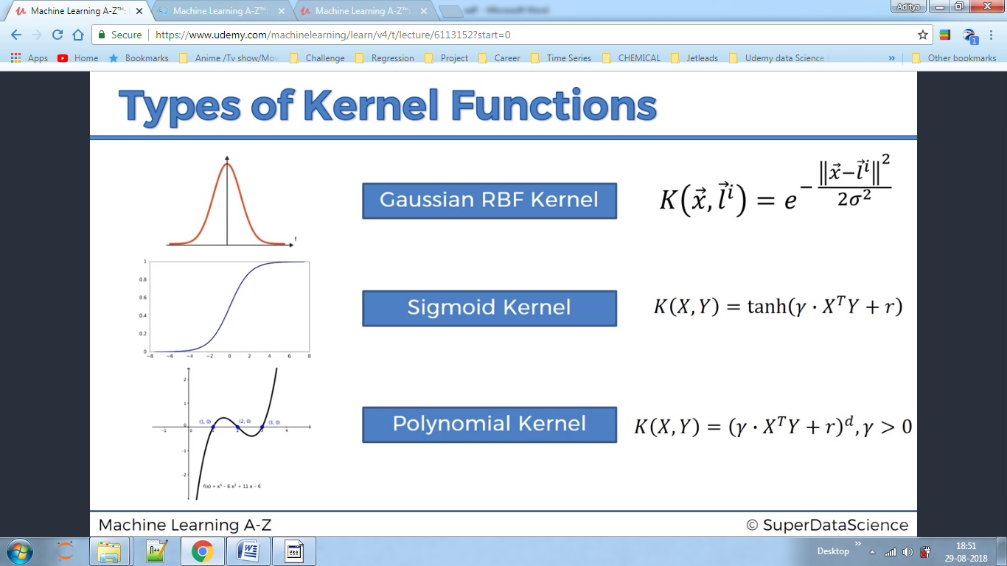

<https://mlkernels.readthedocs.io/en/latest/kernels.html#exponential-kernel>