Random Forest is ensemble learning which means we are using more than one machine learning model. Here the n_estimators is important as it gives us how many trees we should use ,we have here 10 as default ,if we increase it more the model may get overfit.We used criterion as entropy because we want to learn from different models.

*To say it in simple words: Random forest builds multiple decision trees and merges them together to get a more accurate and stable prediction.*

This is called bagging method.

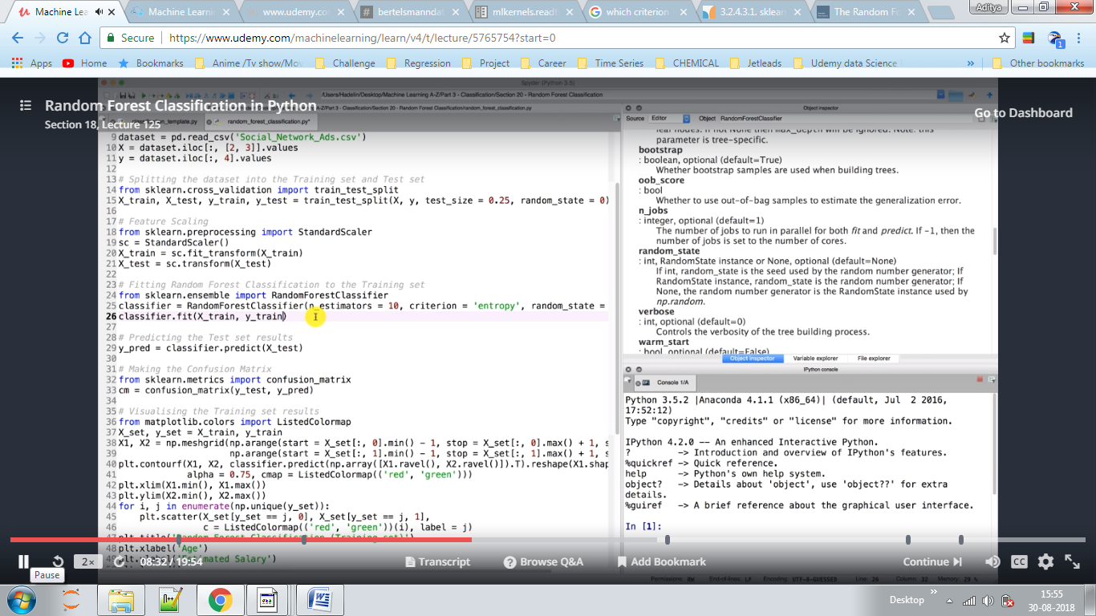

w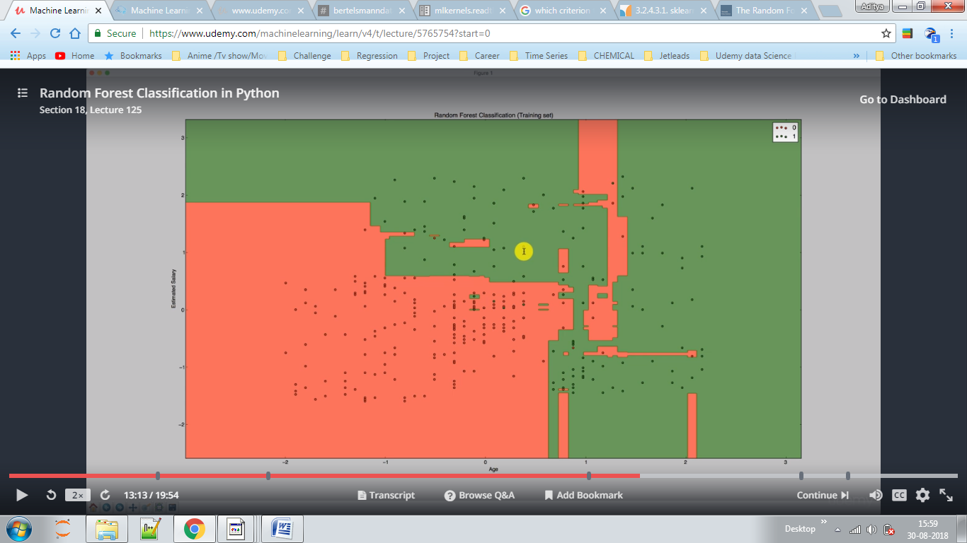

Whats happening here is that we are building 10 trees for a particular point and the model than votes out for yes and no coming from each tree ,say for predicting a green point here model has predicted >5 yes and <5 no so YES for a green region.

Here we have overfitted model as it predicted red region on upper right which is of no use for test cases, other classifiers like SVM have smooth boundary which are not overfitted which are better, and also more wrong prediction were present for this model.