We are finding best line that separates this data.

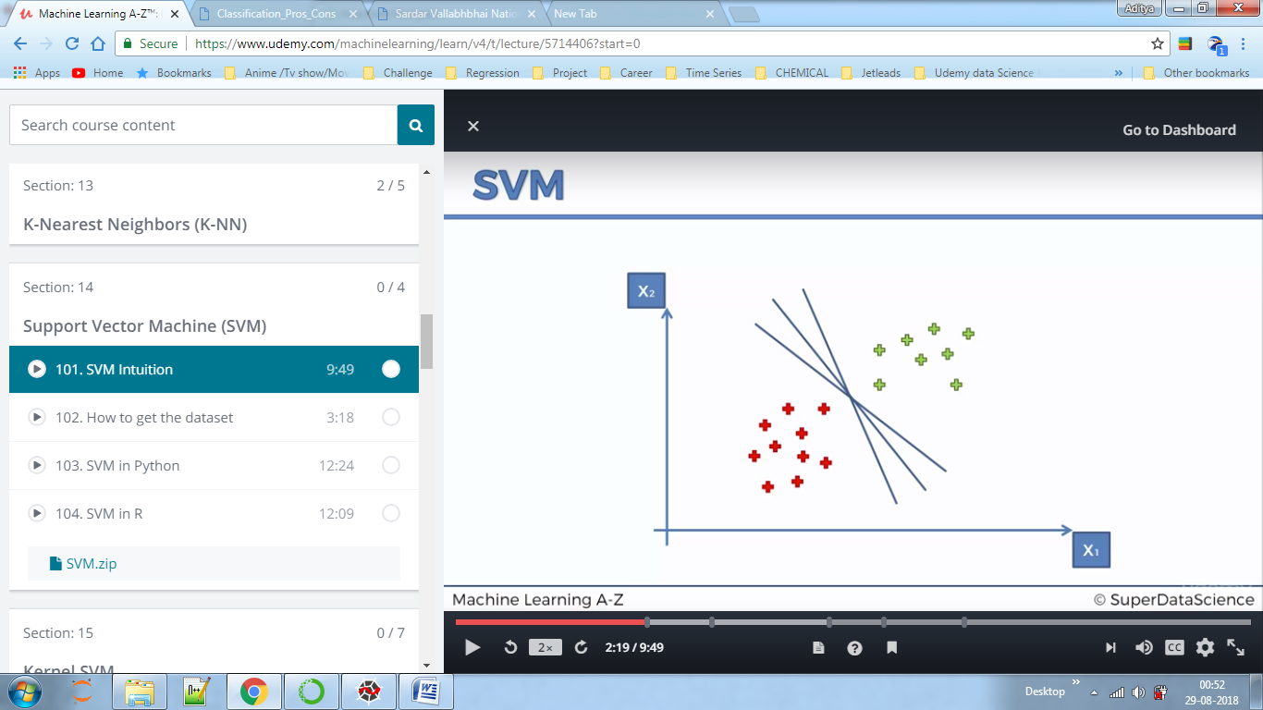

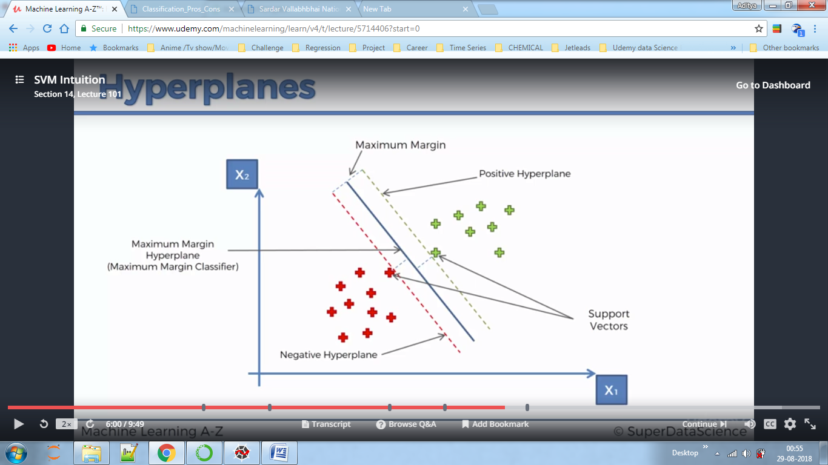

Hyper plane is simply the plane in multidimensional, we have created a plane here in two dimension only.

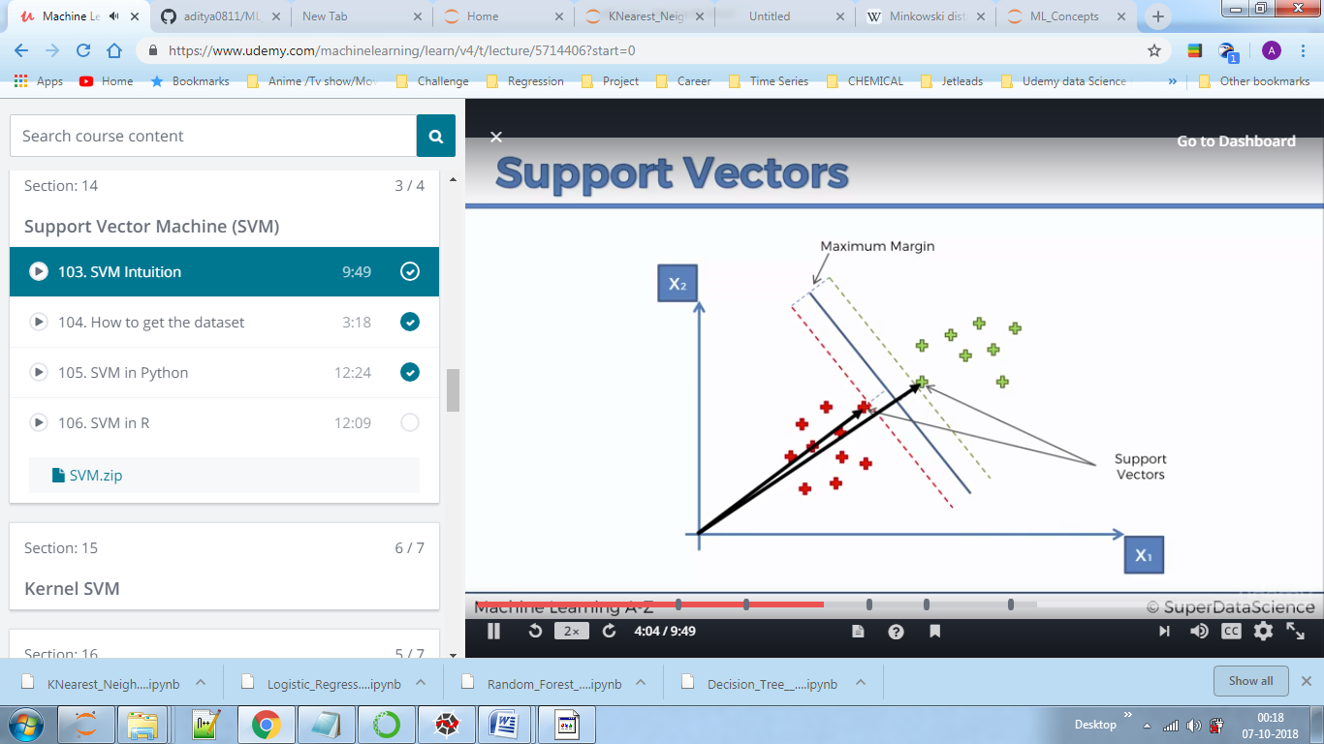

Here our main aim is to maximise distance between support vectors i.e maximise margin. In short those two points result in the algorithm not the other points. These two points are called support vectors.

Why SVM?

Here suppose red points are apple and green are oranges SVM unlike other ML algorithm will find out least possible point for an apple and mark that as support vector instead of choosing the points which have more characteristics of apple(SVM chooses point in apple region which has least number of apple characteristics)

Say ;if, green oranges come than that time the support vector for oranges will be have that green orange as it is very close to the apple (mostly apples are green).

In confusion matrix 2 and 3 are incorrect prediction. = 2+8 below are incorrect values.

