**Tabell som viser endring i absolutte tall med formelen:**

**lm(absolutt endring ~ intensitet + baseline)**

|  |  |  |  |  |  |  |
| --- | --- | --- | --- | --- | --- | --- |
|  | | | | | | |
|  | Avhengige variabler | | | | | |
|  |  | | | | | |
|  | Δ PI | Δ VO2maks | Δ Wmaks | Δ Wlaktatterskel | Δ W15tt | Δ W40tt |
|  | | | | | | |
| Intercept | -11.90*** | -679.38 | -120.47 | -144.11** | -65.01 | 63.81 |
|  | (-17.55, -6.24) | (-2595, 1236) | (-281, 40) | (-270, -19) | (-209, 79) | (-84, 211) |
|  |  |  |  |  |  |  |
| Intensitet | 0.10** | 14.64 | 2.17** | 1.60* | 0.77 | -0.73 |
|  | (0.03, 0.17) | (-4.84, 34.13) | (0.39, 3.94) | (0.07, 3.12) | (-1.01, 2.54) | (-2.52, 1.07) |
|  |  |  |  |  |  |  |
| Baseline | 0.09 | -0.06 | -0.08 | 0.07 | 0.05 | 0.05 |
|  | (-3.03, 3.20) | (-0.20, 0.07) | (-0.23, 0.07) | (-0.09, 0.24) | (-0.12, 0.22) | (-0.19, 0.29) |
|  |  |  |  |  |  |  |
|  |  |  |  |  |  |  |
|  | | | | | | |
| N | 19 | 19 | 19 | 19 | 19 | 19 |
| R2 | 0.36 | 0.18 | 0.29 | 0.29 | 0.09 | 0.04 |
| Adjusted R2 | 0.28 | 0.08 | 0.20 | 0.20 | -0.03 | -0.08 |
| Residual Std. Error (df = 16) | 0.61 | 179.99 | 16.55 | 13.62 | 15.69 | 15.92 |
| F Statistic (df = 2; 16) | 4.43** | 1.75 | 3.23* | 3.28* | 0.77 | 0.33 |
|  | | | | | | |
| Merknader: | *p<0.1**p<0.05***p<0.01 | | | | | |

**Tabell som viser endring i relative tall med formelen:**

**lm(relativ endring ~ intensitet + baseline)**

|  |  |  |  |  |  |  |
| --- | --- | --- | --- | --- | --- | --- |
|  | | | | | | |
|  | Avhengige variabler | | | | | |
|  |  | | | | | |
|  | Δ PI | Δ VO2maks | Δ Wmaks | Δ Wlaktatterskel | Δ W15tt | Δ W40tt |
|  | | | | | | |
| Intercept | -0.32** | -3.50 | -2.08* | -2.20** | -1.37 | 0.65 |
|  | (-0.56, -0.09) | (-31.99, 25.00) | (-4.23, 0.08) | (-3.71, -0.68) | (-3.44, 0.71) | (-1.35, 2.65) |
|  |  |  |  |  |  |  |
| Intensitet | 0.00** | 0.27* | 0.04*** | 0.02** | 0.02 | -0.00 |
|  | (0.00, 0.01) | (0.00, 0.55) | (0.02, 0.07) | (0.00, 0.05) | (-0.01, 0.05) | (-0.03, 0.02) |
|  |  |  |  |  |  |  |
| Baseline | -0.04 | -0.24* | -0.18 | 0.07 | -0.06 | -0.04 |
|  | (-0.22, 0.15) | (-0.46, -0.02) | (-0.40, 0.04) | (-0.13, 0.28) | (-0.32, 0.21) | (-0.34, 0.25) |
|  |  |  |  |  |  |  |
|  |  |  |  |  |  |  |
|  | | | | | | |
| N | 19 | 19 | 19 | 19 | 19 | 19 |
| R2 | 0.37 | 0.35 | 0.40 | 0.40 | 0.13 | 0.02 |
| Adjusted R2 | 0.29 | 0.27 | 0.32 | 0.32 | 0.02 | -0.11 |
| Residual Std. Error (df = 16) | 0.03 | 2.56 | 0.23 | 0.16 | 0.22 | 0.22 |
| F Statistic (df = 2; 16) | 4.72** | 4.35** | 5.24** | 5.24** | 1.17 | 0.14 |
|  | | | | | | |
| Merknader: | *p<0.1**p<0.05***p<0.01 | | | | | |

**Tabell som viser endring i relative tall med formelen:**

**lm(relativ endring ~ intensitet + baseline + endring i kroppsvekt)**

**PS!! Det er nok denne vi går for**

|  |  |  |  |  |  |  |
| --- | --- | --- | --- | --- | --- | --- |
|  | | | | | | |
|  | Avhengige variabler | | | | | |
|  |  | | | | | |
|  | Δ PI | Δ VO2maks | Δ Wmaks | Δ Wlaktatterskel | Δ W15tt | Δ W40tt |
|  | | | | | | |
| Intercept | -0.30** | -0.76 | -1.89* | -2.16** | -1.20 | 0.79 |
|  | (-0.51, -0.09) | (-24.14, 22.61) | (-3.85, 0.07) | (-3.71, -0.61) | (-3.09, 0.68) | (-1.14, 2.71) |
|  |  |  |  |  |  |  |
| Intensitet | 0.00*** | 0.24* | 0.04*** | 0.02** | 0.02 | -0.00 |
|  | (0.00, 0.01) | (0.02, 0.47) | (0.02, 0.06) | (0.00, 0.05) | (-0.01, 0.05) | (-0.03, 0.02) |
|  |  |  |  |  |  |  |
| Baseline | -0.05 | -0.24** | -0.18* | 0.07 | -0.08 | -0.07 |
|  | (-0.22, 0.12) | (-0.42, -0.06) | (-0.38, 0.02) | (-0.15, 0.28) | (-0.32, 0.16) | (-0.35, 0.22) |
|  |  |  |  |  |  |  |
|  |  |  |  |  |  |  |
| Δ kroppsvekt | -0.01** | -0.96*** | -0.07* | -0.01 | -0.07* | -0.05 |
|  | (-0.01, -0.00) | (-1.58, -0.33) | (-0.13, -0.00) | (-0.07, 0.04) | (-0.13, -0.01) | (-0.11, 0.01) |
|  |  |  |  |  |  |  |
|  | | | | | | |
| N | 19 | 19 | 19 | 19 | 19 | 19 |
| R2 | 0.53 | 0.59 | 0.53 | 0.41 | 0.33 | 0.15 |
| Adjusted R2 | 0.43 | 0.51 | 0.44 | 0.29 | 0.20 | -0.01 |
| Residual Std. Error (df = 15) | 0.02 | 2.09 | 0.21 | 0.17 | 0.20 | 0.21 |
| F Statistic (df = 3; 15) | 5.56*** | 7.31*** | 5.71*** | 3.45** | 2.45 | 0.92 |
|  | | | | | | |
| Merknader: | *p<0.1**p<.05***p<0.01 | | | | | |

**Tabell som viser sammenhengen mellom TRIMP, snitt laktat , snitt borg, relativ blodvolum og relativ hbmasse**

|  |  |  |  |  |  |
| --- | --- | --- | --- | --- | --- |
|  | | | | | |
|  | Avhengige variabler | | | | |
|  |  | | | | |
|  | TRIMP | Laktat | BORG | Blodvolum/kg | HBmasse/kg |
|  | | | | | |
| Intercept | -10251* | 6.09 | 12.98** | -10.45 | -4.95 |
|  | (-21714, 1212) | (-7.53, 19.71) | (3.93, 22.02) | (-52.43, 31.54) | (-10.72, 0.82) |
|  |  |  |  |  |  |
| Intensitet | 202.59*** | -0.00 | 0.04 | 0.46** | 0.05* |
|  | (69.29, 335.89) | (-0.16, 0.16) | (-0.07, 0.14) | (0.06, 0.86) | (-0.00, 0.10) |
|  |  |  |  |  |  |
| Baseline |  |  |  | -0.34** | 0.05 |
|  |  |  |  | (-0.57, -0.10) | (-0.21, 0.31) |
|  |  |  |  |  |  |
|  |  |  |  |  |  |
| Δ kroppsvekt |  |  |  | -0.61 | 0.00 |
|  |  |  |  | (-1.72, 0.50) | (-0.15, 0.16) |
|  |  |  |  |  |  |
|  | | | | | |
| N | 19 | 19 | 19 | 19 | 19 |
| R2 | 0.34 | 0.00 | 0.03 | 0.52 | 0.19 |
| Adjusted R2 | 0.30 | -0.06 | -0.03 | 0.42 | 0.02 |
| Residual Std. Error | 1249 (df = 17) | 1.48 (df = 17) | 0.99 (df = 17) | 3.69 (df = 15) | 0.50 (df = 15) |
| F Statistic | 8.87*** (df = 1; 17) | 0.00 (df = 1; 17) | 0.49 (df = 1; 17) | 5.41** (df = 3; 15) | 1.15 (df = 3; 15) |
|  | | | | | |
| Merknader: | *p<01**p<05***p<0.01 | | | | |

|  |  |  |
| --- | --- | --- |
| **Tabell 0** Fysiologiske variabler for pre- og posttest verdiene er oppgitt som gjennomsnitt ± standardavvik. | | |
|  | Pretest | Posttest |
|  | GJ. Snitt ± SD | GJ. Snitt ± SD |
|  | | |
| Kroppsvekt (kg) | 73.9 ± 7.9 | 73.8 ± 7.7 |
| VO2maks (mL O2·min-1) | 5068 ± 623 | 5336 ± 602 |
| VO2maks(mL O2·kg-1·min-1) | 68.7 ± 5.4 | 72.4 ± 4.9 |
| Utnyttingsgrad W4mmol (%) | 82.9 ± 5.4 | 80.8 ± 5.2 |
| GE 175 W (%) | 18.8 ± 0.8 | 19.3 ± 0.9 |
| GE 225 W (%) | 19.7 ± 0.7 | 20.2 ± 0.7 |
| Wmaks (W) | 436 ± 51 | 466 ± 51 |
| Wmaks (W·kg-1) | 5.9 ± 0.5 | 6.3 ± 0.5 |
| W4mmol (W) | 306 ± 40 | 321 ± 47 |
| W4mmol (W·kg-1) | 4.2 ± 0.4 | 4.4 ± 0.6 |
| W15tt (W) | 321 ± 45 | 338 ± 50 |
| W15tt (W·kg-1) | 4.4 ± 0.5 | 4.6 ± 0.6 |
| W40tt (W) | 285 ± 32 | 302 ± 36 |
| W40tt (W·kg-1) | 3.9 ± 0.4 | 4.1 ± 0.4 |
| Prestasjonsindeks (PI) | 0.77 ± 0.07 | 0.81 ± 0.09 |
| *Hematologi* |  |  |
| Blodvolum (mL) | 6407 ± 797 | 6380 ± 702 |
| Blodvolum (mL·kg-1) | 86.8 ± 7.4 | 86.6 ± 6.2 |
| HBmasse(g) | 990 ± 130 | 984 ± 136 |
| HBmasse (g·kg-1) | 13.4 ± 0.9 | 13.3 ± 1 |
| *Muskelstyrke* |  |  |
| Kraftmaks (N) | 2191 ± 384 | 2121 ± 426 |
| Effektmaks (W) | 1361 ± 290 | 1292 ± 287 |
|  | | |

|  |  |  |  |  |  |  |
| --- | --- | --- | --- | --- | --- | --- |
| **Tabell 0** Karakteristikker av deltakerne | | | | | | |
|  | N | GJ. Snitt ± SD |  | Min | Maks |
|  | | | | | | |
| Generelt | | | | | | |
| Alder (år) | 19 | 21.9 ± 6.1 |  | 17 | 37 |
| Kroppshøyde (cm) | 19 | 181.9 ± 6 |  | 173 | 193 |
| Kroppsvekt (kg) | 19 | 73.9 ± 7.9 |  | 61.6 | 84.5 |
| Trening |  |  |  |  |  |
| Total Trening (min) | 19 | 4701 ± 1503 |  | 2702 | 7742 |
| Total Tid Kondisjon | 19 | 4482 ± 1484 |  | 1975 | 7742 |
| Total Tid Styrke | 19 | 219 ± 282 |  | 0 | 955 |
| Kondisjonstrening |  |  |  |  |  |
| Antall Økter | 19 | 54.3 ± 14.1 |  | 29 | 95 |
| Andel Sykling (%) | 19 | 84.7 ± 8.3 |  | 53.3 | 93.4 |
| Andel Løp (%) | 19 | 7.1 ± 3.6 |  | 0 | 16.1 |
| Andel Ski (%) | 19 | 0.1 ± 0.4 |  | 0 | 1.8 |
| Styrketrening |  |  |  |  |  |
| Antall økter | 19 | 3.7 ± 4.8 |  | 0 | 16 |
| Andel Maksimal Stryke (%) | 19 | 15.6 ± 33 |  | 0 | 100 |
| Andel Generell Styrke (%) | 19 | 47.6 ± 48.3 |  | 0 | 100 |
| Treningshistorikk |  |  |  |  |  |
| Aktive År | 18 | 3.8 ± 3 |  | 0 | 11 |
| Nasjonale Ritt 2021 | 18 | 6.6 ± 6.2 |  | 0 | 17 |
| Internasjonale Ritt 2021 | 18 | 3.6 ± 6.8 |  | 0 | 26 |
| Total Treningstid 2021 (min) | 18 | 29313 ± 9128 |  | 15600 | 45240 |
|  | | | | | | |

**Grafer som viser endring i absolutte tall med formelen:**

**lm(absolutt endring ~ intensitet + baseline)**

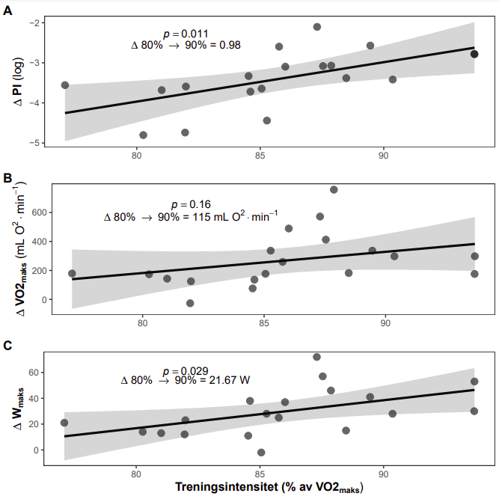

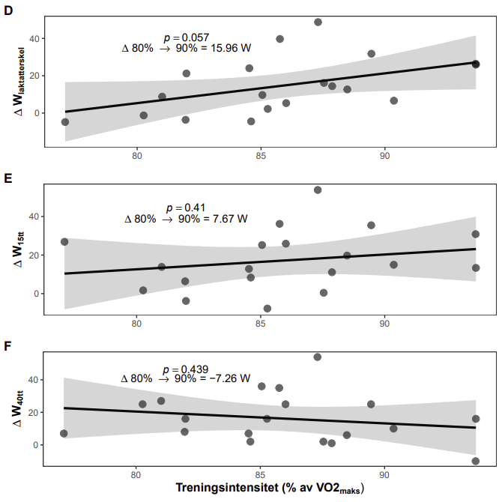

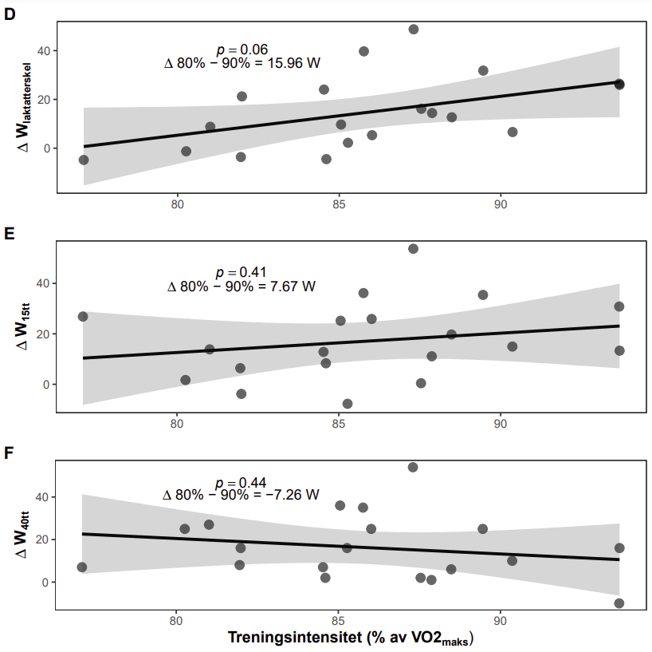

**Grafer som viser endring i relative tall med formelen:**

**lm(relativ endring ~ intensitet + baseline)**

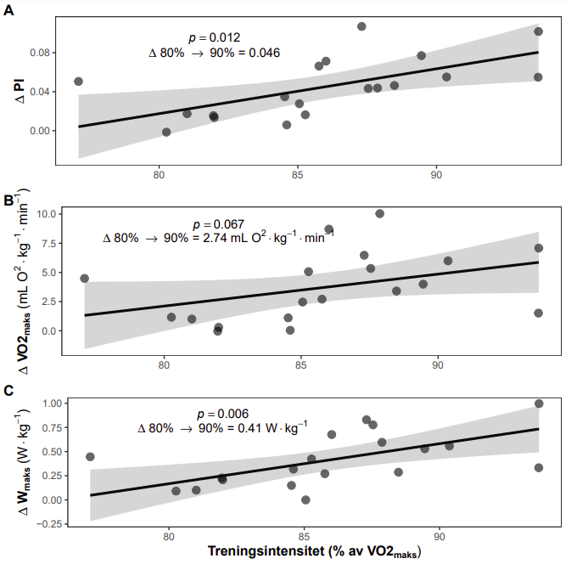

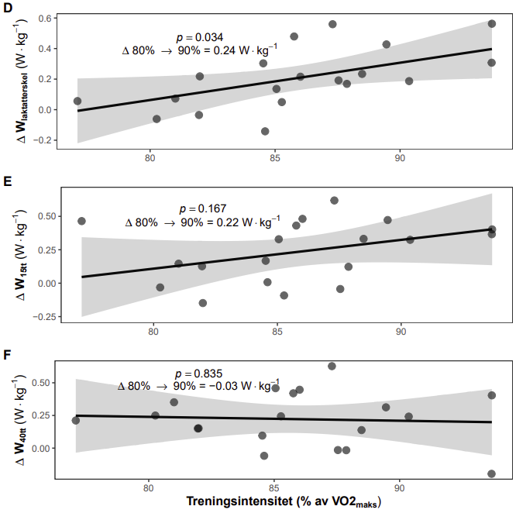

**Grafer som viser endring i relative tall med formelen:**

**lm(relativ endring ~ intensitet + baseline + endring i kroppsvekt)**

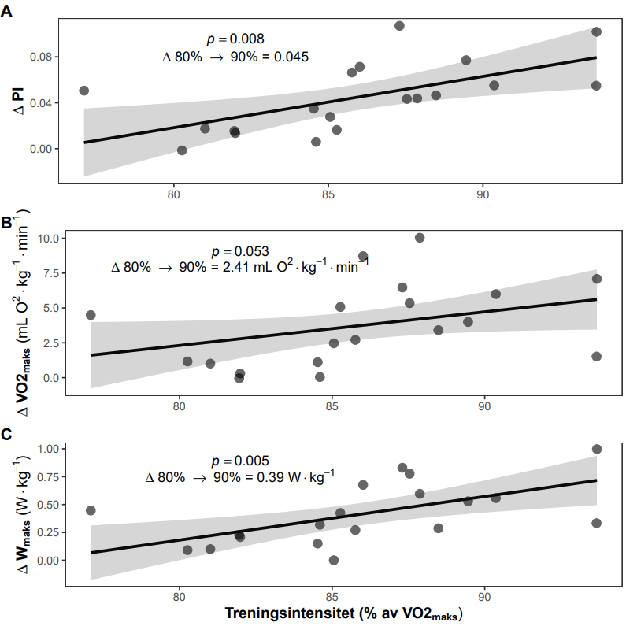

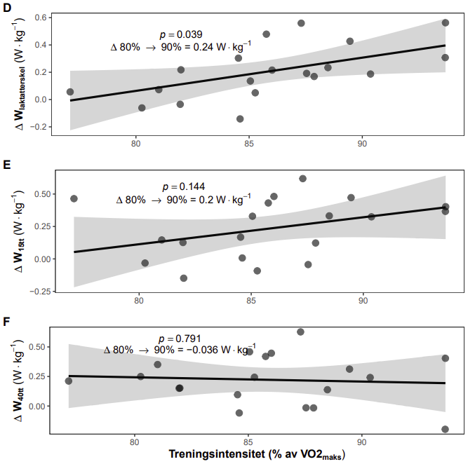

Tabell 0

|  |  |  |  |  |  |  |  |
| --- | --- | --- | --- | --- | --- | --- | --- |
|  | | | | | | | |
|  | Avhengige variabler | | | | | | |
|  |  | | | | | | |
|  | PI | Wmaks | Wla- | W15tt | W40tt | BV | HB |
|  | | | | | | | |
| Intercept | -0.300** | -1.891* | -2.159** | -1.204 | 0.786 | -10.446 | -4.949 |
|  | (-0.514, -0.086) | (-3.855, 0.074) | (-3.712, -0.606) | (-3.089, 0.681) | (-1.135, 2.707) | (-52.429, 31.536) | (-10.722, 0.823) |
|  | p = 0.015 | p = 0.079 | p = 0.016 | p = 0.230 | p = 0.436 | p = 0.633 | p = 0.114 |
| Intensitet | 0.004*** | 0.039*** | 0.024** | 0.021 | -0.004 | 0.458** | 0.049* |
|  | (0.002, 0.007) | (0.016, 0.062) | (0.003, 0.045) | (-0.006, 0.047) | (-0.030, 0.023) | (0.060, 0.857) | (-0.004, 0.103) |
|  | p = 0.009 | p = 0.005 | p = 0.040 | p = 0.145 | p = 0.791 | p = 0.040 | p = 0.091 |
| Grunnivå | -0.051 | -0.180* | 0.066 | -0.081 | -0.066 | -0.336** | 0.049 |
|  | (-0.218, 0.116) | (-0.379, 0.019) | (-0.146, 0.278) | (-0.319, 0.158) | (-0.350, 0.217) | (-0.570, -0.103) | (-0.211, 0.308) |
|  | p = 0.557 | p = 0.097 | p = 0.550 | p = 0.518 | p = 0.654 | p = 0.013 | p = 0.719 |
| Δ kroppsvekt | -0.008** | -0.066* | -0.015 | -0.066* | -0.050 | -0.610 | 0.002 |
|  | (-0.015, -0.001) | (-0.128, -0.004) | (-0.066, 0.036) | (-0.127, -0.005) | (-0.113, 0.013) | (-1.719, 0.499) | (-0.151, 0.155) |
|  | p = 0.043 | p = 0.053 | p = 0.582 | p = 0.051 | p = 0.139 | p = 0.299 | p = 0.980 |
|  | | | | | | | |
| N | 19 | 19 | 19 | 19 | 19 | 19 | 19 |
| R2 | 0.526 | 0.533 | 0.408 | 0.329 | 0.155 | 0.520 | 0.187 |
| Adjusted R2 | 0.432 | 0.440 | 0.290 | 0.195 | -0.014 | 0.424 | 0.025 |
| Residual Std. Error (df = 15) | 0.023 | 0.205 | 0.168 | 0.203 | 0.208 | 3.691 | 0.497 |
| F Statistic (df = 3; 15) | 5.558*** (p = 0.010) | 5.709*** (p = 0.009) | 3.447** (p = 0.044) | 2.455 (p = 0.104) | 0.917 (p = 0.457) | 5.408** (p = 0.011) | 1.151 (p = 0.361) |
|  | | | | | | | |
| Merknader: | *p**p***p<0.01 | | | | | | |

Tabell 0

|  |  |  |  |  |
| --- | --- | --- | --- | --- |
|  | | | | |
|  | Avhengige variabler | | | |
|  |  | | | |
|  | VO2maks | TRIMP | Laktat | BORG |
|  | | | | |
| Intercept | -0.76 | -10250.71* | 6.09 | 12.98** |
|  | (-24.14, 22.61) | (-21713.70, 1,212.27) | (-7.53, 19.71) | (3.93, 22.02) |
|  | p = 0.95 | p = 0.10 | p = 0.40 | p = 0.02 |
| Intensitet | 0.24* | 202.59*** | -0.00 | 0.04 |
|  | (0.02, 0.47) | (69.29, 335.89) | (-0.16, 0.16) | (-0.07, 0.14) |
|  | p = 0.06 | p = 0.01 | p = 0.97 | p = 0.50 |
| Grunnivå | -0.24** |  |  |  |
|  | (-0.42, -0.06) |  |  |  |
|  | p = 0.03 |  |  |  |
| Δ kroppsvekt | -0.96*** |  |  |  |
|  | (-1.58, -0.33) |  |  |  |
|  | p = 0.01 |  |  |  |
|  | | | | |
| N | 19 | 19 | 19 | 19 |
| R2 | 0.59 | 0.34 | 0.00 | 0.03 |
| Adjusted R2 | 0.51 | 0.30 | -0.06 | -0.03 |
| Residual Std. Error | 2.09 (df = 15) | 1,249.13 (df = 17) | 1.48 (df = 17) | 0.99 (df = 17) |
| F Statistic | 7.31*** (df = 3; 15) (p = 0.01) | 8.87*** (df = 1; 17) (p = 0.01) | 0.00 (df = 1; 17) (p = 0.97) | 0.49 (df = 1; 17) (p = 0.50) |
|  | | | | |
| Merknader: | *p**p***p<0.01 | | | |

|  |  |  |  |  |  |
| --- | --- | --- | --- | --- | --- |
| Tabell 0 Variabler for økter | | | | | |
|  | N | GJ.snitt ± SD |  | Min | Maks |
|  | | | | | |
| % av VO2maks | 19 | 85.9 ± 4.3 |  | 77.1 | 93.7 |
| % av HFmaks | 19 | 89.5 ± 1.3 |  | 86 | 91 |
| La- | 19 | 5.8 ± 1.4 |  | 3.0 | 8.5 |
| BORG-skala | 19 | 16.2 ± 1.0 |  | 14.2 | 18.1 |
| TRIMP | 19 | 7150 ± 1498 |  | 4709 | 10680 |
|  | | | | | |

