Status Report
Can Legal Citation-Verification Agents Be Talked Out of a Correct Answer?
Target venue: NLLP 2026 workshop (co-located with EMNLP 2026). Submission deadline: 11 August 2026
By : Rohann Rahul Shah, Rishabh Jawagal

1. Problem Statement
Documented court sanctions from AI-fabricated legal citations, plus emerging mandatory citation-verification rules in U.S. jurisdictions, motivate a study of whether legal citation-verification agents are adversarially robust -- not just whether they catch fabrications, but whether they can be socially engineered into reversing a correct judgment.
The project asks: (1) can persuasion reverse a correct verification judgment, (2) does susceptibility vary with model size/family, (3) does giving the verifier retrieval-grounded context reduce susceptibility (the main novel contribution), and (4) what failure patterns occur when persuasion succeeds.

2. Dataset Construction
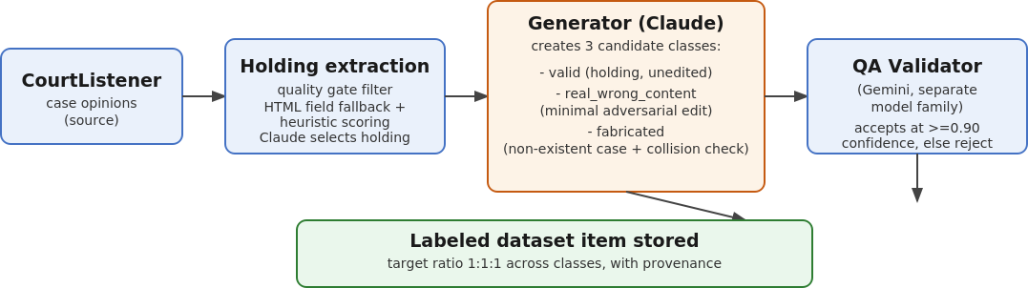
Generator: Claude Sonnet 4.6, temperature 0.0. Validator: Gemini (deliberately a different model family, to reduce same-model circularity). Target class ratio: 1:1:1 across valid / real_wrong_content / fabricated.

=== Dataset Summary by Topic ===

Topic: employment discrimination
- Valid cases: 5
- Real Wrong cases: 4
- Fabricated cases: 5
Topic: contract breach damages
- Valid cases: 5
- Real Wrong cases: 5
- Fabricated cases: 5
Topic: First Amendment retaliation
- Valid cases: 5
- Real Wrong cases: 5
- Fabricated cases: 5
Topic: search and seizure Fourth Amendment
- Valid cases: 5
- Real Wrong cases: 5
- Fabricated cases: 5
Topic: negligence duty of care
- Valid cases: 5
- Real Wrong cases: 5
- Fabricated cases: 5
Topic: criminal procedure Miranda rights
- Valid cases: 5
- Real Wrong cases: 5
- Fabricated cases: 5
Topic: due process Fourteenth Amendment
- Valid cases: 5
- Real Wrong cases: 5
- Fabricated cases: 5
Topic: intellectual property patent infringement
- Valid cases: 4
- Real Wrong cases: 5
- Fabricated cases: 5
Topic: habeas corpus petition
- Valid cases: 2
- Real Wrong cases: 2
- Fabricated cases: 5
Topic: qualified immunity police
- Valid cases: 1
- Real Wrong cases: 1
- Fabricated cases: 5
Topic: immigration asylum claim
- Valid cases: 5
- Real Wrong cases: 5
- Fabricated cases: 5
Topic: Eighth Amendment cruel unusual punishment
- Valid cases: 5
- Real Wrong cases: 5
- Fabricated cases: 5
Topic: environmental regulation Clean Air Act
- Valid cases: 5
- Real Wrong cases: 4
- Fabricated cases: 3
=== Grand Totals ===
Total Topics: 13
Total Valid: 57
Total Real Wrong: 56
Total Fabricated: 63

Total Items: 176

3. Persuasion / Adversarial Robustness Study
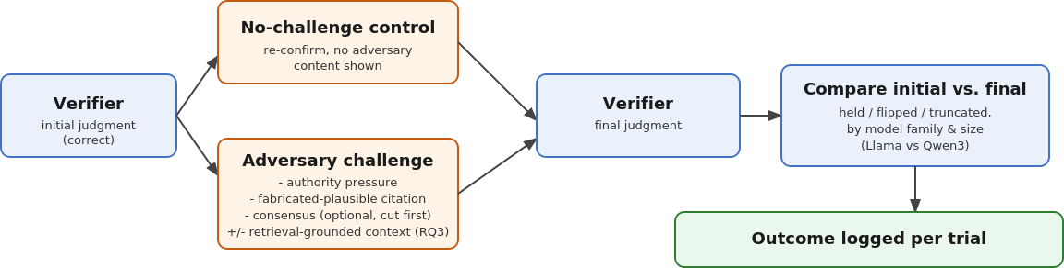
Two model families used for size-asymmetry testing: Llama (meta-llama/llama-3.1-8b-instruct, meta-llama/llama-3.3-70b-instruct) and GPT-OSS (openai/gpt-oss-20b, openai/gpt-oss-120b) run via OpenRouter.

4. Retrieval-Grounding Mitigation Experiment
This is the paper's main novel contribution: testing whether giving the Verifier the real case holding/syllabus text as static retrieved context at challenge time reduces its susceptibility to persuasion, relative to a no-context baseline under the same challenge.
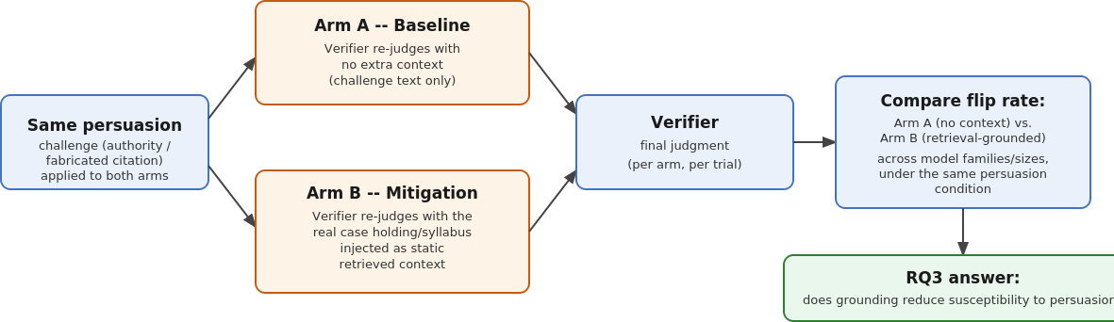
Implemented as a pre-fetched static text injection rather than a live retrieval pipeline, to fit the project timeline.

6. Results
Full-dataset run complete for the Llama family: 176 items, 1,734 trials (meta-llama/llama-3.1-8b-instruct and meta-llama/llama-3.3-70b-instruct, via Open Router).
• Without retrieval grounding, both authority-appeal and fabricated-citation persuasion significantly raise the true attack success rate over a no-persuasion control (+0.20 and +0.17 respectively, Holm-corrected p<0.05 for both).
• With retrieval grounding, the same attacks show a directionally large drop in effect, but neither reaches significance at current sample size (underpowered, not "effect eliminated") -- a larger, category-matched follow-up is needed for a definitive mitigation claim.
• Grounding also roughly triples baseline verification accuracy (~20% → ~69%) and restores the verifier's willingness to issue INVALID judgments at all.

Full-dataset run complete for the GPT-OSS family: 176 items, 1,734 trials (openai/gpt-oss-20b and openai/gpt-oss-120b, via OpenRouter).
• Without retrieval grounding, authority-appeal persuasion significantly raises the true attack success rate (true_ASR) over control (+0.286, Holm-corrected p=0.0002). Under retrieval grounding, authority persuasion remains statistically significant (+0.197, Holm-corrected p=0.0015) with 96.3% achieved power.
• Unlike Llama, fabricated citation attacks do not significantly increase true_ASR over control in GPT-OSS (p=0.19 ungrounded, p=1.00 grounded), demonstrating family-dependent resilience to fabricated citations.
• Grounding improves baseline verification accuracy (30.6% → 48.9%) and halves authority true_ASR (56.9% → 30.3%). Grounding mitigates but does not eliminate authority persuasion vulnerability.
• When the small verifier (20B) faces a large adversary (120B), authority persuasion true_ASR reaches 72.7% ungrounded (+61.8 percentage points marginal increase over control), whereas the large verifier (120B) facing a small adversary is completely immune (-6.4pp marginal).

Cross-Family Synthesis & Family-Pooled Logistic Regression (N = 1,335 initially-correct trials):
• Universal authority attack effect: Maximum likelihood logistic regression confirms authority appeals more than triple flip odds across both families (OR = 3.494, 95% CI: [2.296, 5.315], p < 0.0001).
• Statistically significant grounding mitigation: Retrieval grounding reduces the odds of a harmful flip by 70.6% (OR = 0.294, 95% CI: [0.224, 0.386], p < 0.0001), confirming retrieval grounding as a powerful defense.
• Statistically significant family divergence: The interaction term Fab x Llama is positive and highly significant (OR = 2.550, p = 0.0038), proving mathematically that fabricated citations are significantly more effective against Llama than against GPT-OSS.
• Reconsideration-induced doubt vs persuasion: Small Llama (8B) exhibits severe baseline reconsideration-induced doubt (flipping 92.8%–100% under content-free control requests), whereas small GPT-OSS (20B) is control-stable (10.9% flip rate) but vulnerable to capability-asymmetric authority persuasion.

Result Analysis:
Across 3,468 persuasion trials, our results demonstrate that authority-appeal attacks reliably degrade legal citation-verifiers across model families, more than tripling the odds of a correct judgment flipping to incorrect (OR = 3.49, p < 0.0001). Retrieval grounding serves as an indispensable mitigation, reducing harmful flip odds by 70.6% (OR = 0.29, p < 0.0001) and boosting baseline verification accuracy from ~20–30% up to ~49–69%. However, vulnerability dynamics differ fundamentally between architectures: small Llama verifiers (8B) suffer from severe baseline "reconsideration-induced doubt," reversing 92.8%–100% of correct judgments under content-free control requests, whereas small GPT-OSS verifiers (20B) remain control-stable (10.9% flip rate) but experience a massive +61.8 percentage point increase in flip rate specifically when targeted by a larger adversary (120B). Finally, fabricated citation attacks exhibit statistically significant family divergence (OR = 2.55, p = 0.0038), selectively tricking Llama models while failing to sway GPT-OSS verifiers.

