GOLDEN LEAF HANDICRAFTS

Main Description

Bring home the festive look all throughout the year with this stunning pair of Latkan.

Beautifully handcrafted for Indian homes to work as perfect wall hangings.

When placed on the walls of doors, these latkans give an auspicious look. Also they are easy to assemble.

Latkan is also a perfect gift when celebrating Diwali and other felicitous occassions.

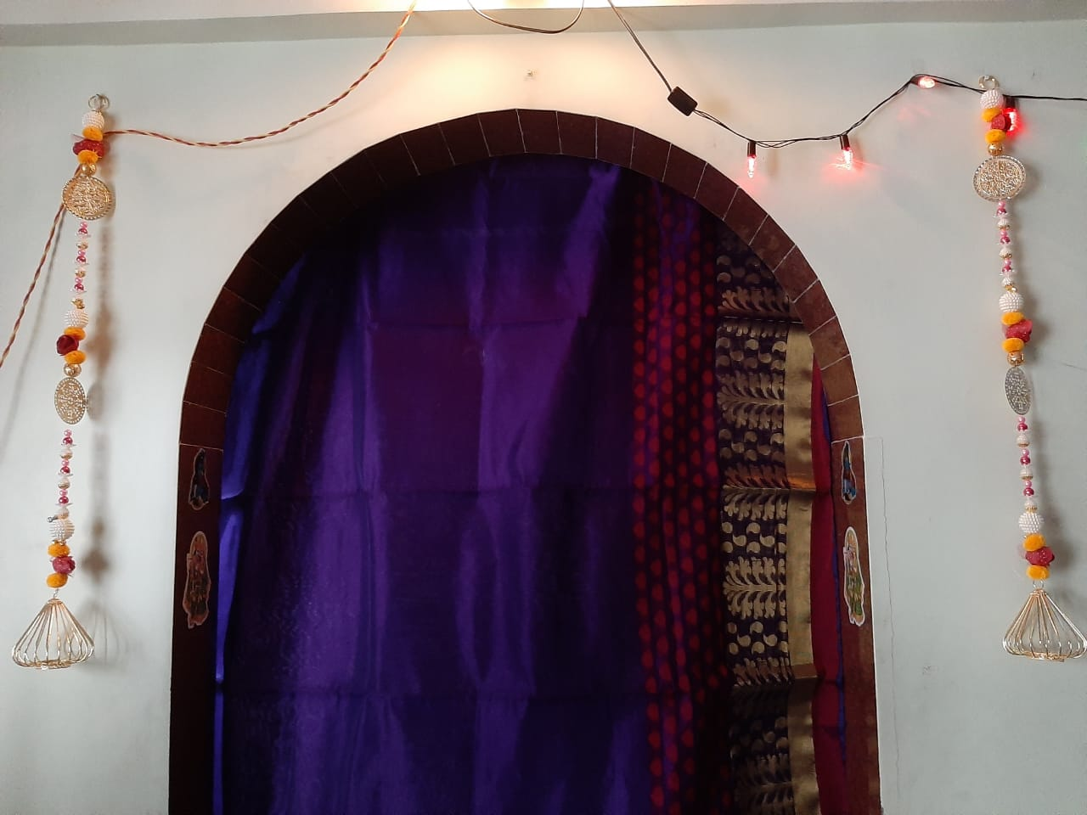

When hanged to the both sides of your home temple, it will give a mesmerizing look to it.

Purchase it just at Rs.499/-.

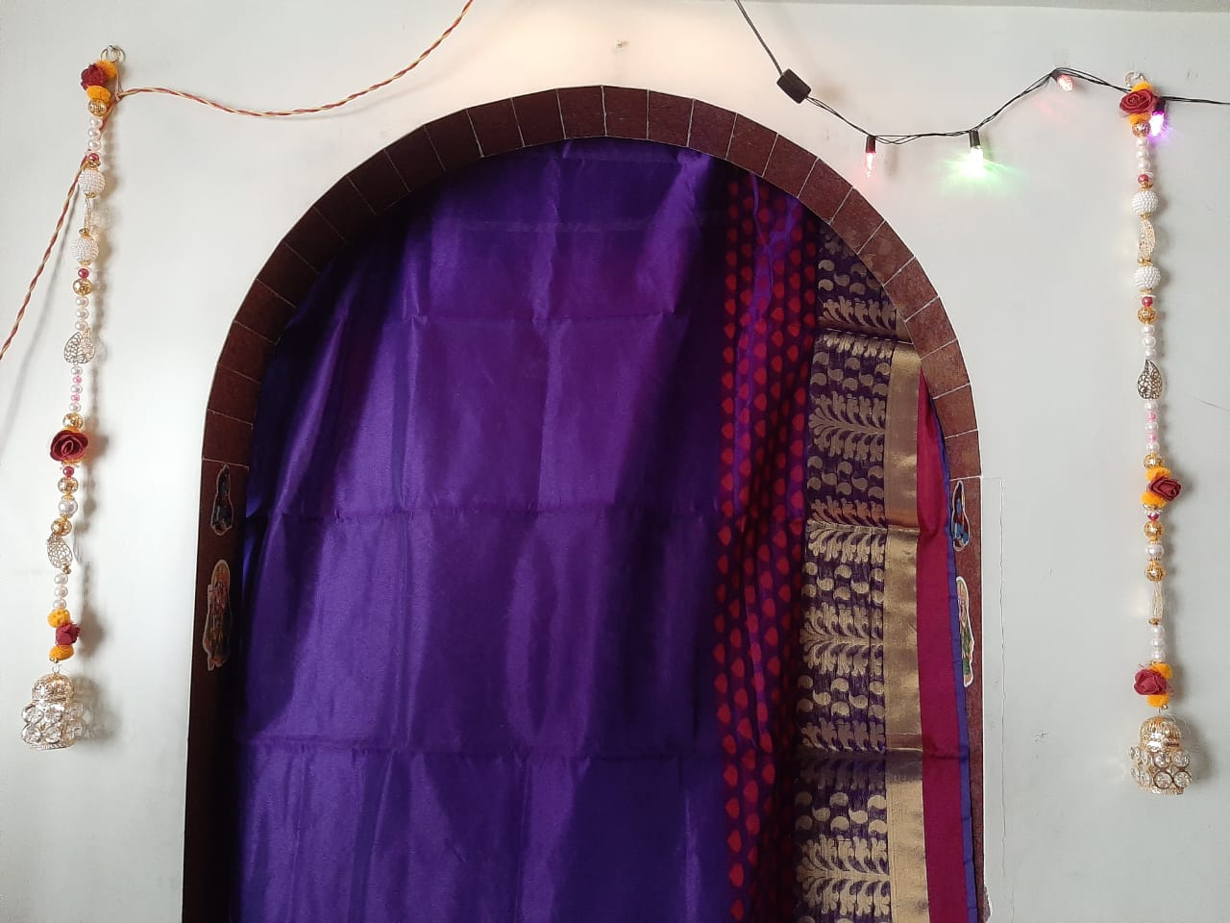

When our beautiful decorative latkans are hanged on your doors, it will give a festive look to your doors and enhance the beauty of your homes.

Purchase at just Rs.499/-.

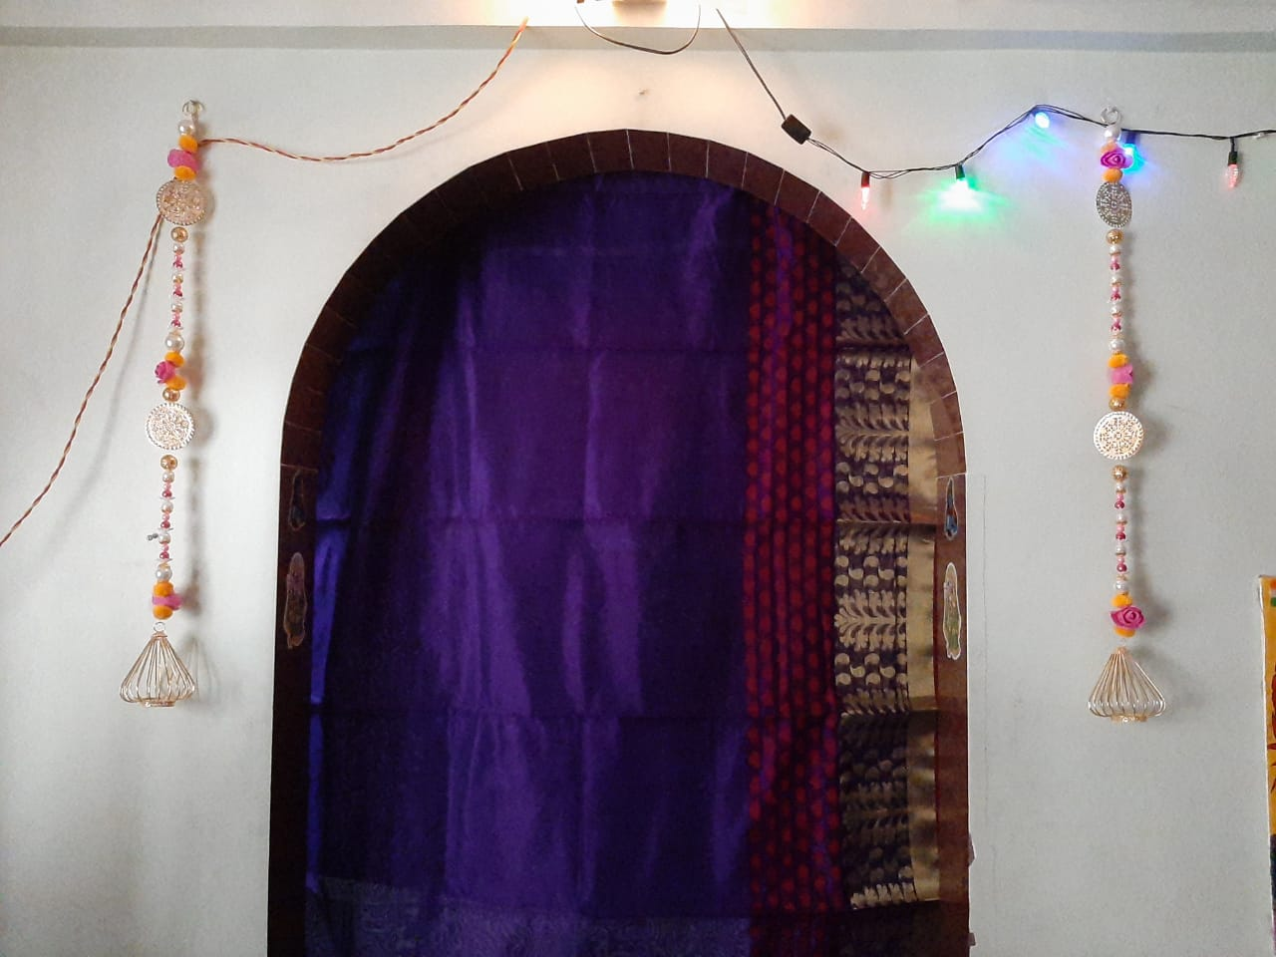

This beautifully decorated pair of Latkan is specially handcrafted with the help of pink roses and pearls to enhance the beauty of your homes.shop now at just Rs.499/-.

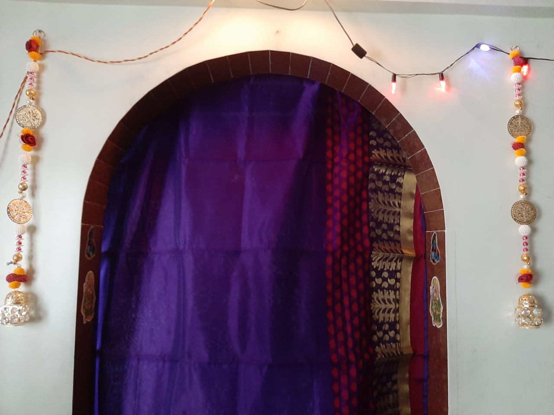

An innovative and new way

to decorate your homes and temples. Cherish the joys of your life and give your homes a festive look throughout the year with our beautiful latkan collection.