GOLDEN LEAF HANDICRAFTS

Pooja Articles

Pooja/prayer has a significant role in our lives.

So why not make that experience grand.

Golden Leaf Handicrafts has crafted a few products to make your pooja experience beautiful.

Category - Puja Thali

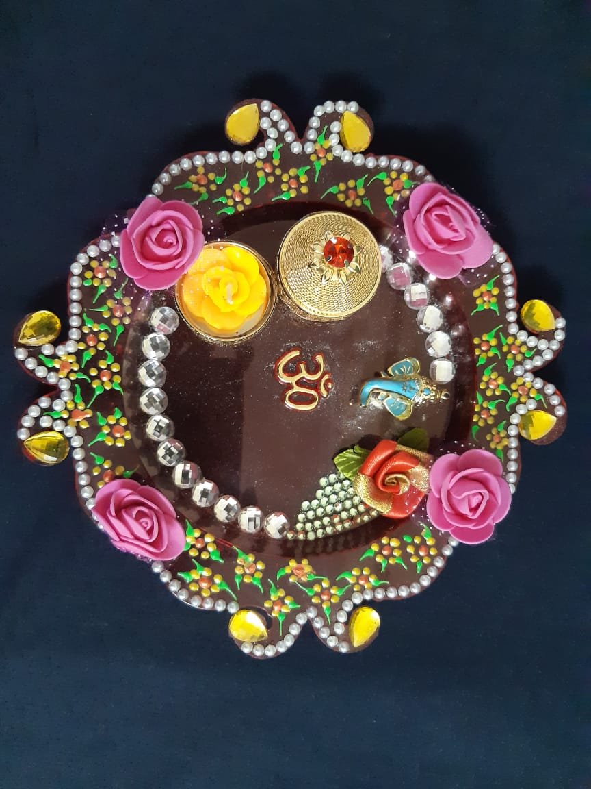

In Indian culture, worship of God has got tremendous importance. For performing pooja, flowers, kumkum and diyas are used.

We have combined everything into one thali and brought to you our vibrant and colourful crystal studded pooja thali.

Category - Kumkum karanda (a tiny vessel to store vermilion)

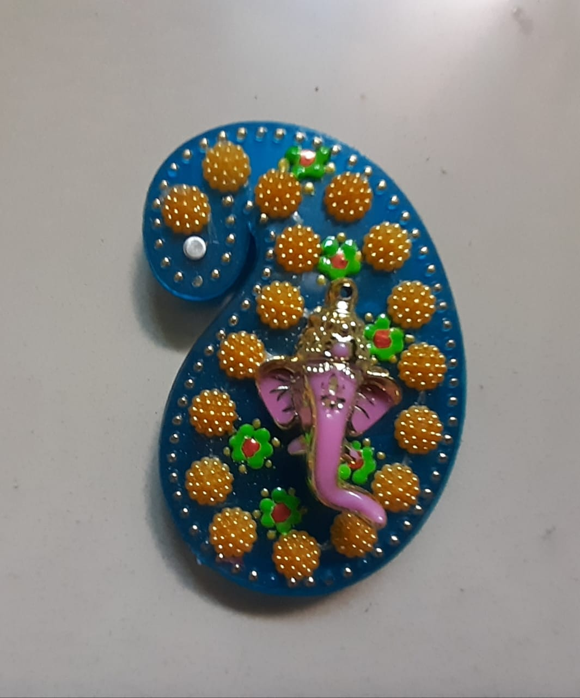

Kumkum has a tremendous importance in Hindu culture.

It is a symbol of prosperity and wellbeing.

It is used for the worship of God.

Here at Golden Leaf Handicrafts, we have brought a new decorative kumkum karanda just at Rs.49/-