GOLDEN LEAF HANDICRAFTS

Category - Shoes

It takes only one shoe to change your life…..By Cindrella

We believe that life is an art and each person is an artist.

Today's young generation is very much fond of various funky artifacts.

Here at Golden Leaf Handicrafts we have brought a pair of shoes specially designed with zentangle patterns .

Select your size and pick up your shoes right away.

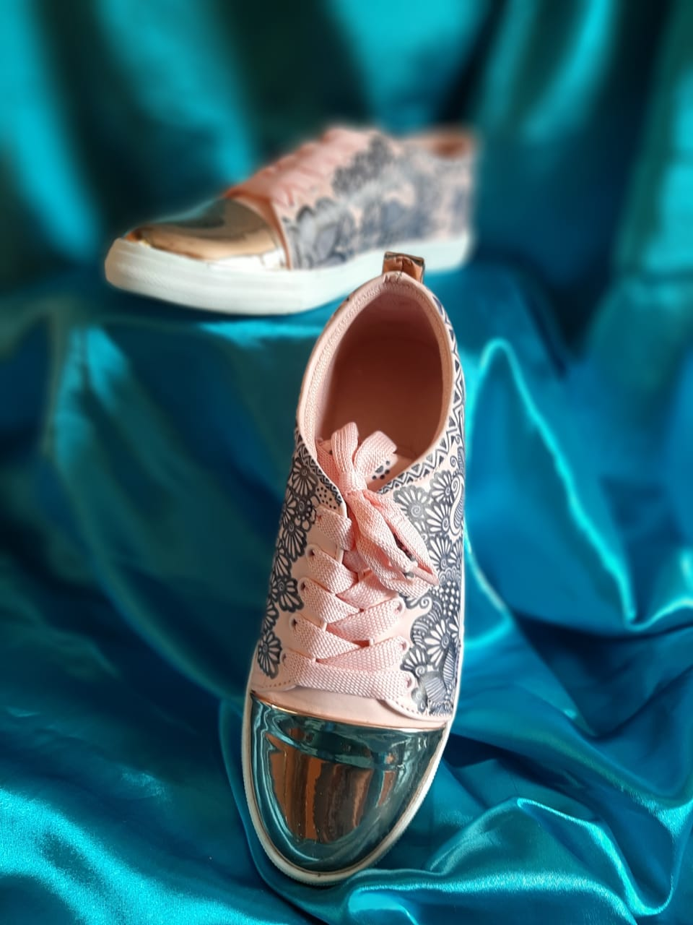

This golden and baby-pink color shoe in itself is a good piece of artwork.

It will definitely intensify your personality. So dear ladies and girls, do check our shoes collection and shop them now just at Golden Leaf Handicrafts.

At Rs.1999/-.

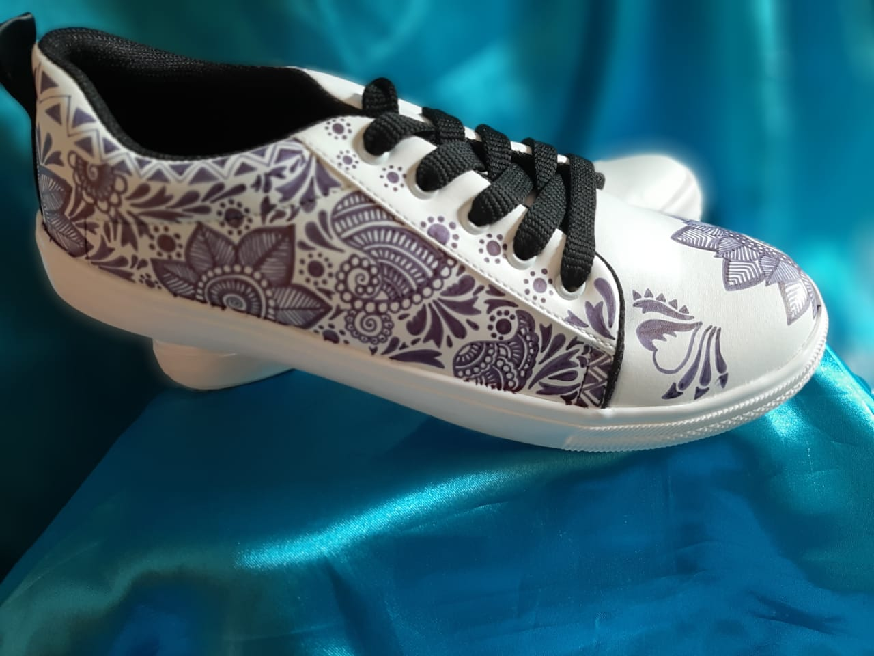

Black and white goes hand-in-hand. This white shoe with an artwork in black improves it's beauty. Grab this opportunity to purchase these shoes now at just Rs.1,999/-.

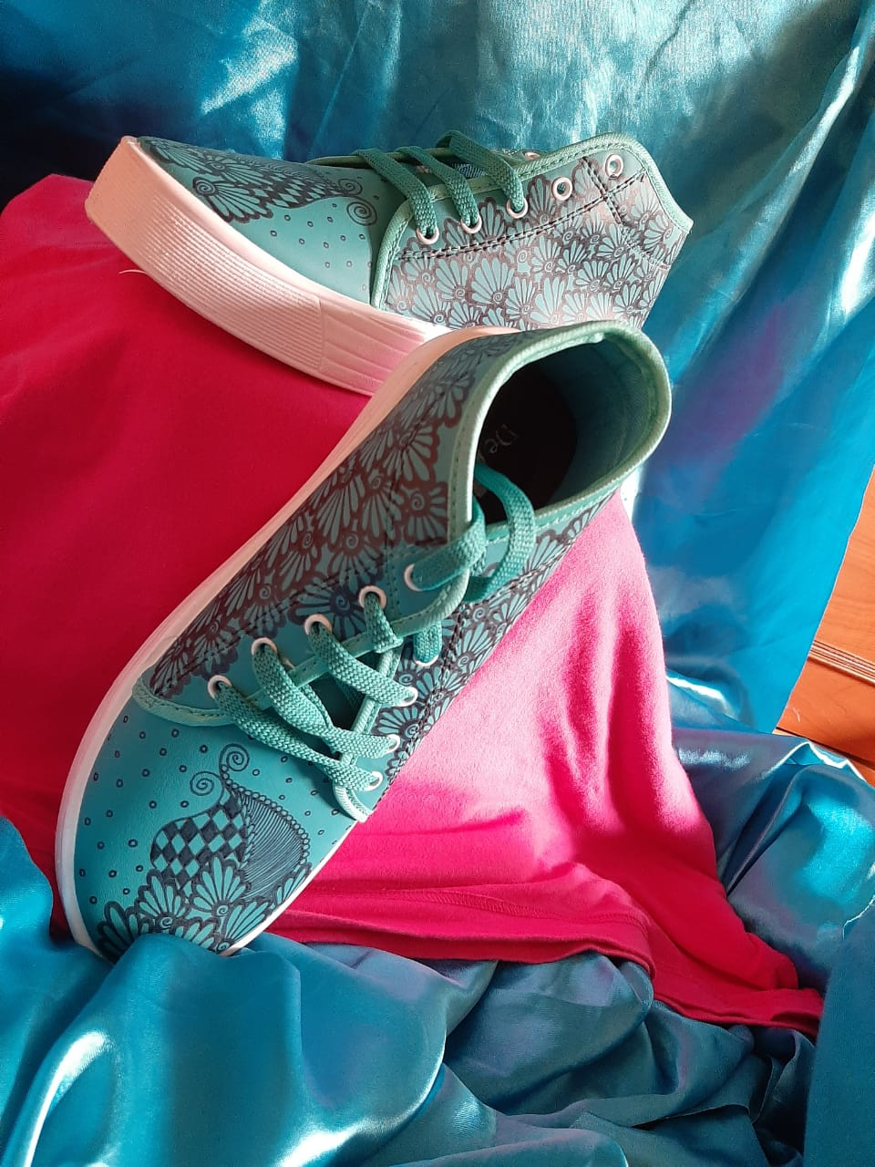

Footwear of a person indicates his/her personality. So intensify your personality with this beautiful peacock-blue colour shoes. Purchase it now at just Rs.1,999/-.