GOLDEN LEAF HANDICRAFTS

Category - Fur curtains

Who doesn't like the woollen fur balls? These curtains made with elegant red-pink fur balls will not only give your doors a stylish look, but also help you redesign them in a new way.

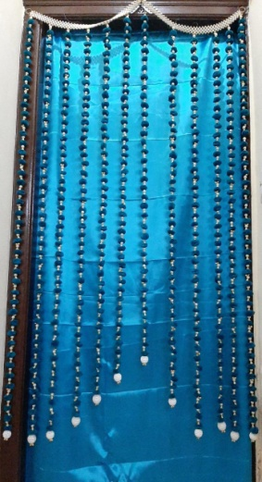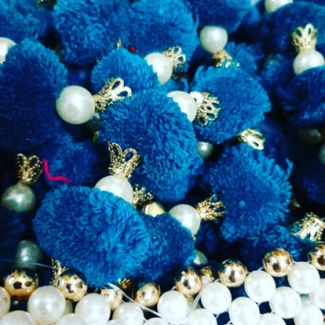

Our beautiful peacock blue curtains prepared with fur balls and pearls will help you give a mesmerizing and oceanic look to your doors and windows.

Get them at just Rs.999/-.

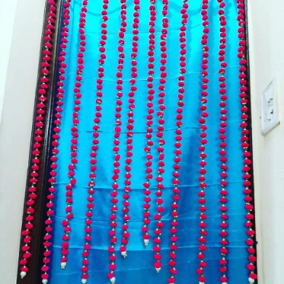

Our simple handcrafted curtains prepared by using pink fur balls and pearls will give a simple and sober look to your homes.

Purchase now at just Rs.999/-

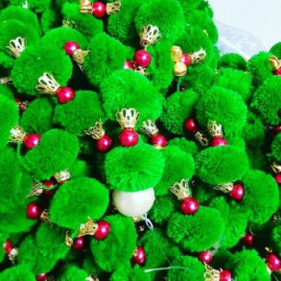

When placed on the doors and windows of your homes, this beautiful sea green colour curtains handcrafted with sea green fur balls and beads will give an enchanting look to your homes.

Purchase it just at Rs.999/-.