GOLDEN LEAF HANDICRAFTS

Category - Toran

Earlier real flowers and leaves were hung on door tops on auspicious occasions. However, in today's busy and fast life, that is not possible.

Here at Golden Leaf Handicrafts, we offer you a vide range of torans to help you decorate your doors and temples, at a reasonable rate. Shop now at Golden Leaf Handicrafts.

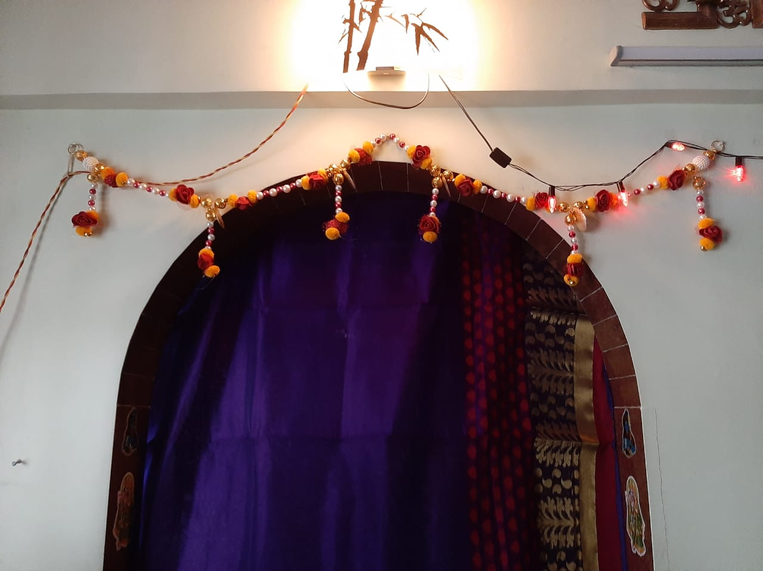

Our beautifully decorated toran specially handcrafted with the help of red roses, yellow fur balls and beautiful pearls to enhance beauty of your homes.

Purchase it just at Rs.449/-

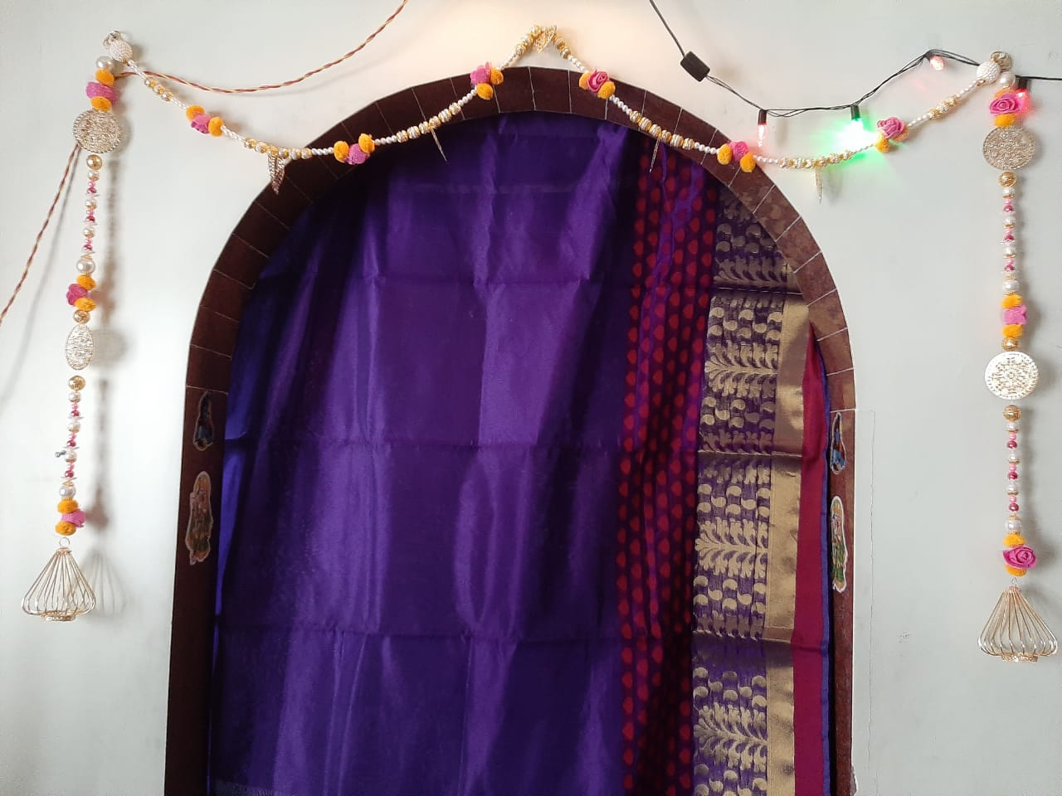

Our beautiful handmade torans are finely crafted with pink roses and fur ball will add to the beauty of your homes and home temples.

Toran and latkan goes hand-in-hand. So buy this pair now at just Rs.999/-.

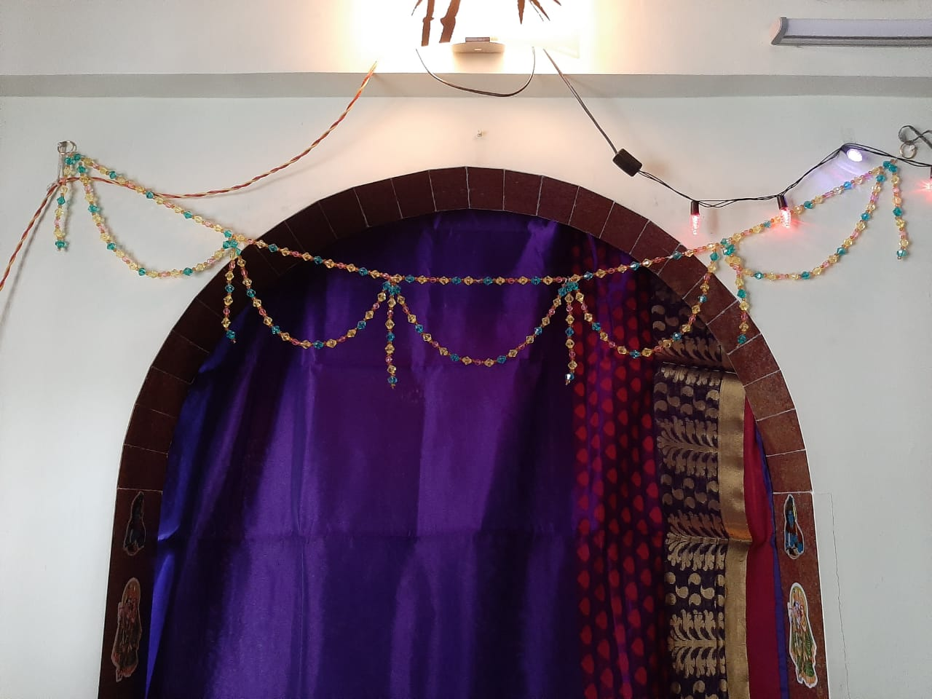

Vibrant and colourful crystal s look beautiful on everything. Why not put them on your doors and temples?

Our handmade stunning crystal toran is beautifully designed to fit every door and temple, with respect to its beauty.

Shop it now just at Rs.,149/-.