# Narrative

## Introduction

The European Vending Association estimates that every day 82 million food and drink items are purchased from a vending machine, by European customers (including Russia, Turkey, and Ukraine).

In 2012 the field of operating machines has remained almost stable with 3.77 million operating machines. 80% of these machines where located in Europe’s 6 big leading markets the big 6 (Italy, France, Germany, the Netherlands, Spain and the United Kingdom.).

An Interesting fact according to the European Vending Association is that 60% of these operating machines are hot drinks vending machines whereas the remaining 40% can be evenly divided between cold drinks and a mix of both hot drinks and cold drinks vending machines.

The total turnover from vending machines in 2012 was €11.3 billion.

The total number of items sold through vending machines in 2012 was 30 billion units, of which 24 billion items were dispensed in the Big Six.

**EasyVending**

We are proposing a system hereafter "EasyVending” to Vending Machine Manufacturers (VMM's), that promises to understand "easy interfacing" and making it the core and heart of every vending machine. EasyVending provides a solution that has the Interest of potential Users, Beneficiaries and Manufacturers in mind by automating vending machines to be less dependant of external interference during poential erros .

With the advent of increasing technology and embedded systems growing with computational capabilities, "EasyVending" will make use of these advances and interface with the vending machines main business operations allowing Beneficiaries to manage their machines without prior programming or technological background.

VMM's who are using "EasyVending" promise their customers full control and maintainability. Most vending machines that are currently operating have limited interfacing options which makes the customer often depend on repair services usually conducted by individuals not associated with the customer’s main business that produces extra cost which in most cases can be avoided. Additionally EasyVending provide customers access to their vending machines through interfacing locally and/or remotely, allowing them to add or remove products, change prices, adjust currency settings,generate error reports, manage temperature settings, keep records of temperatures within the machines which has become a key factor for customers that use their vending machines to sell hot beverages.

During the initial install and setup, EasysVending provides VMM's the opportunity

to set up remote monitoring and remote access to the Vending Machine which gives VMM's the option to identify and track errors early on and can act accordingly.

EasysVending also allows Beneficiaries of Vending Machines to gain access to local and/or remote interfaces where business operations such as Product mapping,pricing,and temperature can be configured through an intuitive easy to use interface.

EasysVending however stands out from conventional VendingMachine software solutions in sofar that it apart from its easy interfacing provides a new approach towards VendingMachine Automation trying to minimize external interferences and maximising the VendingMachine ability to recognize and resolve potential issues internally.

This is where AlertControl comes in.

AlertControl at consist of two bounded interfaces North and South.

The "Northbound"

Interface of Alert Control is concerned to keep an eye on the internal stability of the system, i.e. make sure that temperature sensors don't report values that exceed the required ranges, the curren financial status corresponds with the current product sales, no error reporting within the Vending machines Operating System and possible vandalism.

The "Southbound"

Interface of Alert control is concerned with collecting, recording and according to severity sending reports out the Administrators and Managers.

We estimate that most of EasyVending's revenue stream will come from VMM's who are using EasyVending as their solution, in the form of sell commission and/or a one-time payment for EasyVending.

# SOFTWARE LIFE CIRCLE (SLC)

Software Life Circle or Software Development Life Circle (SDLC) is a framework defining task performed for each step of a software development process. Using a software model helps in the development of a software product in a systematic and structured manner. There are various software life circle models standard which exist today. We consider some of these model approach in relation to our project. They are:

Waterfall Model

Iterative Model

Spiral Model

V-Model

RAD Model

Agile Model

|  |  |  |
| --- | --- | --- |
| **SLC Model Types** | **Advantages** | **Disadvantages** |
| Waterfall Model | -Better with smaller project  -Low cost involvement  -Simple to implement and it is well known  -Good for inexperience developer or staff | -Poor for complex and big project  -Inflexible  -Difficult to integrate risk management and maintenance |
| Iterative Model | -On time feedbacks  -Easy refractory when error occurs | -Rigid phases  -Costly |
| V- Model | -Good bases for partitioning of testing  - Each phases has specific deliverables | -Little flexibility and adjusting scope is difficult.  -Very expensive to maintain  -No clear path for problems found during testing phases |
| Agile Model | -Adaptable  -Working software is delivered frequently  -Close, daily cooperation between customer/User and developers | -Minimal emphasis on designing documentation |
| Spiral Model | -Risk Assessment and reduction  -Good for large and mission critical project  -On-time software production | -Very expensive to use  -Requires expertise risk analysis  -Is not good for smaller projects |

Considering the pros and cons of these model and based on the nature of our project EasyVending, we’ll be using the Agile Model SLC because of the flexibility and implementation using scrum approaches in completing the project requirement.

Waterford model will not suit our project because the project is prone to change frequently as we progress in the development.

In Iterative model, each phase rigidity will not work with EsayVending because each phases of our project may require developmental changes.

V-model will not be suitable because of the difficulty in scope adjustment. The dynamic modern development requires a more scope adjustment based on the frequent change in stakeholders requirements.

Spiral model is not chosen because of the expert risk analysis and the taste for bigger project which does not suit our project.

The flexibility and adaptability of agile approach will suit our mode of operation because there may be few adjustment we’ll be implementing as we build the project (EasyVending).

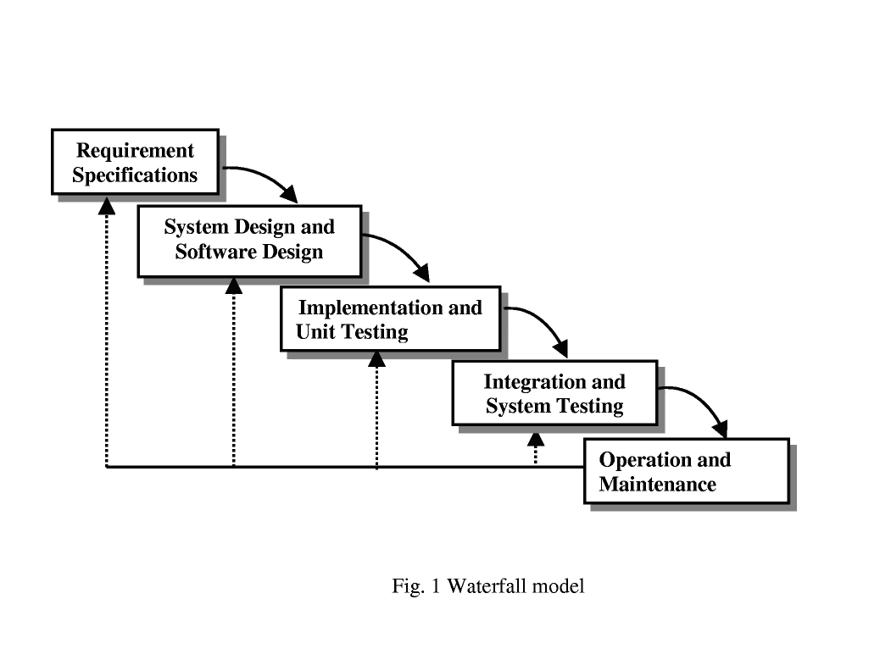

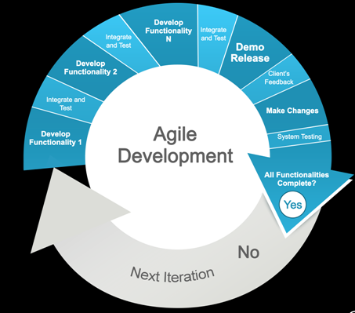



Rerferences

<http://www.ijcsi.org/papers/7-5-94-101.pdf> [Accessed Feb() 2016]