APENDIX 1

Use Case Descriptions from iteration 1:

Machine Installation
Actor’s Action | System Response
1) The factory setup the machine  3) Enters (Default Password, Default Username, Location, ID)  5) Enables remotes access and monitoring for beneficiary | 2) Validates and accepts credentials  4) Sends new credentials to remote servers  6) System operates and is accessible locally and/or remotely by beneficiary
Alternative route
3a) Credential submission not accepted.

[SR] Network error prevents sending credentials to remote servers

Vending Machine
Actor’s Action | System Response
1) Chooses product Mapping from management interface  2) Enters product name into corresponding input box and clicks Ok button  5) Select a product name from a dropdown list  6 ) Selects a desired slot location from a dropdown menu  8) Enters a desired price into corresponding input box and clicks OK button  9) Select A desired price from dropdown menu  10) Select a desired temperature range or status from the current product dropdown menu.  12) Select a quantity for product from a drop down menu.  13) Presses save on management interface. | 3) Validates and accepts price input  7) Validates and accept slots allocation  11) Accepts temperature ranges  14) Accepts and stores created configurations.
Alternative route
8a) Beneficiary enters wrong format for price
[SR] Beneficiary is alerted to his error and machine does not accept input
12) Beneficiary provides wrong quantity for product
[SR] System fails to calculate the individual weight of product

Refill of machine
Actor’s Action | System Response
1) Open machine’s door  2) Places goods into machine  3) Locks the door | 4) System response to suppliers locking the door  5) System calculate individual weight for products in allocated slots  -System initialises AlertControl according to configuration  -System calculates an estimate of overall product value  -System calculates offset against current available money in the Machine
Alternative route
2a) Supplier places products in the wrong slots.

[SR] System fails to estimate overall estimate of current money in the system

Purchase Vending Machine
Actor’s Action | System Response
1) Request vending machine type to a specific location from Machine provider  3) Pay for the vending machine | 2) Location of installation is define and mapped out  4) Machine installation is carried out and machine details (Type, location, ID, Customer) is logged on the Machine provider database server
Alternative route
4a) Customer machine installation is faulty
[SR] System refuses to log and confirm details.

Purchase items
Actor’s Action | System Response
1) Select a preferred item by pressing a button  3) Insert cash or card for payment  6) Get or pick up item from the base of the base of the machine | 2) Vending machine reads and calculate the prefer item details (Type, slot-line, numbers, amount)  4)Vending machine display amount due and receive the proportionate cash value  5) Vending machine dispense or drop the item selected for user to pick it up
Alternative route
4a) User select item and did not insert cash or payment
[SR] Vending machine refuse to dispense item
4b) User select wrong item and insert cash (lower than the item value)
[SR] Vending machine refuse to dispense item and refund cash.

Cash evaluation

Actor’s Action | System Response
1) Sense the ambient environ for change in temperatures proportionate to the value set, for the environs. | 2) Adjust the degree of coldness relatively
Alternative route
2a) Temperature sensor not reading correctly the set-up temperature environ
[SR] Temperature function refuse to work

Reads temperature
Actor’s Action | System Response
1) Read and confirm the cash/card properties that was inserted  3) Compare the cash/card amount to the calculated value of the selected items. | 2) Detect the genuineness of the currency or card properties.  4) Accept the cash/card and send data to confirm (in the case of credit/debit/visa card)
Alternative route
2a) Cash/card cannot be verify
[SR] System cannot dispensed items.

Vandalise
Actor’s Action | System Response
1) Handles machine with aggressive force and malicious intent | Actor’s Action
Alternative route
 | Actor’s Action

Report Weight Data
Actor’s Action | System Response
1) Reports data from sensors that does not correspond to overall estimation of current weight | 2) The system check if a purchase was made  -System check what was purchased  -The system calculates weight imbalance against the individual weight of product that was purchase  -The System determines if the weight balance corresponds to a possible product that was not dispensed due to error  -The system validates should a refund be issued  -The system reports weight imbalance and actions taken to remote server and logs
Alternative route
2a) System cannot read sensor
[SR] System fails to determine if current weight imbalance was related to a foregoing purchase and cannot decide whether it should issue a refund.

Login setup
Actor’s Action | System Response
1)Select change login from management interface  2) Enters new username in provided input Box  3)Enters new password in provided input box  4) Presses save | 5) Validate new credentials  6) Stores new credentials
Alternative route
5a) Beneficiary (customer) supplies password not adhering
[SR] Vending Machine does not accept input and alert beneficiary (customer) the error

Login
Actor’s Action | System Response
1) Enters username  2) Enters password | 3) Validate Credentials  4) Allow access to management interface
Alternative route
3a) Machine Provider supplies wrong username or password
[SR] Vending Machine denies access to management interface.

APENDIX 2

Class Analysis:
Using Data Driven Design, we identify our classes by Noun Identification Techniques.

Beneficiary | Password | Product name | Configuration | Place Goods
Login | Input Box | Slot | Response | Machine Provider
Remote Access | Allocation | Calculation | Vending Machine | Validation
Storage | AlertControl | Location | Server | Menu
Suppliers | Identification | Product | Price | Username
Management Interface | Dropdown Menu | Request | Payment | User
Database | Purchase | Preferred Item | Card | Pick-Up
Amount | Display | Dispense | Credential | Refund
Comparison | Detection | Currency | Verification | Sensor
Value | Environ | Adjust | Temperature | Thresholds
Alert | Imbalance | Operator | Check | Selection
Money | Error

Heuristic

Red Colour – Too Vague
Green Colour- Is an Operation
Blue Colour – Is an attribute
Brown Colour- Out of Scope
Purple Colour - Similarity
Filtered List
Login | Slot | AlertControl | Vending Machine
Server | Product | Management Interface | Database
Currency | Sensor | Environ | Operator
Money

Rerferences
http://www.ijcsi.org/papers/7-5-94-101.pdf [Accessed Feb() 2016]

APENDIX 2
Iteration 1:
Use Cases:
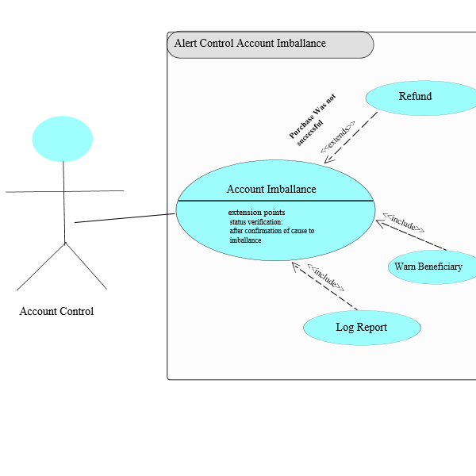

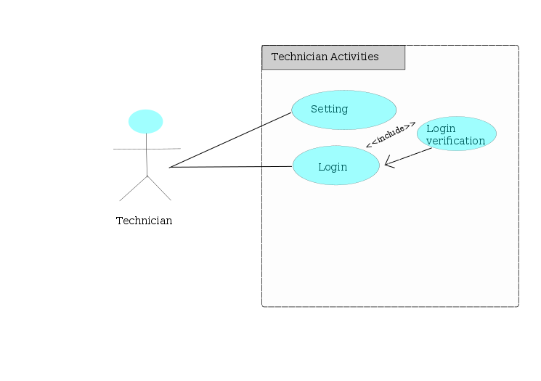

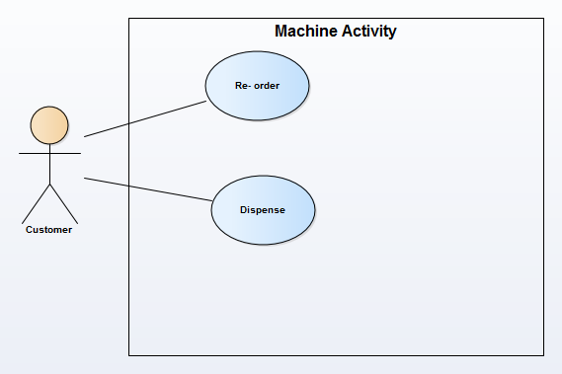
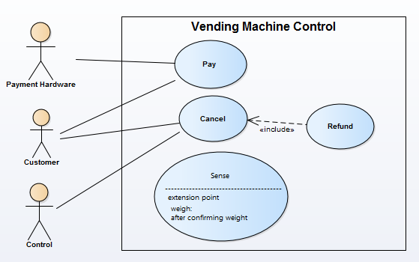
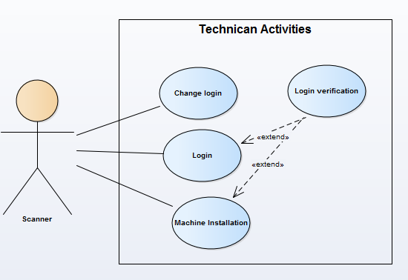
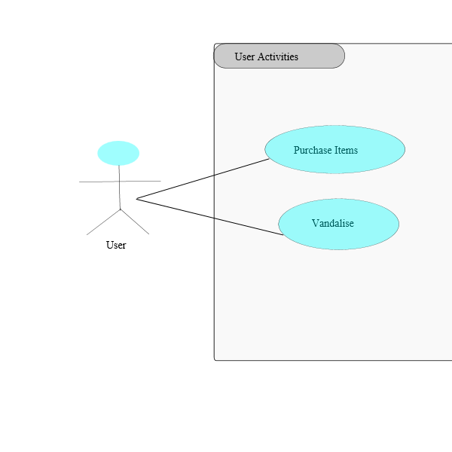

APENDIX 4

Class Diagrams:
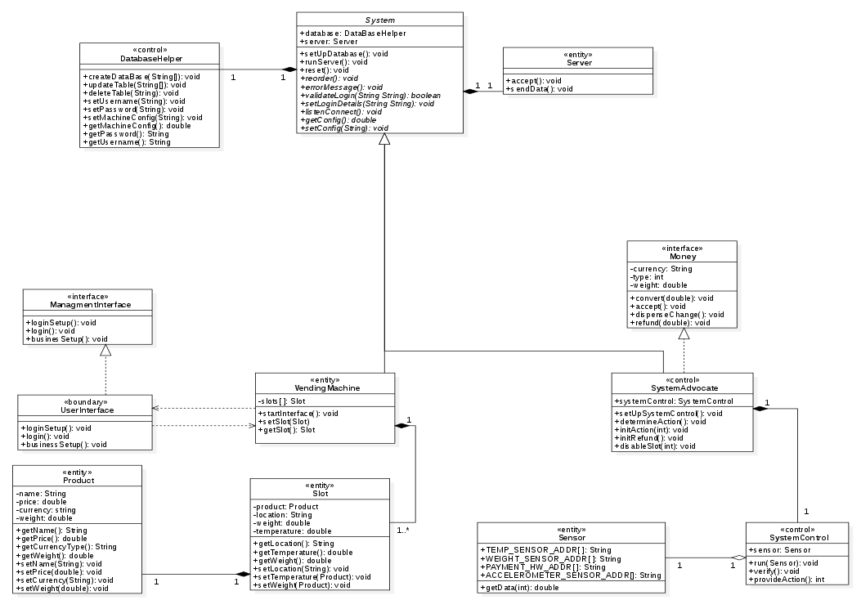

APENDIX 5

Communication Diagram
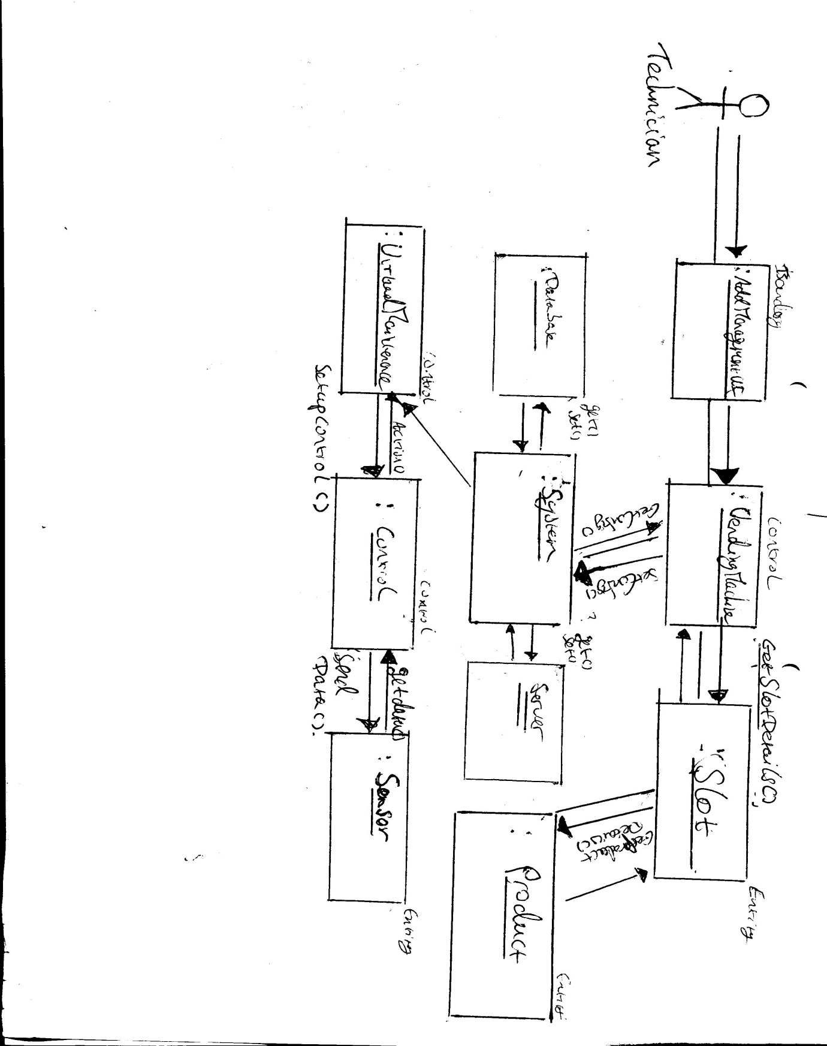

APENDIX 6
Structure use Case description:
USE CASE 2 | Business Setup
Goal in Context | The beneficiary chooses products and goods to put in the machine
Scope & Level | Delivery & Beneficiary Company
Preconditions
Success End Conditions | Everything is validate and pute in the machine ( Price + slots allocation)
Failed End conditions | Input not accepted (wrong quantity, wrong format for price…)
Trigger | Input requet comes in
DESCRIPTION | Step | Action
 | 1 | Beneficiary choose produt Mapping from management interface
 | 2 | He enters product name into corresponding input box and click OK button
 | 3 | Beneficiary select a product name from a dropdown list
 | 4 | He selects a desired slot location for a dropdown menu
 | 5 | He selects a desired price from dropdown menu
 | 6 | He selects a desired temperature range or status from the current product dropdown menu
 | 7 | He selects a quantity for product from adropdown menu
 | 8 | Finally he presses save on management
EXTENSIONS | Step | Branching action
 | 1a | Beneficiary enters wrong format for price
 | 7a | Beneficiary enters wrong ammount of product
VARIATIONS |  | Branching action

