Dead Man’s Draw++ - System Design

UML Diagram

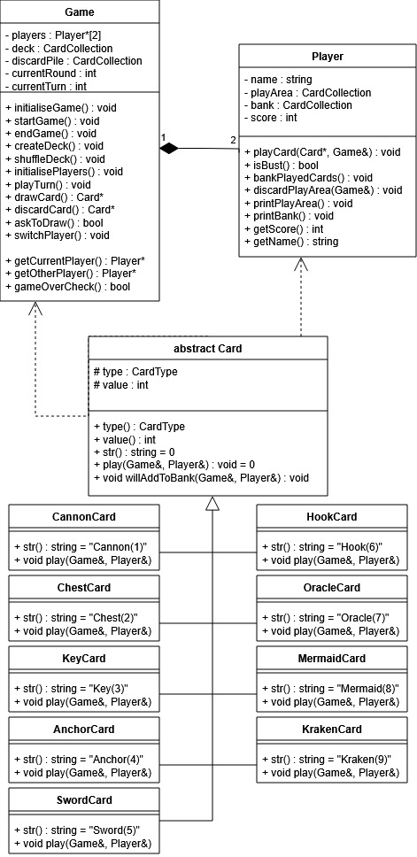

Design Decisions
Here is a list of extra design decisions that differ from the assignment description:
- Game will also be responsible for keeping track of the discard pile.
- Game should be responsible for knowing both the current and other player, so that it can quickly switch them around when a turn ends.

