FR1: Load Patients from File
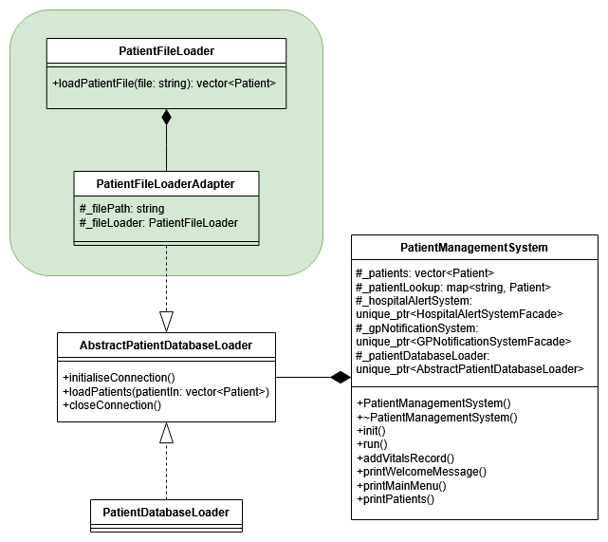
Figure 1 - Adapter design pattern for file loader implementation.
Chosen design pattern: Adapter design pattern
The system has to be able to load patient data from the given patients.txt file. However, the patient management system already utilises an existing database loader, so to prevent a rework of the management system I had to use the adapter pattern and create a file loader adapter that implements the existing abstract database loader similarly to the existing database loader. This then interacts with the provided patient file loader to parse the text file and load the relevant patient data into the database, which is forwarded onto the management system.
With this implementation, the patient management system only needs a single line of code changed to use the new file loader.
How it works:
- After changing the single line of code in PatientManagementSystem, the loader stored in the unique pointer is now PatientFileLoaderAdapter instead of a PatientDatabaseLoader.
- The PatientManagementSystem will initialise the PatientFileLoaderAdapter by calling initialiseConnection(), the same way as with the PatientDatabaseLoader.
- The PatientManagementSystem then calls loadPatients(…) through the PatientFileLoaderAdapter, which is then delegated to the PatientFileLoader.
- The PatientFileLoader then reads the given file path argument, loads the file and then for each line:
  - Splits the line into UID, name, birthday, diagnosis, and vitals strings.
  - Splits the name into first and last name, transforms the birthday into the correct type, then constructs a new patient from this data.
  - Adds the given diagnosis to the patient.
  - If vitals exist: split each record, convert to float/int, then add to the patient in a new Vitals object.
  - Push this into vector and read the next patient.
- Once all patients have been read, the PatientFileLoader then returns the vector of patients back to the PatientFileLoaderAdaptor, which the PatientManagementSystem can then use in the same way as the PatientDatabaseLoader.
- The PatientManagementSystem will then call closeConnection() for the file loader.
Git commits:
- Commits 5d430fb1, 08c7042c, and cdd2997b cover implementation of PatientFileLoader.
- Commits 65d31fd0, 35361d35, and b0bed439 implement the header and source files for PatientFileLoaderAdaptor.
- Commit a31f886e modifies PatientManagementSystem to use the new file loader.
- Commit 2e2aadcc simply deleted a misspelled file, I probably could have amended the commit instead.
- Commit ae8975f5 fixes an encoding issue I had, where curly apostrophes were not printing correctly when running the application. I had to change apostrophes in patients.txt and Patient.cpp to not keep printing garbage memory.

