Assumptions: Weak ASF. Have 0/0 QI stats. A 1 week only City
Progress: 5500 and fighting all levels in QI. (This has room for improvements)
Will struggle on Lvl 1-3 so donations then.

Setup:
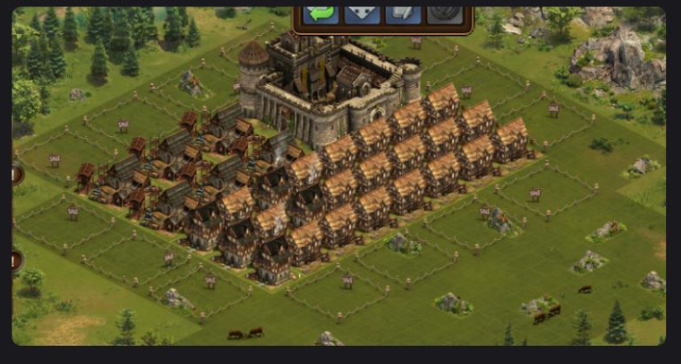
Donate goods in goods mode for all except rope

Collection 1:
- Collect Tannery and delete to churchs to build happy
- Then collect the multistories and delete to churches to max happy
- Collect rest
- Build 1 Shoemaker and come back in hour to confirm built.
- Buy 2 QS shard expansion and do the below

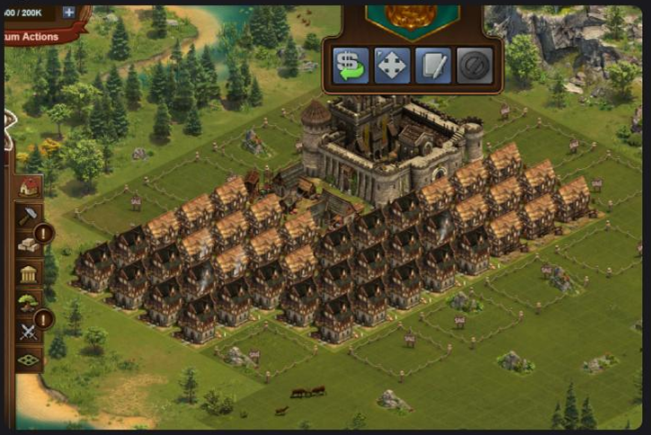

(Fight when guild 100% node is unlocked or donate surplus coins.)

Collection 2:
- Collect tannery delete and build church
- Collect multistorey and delete to build churches
- If not max happy yet continue with estates delete to build max happy
- Delete the as many estates as possible and put in brewery
- Collect from shoemaker
- Build 3 shoemaker, come back in an hour to confirm built + delete the rest till the picture build below
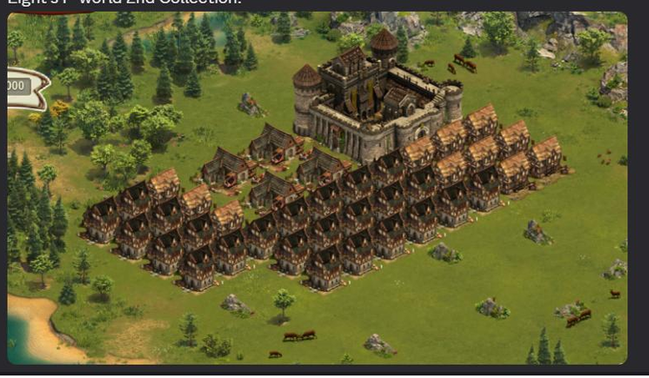

Collection 3:
CollectionSequece same for all
- Collect multistorey and delete to build churches
- If not max happy yet continue with estates delete to build max happy
- Delete the as many estates as possible and put in brewery
- Collect from shoemaker
- Built 1 ropery + 3 more shoemakers. Build 30 goods expansion.
- Fill the rest of the space with 16 Multistories + Estates
- Allow QAs to fill up abit as you should be making only 5000QA so you have 30 hours or 3 collections before full. (otherwise if possible donate or fight whatever manageable)

Collection 4:
CollectionSequece same for all
- Collect multistorey and delete to build churches
- If not max happy yet continue with estates delete to build max happy
- Delete the as many estates as possible and put in brewery
- Collect from shoemaker
- Buy 60 goods expansion
- Build 1 shoemaker, 1 doctor, 1 treb camp. Next collection fighting will be easy as 30 trebs is being built.
(Should now look something like this)
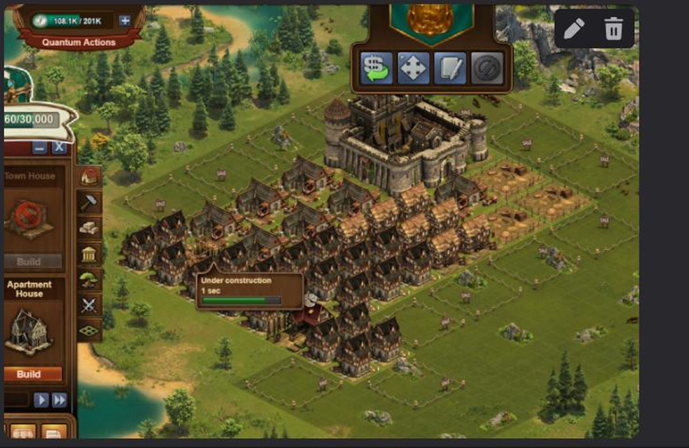

Collection 5:
CollectionSequece same for all
- Collect multistorey and delete to build churches
- If not max happy yet continue with estates delete to build max happy
- Delete the as many estates as possible and put in brewery
- Collect from shoemaker
- Build 1 towerof ruins/group of tree what ever colour you are + 2 doctors +30 trebs
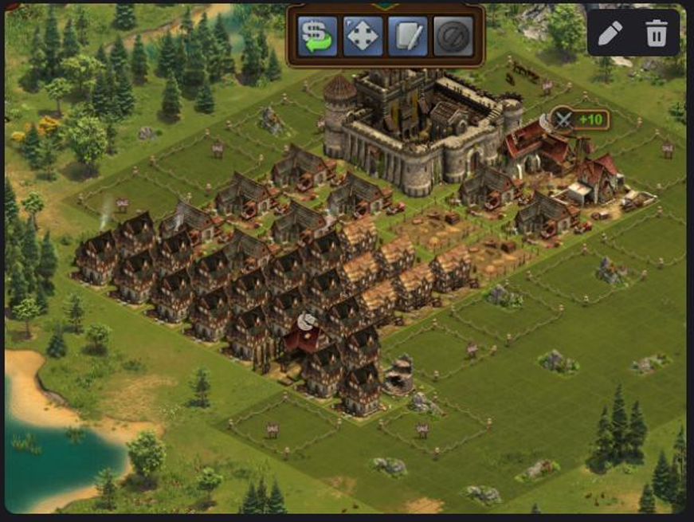

Collection 6:
CollectionSequece same for all
- Collect multistorey and delete to build churches
- If not max happy yet continue with estates delete to build max happy
- Delete the as many estates as possible and put in brewery
- Collect from shoemaker
- Boguht 1 clapboard(rushed) + 90 goods expansion as shown in photo final thing
- 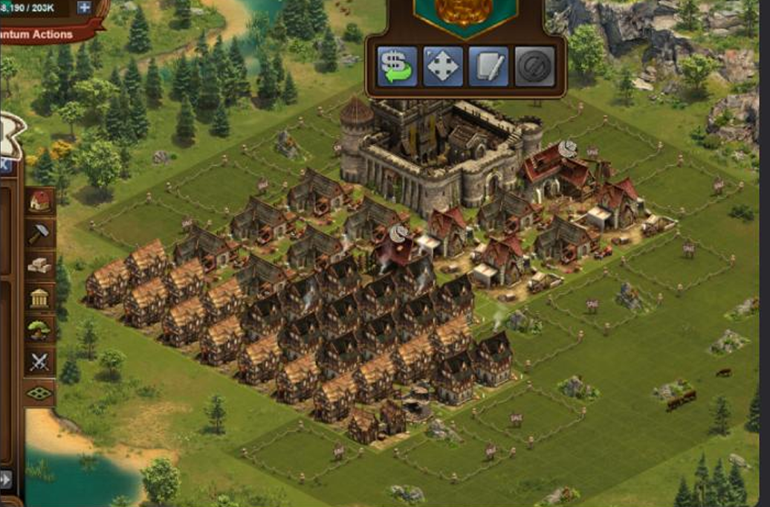

Collection 7:
- Tired of writing collection sequence go above
- Built 2 clapboars(rushed) + 30 trebs + 1 more decos(towerruin/grouptrees)
- This time instead of filling remaing space with estates will fill with tannery as shown in photo below.
- 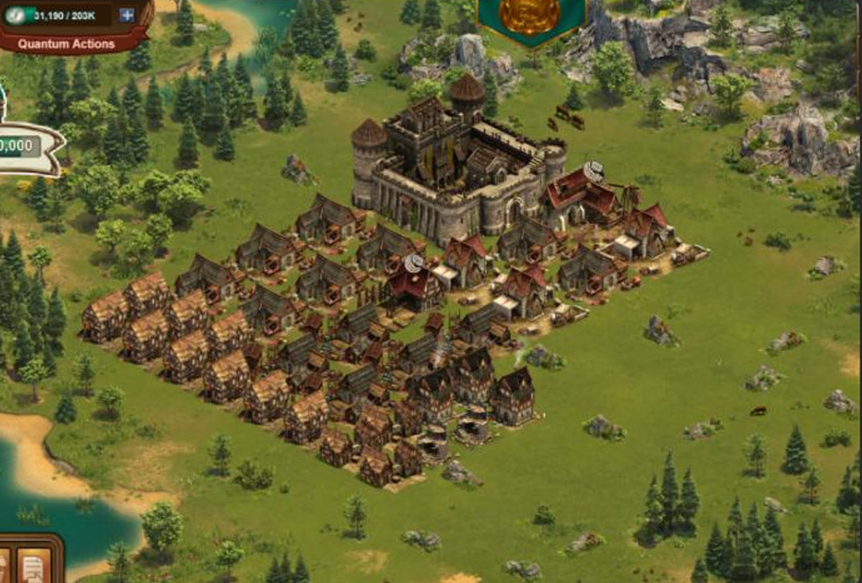

Collection 8:
- Built 1 clapboars(rushed), 1 bakery(rushed), 130 goods expansion + 1 more decos + some trebs until I hit 70 in inventory below is how it should look now
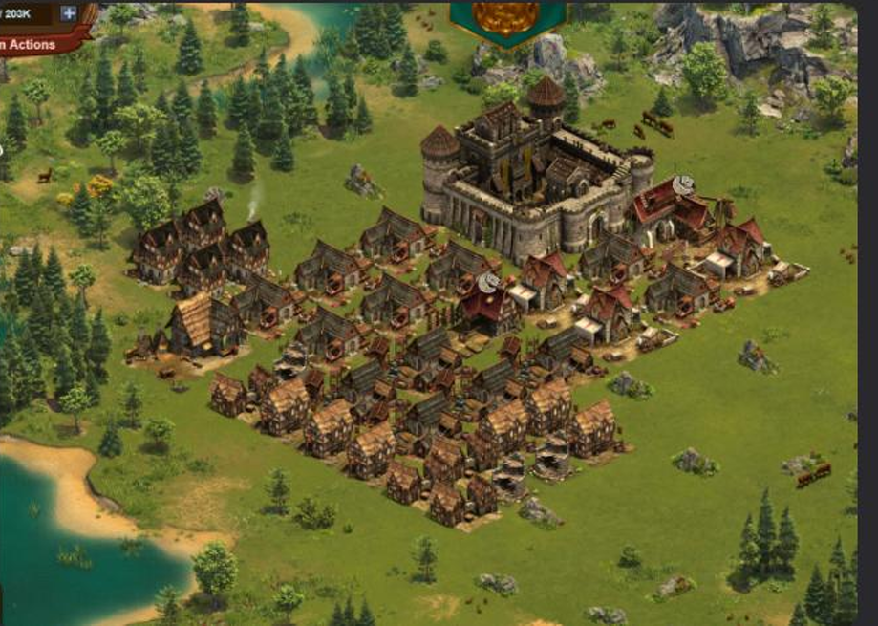

Collection 9:
- Built 2 more clapboards(not rushed) + 1 more goods expansion
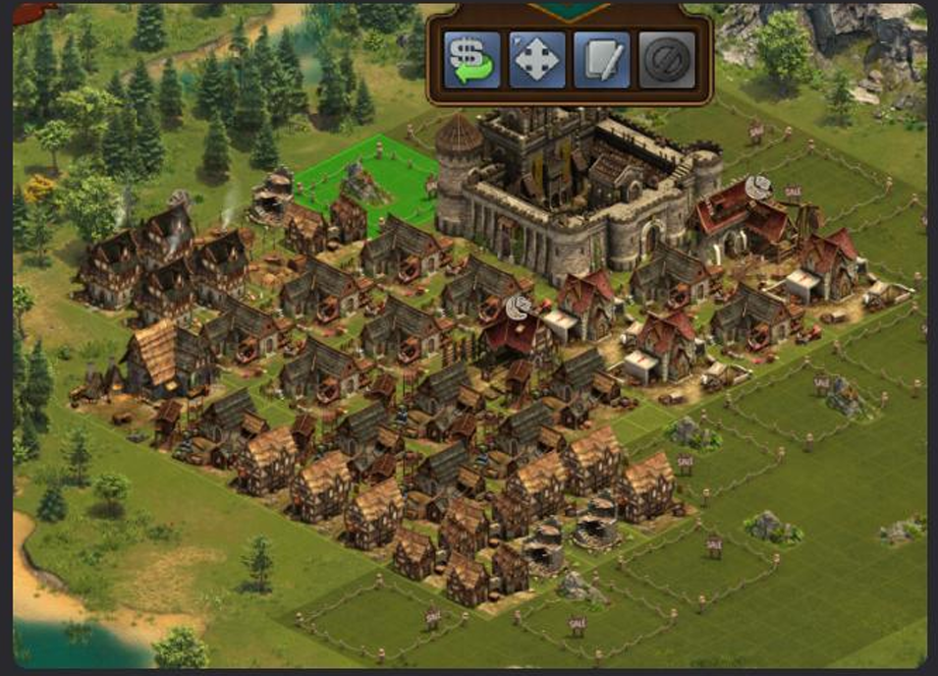

Collection 10:
- Remember in collection tannery to brwery to boost bakery
- Bought 310 goods expansion.
- Deleted All shoemakers + built 4 bakery(rushed)
- Built 2 more clapboards(not rushed) + 1 decoration
(now you should notice how easy it is)
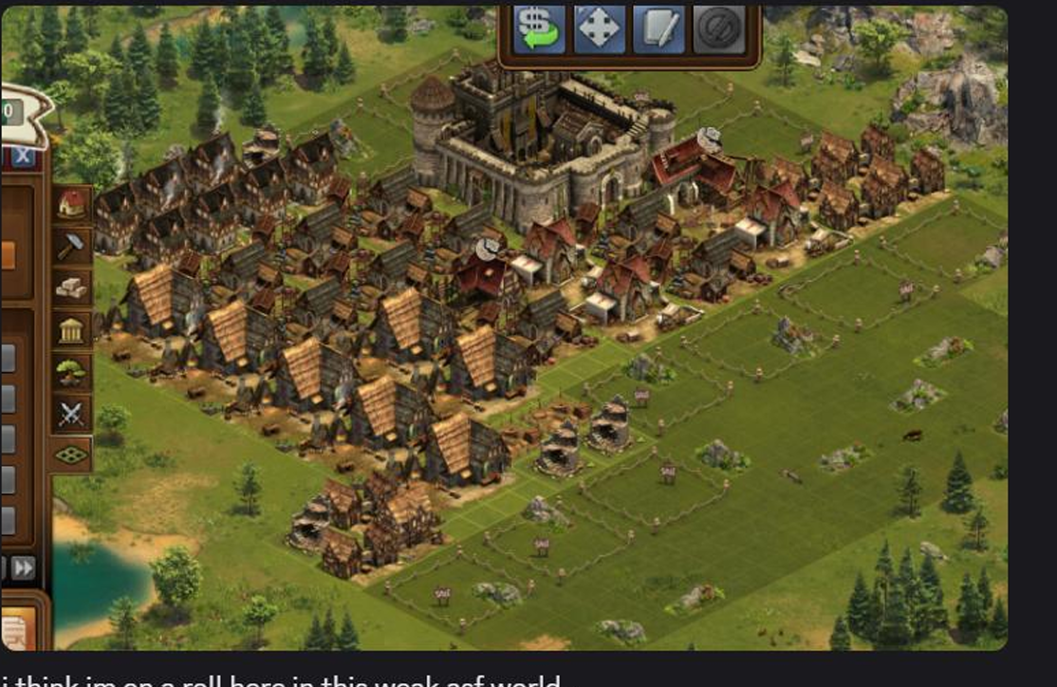

Collection 11:
- Followed Collection Sequence. (Max happy with houses then tan to brewery)
- Bought final goods expansion and deleted ropery + build 1 more decoration
- (this is how it looked after rebuild although looks complete collection I did not record as I did collect then slept)
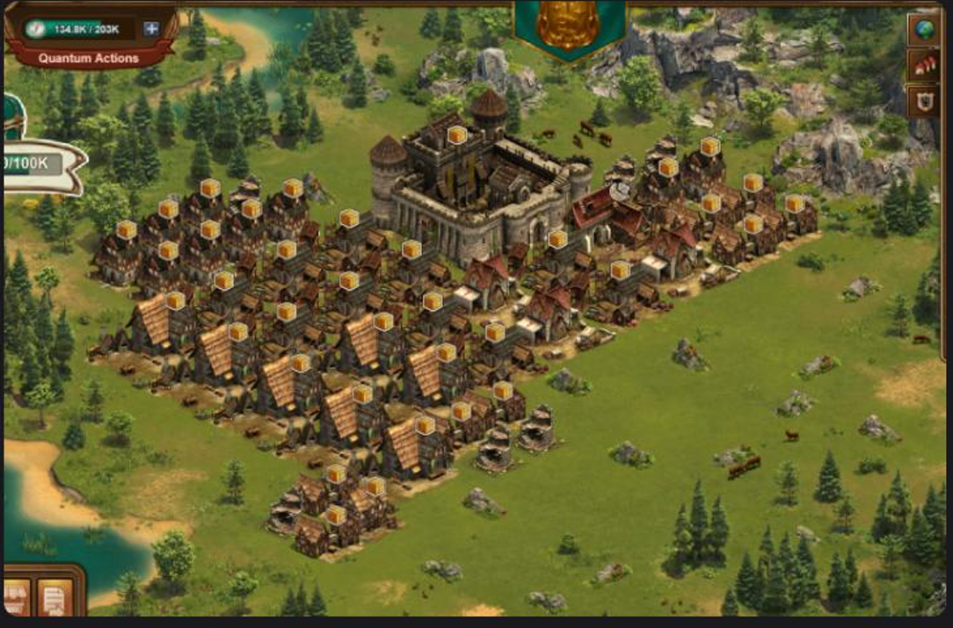
Collection 12:
- Collected All (remember keep up the collection sequence)
- Built some trebs. As many as you want up to you. Did nothing else. So have same image as above.

Collection 13:
- Flipped my whole town.
- Followed Collection Sequence
- Built 300 Trebs
- Built 16 Doctors as shown in image
- And decorations as shown in image.
(note you might be able to build up till 500 trebs if you have surplus supply calculate how you wanna flip your town.)
